# 使用Tiny-dnn训练和分类

Tiny-dnn自带的例子使用的是MNIST手写字符数据库，下面演示使用自己的图像进行训练和测试，关于卷积神经网络的原理及Tiny-dnn的代码理解暂且放一边，只给出以下训练测试实例。

准备训练和测试数据：

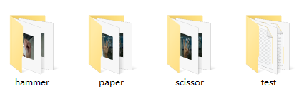

将各训练数据和测试数据路径以文本的形式保存，并标注其分类标签：

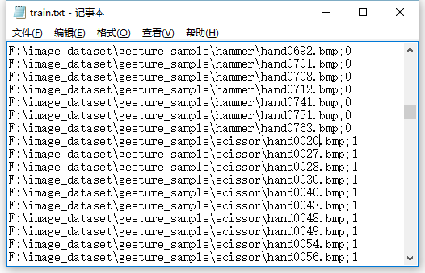

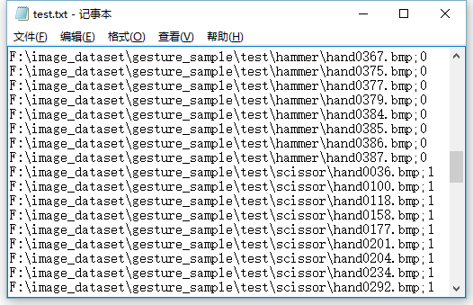

创建工程，添加tiny-dnn-master的路径到包含目录：

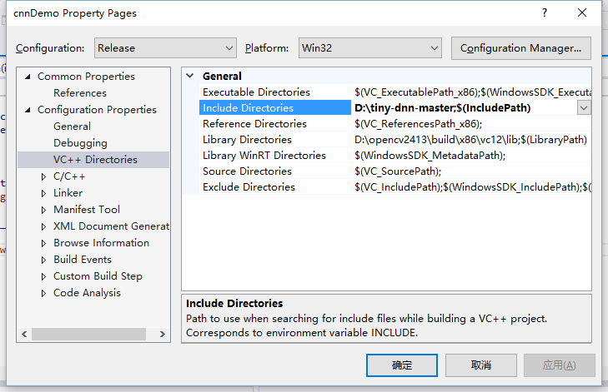

添加预处理命令_SCL_SECURE_NO_WARNINGS：

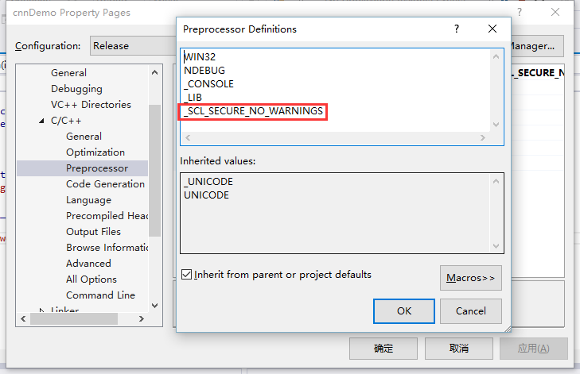

添加以下代码：

#include "stdafx.h"

#include <opencv2\opencv.hpp>

#include <tiny_dnn\tiny_dnn.h>

#include <iostream>

#include <fstream>

#include <memory>

using namespace *tiny_dnn*;

using namespace *tiny_dnn*::activation;

using namespace *tiny_dnn*::*layers*;

using namespace *std*;

*std*::*vector*<*label_t*> train_labels, test_labels;

*std*::*vector*<*vec_t*> train_images, test_images;

void convert_image(const *std*::*string*& imagefilename,

double scale,

int w,

int h,

*std*::*vector*<*vec_t*>&data)

{

auto img = *cv*::*imread*(imagefilename, *cv*::*IMREAD_GRAYSCALE*);

if (img.data == nullptr)return;

*cv*::*Mat_*<*uint8_t*> resized;

*cv*::*resize*(img, resized, *cv*::*Size*(w, h));

*vec_t* d;

*std*::*transform*(resized.*begin*(), resized.*end*(), *std*::*back_inserter*(d),

[=](*uint8_t* c){return c*scale; });

data.*push_back*(d);

}

void readTrainData()

{

*fstream* file("train.txt", *fstream*::*in*);

*string* line;

while (*getline*(file, line))

{

*string* path, label;

char sep = ';';

*stringstream* ss(line);

*getline*(ss, path, sep);

*getline*(ss, label);

convert_image(path, 1.0, 32, 32, train_images);

train_labels.*push_back*(*atoi*(label.*c_str*()));

}

file.*close*();

}

void readTestData()

{

*fstream* file("test.txt", *fstream*::*in*);

*string* line;

while (*getline*(file, line))

{

*string* path, label;

char sep = ';';

*stringstream* ss(line);

*getline*(ss, path, sep);

*getline*(ss, label);

convert_image(path, 1.0, 32, 32, test_images);

test_labels.*push_back*(*atoi*(label.*c_str*()));

}

file.*close*();

}

int *main*(int argc, char** argv) {

network<sequential> nn;

adagrad optimizer;

// connection table [Y.Lecun, 1998 Table.1]

#define O true

#define X false

static const bool connection[] = {

O, X, X, X, O, O, O, X, X, O, O, O, O, X, O, O,

O, O, X, X, X, O, O, O, X, X, O, O, O, O, X, O,

O, O, O, X, X, X, O, O, O, X, X, O, X, O, O, O,

X, O, O, O, X, X, O, O, O, O, X, X, O, X, O, O,

X, X, O, O, O, X, X, O, O, O, O, X, O, O, X, O,

X, X, X, O, O, O, X, X, O, O, O, O, X, O, O, O

};

#undef O

#undef X

nn << convolutional_layer<tan_h>(32, 32, 5, 1, 6) // 32x32 in, 5x5 kernel, 1-6 fmaps conv

<< average_pooling_layer<tan_h>(28, 28, 6, 2) // 28x28 in, 6 fmaps, 2x2 subsampling

<< convolutional_layer<tan_h>(14, 14, 5, 6, 16,

connection_table(connection, 6, 16)) // with connection-table

<< average_pooling_layer<tan_h>(10, 10, 16, 2)

<< convolutional_layer<tan_h>(5, 5, 5, 16, 120)

<< fully_connected_layer<tan_h>(120, 10);

*std*::*cout* << "load models..." << *std*::*endl*;

readTrainData();

readTestData();

*std*::*cout* << "start learning" << *std*::*endl*;

progress_display disp(train_images.*size*());

*timer* t;

int minibatch_size = 10;

optimizer.*alpha* *= *std*::*sqrt*(minibatch_size);

// create callback

auto on_enumerate_epoch = [&](){

*std*::*cout* << t.elapsed() << "s elapsed." << *std*::*endl*;

*tiny_dnn*::*result* res = nn.*test*(test_images, test_labels);

*std*::*cout* << res.num_success << "/" << res.num_total << *std*::*endl*;

disp.*restart*(train_images.*size*());

t.*restart*();

};

auto on_enumerate_minibatch = [&](){

disp += minibatch_size;

};

// training

nn.*train*<mse>(optimizer, train_images, train_labels, minibatch_size, 20, on_enumerate_minibatch, on_enumerate_epoch);

*std*::*cout* << "end training." << *std*::*endl*;

// test and show results

nn.*test*(test_images, test_labels).print_detail(*std*::*cout*);

// save networks

*std*::*ofstream* ofs("LeNet-weights");

ofs << nn;

*cin*.*get*();

}

运行结果：

