# 在MFC中使用OpenCV内存泄漏的问题

一、现象

编译出现类似以下错误：

Detected memory leaks!  
Dumping objects ->  
{1139} normal block at 0x01891A58, 512 bytes long.  
Data: < > 00 00 00 00 00 00 00 00 00 00 00 00 00 00 00 00   
{1138} normal block at 0x01891A10, 8 bytes long.  
Data: <, > 2C 10 89 01 00 00 00 00   
{1137} normal block at 0x018919C8, 8 bytes long.  
Data: < > 00 10 89 01 00 00 00 00   
{1136} normal block at 0x01891980, 8 bytes long.  
Data: < > E0 0F 89 01 00 00 00 00   
{1135} normal block at 0x01891938, 8 bytes long.  
Data: < > B0 0F 89 01 00 00 00 00   
{1134} normal block at 0x018918F0, 8 bytes long.  
Data: < > 90 0F 89 01 00 00 00 00   
{1133} normal block at 0x01891860, 80 bytes long.  
Data: <` ` ` > 60 18 89 01 60 18 89 01 60 18 89 01 CD CD CD CD   
{1132} normal block at 0x01891818, 8 bytes long.  
Data: <| > 7C 0F 89 01 00 00 00 00   
{1131} normal block at 0x018917D0, 8 bytes long.  
Data: <\ > 5C 0F 89 01 00 00 00 00   
{1130} normal block at 0x01891788, 8 bytes long.  
Data: <8 > 38 0F 89 01 00 00 00 00   
{1129} normal block at 0x01891740, 8 bytes long.  
Data: < > 18 0F 89 01 00 00 00 00   
{1128} normal block at 0x018916F8, 8 bytes long.  
Data: < > F0 0E 89 01 00 00 00 00   
{1127} normal block at 0x018916B0, 8 bytes long.  
Data: < > D0 0E 89 01 00 00 00 00   
{1123} normal block at 0x01891590, 8 bytes long.  
Data: < > 1C 0E 89 01 00 00 00 00   
{1122} normal block at 0x01891548, 8 bytes long.  
...

## 二、解决方法

1、在配置属性中设置“在静态库中使用MFC”

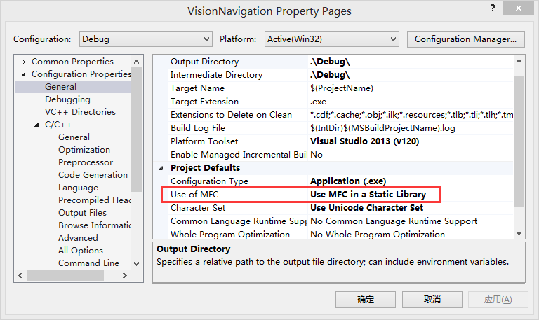

2、在配置属性中设置“多线程调试”：

