# 解决OpenCV编译时部分库下载失败的方法

在使用CMake编译时，一些库常常下载失败，如opencv_ffmpeg.dll，opencv_ffmpeg_64.dll及ippicv。

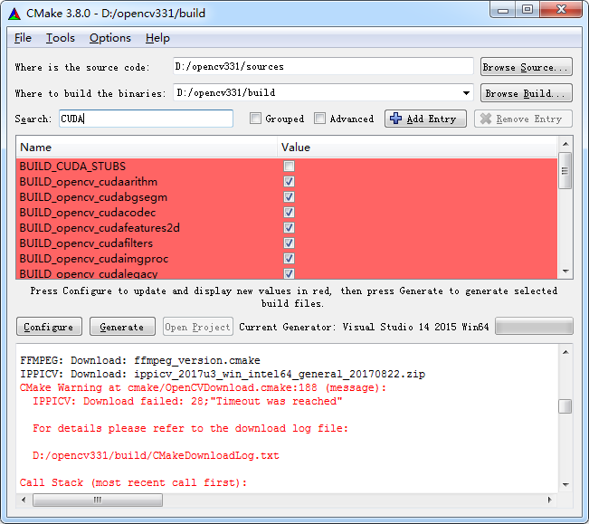

解决方法如下：

打开D:\opencv331\build下的CMakeDownloadLog.txt文件：

|  |
| --- |
| use_cache "D:/opencv331/sources/.cache"  do_copy "opencv_ffmpeg.dll" "3ae76b105113d944984b2351c61e21c6" "https://raw.githubusercontent.com/opencv/opencv_3rdparty/66b1fed06cf3510235f367f96aa26da5cb234a15/ffmpeg/opencv_ffmpeg.dll" "D:/opencv331/build/3rdparty/ffmpeg"  #missing "D:/opencv331/build/3rdparty/ffmpeg/opencv_ffmpeg.dll"  #check_md5 "D:/opencv331/sources/.cache/ffmpeg/3ae76b105113d944984b2351c61e21c6-opencv_ffmpeg.dll"  #mismatch_md5 "D:/opencv331/sources/.cache/ffmpeg/3ae76b105113d944984b2351c61e21c6-opencv_ffmpeg.dll" "6e7842112f65b32647bebdb5ade1cbf5"  #delete "D:/opencv331/sources/.cache/ffmpeg/3ae76b105113d944984b2351c61e21c6-opencv_ffmpeg.dll"  #cmake_download "D:/opencv331/sources/.cache/ffmpeg/3ae76b105113d944984b2351c61e21c6-opencv_ffmpeg.dll" "https://raw.githubusercontent.com/opencv/opencv_3rdparty/66b1fed06cf3510235f367f96aa26da5cb234a15/ffmpeg/opencv_ffmpeg.dll"  do_copy "opencv_ffmpeg_64.dll" "cf3bb5bc9d393b022ea7a42eb63e794d" "https://raw.githubusercontent.com/opencv/opencv_3rdparty/66b1fed06cf3510235f367f96aa26da5cb234a15/ffmpeg/opencv_ffmpeg_64.dll" "D:/opencv331/build/3rdparty/ffmpeg"  #missing "D:/opencv331/build/3rdparty/ffmpeg/opencv_ffmpeg_64.dll"  #check_md5 "D:/opencv331/sources/.cache/ffmpeg/cf3bb5bc9d393b022ea7a42eb63e794d-opencv_ffmpeg_64.dll"  #mismatch_md5 "D:/opencv331/sources/.cache/ffmpeg/cf3bb5bc9d393b022ea7a42eb63e794d-opencv_ffmpeg_64.dll" "55d5648a647a7f8dfcb3e9069924e637"  #delete "D:/opencv331/sources/.cache/ffmpeg/cf3bb5bc9d393b022ea7a42eb63e794d-opencv_ffmpeg_64.dll"  #cmake_download "D:/opencv331/sources/.cache/ffmpeg/cf3bb5bc9d393b022ea7a42eb63e794d-opencv_ffmpeg_64.dll" "https://raw.githubusercontent.com/opencv/opencv_3rdparty/66b1fed06cf3510235f367f96aa26da5cb234a15/ffmpeg/opencv_ffmpeg_64.dll"  do_copy "ffmpeg_version.cmake" "ec59008da403fb18ab3c1ed66aed583b" "https://raw.githubusercontent.com/opencv/opencv_3rdparty/66b1fed06cf3510235f367f96aa26da5cb234a15/ffmpeg/ffmpeg_version.cmake" "D:/opencv331/build/3rdparty/ffmpeg"  #check_md5 "D:/opencv331/build/3rdparty/ffmpeg/ffmpeg_version.cmake"  #match_md5 "D:/opencv331/build/3rdparty/ffmpeg/ffmpeg_version.cmake" "ec59008da403fb18ab3c1ed66aed583b"  do_unpack "ippicv_2017u3_win_intel64_general_20170822.zip" "0421e642bc7ad741a2236d3ec4190bdd" "https://raw.githubusercontent.com/opencv/opencv_3rdparty/dfe3162c237af211e98b8960018b564bc209261d/ippicv/ippicv_2017u3_win_intel64_general_20170822.zip" "D:/opencv331/build/3rdparty/ippicv"  #cmake_download "D:/opencv331/sources/.cache/ippicv/0421e642bc7ad741a2236d3ec4190bdd-ippicv_2017u3_win_intel64_general_20170822.zip" "https://raw.githubusercontent.com/opencv/opencv_3rdparty/dfe3162c237af211e98b8960018b564bc209261d/ippicv/ippicv_2017u3_win_intel64_general_20170822.zip" |

从以上日志中，我们可以发现这些文件的下载地址：

<https://raw.githubusercontent.com/opencv/opencv_3rdparty/66b1fed06cf3510235f367f96aa26da5cb234a15/ffmpeg/opencv_ffmpeg.dll>

<https://raw.githubusercontent.com/opencv/opencv_3rdparty/66b1fed06cf3510235f367f96aa26da5cb234a15/ffmpeg/opencv_ffmpeg_64.dll>

<https://raw.githubusercontent.com/opencv/opencv_3rdparty/dfe3162c237af211e98b8960018b564bc209261d/ippicv/ippicv_2017u3_win_intel64_general_20170822.zip>

以及下载到的目录分别是：

D:/opencv331/build/3rdparty/ffmpeg

D:/opencv331/build/3rdparty/ffmpeg

D:/opencv331/build/3rdparty/ippicv

将这些文件下载下来，放置到对应的目录下：

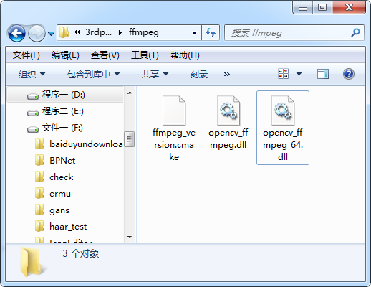

重新configure，opencv_ffmpeg.dll和opencv_ffmpeg_64.dll下载这两步顺利通过了，但是到ippicv这一步，还是出现了问题，如下：

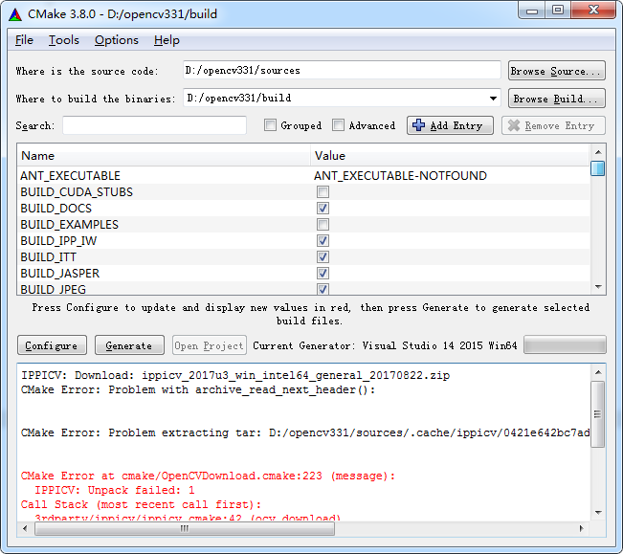

解决方法，打开D:\opencv331\sources\.cache\ippicv目录，发现以下有一个类似图中文件名的文件，将我们下载的ippicv_2017u3_win_intel64_general_20170822.zip重命名成它的名字并替换它，再次configure就成功了！

