# 使用PCL库和XTION获取深度图像

## 下载并安装PCL库

网址：<http://pointclouds.org/downloads/windows.html>

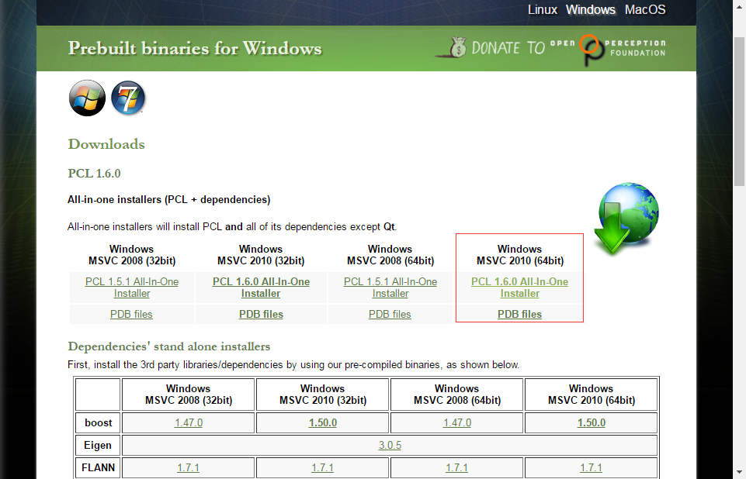

安装后：

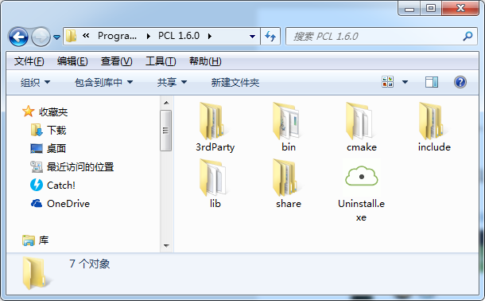

这里有include目录，在3rdParty下的各个文件夹下也有include目录，把这些目录全设置到Visual Studio 2010的工程目录中，同样，lib目录设置成库目录，把bin目录加入到环境变量中。

## 安装XTion驱动

下载地址：<https://dlsvr04.asus.com/pub/ASUS/MM/Xtion_Pro/V1164_1202.zip>，安装到了如下位置：

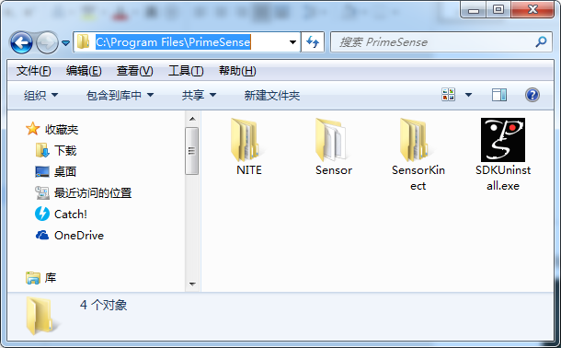

把C:\Program Files\PrimeSense\Sensor\Bin64添加到环境变量。

## 安装OpenNI

我没有使用pcl自带的OpenNI，而是自己下载的OpenNI，下载地址：<http://www.openni.ru/openni-sdk/index.html>

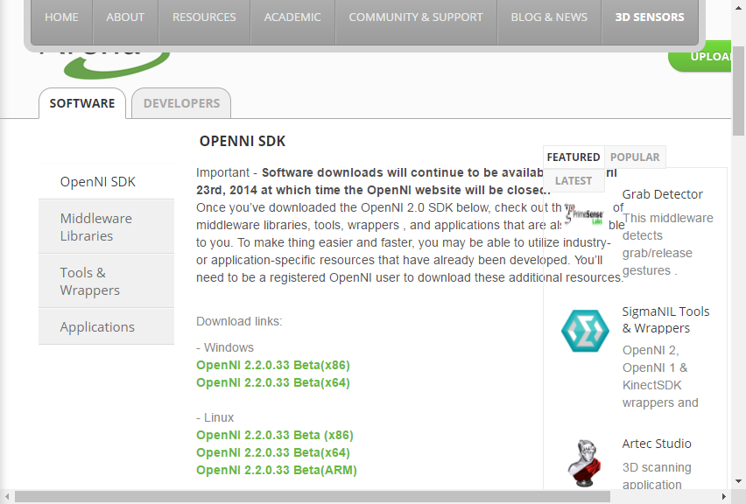

安装后：

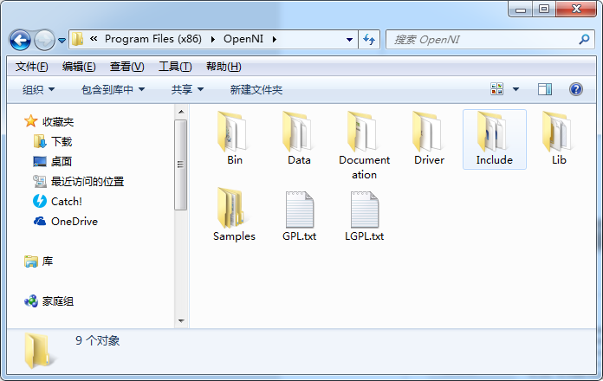

同样，这里有include目录，lib目录和bin目录，与上面处理方法相同。

## 配置汇总

包含目录：

|  |
| --- |
| D:\Program Files\PCL 1.6.0\include\pcl-1.6;  D:\Program Files\PCL 1.6.0\3rdParty\Eigen\include;  C:\Program Files (x86)\OpenNI\Include;  D:\Program Files\PCL 1.6.0\3rdParty\Boost\include;  D:\Program Files\PCL 1.6.0\3rdParty\VTK\include;  D:\Program Files\PCL 1.6.0\3rdParty\VTK\include\vtk-5.8; |

库目录：

|  |
| --- |
| D:\Program Files\PCL 1.6.0\lib;  C:\Program Files (x86)\OpenNI\Lib;  D:\Program Files\PCL 1.6.0\3rdParty\Boost\lib;  D:\Program Files\PCL 1.6.0\3rdParty\VTK\lib\vtk-5.8; |

依赖项：

|  |
| --- |
| pcl_apps_debug.lib  pcl_common_debug.lib  pcl_features_debug.lib  pcl_filters_debug.lib  pcl_io_debug.lib  pcl_io_ply_debug.lib  pcl_kdtree_debug.lib  pcl_keypoints_debug.lib  pcl_octree_debug.lib  pcl_registration_debug.lib  pcl_sample_consensus_debug.lib  pcl_search_debug.lib  pcl_segmentation_debug.lib  pcl_surface_debug.lib  pcl_tracking_debug.lib  pcl_visualization_debug.lib  NiSampleExtensionModule.lib  NiSampleModule.lib  OpenNI.jni.lib  openNI.lib  boost_chrono-vc100-mt-1_49.lib  boost_chrono-vc100-mt-gd-1_49.lib  boost_date_time-vc100-mt-1_47.lib  boost_date_time-vc100-mt-1_49.lib  boost_date_time-vc100-mt-gd-1_47.lib  boost_date_time-vc100-mt-gd-1_49.lib  boost_filesystem-vc100-mt-1_47.lib  boost_filesystem-vc100-mt-1_49.lib  boost_filesystem-vc100-mt-gd-1_47.lib  boost_filesystem-vc100-mt-gd-1_49.lib  boost_graph-vc100-mt-1_49.lib  boost_graph-vc100-mt-gd-1_49.lib  boost_graph_parallel-vc100-mt-1_49.lib  boost_graph_parallel-vc100-mt-gd-1_49.lib  boost_iostreams-vc100-mt-1_47.lib  boost_iostreams-vc100-mt-1_49.lib  boost_iostreams-vc100-mt-gd-1_47.lib  boost_iostreams-vc100-mt-gd-1_49.lib  boost_locale-vc100-mt-1_49.lib  boost_locale-vc100-mt-gd-1_49.lib  boost_math_c99-vc100-mt-1_49.lib  boost_math_c99-vc100-mt-gd-1_49.lib  boost_math_c99f-vc100-mt-1_49.lib  boost_math_c99f-vc100-mt-gd-1_49.lib  boost_math_tr1-vc100-mt-1_49.lib  boost_math_tr1-vc100-mt-gd-1_49.lib  boost_math_tr1f-vc100-mt-1_49.lib  boost_math_tr1f-vc100-mt-gd-1_49.lib  boost_mpi-vc100-mt-1_49.lib  boost_mpi-vc100-mt-gd-1_49.lib  boost_prg_exec_monitor-vc100-mt-1_49.lib  boost_prg_exec_monitor-vc100-mt-gd-1_49.lib  boost_program_options-vc100-mt-1_49.lib  boost_program_options-vc100-mt-gd-1_49.lib  boost_random-vc100-mt-1_49.lib  boost_random-vc100-mt-gd-1_49.lib  boost_regex-vc100-mt-1_49.lib  boost_regex-vc100-mt-gd-1_49.lib  boost_serialization-vc100-mt-1_49.lib  boost_serialization-vc100-mt-gd-1_49.lib  boost_signals-vc100-mt-1_49.lib  boost_signals-vc100-mt-gd-1_49.lib  boost_system-vc100-mt-1_47.lib  boost_system-vc100-mt-1_49.lib  boost_system-vc100-mt-gd-1_47.lib  boost_system-vc100-mt-gd-1_49.lib  boost_thread-vc100-mt-1_47.lib  boost_thread-vc100-mt-1_49.lib  boost_thread-vc100-mt-gd-1_47.lib  boost_thread-vc100-mt-gd-1_49.lib  boost_timer-vc100-mt-1_49.lib  boost_timer-vc100-mt-gd-1_49.lib  boost_unit_test_framework-vc100-mt-1_49.lib  boost_unit_test_framework-vc100-mt-gd-1_49.lib  boost_wave-vc100-mt-1_49.lib  boost_wave-vc100-mt-gd-1_49.lib  boost_wserialization-vc100-mt-1_49.lib  boost_wserialization-vc100-mt-gd-1_49.lib  libboost_chrono-vc100-mt-1_49.lib  libboost_chrono-vc100-mt-gd-1_49.lib  libboost_date_time-vc100-mt-1_47.lib  libboost_date_time-vc100-mt-1_49.lib  libboost_date_time-vc100-mt-gd-1_47.lib  libboost_date_time-vc100-mt-gd-1_49.lib  libboost_filesystem-vc100-mt-1_47.lib  libboost_filesystem-vc100-mt-1_49.lib  libboost_filesystem-vc100-mt-gd-1_47.lib  libboost_filesystem-vc100-mt-gd-1_49.lib  libboost_graph_parallel-vc100-mt-1_49.lib  libboost_graph_parallel-vc100-mt-gd-1_49.lib  libboost_iostreams-vc100-mt-1_47.lib  libboost_iostreams-vc100-mt-1_49.lib  libboost_iostreams-vc100-mt-gd-1_47.lib  libboost_iostreams-vc100-mt-gd-1_49.lib  libboost_locale-vc100-mt-1_49.lib  libboost_locale-vc100-mt-gd-1_49.lib  libboost_math_c99-vc100-mt-1_49.lib  libboost_math_c99-vc100-mt-gd-1_49.lib  libboost_math_c99f-vc100-mt-1_49.lib  libboost_math_c99f-vc100-mt-gd-1_49.lib  libboost_math_tr1-vc100-mt-1_49.lib  libboost_math_tr1-vc100-mt-gd-1_49.lib  libboost_math_tr1f-vc100-mt-1_49.lib  libboost_math_tr1f-vc100-mt-gd-1_49.lib  libboost_mpi-vc100-mt-1_49.lib  libboost_mpi-vc100-mt-gd-1_49.lib  libboost_prg_exec_monitor-vc100-mt-1_49.lib  libboost_prg_exec_monitor-vc100-mt-gd-1_49.lib  libboost_program_options-vc100-mt-1_49.lib  libboost_program_options-vc100-mt-gd-1_49.lib  libboost_random-vc100-mt-1_49.lib  libboost_random-vc100-mt-gd-1_49.lib  libboost_regex-vc100-mt-1_49.lib  libboost_regex-vc100-mt-gd-1_49.lib  libboost_serialization-vc100-mt-1_49.lib  libboost_serialization-vc100-mt-gd-1_49.lib  libboost_signals-vc100-mt-1_49.lib  libboost_signals-vc100-mt-gd-1_49.lib  libboost_system-vc100-mt-1_47.lib  libboost_system-vc100-mt-1_49.lib  libboost_system-vc100-mt-gd-1_47.lib  libboost_system-vc100-mt-gd-1_49.lib  libboost_test_exec_monitor-vc100-mt-1_49.lib  libboost_test_exec_monitor-vc100-mt-gd-1_49.lib  libboost_thread-vc100-mt-1_47.lib  libboost_thread-vc100-mt-1_49.lib  libboost_thread-vc100-mt-gd-1_47.lib  libboost_thread-vc100-mt-gd-1_49.lib  libboost_timer-vc100-mt-1_49.lib  libboost_timer-vc100-mt-gd-1_49.lib  libboost_unit_test_framework-vc100-mt-1_49.lib  libboost_unit_test_framework-vc100-mt-gd-1_49.lib  libboost_wave-vc100-mt-1_49.lib  libboost_wave-vc100-mt-gd-1_49.lib  libboost_wserialization-vc100-mt-1_49.lib  libboost_wserialization-vc100-mt-gd-1_49.lib  MapReduceMPI-gd.lib  MapReduceMPI.lib  mpistubs-gd.lib  mpistubs.lib  QVTK-gd.lib  QVTK.lib  vtkalglib-gd.lib  vtkalglib.lib  vtkCharts-gd.lib  vtkCharts.lib  vtkCommon-gd.lib  vtkCommon.lib  vtkDICOMParser-gd.lib  vtkDICOMParser.lib  vtkexoIIc-gd.lib  vtkexoIIc.lib  vtkexpat-gd.lib  vtkexpat.lib  vtkFiltering-gd.lib  vtkFiltering.lib  vtkfreetype-gd.lib  vtkfreetype.lib  vtkftgl-gd.lib  vtkftgl.lib  vtkGenericFiltering-gd.lib  vtkGenericFiltering.lib  vtkGeovis-gd.lib  vtkGeovis.lib  vtkGraphics-gd.lib  vtkGraphics.lib  vtkhdf5-gd.lib  vtkhdf5.lib  vtkHybrid-gd.lib  vtkHybrid.lib  vtkImaging-gd.lib  vtkImaging.lib  vtkInfovis-gd.lib  vtkInfovis.lib  vtkIO-gd.lib  vtkIO.lib  vtkjpeg-gd.lib  vtkjpeg.lib  vtklibxml2-gd.lib  vtklibxml2.lib  vtkmetaio-gd.lib  vtkmetaio.lib  vtkNetCDF-gd.lib  vtkNetCDF.lib  vtkNetCDF_cxx-gd.lib  vtkNetCDF_cxx.lib  vtkpng-gd.lib  vtkpng.lib  vtkproj4-gd.lib  vtkproj4.lib  vtkRendering-gd.lib  vtkRendering.lib  vtksqlite-gd.lib  vtksqlite.lib  vtksys-gd.lib  vtksys.lib  vtktiff-gd.lib  vtktiff.lib  vtkverdict-gd.lib  vtkverdict.lib  vtkViews-gd.lib  vtkViews.lib  vtkVolumeRendering-gd.lib  vtkVolumeRendering.lib  vtkWidgets-gd.lib  vtkWidgets.lib  vtkzlib-gd.lib  vtkzlib.lib |

## 5测试

|  |
| --- |
| #include "stdafx.h"  #include <pcl/io/openni_grabber.h>  #include <pcl/visualization/cloud_viewer.h>  #include <pcl/io/pcd_io.h>  #include <iostream>  #include <string>  #include <strstream>  #include <pcl/common/time.h>  #include <pcl/console/parse.h>    class SimpleOpenNIViewer  {  public:  SimpleOpenNIViewer () : viewer ("PCL OpenNI Viewer") {}  void cloud_cb_ (const pcl::PointCloud<pcl::PointXYZRGB>::ConstPtr &cloud)  {  if (!viewer.wasStopped())  {  viewer.showCloud (cloud);  std::stringstream ss;  ss << std::setprecision (12) << pcl::getTime () * 100 << ".pcd";  pcl::PCDWriter w;  w.writeBinaryCompressed (ss.str (), *cloud);  }  }    void run ()  {  pcl::Grabber* interface = new pcl::OpenNIGrabber();    boost::function<void (const pcl::PointCloud<pcl::PointXYZRGB>::ConstPtr&)> f =  boost::bind (&SimpleOpenNIViewer::cloud_cb_, this, _1);  interface->registerCallback (f);  interface->start ();  while (!viewer.wasStopped())  {  boost::this_thread::sleep (boost::posix_time::seconds (1));  }  interface->stop ();  }  pcl::visualization::CloudViewer viewer;  };    int main ()  {  SimpleOpenNIViewer v;  v.run ();  return 0;  } |

