# ROS编程之图像消息

以下例子演示了在ROS的图像消息发布与订阅。

创建功能包：

catkin_create_pkg tutorials image_transport cv_bridge std_msgs rospy roscpp

服务器端：

|  |
| --- |
| #include <ros/ros.h>  #include <image_transport/image_transport.h>  #include <opencv2/highgui/highgui.hpp>  #include <cv_bridge/cv_bridge.h>  #include <iostream>  int main(int argc, char** argv)  {  ros::init(argc, argv, "image_publisher");  ros::NodeHandle nh;  image_transport::ImageTransport it(nh);  image_transport::Publisher pub = it.advertise("image", 1);  cv::Mat image = cv::imread("/home/hy17003/catkin_ws/src/tutorials/imgs/Penguins.jpg");  if(image.empty())  {  std::cout << "read image failed!" << std::endl;  return -1;  }  std::cout << image.rows << "," << image.cols << std::endl;  sensor_msgs::ImagePtr msg = cv_bridge::CvImage(std_msgs::Header(), "bgr8", image).toImageMsg();  ros::Rate loop_rate(5);  while(nh.ok())  {  pub.publish(msg);  ros::spinOnce();  loop_rate.sleep();  }  } |

客户端：

|  |
| --- |
| #include <ros/ros.h>  #include <image_transport/image_transport.h>  #include <opencv2/highgui/highgui.hpp>  #include <cv_bridge/cv_bridge.h>  void imageCallback(const sensor_msgs::ImageConstPtr& msg)  {  try  {  cv::imshow("view", cv_bridge::toCvShare(msg, "bgr8")->image);  }  catch(cv_bridge::Exception& e)  {  ROS_ERROR("Could not convert from '%s' to 'bgr8'.", msg->encoding.c_str());  }  }  int main(int argc, char **argv)  {  ros::init(argc, argv, "image_listener");  ros::NodeHandle nh;  cv::namedWindow("view");  cv::startWindowThread();  image_transport::ImageTransport it(nh);  image_transport::Subscriber sub = it.subscribe("image", 1, imageCallback);  ros::spin();  cv::destroyWindow("view");  } |

注意以上如果没有cv::startWindowThread()不会显示出图像。

package.xml中关键部分：

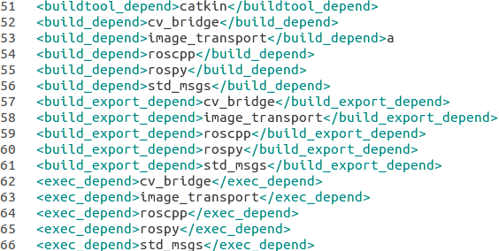

CMakeLists.txt中关键部分：

