Qt+CMake+OpenCV2.4.9配置

一、安装Qt
安装完毕后根据安装位置设置环境变量：D:\Qt\Qt5.5.0_mingw\Tools\mingw492_32\bin;

二、使用CMake编译OpenCV
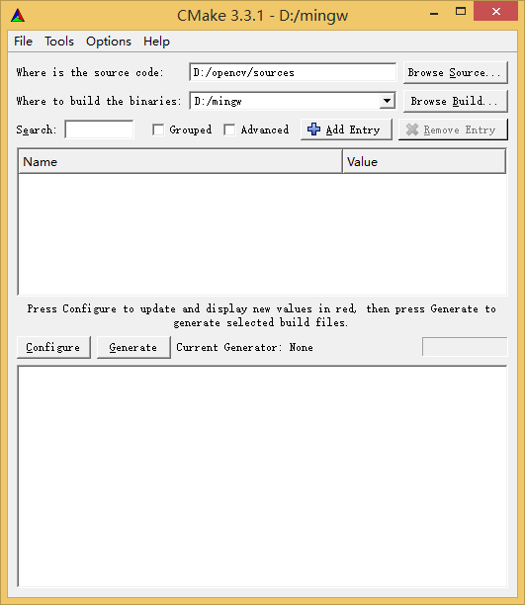
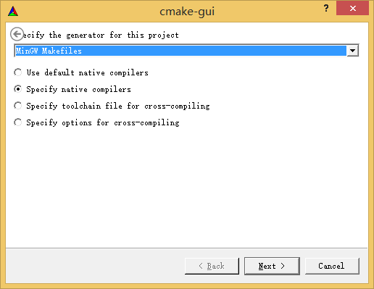
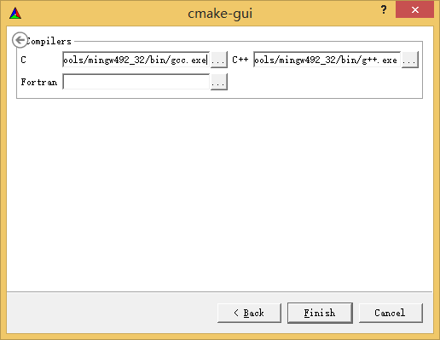
D:/Qt/Qt5.5.0_mingw/Tools/mingw492_32/bin/gcc.exe
D:/Qt/Qt5.5.0_mingw/Tools/mingw492_32/bin/g++.exe
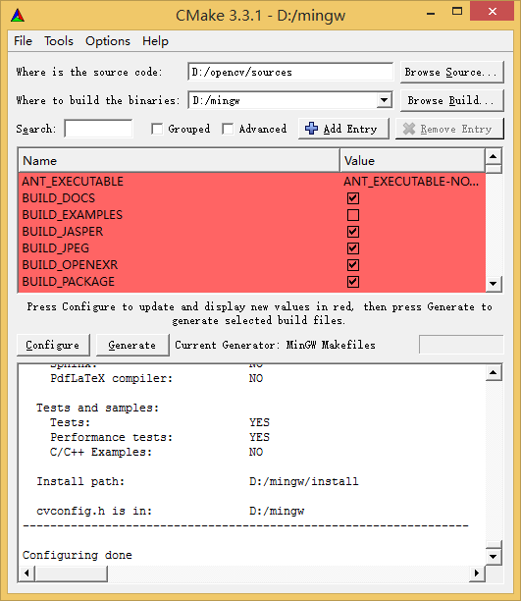
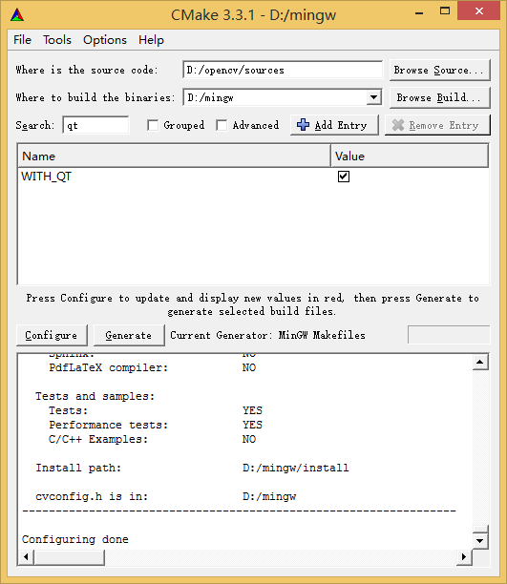
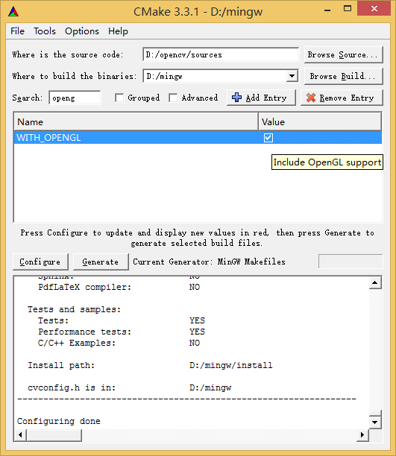
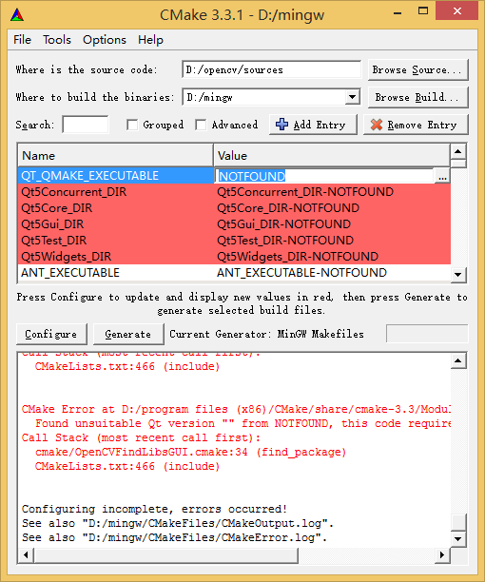
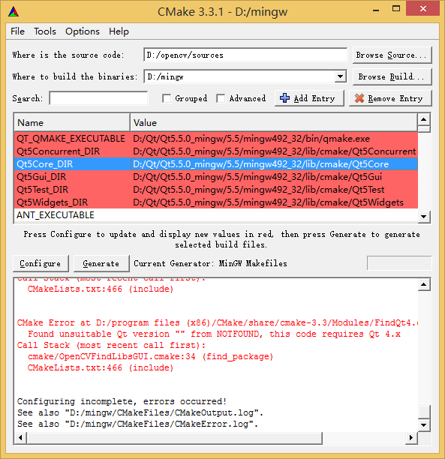
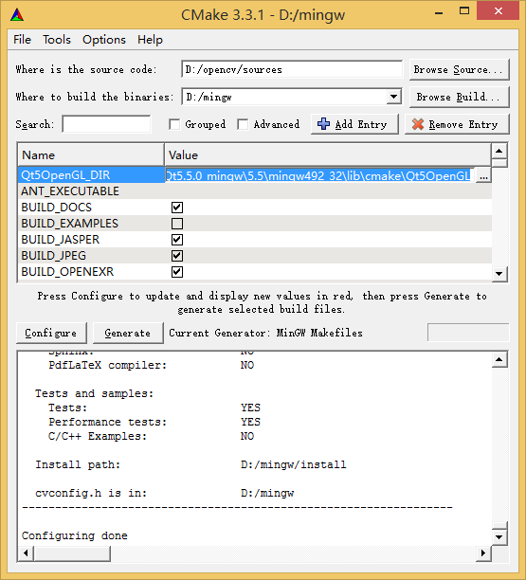
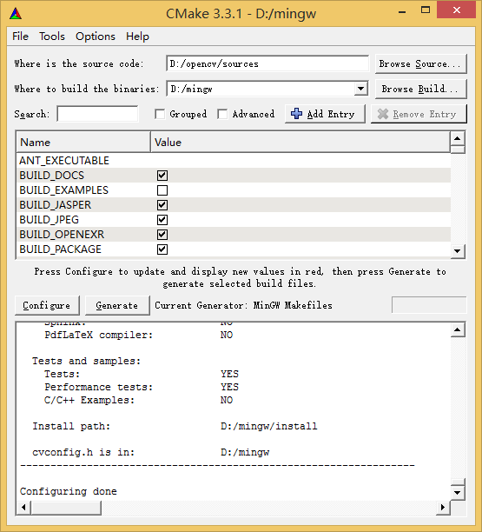
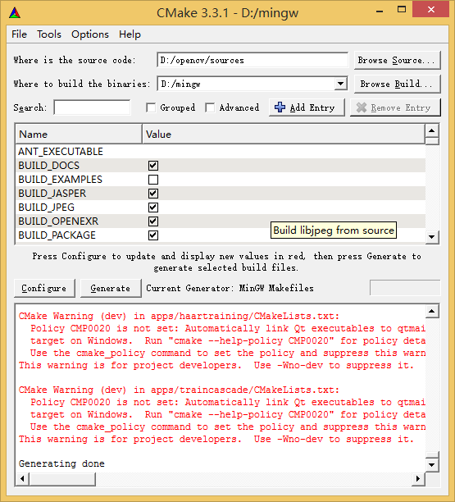

三、执行mingw32-make install
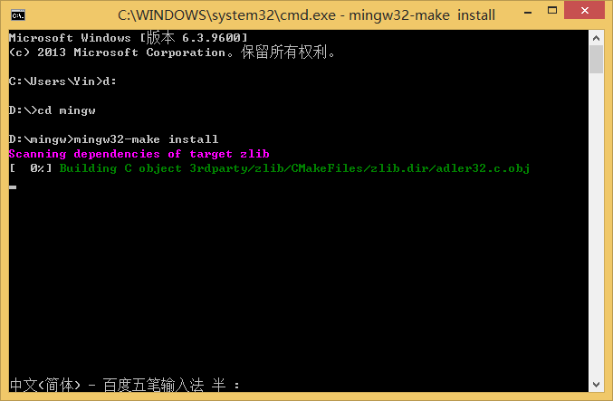
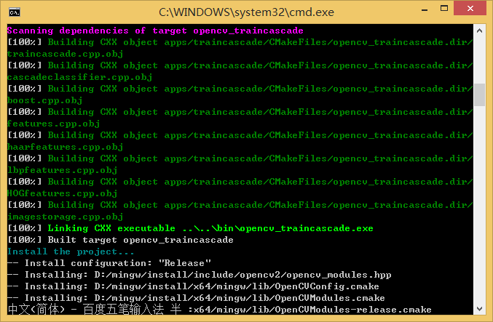
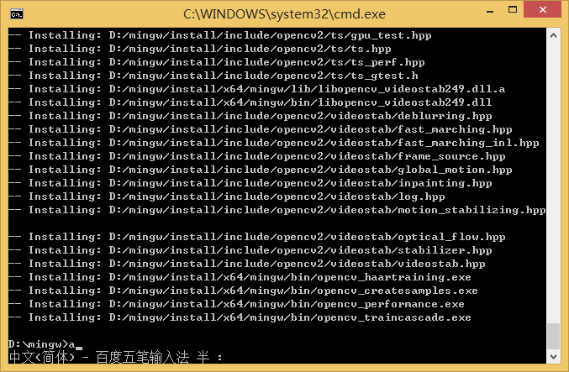

四、设置环境变量
一共要设三条环境变量：
D:\Qt\Qt5.5.0_mingw\Tools\mingw492_32\bin;
D:\opencv\build\x86\mingw\bin;
D:\Qt\Qt5.5.0_mingw\5.5\mingw492_32\bin

五、测试
新建一个工程，在工程文件中加入：
INCLUDEPATH += d:\opencv\build\include\
d:\opencv\build\include\opencv\
d:\opencv\build\include\opencv2

LIBS += d:\opencv\build\x86\mingw\lib\libopencv_calib3d249.dll.a\
d:\opencv\build\x86\mingw\lib\libopencv_contrib249.dll.a\
d:\opencv\build\x86\mingw\lib\libopencv_core249.dll.a\
d:\opencv\build\x86\mingw\lib\libopencv_features2d249.dll.a\
d:\opencv\build\x86\mingw\lib\libopencv_flann249.dll.a\
d:\opencv\build\x86\mingw\lib\libopencv_gpu249.dll.a\
d:\opencv\build\x86\mingw\lib\libopencv_highgui249.dll.a\
d:\opencv\build\x86\mingw\lib\libopencv_imgproc249.dll.a\
d:\opencv\build\x86\mingw\lib\libopencv_legacy249.dll.a\
d:\opencv\build\x86\mingw\lib\libopencv_ml249.dll.a\
d:\opencv\build\x86\mingw\lib\libopencv_objdetect249.dll.a\
d:\opencv\build\x86\mingw\lib\libopencv_video249.dll.a

实验代码：
#include <QCoreApplication>
#include <opencv2/core/core.hpp>
#include <opencv2/highgui/highgui.hpp>
#include <iostream>
int main()
{
cv::Mat image = cv::imread("D:\\test.jpg");
if(!image.data)
{
std::cout<<"No Image!"<<std::endl;
return 1;
}
cv::namedWindow("My image",CV_WINDOW_AUTOSIZE);
cv::imshow("My image",image);
cv::waitKey(0);
cv::destroyWindow("My image");
return 0;
}
注：以上步骤在我的电脑下操作的，但实验不成功，但在另一台win7电脑上操作成功。

