# Linux中Eclipse+cdt的安装

1、在终端下执行以下命令：

$sudo apt-get install eclipse  
$sudo apt-get install eclipse-cdt

2、下载cdt

<http://archive.eclipse.org/tools/cdt/releases/europa/dist/cdt-master-4.0.2.zip>

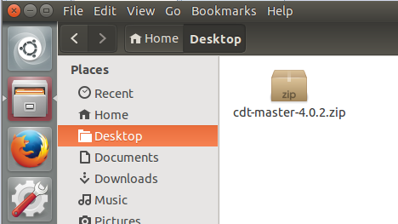

拷贝到usr/share/eclipse目录下：

sudo cp cdt-master-4.0.2.zip /usr/share/eclipse/

3、解压cdt-master-4.0.2.zip:

hy17003@ubuntu:~/Desktop$ cd /usr/share/eclipse/

hy17003@ubuntu:/usr/share/eclipse$ sudo unzip cdt-master-4.0.2.zip

hy17003@ubuntu:/usr/share/eclipse$ sudo chmod -R 777 .

4、运行

hy17003@ubuntu:/usr/share/eclipse$ eclipse