# Caffe中自定义数据层

## 自定义数据层基本步骤

自定义数据层主要有几个步骤：

1. 在caffe.proto中注册新类，添加变量
2. 自定义hpp头文件和cpp源文件，重写type，LayerSetUp，ShuffleImage，load_batch方法；
3. 重新编译caffe

下面以读取一个包含50×100幅20×20的手写数字图像的大图像为例，说明自定义数据层的实现。

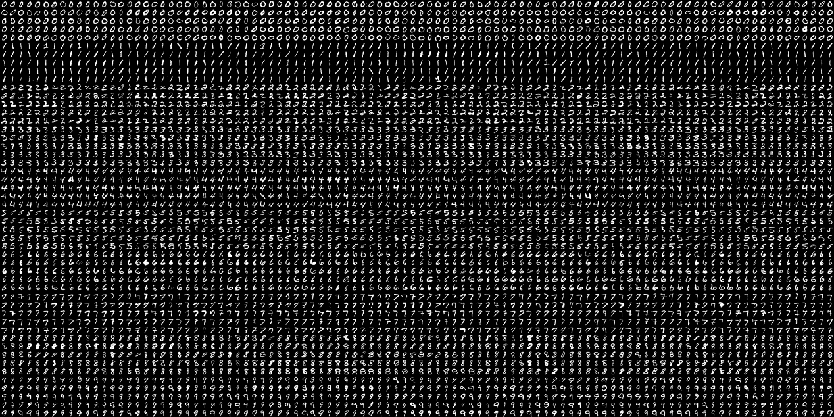

图 1 测试图像

图像包括10个数字的手写图像，每一个数字有5行，100列，选择前70列作为训练，后30列作为测试。

## 在caffe.proto中注册新类

打开/src/caffe/proto/caffe.proto文件，定义层参数和相关参数：

意义如下：

cols：图像行数，这里为100

rows：图像列数，这里为50

width：每幅小图像宽度，这里为20

height：每幅小图像高度，这里为20

start_col：输入图像起始行数，训练时为0，测试时为70

end_col：输入图像截止行数，训练时为70，测试时为100

image_address：输入图像的地址

is_save = 8：是否保存子图像，便于查看图像是否分割正确

save_folder：保存路径

is_color：是否是彩色图像

batch_size：批大小

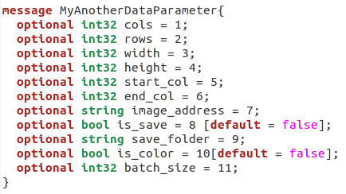

图 2 自定义层参数

在LayerParameter中添加自定义的层参数对象：



图 3 添加层参数对象

## 自定义头文件和源文件并重写相关方法

### 头文件

在include/caffe/layers目录中复制一份image_data_layer.hpp文件，改名成my_another_data_layer.hpp，将原ImageDataLayer改成MyAnotherDataLayer，并修改其它必要的代码。

对2中定义的参数，在头文件中添加相应的变量，用于保存这些数据，并定义一个pair类型的向量，用于保存图像和对应的标签：

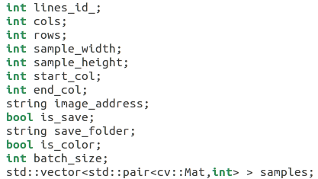

修改type函数，返回类别名称，此函数仅用于信息的打印：



修改后头文件如下：

#ifndef CAFFE_MY_ANOTHER_DATA_LAYER_HPP_

#define CAFFE_MY_ANOTHER_DATA_LAYER_HPP_

#include <string>

#include <utility>

#include <vector>

#include "caffe/blob.hpp"

#include "caffe/data_transformer.hpp"

#include "caffe/internal_thread.hpp"

#include "caffe/layer.hpp"

#include "caffe/layers/base_data_layer.hpp"

#include "caffe/proto/caffe.pb.h"

namespace caffe {

/**

* @brief Provides data to the Net from image files.

*

* TODO(dox): thorough documentation for Forward and proto params.

*/

template <typename Dtype>

class MyAnotherDataLayer : public BasePrefetchingDataLayer<Dtype> {

public:

explicit MyAnotherDataLayer(const LayerParameter& param)

: BasePrefetchingDataLayer<Dtype>(param) {}

virtual ~MyAnotherDataLayer();

virtual void DataLayerSetUp(const vector<Blob<Dtype>*>& bottom,

const vector<Blob<Dtype>*>& top);

virtual inline const char* type() const { return "MyAnotherData"; }

virtual inline int ExactNumBottomBlobs() const { return 0; }

virtual inline int ExactNumTopBlobs() const { return 2; }

cv::Mat getSample(cv::Mat image, int x, int y, int w, int h);

protected:

virtual void ShuffleImages();

virtual void load_batch(Batch<Dtype>* batch);

int lines_id_;

int cols;

int rows;

int sample_width;

int sample_height;

int start_col;

int end_col;

string image_address;

bool is_save;

string save_folder;

bool is_color;

int batch_size;

std::vector<std::pair<cv::Mat,int> > samples;

};

} // namespace caffe

#endif // CAFFE_MY_ANOTHER_DATA_LAYER_HPP_

### 源文件

在src/caffe/layers目录中复制一份image_data_layer.cpp文件，改名成my_another_data_layer.cpp，将原ImageDataLayer改成MyAnotherDataLayer，并修改其它必要的代码。

改写DataLayerSetUp，load_batch函数。

#### DataLayerSetUp函数

重写DataLayerSetUp函数，改函数主要完成以下功能：读取层参数，读取图像和对应标签，重排图像，初始化transformed_data，prefetch_等形状的初始化。与ImageDataLayer相比，我们只是改变了图像的输入方式，因此我们只需要重写读取参数，读取图像，重排图像等相关部分即可。

1. 读取参数

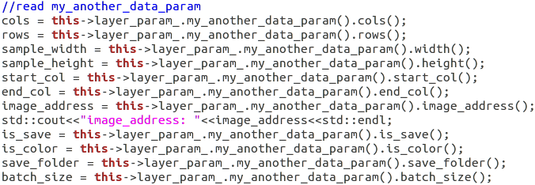

1. 读取图像

图像保存在std::vector<std::pair<cv::Mat,int>> samples中，注意，“>>”中间需要加一个空格。

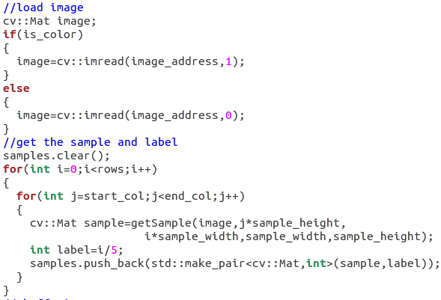

其中getSample的函数定义如下：

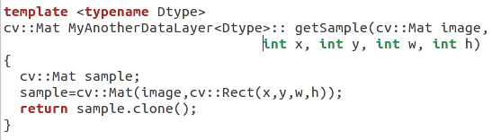

1. 重排图像

重排图像调用ShuffleImages()函数，其定义如下：

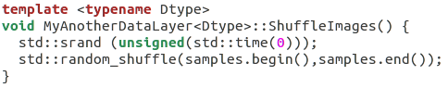

1. 其它

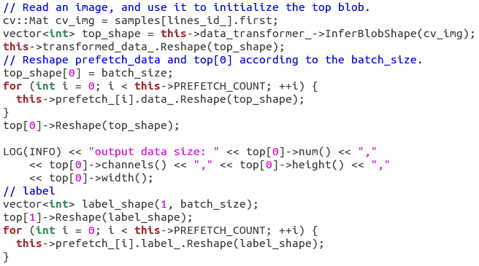

#### load_batch函数

改函数将读取的图像转换为Blob类型，保存到cpu数据中。

batch包括图像数据和标签两个成员。在load_batch函数中，将读取到的图像和对应标签传入到cpu中，每一批的数量是batch_size，如果读取完了所有图像，再将图像打乱，从头开始，继续读取。

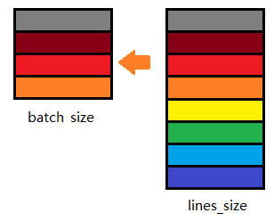

将图像传入到cpu中是以下代码实现的：



其中Transform函数将samle图像减去均值图像，然后剪切、镜向，保存到transformed_data_这个Blob类型变量中。

整个函数代码如下：

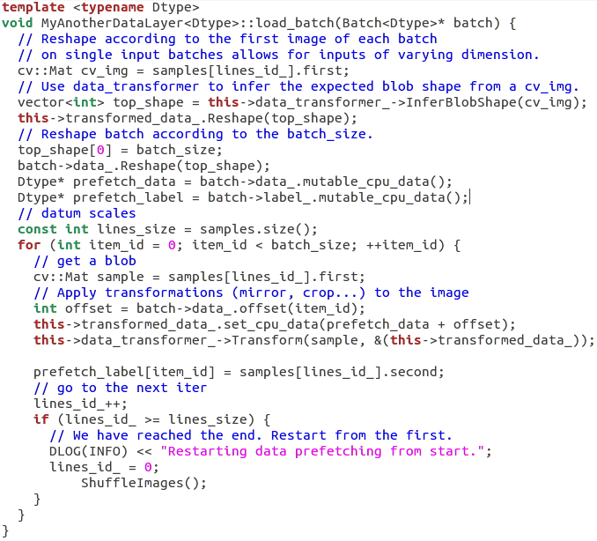

#### 其它

在源文件最后，修改以下宏：



这里的把MyAnotherDataLayer注册一个名字MyAnotherData，这在网络文件中使用该层直接使用该名字即可。

修改后，整个源文件代码如下：

#ifdef USE_OPENCV

#include <opencv2/core/core.hpp>

#include <opencv2/highgui/highgui.hpp>

#include <fstream> // NOLINT(readability/streams)

#include <iostream> // NOLINT(readability/streams)

#include <string>

#include <utility>

#include <vector>

#include "caffe/data_transformer.hpp"

#include "caffe/layers/base_data_layer.hpp"

#include "caffe/layers/my_another_data_layer.hpp"

#include "caffe/util/benchmark.hpp"

#include "caffe/util/io.hpp"

#include "caffe/util/math_functions.hpp"

#include "caffe/util/rng.hpp"

namespace caffe {

template <typename Dtype>

MyAnotherDataLayer<Dtype>::~MyAnotherDataLayer<Dtype>() {

this->StopInternalThread();

}

template <typename Dtype>

void MyAnotherDataLayer<Dtype>::DataLayerSetUp(const vector<Blob<Dtype>*>& bottom,const vector<Blob<Dtype>*>& top) {

//read my_another_data_param

cols = this->layer_param_.my_another_data_param().cols();

rows = this->layer_param_.my_another_data_param().rows();

sample_width = this->layer_param_.my_another_data_param().width();

sample_height = this->layer_param_.my_another_data_param().height();

start_col = this->layer_param_.my_another_data_param().start_col();

end_col = this->layer_param_.my_another_data_param().end_col();

image_address = this->layer_param_.my_another_data_param().image_address();

std::cout<<"image_address: "<<image_address<<std::endl;

is_save = this->layer_param_.my_another_data_param().is_save();

is_color = this->layer_param_.my_another_data_param().is_color();

save_folder = this->layer_param_.my_another_data_param().save_folder();

batch_size = this->layer_param_.my_another_data_param().batch_size();

lines_id_ = 0;

//load image

cv::Mat image;

if(is_color)

{

image=cv::imread(image_address,1);

}

else

{

image=cv::imread(image_address,0);

}

//get the sample and label

samples.clear();

for(int i=0;i<rows;i++)

{

for(int j=start_col;j<end_col;j++)

{

cv::Mat sample=getSample(image,j*sample_height,

i*sample_width,sample_width,sample_height);

int label=i/5;

samples.push_back(std::make_pair<cv::Mat,int>(sample,label));

}

}

//shuffe images

ShuffleImages();

//save images

if(is_save)

{

for(int i=0;i<samples.size();i++)

{

char image_name[100];

sprintf(image_name,"%s/%04d.jpg",save_folder.c_str(),i);

cv::imwrite(image_name,samples[i].first);

// std::cout<<"save image:"<<image_name<<std::endl;

}

}

lines_id_ = 0;

// Read an image, and use it to initialize the top blob.

cv::Mat cv_img = samples[lines_id_].first;

vector<int> top_shape = this->data_transformer_->InferBlobShape(cv_img);

this->transformed_data_.Reshape(top_shape);

// Reshape prefetch_data and top[0] according to the batch_size.

top_shape[0] = batch_size;

for (int i = 0; i < this->PREFETCH_COUNT; ++i) {

this->prefetch_[i].data_.Reshape(top_shape);

}

top[0]->Reshape(top_shape);

LOG(INFO) << "output data size: " << top[0]->num() << ","

<< top[0]->channels() << "," << top[0]->height() << ","

<< top[0]->width();

// label

vector<int> label_shape(1, batch_size);

top[1]->Reshape(label_shape);

for (int i = 0; i < this->PREFETCH_COUNT; ++i) {

this->prefetch_[i].label_.Reshape(label_shape);

}

}

template <typename Dtype>

cv::Mat MyAnotherDataLayer<Dtype>:: getSample(cv::Mat image,

int x, int y, int w, int h)

{

cv::Mat sample;

sample=cv::Mat(image,cv::Rect(x,y,w,h));

return sample.clone();

}

template <typename Dtype>

void MyAnotherDataLayer<Dtype>::ShuffleImages() {

std::srand (unsigned(std::time(0)));

std::random_shuffle(samples.begin(),samples.end());

}

// This function is called on prefetch thread

template <typename Dtype>

void MyAnotherDataLayer<Dtype>::load_batch(Batch<Dtype>* batch) {

// Reshape according to the first image of each batch

// on single input batches allows for inputs of varying dimension.

cv::Mat cv_img = samples[lines_id_].first;

// Use data_transformer to infer the expected blob shape from a cv_img.

vector<int> top_shape = this->data_transformer_->InferBlobShape(cv_img);

this->transformed_data_.Reshape(top_shape);

// Reshape batch according to the batch_size.

top_shape[0] = batch_size;

batch->data_.Reshape(top_shape);

Dtype* prefetch_data = batch->data_.mutable_cpu_data();

Dtype* prefetch_label = batch->label_.mutable_cpu_data();

// datum scales

const int lines_size = samples.size();

for (int item_id = 0; item_id < batch_size; ++item_id) {

// get a blob

cv::Mat sample = samples[lines_id_].first;

// Apply transformations (mirror, crop...) to the image

int offset = batch->data_.offset(item_id);

this->transformed_data_.set_cpu_data(prefetch_data + offset);

this->data_transformer_->Transform(sample, &(this->transformed_data_));

prefetch_label[item_id] = samples[lines_id_].second;

// go to the next iter

lines_id_++;

if (lines_id_ >= lines_size) {

// We have reached the end. Restart from the first.

DLOG(INFO) << "Restarting data prefetching from start.";

lines_id_ = 0;

ShuffleImages();

}

}

}

INSTANTIATE_CLASS(MyAnotherDataLayer);

REGISTER_LAYER_CLASS(MyAnotherData);

} // namespace caffe

#endif // USE_OPENCV

## 重新编译caffe

hy17003@ubuntu:~/caffer/build$ cmake ..

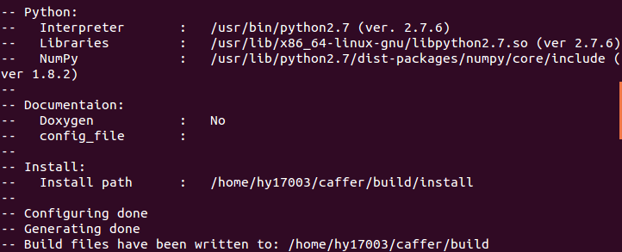

hy17003@ubuntu:~/caffer/build$ make all

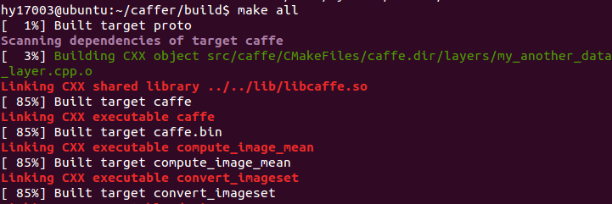

## 测试

在examples/minst中创建一个文件夹my_another_data，并在其中创建三个文件：

网络设计文件：my_another_data_lenet_train_test.prototxt

超参数文件：my_another_data_solver.prototxt

训练脚本文件：my_another_data_train.sh

### 网络设计文件

name: "LeNet"

layer {

name: "mnist"

type: "MyAnotherData"

top: "data"

top: "label"

include {

phase: TRAIN

}

transform_param {

scale: 0.00390625

}

my_another_data_param {

cols:100

rows:50

width:20

height:20

start_col:0

end_col:70

image_address:"/home/hy17003/caffer/examples/images/digits.png"

is_save:true

save_folder:"/home/hy17003/caffer/examples/images/img"

is_color:false

batch_size:11

}

}

layer {

name: "mnist"

type: "MyAnotherData"

top: "data"

top: "label"

include {

phase: TEST

}

transform_param {

scale: 0.00390625

}

my_another_data_param {

cols:100

rows:50

width:20

height:20

start_col:70

end_col:100

image_address:"/home/hy17003/caffer/examples/images/digits.png"

is_save:false

is_color:false

batch_size:11

}

}

layer {

name: "conv1"

type: "Convolution"

bottom: "data"

top: "conv1"

param {

lr_mult: 1

}

param {

lr_mult: 2

}

convolution_param {

num_output: 20

kernel_size: 5

stride: 1

weight_filler {

type: "xavier"

}

bias_filler {

type: "constant"

}

}

}

layer {

name: "pool1"

type: "Pooling"

bottom: "conv1"

top: "pool1"

pooling_param {

pool: MAX

kernel_size: 2

stride: 2

}

}

layer {

name: "conv2"

type: "Convolution"

bottom: "pool1"

top: "conv2"

param {

lr_mult: 1

}

param {

lr_mult: 2

}

convolution_param {

num_output: 50

kernel_size: 5

stride: 1

weight_filler {

type: "xavier"

}

bias_filler {

type: "constant"

}

}

}

layer {

name: "pool2"

type: "Pooling"

bottom: "conv2"

top: "pool2"

pooling_param {

pool: MAX

kernel_size: 2

stride: 2

}

}

layer {

name: "ip1"

type: "InnerProduct"

bottom: "pool2"

top: "ip1"

param {

lr_mult: 1

}

param {

lr_mult: 2

}

inner_product_param {

num_output: 500

weight_filler {

type: "xavier"

}

bias_filler {

type: "constant"

}

}

}

layer {

name: "relu1"

type: "ReLU"

bottom: "ip1"

top: "ip1"

}

layer {

name: "ip2"

type: "InnerProduct"

bottom: "ip1"

top: "ip2"

param {

lr_mult: 1

}

param {

lr_mult: 2

}

inner_product_param {

num_output: 10

weight_filler {

type: "xavier"

}

bias_filler {

type: "constant"

}

}

}

layer {

name: "accuracy"

type: "Accuracy"

bottom: "ip2"

bottom: "label"

top: "accuracy"

include {

phase: TEST

}

}

layer {

name: "loss"

type: "SoftmaxWithLoss"

bottom: "ip2"

bottom: "label"

top: "loss"

}

### 超参数文件

# The train/test net protocol buffer definition

net: "/home/hy17003/caffer/examples/mnist/my_another_data/my_another_data_lenet_train_test.prototxt"

# test_iter specifies how many forward passes the test should carry out.

# In the case of MNIST, we have test batch size 100 and 100 test iterations,

# covering the full 10,000 testing images.

test_iter: 50

# Carry out testing every 500 training iterations.

test_interval: 200

# The base learning rate, momentum and the weight decay of the network.

base_lr: 0.01

momentum: 0.9

weight_decay: 0.0005

# The learning rate policy

lr_policy: "inv"

gamma: 0.0001

power: 0.75

# Display every 100 iterations

display: 200

# The maximum number of iterations

max_iter: 1000

# snapshot intermediate results

snapshot: 500

snapshot_prefix: "./"

# solver mode: CPU or GPU

solver_mode: CPU

### 训练脚本文件

#!/usr/bin/env sh

set -e

./build/tools/caffe train \

--solver=examples/mnist/my_another_data/my_another_data_solver.prototxt $@

### 训练和测试

hy17003@ubuntu:~/caffer$ ./examples/mnist/my_another_data/my_another_data_train.sh

