# Caffe多标签分类（二）

## 准备数据

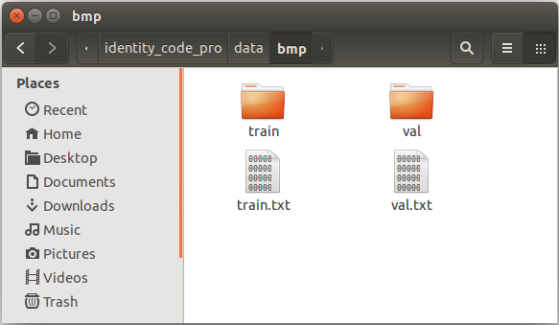

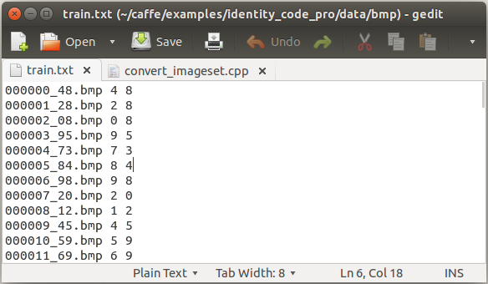

## 修改convert_imageset.cpp

因为图像列表有为0001.bmp 1 2这样的形式，注意代码中红色加粗的部分

//#ifdef MULTILABEL

#include <algorithm>

#include <fstream> // NOLINT(readability/streams)

#include <string>

#include <utility>

#include <vector>

#include "boost/scoped_ptr.hpp"

#include "gflags/gflags.h"

#include "glog/logging.h"

#include "caffe/proto/caffe.pb.h"

#include "caffe/util/db.hpp"

#include "caffe/util/format.hpp"

#include "caffe/util/io.hpp"

#include "caffe/util/rng.hpp"

using namespace caffe; // NOLINT(build/namespaces)

using std::pair;

using boost::scoped_ptr;

DEFINE_bool(gray, false,

"When this option is on, treat images as grayscale ones");

DEFINE_bool(shuffle, false,

"Randomly shuffle the order of images and their labels");

DEFINE_string(backend, "lmdb",

"The backend {lmdb, leveldb} for storing the result");

DEFINE_int32(resize_width, 0, "Width images are resized to");

DEFINE_int32(resize_height, 0, "Height images are resized to");

DEFINE_bool(check_size, false,

"When this option is on, check that all the datum have the same size");

DEFINE_bool(encoded, false,

"When this option is on, the encoded image will be save in datum");

DEFINE_string(encode_type, "",

"Optional: What type should we encode the image as ('png','jpg',...).");

int main(int argc, char** argv) {

#ifdef USE_OPENCV

::google::InitGoogleLogging(argv[0]);

// Print output to stderr (while still logging)

FLAGS_alsologtostderr = 1;

#ifndef GFLAGS_GFLAGS_H_

namespace gflags = google;

#endif

gflags::SetUsageMessage("Convert a set of images to the leveldb/lmdb\n"

"format used as input for Caffe.\n"

"Usage:\n"

" convert_imageset [FLAGS] ROOTFOLDER/ LISTFILE DB_NAME\n"

"The ImageNet dataset for the training demo is at\n"

" http://www.image-net.org/download-images\n");

gflags::ParseCommandLineFlags(&argc, &argv, true);

//001.jpg 1 2

**if (argc < 3) {**

gflags::ShowUsageWithFlagsRestrict(argv[0], "tools/convert_imageset");

return 1;

}

const bool is_color = !FLAGS_gray;

const bool check_size = FLAGS_check_size;

const bool encoded = FLAGS_encoded;

const string encode_type = FLAGS_encode_type;

std::ifstream infile(argv[2]);

std::vector<std::pair<std::string, std::vector<float> > > lines;

std::string filename;

std::string label_count_string = argv[5];

int label_count = std::atoi(label_count_string.c_str());

std::vector<float> label(label_count);

while (infile >> filename)

{

for (int i = 0; i < label_count;i++)

{

infile >> label[i];

}

lines.push_back(std::make_pair(filename, label));

}

if (FLAGS_shuffle) {

// randomly shuffle data

LOG(INFO) << "Shuffling data";

shuffle(lines.begin(), lines.end());

}

LOG(INFO) << "A total of " << lines.size() << " images.";

if (encode_type.size() && !encoded)

LOG(INFO) << "encode_type specified, assuming encoded=true.";

int resize_height = std::max<int>(0, FLAGS_resize_height);

int resize_width = std::max<int>(0, FLAGS_resize_width);

// Create new DB

scoped_ptr<db::DB> db_image(db::GetDB(FLAGS_backend));

scoped_ptr<db::DB> db_label(db::GetDB(FLAGS_backend));

db_image->Open(argv[3], db::NEW);

db_label->Open(argv[4], db::NEW);

scoped_ptr<db::Transaction> txn_image(db_image->NewTransaction());

scoped_ptr<db::Transaction> txn_label(db_label->NewTransaction());

// Storing to db

std::string root_folder(argv[1]);

Datum datum_label;

Datum datum_image;

int count = 0;

int data_size_label = 0;

int data_size_image = 0;

bool data_size_initialized = false;

for (int line_id = 0; line_id < lines.size(); ++line_id) {

bool status;

std::string enc = encode_type;

if (encoded && !enc.size()) {

// Guess the encoding type from the file name

string fn = lines[line_id].first;

size_t p = fn.rfind('.');

if (p == fn.npos)

LOG(WARNING) << "Failed to guess the encoding of '" << fn << "'";

enc = fn.substr(p);

std::transform(enc.begin(), enc.end(), enc.begin(), ::tolower);

}

status = ReadImageToDatum(root_folder + lines[line_id].first,

lines[line_id].second[0], resize_height, resize_width, is_color,

enc, &datum_image);

if (status == false) continue;

datum_label.set_height(1);

datum_label.set_width(1);

datum_label.set_channels(label_count);

//int count_tmp = datum_label.float_data_size();

for (int index_label = 0; index_label < lines[line_id].second.size(); index_label++)

{

float tmp_float_value = lines[line_id].second[index_label];

datum_label.add_float_data(tmp_float_value);

}

if (check_size) {

if (!data_size_initialized) {

data_size_label = datum_label.channels() * datum_label.height() * datum_label.width();

data_size_image = datum_image.channels() * datum_image.height() * datum_image.width();

data_size_initialized = true;

}

else {

const std::string& data_label = datum_label.data();

CHECK_EQ(data_label.size(), data_size_label) << "Incorrect data field size "

<< data_label.size();

const std::string& data_image = data_image.data();

CHECK_EQ(data_image.size(), data_size_image) << "Incorrect data field size "

<< data_image.size();

}

}

// sequential

string key_str_image = caffe::format_int(line_id, 8) + "_" + lines[line_id].first;

string key_str_label = caffe::format_int(line_id, 8) + "label_" + lines[line_id].first;

// Put in db

string out_label;

string out_image;

CHECK(datum_label.SerializeToString(&out_label));

CHECK(datum_image.SerializeToString(&out_image));

datum_label.clear_float_data();

txn_label->Put(key_str_label, out_label);

txn_image->Put(key_str_image, out_image);

if (++count % 1000 == 0) {

// Commit db

txn_image->Commit();

txn_image.reset(db_image->NewTransaction());

txn_label->Commit();

txn_label.reset(db_label->NewTransaction());

LOG(INFO) << "Processed " << count << " files.";

}

}

// write the last batch

if (count % 1000 != 0) {

txn_label->Commit();

txn_image->Commit();

LOG(INFO) << "Processed " << count << " files.";

}

#else

LOG(FATAL) << "This tool requires OpenCV; compile with USE_OPENCV.";

#endif // USE_OPENCV

return 0;

}

//#endif

## 创建convert_data_lmdb.sh脚本文件

注意这里有两个标签，红色加粗部分设置成2

#!/usr/bin/env sh

# Create the image to lmdb inputs

TOOLS=/home/hy17003/caffe/build/tools

#图像文件的存放位置

TRAIN_DATA_ROOT=/home/hy17003/caffe/examples/identity_code_pro/data/bmp/train/

VAL_DATA_ROOT=/home/hy17003/caffe/examples/identity_code_pro/data/bmp/val/

IMAGE_LIST_ROOT=/home/hy17003/caffe/examples/identity_code_pro/data/bmp/

#LMDB文件的存放位置

ROOT_LMDB=/home/hy17003/caffe/examples/identity_code_pro/data/lmdb

# Set RESIZE=true to resize the images to 50x100. Leave as false if images have

# already been resized using another tool.

#是否剪切为相同的大小

RESIZE=true

if $RESIZE; then

RESIZE_HEIGHT=50

RESIZE_WIDTH=100

else

RESIZE_HEIGHT=0

RESIZE_WIDTH=0

fi

if [ ! -d "$TRAIN_DATA_ROOT" ]; then

echo "Error: TRAIN_DATA_ROOT is not a path to a directory: $TRAIN_DATA_ROOT"

echo "Set the TRAIN_DATA_ROOT variable in create_imagenet.sh to the path" \

"where the ImageNet training data is stored."

exit 1

fi

if [ ! -d "$VAL_DATA_ROOT" ]; then

echo "Error: VAL_DATA_ROOT is not a path to a directory: $VAL_DATA_ROOT"

echo "Set the VAL_DATA_ROOT variable in create_imagenet.sh to the path" \

"where the ImageNet validation data is stored."

exit 1

fi

echo "Creating train lmdb..."

GLOG_logtostderr=1 $TOOLS/convert_imageset \

--resize_height=$RESIZE_HEIGHT \

--resize_width=$RESIZE_WIDTH \

--shuffle \

$TRAIN_DATA_ROOT \

$IMAGE_LIST_ROOT/train.txt \

$ROOT_LMDB/train_image \

$ROOT_LMDB/train_label \

**2**

echo "Creating val lmdb..."

GLOG_logtostderr=1 $TOOLS/convert_imageset \

--resize_height=$RESIZE_HEIGHT \

--resize_width=$RESIZE_WIDTH \

--shuffle \

$VAL_DATA_ROOT \

$IMAGE_LIST_ROOT/val.txt \

$ROOT_LMDB/val_image \

$ROOT_LMDB/val_label \

**2**

$TOOLS/compute_image_mean $ROOT_LMDB/train_image \

$ROOT_LMDB/mean.binaryproto

echo "Done."

## 重新编译caffe

删除build目录，新建build目录，

cmake ..

make all

sudo make install

## 网络文件

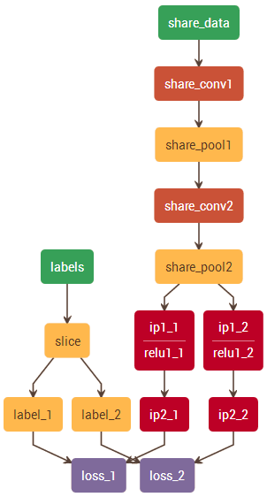

name: "lenet_pro"

#数据输入层

layer {

top: "share_data"

name: "share_data"

type: "Data"

data_param {

source: "/home/hy17003/caffe/examples/identity_code_pro/data/lmdb/train_image"

backend:LMDB

batch_size: 64

}

transform_param {

mean_file: "/home/hy17003/caffe/examples/identity_code_pro/data/lmdb/mean.binaryproto"

mirror: false

}

include: {

phase: TRAIN

}

}

layer {

top: "share_data"

name: "share_data"

type: "Data"

data_param {

source: "/home/hy17003/caffe/examples/identity_code_pro/data/lmdb/val_image"

backend:LMDB

batch_size: 64

}

transform_param {

mean_file: "/home/hy17003/caffe/examples/identity_code_pro/data/lmdb/mean.binaryproto"

mirror: false

}

include: {

phase: TEST

}

}

#标签输入层

layer {

name: "labels"

type: "Data"

top: "labels"

data_param {

source: "/home/hy17003/caffe/examples/identity_code_pro/data/lmdb/train_label"

backend:LMDB

batch_size: 64

}

include {

phase: TRAIN

}

}

layer {

name: "labels"

type: "Data"

top: "labels"

data_param {

source: "/home/hy17003/caffe/examples/identity_code_pro/data/lmdb/val_label"

backend:LMDB

batch_size: 64

}

include {

phase: TEST

}

}

layer {

name: "slice"

type: "Slice"

bottom: "labels"

top: "label_1"

top: "label_2"

slice_param {

slice_dim: 1

slice_point: 1

}

}

#共用的卷积池化层

layer {

name: "share_conv1"

type: "Convolution"

bottom: "share_data"

top: "share_conv1"

param {

lr_mult: 1

}

param {

lr_mult: 2

}

convolution_param {

num_output: 20

kernel_size: 5

stride: 1

weight_filler {

type: "xavier"

}

bias_filler {

type: "constant"

}

}

}

layer {

name: "share_pool1"

type: "Pooling"

bottom: "share_conv1"

top: "share_pool1"

pooling_param {

pool: MAX

kernel_size: 2

stride: 2

}

}

layer {

name: "share_conv2"

type: "Convolution"

bottom: "share_pool1"

top: "share_conv2"

param {

lr_mult: 1

}

param {

lr_mult: 2

}

convolution_param {

num_output: 50

kernel_size: 5

stride: 1

weight_filler {

type: "xavier"

}

bias_filler {

type: "constant"

}

}

}

layer {

name: "share_pool2"

type: "Pooling"

bottom: "share_conv2"

top: "share_pool2"

pooling_param {

pool: MAX

kernel_size: 2

stride: 2

}

}

#第一个全连接层分支

layer {

name: "ip1_1"

type: "InnerProduct"

bottom: "share_pool2"

top: "ip1_1"

param {

lr_mult: 1

}

param {

lr_mult: 2

}

inner_product_param {

num_output: 500

weight_filler {

type: "xavier"

}

bias_filler {

type: "constant"

}

}

}

layer {

name: "relu1_1"

type: "ReLU"

bottom: "ip1_1"

top: "ip1_1"

}

layer {

name: "ip2_1"

type: "InnerProduct"

bottom: "ip1_1"

top: "ip2_1"

param {

lr_mult: 1

}

param {

lr_mult: 2

}

inner_product_param {

num_output: 10

weight_filler {

type: "xavier"

}

bias_filler {

type: "constant"

}

}

}

layer {

name: "accuracy_1"

type: "Accuracy"

bottom: "ip2_1"

bottom: "label_1"

top: "accuracy_1"

include {

phase: TEST

}

}

layer {

name: "loss_1"

type: "SoftmaxWithLoss"

bottom: "ip2_1"

bottom: "label_1"

top: "loss_1"

}

#第二个全连接层分支

layer {

name: "ip1_2"

type: "InnerProduct"

bottom: "share_pool2"

top: "ip1_2"

param {

lr_mult: 1

}

param {

lr_mult: 2

}

inner_product_param {

num_output: 500

weight_filler {

type: "xavier"

}

bias_filler {

type: "constant"

}

}

}

layer {

name: "relu1_2"

type: "ReLU"

bottom: "ip1_2"

top: "ip1_2"

}

layer {

name: "ip2_2"

type: "InnerProduct"

bottom: "ip1_2"

top: "ip2_2"

param {

lr_mult: 1

}

param {

lr_mult: 2

}

inner_product_param {

num_output: 10

weight_filler {

type: "xavier"

}

bias_filler {

type: "constant"

}

}

}

layer {

name: "accuracy_2"

type: "Accuracy"

bottom: "ip2_2"

bottom: "label_2"

top: "accuracy_2"

include {

phase: TEST

}

}

layer {

name: "loss_2"

type: "SoftmaxWithLoss"

bottom: "ip2_2"

bottom: "label_2"

top: "loss_2"

}

## solver文件

# The train/test net protocol buffer definition

net: "/home/hy17003/caffe/examples/identity_code_pro/net/lenet_pro.prototxt"

test_iter: 100

test_interval: 1000

base_lr: 0.01

momentum: 0.9

weight_decay: 0.0005

lr_policy: "inv"

gamma: 0.0001

power: 0.75

display: 100

max_iter: 20000

snapshot: 5000

snapshot_prefix: "/home/hy17003/caffe/examples/identity_code_pro/result/multi_label"

solver_mode: CPU

## 训练脚本文件

#!/usr/bin/env sh

set -e

/home/hy17003/caffe/build/tools/caffe train –solver = /home/hy17003/caffe/examples/identity_code_pro/net/solver.prototxt $@

## 训练

