# SeetaFace的使用

SeetaFace包括人脸检测模块、人脸对齐模块和人脸识别模块，项目地址：

<https://github.com/seetaface/SeetaFaceEngine>，项目中包括详细的配置文档，参考该文档即可完成工程配置，所以配置过程在这里省略。

## 1人脸检测模块

配置好工程后，我仿照官方的例子，编写了以下代码进行测试：

|  |
| --- |
| #include <cstdint>  #include <fstream>  #include <iostream>  #include <string>  #include "opencv2/highgui/highgui.hpp"  #include "opencv2/imgproc/imgproc.hpp"  #include "face_detection.h"  using namespace std;  using namespace cv;  int main(int argc, char** argv) {  const char* img_path = "data/test_01.jpg";  seeta::FaceDetection detector("data/seeta_fd_frontal_v1.0.bin");  detector.SetMinFaceSize(40);  detector.SetScoreThresh(2.f);  detector.SetImagePyramidScaleFactor(0.8f);  detector.SetWindowStep(4, 4);  VideoCapture cap(0);  Mat img;  Mat img_gray;  cap >> img;  while (img.data)  {  if (img.channels() != 1)  cv::cvtColor(img, img_gray, cv::COLOR_BGR2GRAY);  else  img_gray = img;  seeta::ImageData img_data;  img_data.data = img_gray.data;  img_data.width = img_gray.cols;  img_data.height = img_gray.rows;  img_data.num_channels = 1;  long t0 = cv::getTickCount();  std::vector<seeta::FaceInfo> faces = detector.Detect(img_data);  long t1 = cv::getTickCount();  double secs = (t1 - t0) / cv::getTickFrequency();  cout << "Detections takes " << secs << " seconds " << endl;  cout << "Image size (wxh): " << img_data.width << "x"  << img_data.height << endl;  cv::Rect face_rect;  int32_t num_face = static_cast<int32_t>(faces.size());  for (int32_t i = 0; i < num_face; i++) {  face_rect.x = faces[i].bbox.x;  face_rect.y = faces[i].bbox.y;  face_rect.width = faces[i].bbox.width;  face_rect.height = faces[i].bbox.height;  cv::rectangle(img, face_rect, CV_RGB(0, 0, 255), 4, 8, 0);  }  cv::namedWindow("Test", cv::WINDOW_AUTOSIZE);  cv::imshow("Test", img);  cv::waitKey(10);  cap >> img;  }  } |

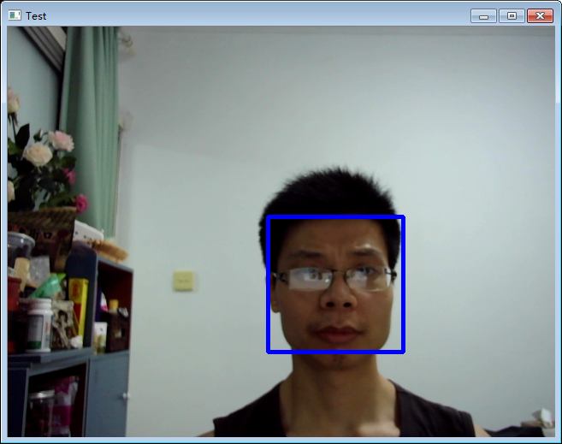

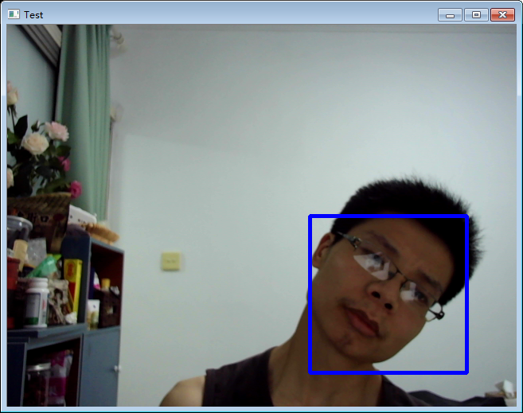

SeetaFace的人脸检测效果较好，对倾斜的人脸也能检测出来，速度也较快，在我的机器上平均160ms左右能够完成640*480大小图像的处理。

## 2人脸对齐模块

配置好工程后，我仿照官方的例子，编写了以下代码进行测试：

|  |
| --- |
| #include <cstdint>  #include <fstream>  #include <iostream>  #include <string>  #include "opencv2/highgui/highgui.hpp"  #include "opencv2/imgproc/imgproc.hpp"  #include "face_detection.h"  #include "face_alignment.h"  using namespace std;  using namespace cv;  int main(int argc, char** argv) {  //人脸检测模型  seeta::FaceDetection detector("data/seeta_fd_frontal_v1.0.bin");  detector.SetMinFaceSize(40);  detector.SetScoreThresh(2.f);  detector.SetImagePyramidScaleFactor(0.8f);  detector.SetWindowStep(4, 4);  //人脸对齐模型  seeta::FaceAlignment point_detector("data/seeta_fa_v1.1.bin");  VideoCapture cap(0);  Mat img;  Mat img_gray;  cap >> img;  while (img.data)  {  if (img.channels() != 1)  cv::cvtColor(img, img_gray, cv::COLOR_BGR2GRAY);  else  img_gray = img;  seeta::ImageData img_data;  img_data.data = img_gray.data;  img_data.width = img_gray.cols;  img_data.height = img_gray.rows;  img_data.num_channels = 1;  long t0 = cv::getTickCount();  //检测人脸  std::vector<seeta::FaceInfo> faces = detector.Detect(img_data);  cv::Rect face_rect;  int32_t num_face = static_cast<int32_t>(faces.size());  for (int32_t i = 0; i < num_face; i++) {  face_rect.x = faces[i].bbox.x;  face_rect.y = faces[i].bbox.y;  face_rect.width = faces[i].bbox.width;  face_rect.height = faces[i].bbox.height;  cv::rectangle(img, face_rect, CV_RGB(0, 0, 255), 4, 8, 0);  //检测人脸特征点  seeta::FacialLandmark points[5];  point_detector.PointDetectLandmarks(img_data, faces[0], points);  for (int i = 0; i<5; i++)  {  circle(img, Point(points[i].x, points[i].y), 2, CV_RGB(0, 255, 0), -1);  }  }  long t1 = cv::getTickCount();  double secs = (t1 - t0) / cv::getTickFrequency();  cout << "Detections takes " << secs << " seconds " << endl;  cv::namedWindow("Test", cv::WINDOW_AUTOSIZE);  cv::imshow("Test", img);  cv::waitKey(10);  cap >> img;  }  } |

从程序效果来看，SeetaFace能够准确检测出5个人脸特征点，并且当人脸局部被遮挡后，仍能够较为准确的给出人脸特征点的位置。

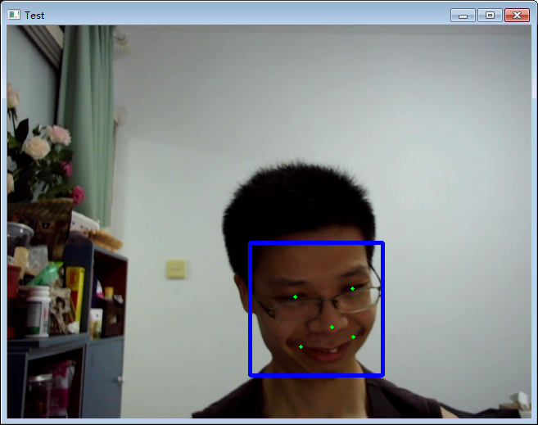

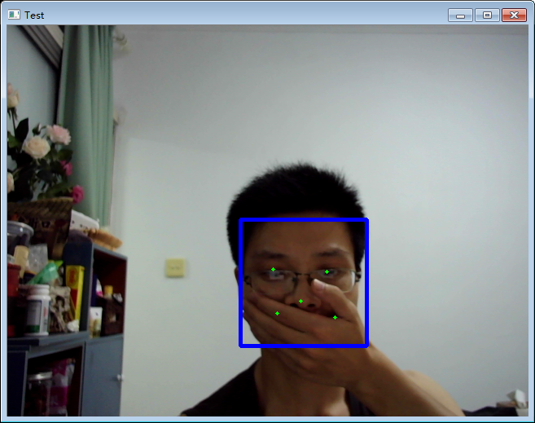

## 3人脸识别模块

为方便使用，我将人脸检测和特征点检测模块封装成两个函数模块，并参考例程编写了以下测试程序：

|  |
| --- |
| #include <cstdint>  #include <fstream>  #include <iostream>  #include <string>  #include "opencv2/highgui/highgui.hpp"  #include "opencv2/imgproc/imgproc.hpp"  #include "face_detection.h"  #include "face_alignment.h"  #include "face_identification.h"  using namespace std;  using namespace cv;  #define SAMPLE_NUM 10  struct FACE_SHAPE  {  Rect rect;  vector<seeta::FacialLandmark> landmark;  };  vector<FACE_SHAPE> detectFace(seeta::FaceDetection& detector, seeta::FaceAlignment& point_detector, Mat image)  {  vector<FACE_SHAPE> face_shapes;  Mat img_gray;  cvtColor(image, img_gray, COLOR_RGB2GRAY);  seeta::ImageData img_data;  img_data.data = img_gray.data;  img_data.width = img_gray.cols;  img_data.height = img_gray.rows;  img_data.num_channels = 1;  //检测人脸  std::vector<seeta::FaceInfo> faces = detector.Detect(img_data);  cv::Rect face_rect;  int32_t num_face = static_cast<int32_t>(faces.size());  for (int32_t i = 0; i < num_face; i++) {  FACE_SHAPE face_shape;  face_shape.rect.x = faces[i].bbox.x;  face_shape.rect.y = faces[i].bbox.y;  face_shape.rect.width = faces[i].bbox.width;  face_shape.rect.height = faces[i].bbox.height;  //检测人脸特征点  seeta::FacialLandmark points[5];  point_detector.PointDetectLandmarks(img_data, faces[i], points);  for (int j = 0; j<5; j++)  {  face_shape.landmark.push_back(points[j]);  }  face_shapes.push_back(face_shape);  }  return face_shapes;  }  void FeatureExtract(seeta::FaceIdentification& face_recognizer, FACE_SHAPE face_shape, Mat image, float* feat)  {  seeta::FacialLandmark* pt5 = &(face_shape.landmark[0]);  seeta::ImageData src_img_data(image.cols, image.rows, image.channels());  src_img_data.data = image.data;  face_recognizer.ExtractFeatureWithCrop(src_img_data, pt5, feat);  }  int main(int argc, char** argv) {  //人脸检测模型  seeta::FaceDetection detector("data/seeta_fd_frontal_v1.0.bin");  detector.SetMinFaceSize(40);  detector.SetScoreThresh(2.f);  detector.SetImagePyramidScaleFactor(0.8f);  detector.SetWindowStep(4, 4);  //人脸对齐模型  seeta::FaceAlignment point_detector("data/seeta_fa_v1.1.bin");  //人脸特征提取  seeta::FaceIdentification face_recognizer("data/seeta_fr_v1.0.bin");  int feat_size = face_recognizer.feature_size();  assert(feat_size == 2048);  int n = 50, c = 2048, h = 1, w = 1;  Mat img;  Mat img_gray;  string Obama_images[SAMPLE_NUM] = {  "data/Obama/01.jpg",  "data/Obama/02.jpg",  "data/Obama/03.jpg",  "data/Obama/04.jpg",  "data/Obama/05.jpg",  "data/Obama/06.jpg",  "data/Obama/07.jpg",  "data/Obama/08.jpg",  "data/Obama/09.jpg",  "data/Obama/10.jpg",  };  string Trump_images[SAMPLE_NUM] = {  "data/Trump/01.jpg",  "data/Trump/02.jpg",  "data/Trump/03.jpg",  "data/Trump/04.jpg",  "data/Trump/05.jpg",  "data/Trump/06.jpg",  "data/Trump/07.jpg",  "data/Trump/08.jpg",  "data/Trump/09.jpg",  "data/Trump/10.jpg",  };  float *obama_feats = new float[n * c * w * h * SAMPLE_NUM];  float *trump_feats = new float[n * c * w * h * SAMPLE_NUM];  memset(obama_feats, 0, (n * c * w * h * SAMPLE_NUM) * sizeof(float));  memset(trump_feats, 0, (n * c * w * h * SAMPLE_NUM) * sizeof(float));  for (int i = 0;i < SAMPLE_NUM;i++)  {  Mat img = imread(Obama_images[i]);  vector<FACE_SHAPE> face_shapes = detectFace(detector, point_detector, img);  for (int t = 0;t < face_shapes.size();t++)  {  FeatureExtract(face_recognizer, face_shapes[t], img, obama_feats + i * feat_size);  }  img = imread(Trump_images[i]);  face_shapes = detectFace(detector, point_detector, img);  for (int t = 0;t < face_shapes.size();t++)  {  FeatureExtract(face_recognizer, face_shapes[t], img, trump_feats + i * feat_size);  }  }  //人脸检测及识别  Mat image = imread("data/test.jpg");  vector<FACE_SHAPE> face_shapes = detectFace(detector, point_detector, image);  for (int i = 0;i < face_shapes.size();i++)  {  float* feat = new float[n * c * w * h];  FeatureExtract(face_recognizer, face_shapes[i], image, feat);  //特征比对  float sim_obama = 0, sim_trump = 0;  for (int j = 0;j < SAMPLE_NUM;j++)  {  float sim = face_recognizer.CalcSimilarity(feat, trump_feats + j * feat_size);  sim_trump += sim;  cout << " ,trump_sim:" << sim << endl;  sim = face_recognizer.CalcSimilarity(feat, obama_feats + j * feat_size);  sim_obama += sim;  cout << "obama_sim:" << sim;  }  sim_obama /= SAMPLE_NUM;  sim_trump /= SAMPLE_NUM;  cout << sim_obama << "," << sim_trump << endl;  if (max(sim_obama, sim_trump) > 0.5)  {  if (sim_obama > sim_trump)  {  rectangle(image, face_shapes[i].rect, Scalar(0, 255, 0), 2);  putText(image, "Obama", face_shapes[i].rect.tl(), 1, 2, Scalar(0, 255, 0), 2);  }  else  {  rectangle(image, face_shapes[i].rect, Scalar(255, 255, 0), 2);  putText(image, "Trump", face_shapes[i].rect.tl(), 1, 2, Scalar(255, 255, 0), 2);  }  }  }  delete[] obama_feats;  delete[] trump_feats;  cv::imshow("Test", image);  cv::waitKey(0);  } |

我准备了一些人物照片：

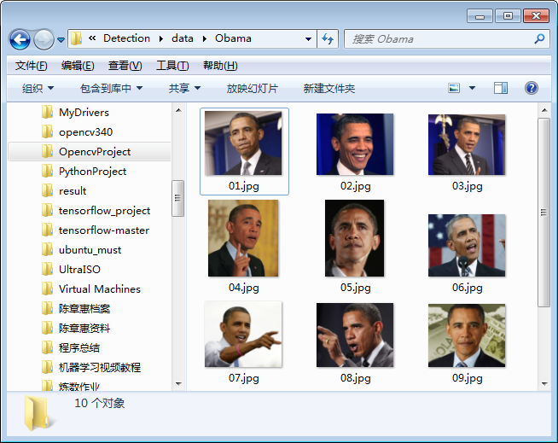

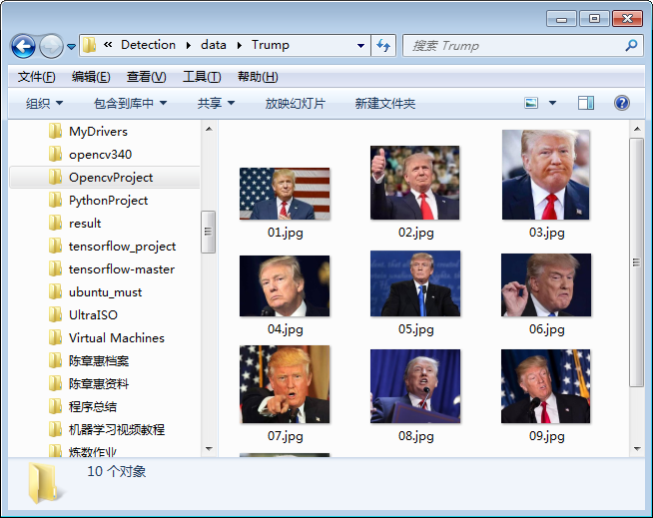

测试结果：

