# Tensorflow模型的保存与恢复

## 方法一

Tensorflow提供了一个tf.train.Saver类来保存和恢复网络模型，简单介绍模型的使用方法。

### 1.1模型的保存

在定义好网络的结构后，使用saver=tf.train.Saver()创建一个Saver对象，在训练结束后使用saver.save(sess, 'path/to/model/model.ckpt')来保存模型，在相应文件夹下会生成四个文件：

Checkpoint:保存了目录下所有模型文件的列表

Model.ckpt.data和Model.ckpt.index:保存模型参数

Model.ckpt.meta:保存了计算图的结构

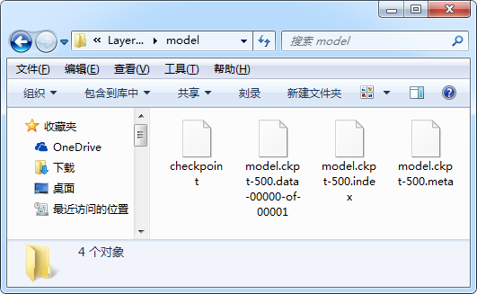

### 1.2模型的恢复

恢复模型分为恢复模型结构和恢复模型参数两个步骤，也可以不从文件中恢复模型结构而重新实现与原结构一样的计算图。

使用saver=tf.train.import_meta_graph('path/to /model.ckpt.meta')来恢复网络结构。

使用saver.restore(sess, 'path/to/model.ckpt')来恢复网络参数。

除此之外，为了运行网络，还需要从图中读取到网络的输入tensor和输出tensor，这可以使用tf.get_tensor_by_name获取对应的tensor，tensor的名称形式为<op_name>:<output_idx>，例如恢复网络的输入和输出可以实现：

|  |
| --- |
| x = graph.get_tensor_by_name('x:0') y_true = graph.get_tensor_by_name('y_true:0') accuracy = graph.get_tensor_by_name('accuracy:0') |

另外，要注意的是，从文件中恢复模型后，不要再像训练模型阶段那样，使用sess.run(tf.global_variables_initializer())来初始化参数，否则参数值会被冲掉，特别注意！

## 方法二

在上面基本方法中，将模型与参数保存为几个文件，下面的方法将模型和参数保存到同一文件，比较好用。

### 2.1模型的保存

在模型训练结束后，使用convert_variables_to_constants方法将指定节点转换为常数，通常为网络的输出，使用tf.train.write_graph将图保存。以下代码演示了这些操作：

|  |
| --- |
| **import** tensorflow **as** tf **from** tensorflow.python.framework.graph_util **import** convert_variables_to_constants  input1 = tf.placeholder(tf.float32, name=**'input1'**) input2 = tf.placeholder(tf.float32, name=**'input2'**) output = tf.add(input1, input2, name = **'output'**) **with** tf.Session() **as** sess:  sess.run(tf.global_variables_initializer())  print(sess.run(output, feed_dict={input1:1,input2:2}))  graph = convert_variables_to_constants(sess, sess.graph_def, [**"output"**])  tf.train.write_graph(graph, **'model'**, **'graph.pb'**, as_text=**False**) |

输出：



这里write_graph函数的参数as_text设置为False，模型以二进制的形式保存，如果设置为True,将以文本形式保存。在恢复模型时，要将读取方式设置为相应的形式。

### 2.2模型的恢复

使用open函数以指定的形式（二进制或文本）打开模型，使用ParseFromString将模型读取到graph_def文件，使用import_graph_def从graph_def文件中导出指定节点和placeholder，以下程序演示了该方法：

|  |
| --- |
| **import** tensorflow **as** tf new_input1 = tf.placeholder(tf.float32, shape=()) new_input2 = tf.placeholder(tf.float32, shape=()) **with** tf.Session() **as** sess:  **with** open(**'model/graph.pb'**, **'rb'**) **as** f:  graph_def = tf.GraphDef()  graph_def.ParseFromString(f.read())  new_output = tf.import_graph_def(graph_def, input_map={**'input1:0'**:new_input1, **'input2:0'**: new_input2},  return_elements=[**'output:0'**])  print(sess.run(new_output, feed_dict={new_input1:4, new_input2:3})) |

输出：



## 实例

### 3.1 方法一

#### 3.1.1 训练模型

|  |
| --- |
| **import** tensorflow **as** tf **from** tensorflow.examples.tutorials.mnist **import** input_data data=input_data.read_data_sets(**'F:/tmp/data'**, one_hot=**True**)  IMG_SIZE=28 IMG_SIZE_FLAT=IMG_SIZE*IMG_SIZE IMG_SHAPE=(IMG_SIZE,IMG_SIZE) NUM_CHANNEL=1 NUM_CLASSES=10 BATCH_SIZE = 64 NUM_ITERATIONS=500  **def** get_weights_variable(layer_name):  **with** tf.variable_scope(layer_name, reuse=**True**):  variable=tf.get_variable(**'kernel'**)  **return** variable  x=tf.placeholder(tf.float32,shape=[**None**, IMG_SIZE_FLAT], name=**'x'**) x_image=tf.reshape(x, [-1, IMG_SIZE, IMG_SIZE, NUM_CHANNEL]) y_true=tf.placeholder(tf.float32,shape=[**None**, NUM_CLASSES], name=**'y_true'**) y_true_cls=tf.argmax(y_true, dimension=1)  net=x_image net=tf.layers.conv2d(inputs=net, name=**'layer_conv1'**, padding=**'same'**, filters=16, kernel_size=5,activation=tf.nn.relu) layer1_conv1=net net=tf.layers.conv2d(inputs=net, name=**'layer_conv2'**, padding=**'same'**, filters=36, kernel_size=5,activation=tf.nn.relu) layer2_conv2=net net=tf.layers.max_pooling2d(inputs=net, pool_size=2,strides=2) net=tf.contrib.layers.flatten(net) net=tf.layers.dense(inputs=net,name=**'layer_fc1'**, units=128, activation=tf.nn.relu) net=tf.layers.dense(inputs=net,name=**'layer_out'**, units=NUM_CLASSES, activation=**None**) logits=net y_pred=tf.nn.softmax(logits=logits) y_pred_cls=tf.argmax(y_pred,dimension=1) cross_entropy=tf.nn.softmax_cross_entropy_with_logits(labels=y_true, logits=logits) loss=tf.reduce_mean(cross_entropy)  optimizer=tf.train.AdamOptimizer(learning_rate=0.0001).minimize(loss) correct_prediction=tf.equal(y_pred_cls,y_true_cls) accuracy=tf.reduce_mean(tf.cast(correct_prediction, tf.float32), name=**'accuracy'**) saver = tf.train.Saver() **with** tf.Session() **as** sess:  sess.run(tf.global_variables_initializer())  **for** i **in** range(NUM_ITERATIONS):  x_batch, y_true_batch = data.train.next_batch(BATCH_SIZE)  feed_dict_train={x:x_batch,y_true:y_true_batch}  sess.run(optimizer, feed_dict=feed_dict_train)  **if** i%100 == 0:  acc=sess.run(accuracy, feed_dict=feed_dict_train)  print(**'accuracy: '**, acc * 100, **'%'**)  saver.save(sess, **'F:/tensorflow_project/LayerAPITest/model/model.ckpt'**, global_step = NUM_ITERATIONS)  w2=get_weights_variable(**'layer_out'**)  print(sess.run(w2)) |

输出：

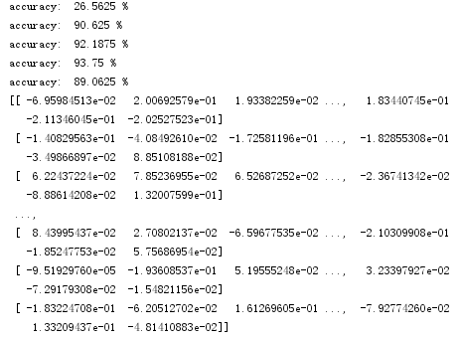

#### 3.1.2 恢复模型

|  |
| --- |
| *#coding=utf-8* **import** tensorflow **as** tf **from** tensorflow.examples.tutorials.mnist **import** input_data data=input_data.read_data_sets(**'F:/tmp/data'**, one_hot=**True**)  BATCH_SIZE = 64 saver=tf.train.import_meta_graph(**'F:/tensorflow_project/LayerAPITest/model/model.ckpt.meta'**) **with** tf.Session() **as** sess:  saver.restore(sess, **'F:/tensorflow_project/LayerAPITest/model/model.ckpt'**)  graph = tf.get_default_graph()  x = graph.get_tensor_by_name(**'x:0'**)  y_true = graph.get_tensor_by_name(**'y_true:0'**)  accuracy = graph.get_tensor_by_name(**'accuracy:0'**)   w2=graph.get_tensor_by_name(**'layer_out/kernel:0'**)  **for** i **in** range(5):  x_val, y_val = data.validation.next_batch(BATCH_SIZE)  validate_feed = {x: x_val, y_true: y_val}  acc = sess.run(accuracy, feed_dict=validate_feed)  print(**"Validate Accuracy: "**, acc)  print(**"w2="**, sess.run(w2)) |

输出：

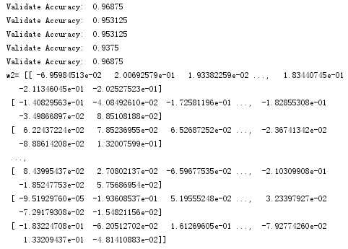

### 3.2 方法二

#### 3.2.1 训练模型

|  |
| --- |
| **import** tensorflow **as** tf **from** tensorflow.examples.tutorials.mnist **import** input_data data=input_data.read_data_sets(**'F:/tmp/data'**, one_hot=**True**)  IMG_SIZE=28 IMG_SIZE_FLAT=IMG_SIZE*IMG_SIZE IMG_SHAPE=(IMG_SIZE,IMG_SIZE) NUM_CHANNEL=1 NUM_CLASSES=10 BATCH_SIZE = 64 NUM_ITERATIONS=1000  input_x=tf.placeholder(tf.float32,shape=[**None**, IMG_SIZE_FLAT], name=**'x'**) x_image=tf.reshape(input_x, [-1, IMG_SIZE, IMG_SIZE, NUM_CHANNEL]) input_y=tf.placeholder(tf.float32,shape=[**None**, NUM_CLASSES], name=**'y_true'**) y_true_cls=tf.argmax(input_y, dimension=1)  net=x_image net=tf.layers.conv2d(inputs=net, name=**'layer_conv1'**, padding=**'same'**, filters=16, kernel_size=5,activation=tf.nn.relu) layer1_conv1=net net=tf.layers.conv2d(inputs=net, name=**'layer_conv2'**, padding=**'same'**, filters=36, kernel_size=5,activation=tf.nn.relu) layer2_conv2=net net=tf.layers.max_pooling2d(inputs=net, pool_size=2,strides=2) net=tf.contrib.layers.flatten(net) net=tf.layers.dense(inputs=net,name=**'layer_fc1'**, units=128, activation=tf.nn.relu) net=tf.layers.dense(inputs=net,name=**'layer_out'**, units=NUM_CLASSES, activation=**None**) logits=net y_pred=tf.nn.softmax(logits=logits) y_pred_cls=tf.argmax(y_pred,dimension=1) cross_entropy=tf.nn.softmax_cross_entropy_with_logits(labels=input_y, logits=logits) loss=tf.reduce_mean(cross_entropy)  optimizer=tf.train.AdamOptimizer(learning_rate=0.0001).minimize(loss) correct_prediction=tf.equal(y_pred_cls,y_true_cls) accuracy=tf.reduce_mean(tf.cast(correct_prediction, tf.float32), name=**'accuracy'**)  **with** tf.Session() **as** sess:  sess.run(tf.global_variables_initializer())  **for** i **in** range(NUM_ITERATIONS):  x_batch, y_true_batch = data.train.next_batch(BATCH_SIZE)  feed_dict_train={input_x:x_batch,input_y:y_true_batch}  sess.run(optimizer, feed_dict=feed_dict_train)  **if** i%100 == 0:  acc=sess.run(accuracy, feed_dict=feed_dict_train)  print(**'accuracy: '**, acc * 100, **'%'**)  graph = tf.graph_util.convert_variables_to_constants(sess, sess.graph_def,[**"accuracy"**])  tf.train.write_graph(graph, **'model'**, **'graph.pb'**, as_text=**False**) |

输出：

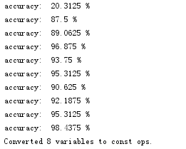

#### 3.2.2 恢复模型

|  |
| --- |
| *#coding=utf-8* **import** tensorflow **as** tf **from** tensorflow.examples.tutorials.mnist **import** input_data data=input_data.read_data_sets(**'F:/tmp/data'**, one_hot=**True**)  IMG_SIZE=28 IMG_SIZE_FLAT=IMG_SIZE*IMG_SIZE NUM_CLASSES=10 BATCH_SIZE = 64  input_x=tf.placeholder(tf.float32,shape=[**None**, IMG_SIZE_FLAT]) input_y=tf.placeholder(tf.float32,shape=[**None**, NUM_CLASSES])  **with** tf.Session() **as** sess:  **with** open(**'model/graph.pb'**, **'rb'**) **as** f:  graph_def = tf.GraphDef()  graph_def.ParseFromString(f.read())  accuracy = tf.import_graph_def(graph_def, input_map={**'x:0'**: input_x, **'y_true:0'**: input_y},  return_elements=[**'accuracy:0'**])  **for** i **in** range(5):  x_val, y_val = data.validation.next_batch(BATCH_SIZE)  validate_feed = {input_x: x_val, input_y: y_val}  acc = sess.run(accuracy, feed_dict=validate_feed)  print(**"Validate Accuracy: "**, acc) |

输出：

