# Tfrecords文件的生成与读取

## tfrecords文件的生成

### 1.1基本步骤：

1. 创建tfrecords文件：

writer = tf.python_io.TFRecordWriter(tfrecord_file)

1. 使用PIL的Image.open函数打开图像，

img=Image.open(img_path)

1. 将图像转成二进制格式：

Img_raw=img.tobytes()

1. 将label和图像封装成example:

example = tf.train.Example(features=tf.train.Features(feature={

"label": tf.train.Feature(int64_list=tf.train.Int64List(value=[index])),

'img_raw':tf.train.Feature(bytes_list=tf.train.BytesList(value=[img_raw]))}))

1. 将example序列化为字符串，写入tfrecords文件：

writer.writer(example.SerializeToString())

### 代码

如在notMNIST_small文件夹下有以下目录，将其转成tfrecords格式：

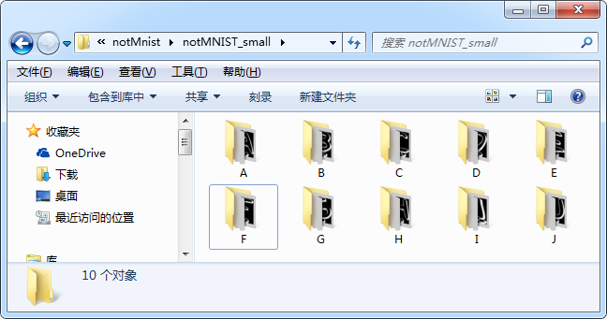

|  |
| --- |
| *#coding=utf-8* **import** os **import** tensorflow **as** tf **import** numpy **as** np **from** PIL **import** Image *# 注意Image,后面会用到* **def** image2tfrecords(root_folder, classes, tfrecord_file):  writer = tf.python_io.TFRecordWriter(tfrecord_file) *# 要生成的文件* images=[]  labels=[]  **for** index **in** range(0, len(classes)):  class_path = root_folder + classes[index] + **'\\'  for** img_name **in** os.listdir(class_path):  img_path = class_path + img_name *# 每一个图片的地址* images.append(img_path)  labels.append(index)  *# 使用numpy的乱序功能进行乱序处理，先将其转成numpy的array格式*  temp = np.array([images, labels])  temp = temp.transpose()  np.random.shuffle(temp)  images = list(temp[:,0])  labels = [int(i) **for** i **in** temp[:,1]]  num = len(images)  print(**'convert start...'**)  **for** i **in** range(0, num):  **try**:  image_path = images[i]  label = labels[i]  img = Image.open(image_path)  img = img.resize([28, 28])  img_raw = img.tobytes() *# 将图片转化为二进制格式* example = tf.train.Example(features=tf.train.Features(feature={  **"label"**: tf.train.Feature(int64_list=tf.train.Int64List(value=[label])),  **'image_raw'**: tf.train.Feature(bytes_list=tf.train.BytesList(value=[img_raw]))  })) *# example对象对label和image数据进行封装* writer.write(example.SerializeToString()) *# 序列化为字符串* **except** IOError **as** e:  print(**'cannot open '**,img_path)  writer.close()  print(**'convert done!'**) |

测试：

|  |
| --- |
| cwd = **'C:\\Users\\Administrator\\PycharmProjects\\notMnist\\notMNIST_small\\'** classes = [**'A'**, **'B'**, **'C'**, **'D'**, **'E'**, **'F'**, **'G'**, **'H'**, **'I'**, **'J'**] image2tfrecords(root_folder=cwd, classes=classes, tfrecord_file=**'train.tfrecords'**) |

## 读取tfrecords文件

### 2.1 读取tfrecords文件的基本步骤：

1. 使用tf.train.string_input_producer读取tfrecords文件，返回队列
2. 使用tf.TFRecordReader读取队列，返回serialized_example
3. 使用[tf.TFRecordReader](http://wiki.jikexueyuan.com/project/tensorflow-zh/how_tos/tensorflow-zh/SOURCE/api_docs/python/io_ops.html)的[tf.parse_single_example](http://wiki.jikexueyuan.com/project/tensorflow-zh/how_tos/tensorflow-zh/SOURCE/api_docs/python/io_ops.html)解析器将Example协议内存块(protocol buffer)解析为张量img_features，其中img_features['image_raw']为图像数据，img_features['label']为标签数据
4. 使用tf.decode_raw进行解码
5. 使用tf.train.batch生成batch

### 2.2 代码

|  |
| --- |
| *#coding=utf-8* **import** tensorflow **as** tf **def** read_and_decode(tfrecords_file, batch_size):  filename_queue = tf.train.string_input_producer([tfrecords_file])  reader = tf.TFRecordReader()  _, serialized_example = reader.read(filename_queue)  img_features = tf.parse_single_example(  serialized_example,  features={  **'label'**: tf.FixedLenFeature([], tf.int64),  **'image_raw'**: tf.FixedLenFeature([], tf.string),  })  image = tf.decode_raw(img_features[**'image_raw'**], tf.uint8)  image = tf.reshape(image, [28, 28])  label = tf.cast(img_features[**'label'**], tf.int32)  image_batch, label_batch = tf.train.batch([image, label],  batch_size=batch_size,  capacity=1000,  num_threads=64)  **return** image_batch, tf.reshape(label_batch, [batch_size]) |

测试：

|  |
| --- |
| *#coding=utf-8* **import** tensorflow **as** tf **import** numpy **as** np **import** matplotlib.pyplot **as** plt **import** readTfrecord  BATCH_SIZE = 10 tfrecord_file = **'notMNIST_train.tfrecords'  def** plot_images(images, labels):  **for** i **in** np.arange(0, BATCH_SIZE):  print(**'label:'**,labels[i])  plt.imshow(images[i])  plt.show()  image_batch, label_batch = readTfrecord.read_and_decode(tfrecords_file=tfrecord_file, batch_size=BATCH_SIZE) **with** tf.Session() **as** sess:  i = 0  coord = tf.train.Coordinator()  threads = tf.train.start_queue_runners(coord=coord)  **try**:  **while not** coord.should_stop() **and** i < 2:#只查看2个batch  *# just plot one batch size* image, label = sess.run([image_batch, label_batch])  plot_images(image, label)  i += 1  **except** tf.errors.OutOfRangeError:  print(**'done!'**)  **finally**:  coord.request_stop()  coord.join(threads) |