# 修改AlexNet实现验证码识别

## 原理

将原先一个输出改成4个输出，相当于4个网络，除最后一层外，其它层共用。

## 2. 实现

### 2.1修改网络结构

AlexNet网络原只有一个输出，为适应多任务识别，将其改成多个输出，网络结构如下：

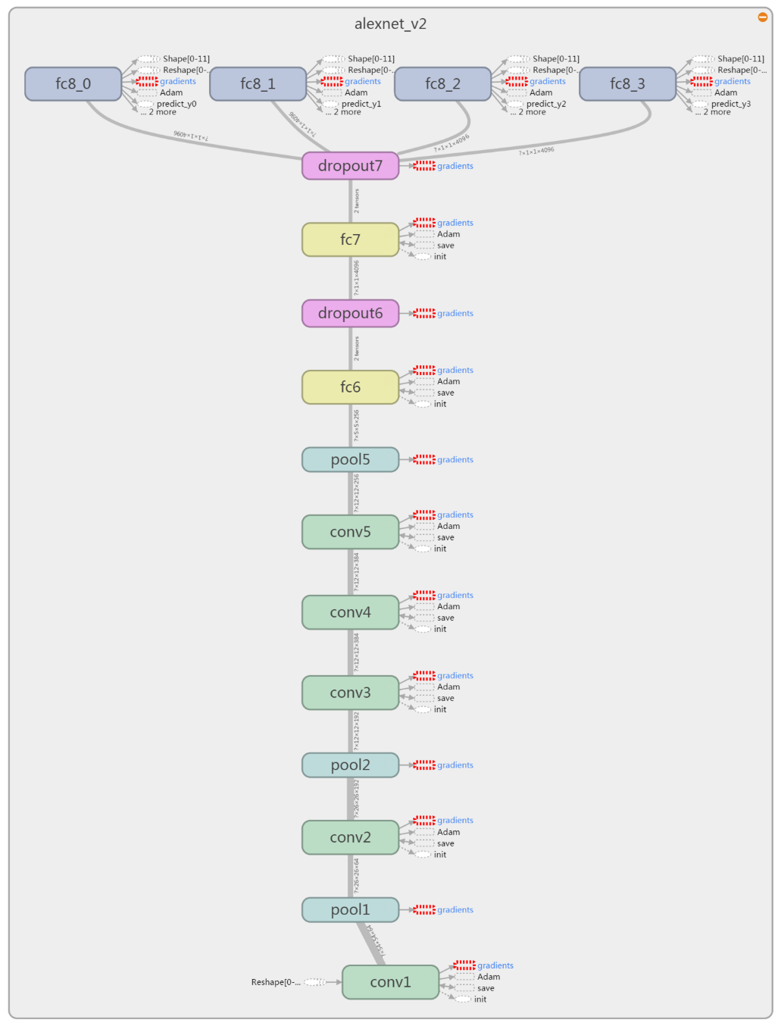

在github上下载models仓库，地址：<https://github.com/tensorflow/models>，在其nets文件夹下实现了很多经典网络，打开alexnet.py文件，后半部分代码如下：

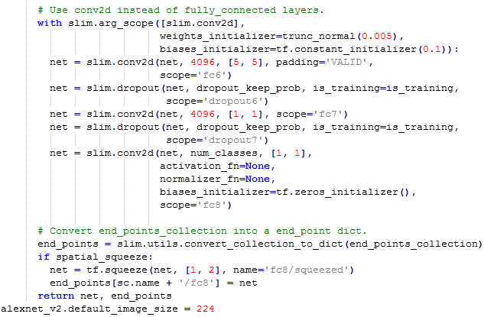

将其改成：

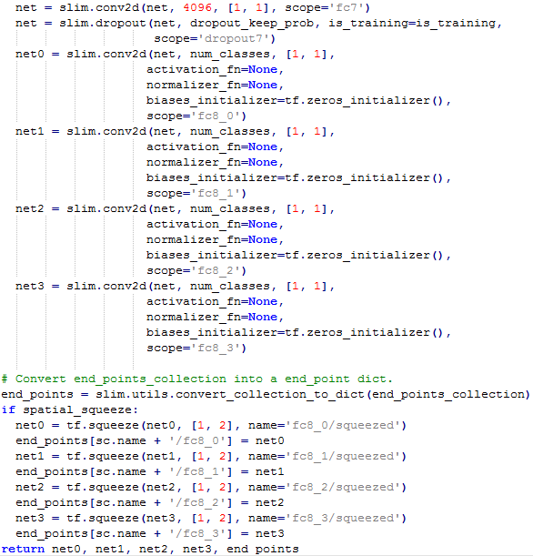



将nets目录拷到工程目录下。

### 2.2 数据准备

#### 1) 生成验证码

生成验证码不是本文的重点，代码如下：

|  |
| --- |
| *# coding: utf-8 # 验证码生成库* **from** captcha.image **import** ImageCaptcha *# pip install captcha* **import** random **import** sys   number = [**'0'**,**'1'**,**'2'**,**'3'**,**'4'**,**'5'**,**'6'**,**'7'**,**'8'**,**'9'**] i = 0 num = 20000  **def** random_captcha_text(char_set=number, captcha_size=4):  *# 验证码列表* captcha_text = []  **for** i **in** range(captcha_size):  *#随机选择* c = random.choice(char_set)  *#加入验证码列表* captcha_text.append(c)  **return** captcha_text  **def** gen_captcha_text_and_image(index):  image = ImageCaptcha()  *#获得随机生成的验证码* captcha_text = random_captcha_text()  *#把验证码列表转为字符串* captcha_text = **''**.join(captcha_text)  *#生成验证码* captcha = image.generate(captcha_text)  **if** index < 0.5 * num:  image.write(captcha_text, **'images/train/'** + captcha_text + **'.jpg'**) *# 写到文件* **else**:  image.write(captcha_text, **'images/val/'** + captcha_text + **'.jpg'**) *# 写到文件* **if** __name__ == **'__main__'**:  **for** i **in** range(num):  gen_captcha_text_and_image(i)  sys.stdout.write(**'\r>> Creating image %d/%d\n'** % (i+1, num))  sys.stdout.flush()  sys.stdout.write(**'\n'**)  sys.stdout.flush()  print(**"生成完毕"**) |

生成验证码：

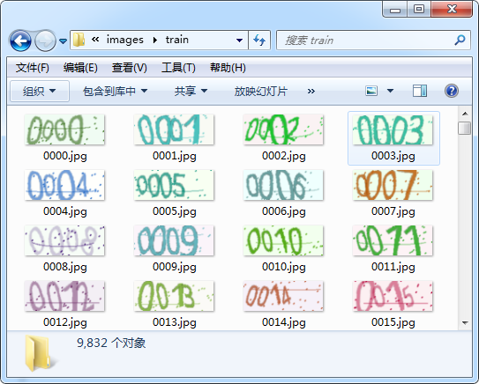

#### 2) 生成tfrecords文件

根据文件名生成对应的标签，4个标签相互独立，以一个标题数字返回，而不是以一个4个元素的向量。

首先定义一个TFRecordWriter，使用PIL的Image.open函数打开图像文件，缩放到[224, 224]大小，使用img.convert(**'L'**)转成灰度图像，并转成numpy的array类型，最后转成byte类型。

将图像与标签作为特征，打包到example中，序列化到文件中。

|  |
| --- |
| *# coding: utf-8* **import** tensorflow **as** tf **import** os **from** PIL **import** Image **import** numpy **as** np  **def** get_labels_from_image_name(image_name):  **return** int(image_name[0]), int(image_name[1]), int(image_name[2]), int(image_name[3])  **def** createTfrecord(folder, tfrecord_file):  writer = tf.python_io.TFRecordWriter(tfrecord_file)  print(**'convert start ...'**)  **for** img_name **in** os.listdir(folder):  img_path = os.path.join(folder, img_name)  **try**:  label_0, label_1, label_2, label_3 = get_labels_from_image_name(img_name)  img = Image.open(img_path)  img = img.resize([224, 224])  img = np.array(img.convert(**'L'**))  img = img.tobytes()  example = tf.train.Example(features=tf.train.Features(feature={  **'image'**: tf.train.Feature(bytes_list=tf.train.BytesList(value=[img])),  **"label_0"**: tf.train.Feature(int64_list=tf.train.Int64List(value=[label_0])),  **"label_1"**: tf.train.Feature(int64_list=tf.train.Int64List(value=[label_1])),  **"label_2"**: tf.train.Feature(int64_list=tf.train.Int64List(value=[label_2])),  **"label_3"**: tf.train.Feature(int64_list=tf.train.Int64List(value=[label_3]))  }))  writer.write(example.SerializeToString())  **except** IOError **as** e:  print(**'cannot open '**, img_path)  writer.close()  print(**'convert done!'**)  createTfrecord(**'images/train'**, **'train.tfrecords'**) |

### 2.3 训练模型

在训练过程中，将模型保存以方便在测试时将模型恢复。

|  |
| --- |
| *#coding=utf-8* **import** tensorflow **as** tf **from** nets **import** nets_factory  TFRECORD_FILE = **'train.tfrecords'** BATCH_SIZE = 20 CLASS_NUM = 10  *#输入* input_x = tf.placeholder(tf.float32, [**None**, 224, 224], name = **'input_x'**) input_y0 = tf.placeholder(tf.float32, [**None**], name = **'input_y0'**) input_y1 = tf.placeholder(tf.float32, [**None**], name = **'input_y1'**) input_y2 = tf.placeholder(tf.float32, [**None**], name = **'input_y2'**) input_y3 = tf.placeholder(tf.float32, [**None**], name = **'input_y3'**)  *#学习率* lr = tf.Variable(0.003, dtype=tf.float32) *#从tfrecord读出数据* **def** read_and_decode(tfrecords_file):  *#创建队列* filename_queue = tf.train.string_input_producer([tfrecords_file])  *#读取文件* reader = tf.TFRecordReader()  _, serialized_example = reader.read(filename_queue)  *#导出特征* features = tf.parse_single_example(serialized_example,  features={  **'image'**: tf.FixedLenFeature([], tf.string),  **'label_0'**: tf.FixedLenFeature([], tf.int64),  **'label_1'**: tf.FixedLenFeature([], tf.int64),  **'label_2'**: tf.FixedLenFeature([], tf.int64),  **'label_3'**: tf.FixedLenFeature([], tf.int64)  })  *#获取图片数据* image = tf.decode_raw(features[**'image'**], tf.uint8)  image = tf.reshape(image, [224, 224])  *#预处理* image = tf.cast(image, tf.float32) / 255.0  image = tf.subtract(image, 0.5)  image = tf.multiply(image, 2.0)  *#获取label* label_0 = tf.cast(features[**'label_0'**], tf.int32)  label_1 = tf.cast(features[**'label_1'**], tf.int32)  label_2 = tf.cast(features[**'label_2'**], tf.int32)  label_3 = tf.cast(features[**'label_3'**], tf.int32)  **return** image, label_0, label_1, label_2, label_3 *#读取图像与标签* image, label_0, label_1, label_2, label_3 = read_and_decode(**'train.tfrecords'**) *#生成Batch* image_batch, label_0_batch,label_1_batch, label_2_batch, label_3_batch = tf.train.shuffle_batch(  [image, label_0, label_1, label_2, label_3], batch_size = BATCH_SIZE,  capacity=50000, min_after_dequeue=10000, num_threads=1 ) *#定义网络* net_fn = nets_factory.get_network_fn(  name=**'alexnet_v2'**, num_classes=CLASS_NUM,weight_decay=0.0005,is_training=**True** )  **with** tf.Session() **as** sess:  input_X = tf.reshape(input_x, [-1, 224, 224, 1])  logist0, logist1, logist2, logist3, end_points = net_fn(input_X)  one_hot_label_0 = tf.one_hot(indices = tf.cast(input_y0, tf.int32), depth = CLASS_NUM)  one_hot_label_1 = tf.one_hot(indices = tf.cast(input_y1, tf.int32), depth = CLASS_NUM)  one_hot_label_2 = tf.one_hot(indices = tf.cast(input_y2, tf.int32), depth = CLASS_NUM)  one_hot_label_3 = tf.one_hot(indices = tf.cast(input_y3, tf.int32), depth = CLASS_NUM)  *#计算loss* loss_0 = tf.reduce_mean(tf.nn.softmax_cross_entropy_with_logits(logits=logist0, labels=one_hot_label_0))  loss_1 = tf.reduce_mean(tf.nn.softmax_cross_entropy_with_logits(logits=logist1, labels=one_hot_label_1))  loss_2 = tf.reduce_mean(tf.nn.softmax_cross_entropy_with_logits(logits=logist2, labels=one_hot_label_2))  loss_3 = tf.reduce_mean(tf.nn.softmax_cross_entropy_with_logits(logits=logist3, labels=one_hot_label_3))  total_loss = (loss_0 + loss_1 + loss_2 + loss_3)  *#优化* optimzer = tf.train.AdamOptimizer(learning_rate=lr).minimize(total_loss)  *#准确率* predict_y0 = tf.argmax(logist0, 1, name = **'predict_y0'**)  predict_y1 = tf.argmax(logist1, 1, name = **'predict_y1'**)  predict_y2 = tf.argmax(logist2, 1, name = **'predict_y2'**)  predict_y3 = tf.argmax(logist3, 1, name = **'predict_y3'**)  correct_prediction_0 = tf.equal(tf.argmax(one_hot_label_0, 1), predict_y0)  accuracy_0 = tf.reduce_mean(tf.cast(correct_prediction_0, tf.float32))  correct_prediction_1 = tf.equal(tf.argmax(one_hot_label_1, 1), predict_y1)  accuracy_1 = tf.reduce_mean(tf.cast(correct_prediction_1, tf.float32))  correct_prediction_2 = tf.equal(tf.argmax(one_hot_label_2, 1), predict_y2)  accuracy_2 = tf.reduce_mean(tf.cast(correct_prediction_2, tf.float32))  correct_prediction_3 = tf.equal(tf.argmax(one_hot_label_3, 1), predict_y3)  accuracy_3 = tf.reduce_mean(tf.cast(correct_prediction_3, tf.float32))  tf.summary.scalar(**'acc0'**, accuracy_0)  tf.summary.scalar(**'acc1'**, accuracy_1)  tf.summary.scalar(**'acc2'**, accuracy_2)  tf.summary.scalar(**'acc3'**, accuracy_3)  merged = tf.summary.merge_all()  *#保存模型* saver = tf.train.Saver()  *#初始化* sess.run(tf.global_variables_initializer())   coord = tf.train.Coordinator()  threads = tf.train.start_queue_runners(sess = sess, coord = coord)  writer = tf.summary.FileWriter(**'logs/'**, sess.graph)  **for** i **in** range(6001):  b_image, b_label_0, b_label_1, b_label_2, b_label_3 = sess.run([image_batch, label_0_batch,label_1_batch,  label_2_batch, label_3_batch])  dict = {input_x:b_image, input_y0:b_label_0,input_y1:b_label_1,input_y2:b_label_2, input_y3:b_label_3}  sess.run(optimzer, feed_dict = dict)  **if** i % 20 == 0:  **if** i%6000 == 0:  sess.run(tf.assign(lr, lr/3))  saver.save(sess, **"models/captcha_model.ckpt"**, global_step = i)  acc0, acc1, acc2, acc3, loss = sess.run([accuracy_0, accuracy_1, accuracy_2, accuracy_3, total_loss], feed_dict = dict)  summary = sess.run(merged, feed_dict=dict)  writer.add_summary(summary, i)  print(**"Iter:%d Loss:%.3f Accuracy:%.2f,%.2f,%.2f,%.2f"** % (i, loss, acc0, acc1, acc2, acc3))  coord.request_stop() coord.join(threads) |

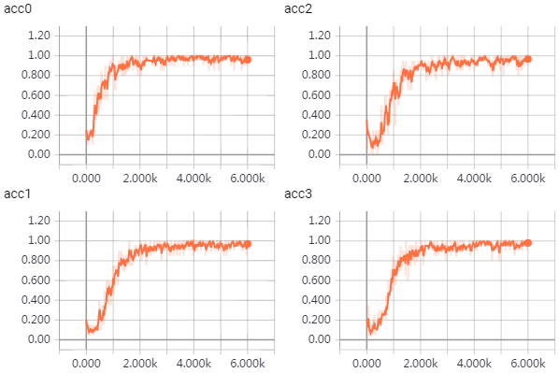

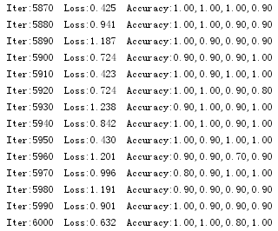

### 2.4 测试模型

模型的恢复，使用**captcha_model.ckpt-6000.meta文件**恢复网络结构，使用**models/captcha_model.ckpt-6000**文件来恢复模型参数，恢复方法及步骤参考以下程序。需要注意的是，必须恢复输入的placeholder和预测结果tensor，在测试模型时，只要将数据喂给输入placeholder即可从预测结构tensor中得到预测结果。喂给placeholder的必须是真正的数据，而不是tensor，因为读取图像得到的image是一个tensor，需要使用image.eval()来得到其数据。以下演示了直接输入图像格式的数据，得到预测结果的方法。

|  |
| --- |
| *#coding=utf-8* **import** tensorflow **as** tf **from** PIL **import** Image **import** matplotlib.pyplot **as** plt **import** numpy **as** np **import** random **import** os  **def** get_one_image(image_path):  image = Image.open(image_path)  plt.imshow(image)  image = image.resize([224,224])  image = np.array(image.convert(**'L'**))  image = tf.cast(image, tf.float32) / 255.0  image = tf.subtract(image, 0.5)  image = tf.multiply(image, 2.0)  **return** image  saver = tf.train.import_meta_graph(**'models/captcha_model.ckpt-6000.meta'**) **with** tf.Session() **as** sess:  saver.restore(sess, **'models/captcha_model.ckpt-6000'**)  graph = tf.get_default_graph()  input_x = graph.get_tensor_by_name(**'input_x:0'**)  pred_y0 = graph.get_tensor_by_name(**'predict_y0:0'**)  pred_y1 = graph.get_tensor_by_name(**'predict_y1:0'**)  pred_y2 = graph.get_tensor_by_name(**'predict_y2:0'**)  pred_y3 = graph.get_tensor_by_name(**'predict_y3:0'**)  filelist = [os.path.join(**'images/val'**, filename) **for** filename **in** os.listdir(**'images/val'**)]  random.shuffle(filelist)  **for** image_path **in** filelist:  image = get_one_image(image_path)  image = tf.reshape(image, [1, 224, 224])  y0, y1, y2, y3 = sess.run([pred_y0, pred_y1, pred_y2, pred_y3], feed_dict={input_x: image.eval()})  print(y0 ,y1, y2, y3)  plt.show() |

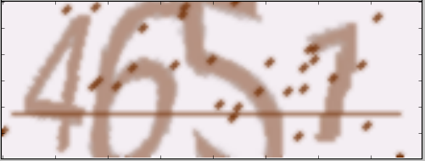 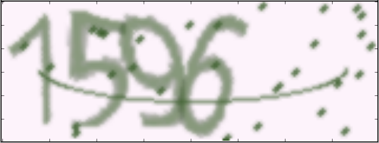

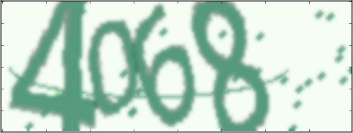 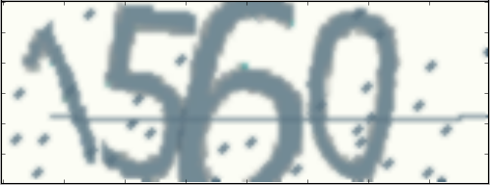

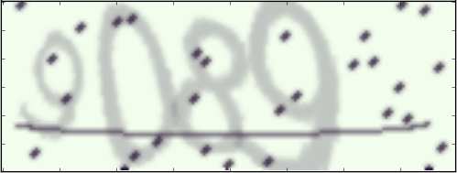 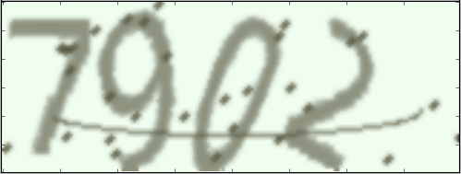

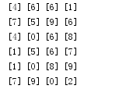

## 总结

这里演示了修改AlexNet来实现验证码识别，内容比较丰富，如slim中nets的使用，tfrecords文件的创建，数据输入pipeline，模型的保存与恢复，变量的监控，图像预处理，单张图像的测试，代码也较为全面，可供其它案例参考。