# 基于全卷积神经网络进行人脸检测

## 网络设计

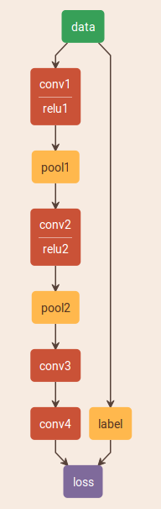

全卷积神经网络与一般的卷积神经网络不同，全卷积神经网络没有全连接层，最后的卷积层直接输入到损失层。对于二分类任务，最后的卷积层共有2个通道，每一个通道图像上的某个像素值，表示以该像素为中心，宽为W的窗口图像以属于该通道对应类别的概率，其中W为训练时所使用的样本宽度，即，训练样本为W*W的图像。

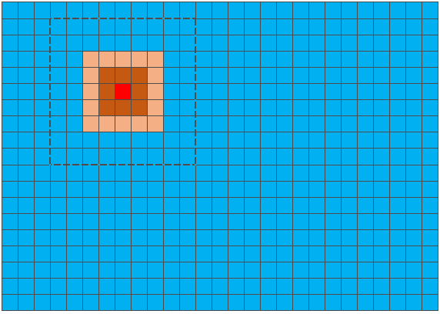

在训练时，使用W*W的样本，输入到网络中，卷积层4的输出为2*1*1的feature map，即2个通道，每个通道图像只有1个像素，每个像素的值代表属于该类的可能性，在0～1之间。

## 网络训练

使用78143张正样本和308848张负样本进行作为训练样本，10000张正样本和10000张负样本作为测试样本。转换成lmdb数据文件。

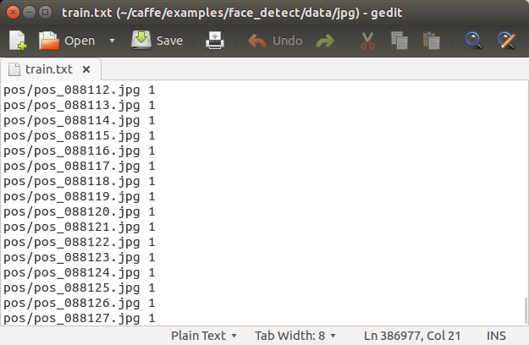

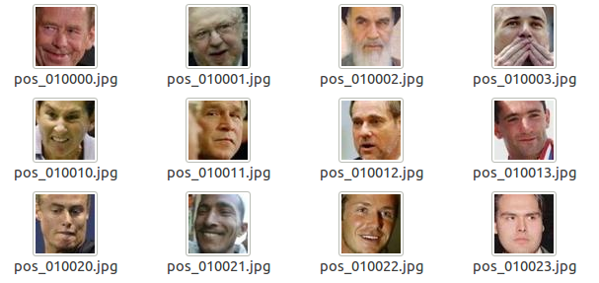

训练使用2000次迭代即可达到99%以上准确率。

生成lmdb数据、均值文件及训练步骤略。

## 测试

#include <opencv2/dnn.hpp>

#include <opencv2/imgproc.hpp>

#include <opencv2/highgui.hpp>

using namespace cv;

using namespace cv::dnn;

#include <fstream>

#include <iostream>

#include <cstdlib>

using namespace std;

//g++ -o detect detect.cpp -lopencv_dnn -lopencv_highgui -lopencv_imgcodecs -lopencv_imgproc -lstdc++ -lopencv_core -L/usr/local/lib

int main(int argc, char **argv)

{

String modelTxt="deploy.prototxt";

String modelBin="face_detect_iter_20000.caffemodel";

Ptr<dnn::Importer> importer;

try

{

importer=dnn::createCaffeImporter(modelTxt,modelBin);

}

catch(const cv::Exception &err)

{

std::cerr<<err.msg<<std::endl;

}

if(!importer)

{

std::cerr<<"cant load network!"<<std::endl;

return 0;

}

dnn::Net net;

importer->populateNet(net);

importer.release();

Mat img = imread("000001.jpg",1);

if(img.empty())

{

std::cerr<<"cant load image!"<<std::endl;

return 0;

}

dnn::Blob inputBlob = dnn::Blob(img);

net.setBlob(".data",inputBlob);

net.forward();

dnn::Blob prob=net.getBlob("conv4");

imshow("src",img);

for(int i=0;i<2;i++)

{

Mat featureImg=prob.getPlane(0,i);

featureImg.convertTo(featureImg,CV_8UC1);

resize(featureImg, featureImg,img.size());

Mat heatmap;

applyColorMap(featureImg, heatmap, COLORMAP_JET);

imshow("heatmap", heatmap);

waitKey(0);

}

}



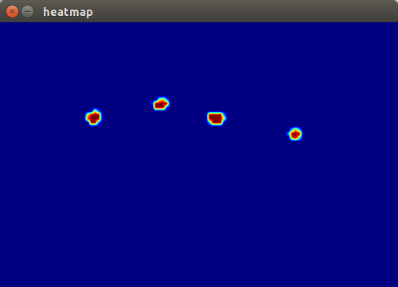

说明：

以上得到的红色区域给出了人脸的位置，但并没有给出人脸的大小。人脸大小可以按照以下方式得到。

将原图像以建立图像金字塔，将金字塔每一层都输入到网络中，对于每一个层都可以得到一个heatmap，然后可以画出一些人脸框，将这些图像再归一化到原图像大小，将这些缩放了的框进行合并。

## 相关文件

### 4.1 train_val.prototxt

name: "CaffeNet"

layer {

name: "data"

type: "Data"

top: "data"

top: "label"

include {

phase: TRAIN

}

transform_param {

mirror: true

crop_size: 227

mean_file: "examples/cat_dog/data/mean.binaryproto"

}

data_param {

source: "examples/cat_dog/data/lmdb/train_lmdb"

batch_size: 256

backend: LMDB

}

}

layer {

name: "data"

type: "Data"

top: "data"

top: "label"

include {

phase: TEST

}

transform_param {

mirror: false

crop_size: 227

mean_file: "examples/cat_dog/data/mean.binaryproto"

}

data_param {

source: "examples/cat_dog/data/lmdb/val_lmdb"

batch_size: 50

backend: LMDB

}

}

layer {

name: "conv1"

type: "Convolution"

bottom: "data"

top: "conv1"

param {

lr_mult: 1

decay_mult: 1

}

param {

lr_mult: 2

decay_mult: 0

}

convolution_param {

num_output: 96

kernel_size: 11

stride: 4

weight_filler {

type: "gaussian"

std: 0.01

}

bias_filler {

type: "constant"

value: 0

}

}

}

layer {

name: "relu1"

type: "ReLU"

bottom: "conv1"

top: "conv1"

}

layer {

name: "pool1"

type: "Pooling"

bottom: "conv1"

top: "pool1"

pooling_param {

pool: MAX

kernel_size: 3

stride: 2

}

}

layer {

name: "norm1"

type: "LRN"

bottom: "pool1"

top: "norm1"

lrn_param {

local_size: 5

alpha: 0.0001

beta: 0.75

}

}

layer {

name: "conv2"

type: "Convolution"

bottom: "norm1"

top: "conv2"

param {

lr_mult: 1

decay_mult: 1

}

param {

lr_mult: 2

decay_mult: 0

}

convolution_param {

num_output: 256

pad: 2

kernel_size: 5

group: 2

weight_filler {

type: "gaussian"

std: 0.01

}

bias_filler {

type: "constant"

value: 1

}

}

}

layer {

name: "relu2"

type: "ReLU"

bottom: "conv2"

top: "conv2"

}

layer {

name: "pool2"

type: "Pooling"

bottom: "conv2"

top: "pool2"

pooling_param {

pool: MAX

kernel_size: 3

stride: 2

}

}

layer {

name: "norm2"

type: "LRN"

bottom: "pool2"

top: "norm2"

lrn_param {

local_size: 5

alpha: 0.0001

beta: 0.75

}

}

layer {

name: "conv3"

type: "Convolution"

bottom: "norm2"

top: "conv3"

param {

lr_mult: 1

decay_mult: 1

}

param {

lr_mult: 2

decay_mult: 0

}

convolution_param {

num_output: 384

pad: 1

kernel_size: 3

weight_filler {

type: "gaussian"

std: 0.01

}

bias_filler {

type: "constant"

value: 0

}

}

}

layer {

name: "relu3"

type: "ReLU"

bottom: "conv3"

top: "conv3"

}

layer {

name: "conv4"

type: "Convolution"

bottom: "conv3"

top: "conv4"

param {

lr_mult: 1

decay_mult: 1

}

param {

lr_mult: 2

decay_mult: 0

}

convolution_param {

num_output: 384

pad: 1

kernel_size: 3

group: 2

weight_filler {

type: "gaussian"

std: 0.01

}

bias_filler {

type: "constant"

value: 1

}

}

}

layer {

name: "relu4"

type: "ReLU"

bottom: "conv4"

top: "conv4"

}

layer {

name: "conv5"

type: "Convolution"

bottom: "conv4"

top: "conv5"

param {

lr_mult: 1

decay_mult: 1

}

param {

lr_mult: 2

decay_mult: 0

}

convolution_param {

num_output: 256

pad: 1

kernel_size: 3

group: 2

weight_filler {

type: "gaussian"

std: 0.01

}

bias_filler {

type: "constant"

value: 1

}

}

}

layer {

name: "relu5"

type: "ReLU"

bottom: "conv5"

top: "conv5"

}

layer {

name: "pool5"

type: "Pooling"

bottom: "conv5"

top: "pool5"

pooling_param {

pool: MAX

kernel_size: 3

stride: 2

}

}

layer {

name: "fc6"

type: "InnerProduct"

bottom: "pool5"

top: "fc6"

param {

lr_mult: 1

decay_mult: 1

}

param {

lr_mult: 2

decay_mult: 0

}

inner_product_param {

num_output: 4096

weight_filler {

type: "gaussian"

std: 0.005

}

bias_filler {

type: "constant"

value: 1

}

}

}

layer {

name: "relu6"

type: "ReLU"

bottom: "fc6"

top: "fc6"

}

layer {

name: "drop6"

type: "Dropout"

bottom: "fc6"

top: "fc6"

dropout_param {

dropout_ratio: 0.5

}

}

layer {

name: "fc7"

type: "InnerProduct"

bottom: "fc6"

top: "fc7"

param {

lr_mult: 1

decay_mult: 1

}

param {

lr_mult: 2

decay_mult: 0

}

inner_product_param {

num_output: 4096

weight_filler {

type: "gaussian"

std: 0.005

}

bias_filler {

type: "constant"

value: 1

}

}

}

layer {

name: "relu7"

type: "ReLU"

bottom: "fc7"

top: "fc7"

}

layer {

name: "drop7"

type: "Dropout"

bottom: "fc7"

top: "fc7"

dropout_param {

dropout_ratio: 0.5

}

}

layer {

name: "my_fc8"

type: "InnerProduct"

bottom: "fc7"

top: "my_fc8"

param {

lr_mult: 1

decay_mult: 1

}

param {

lr_mult: 2

decay_mult: 0

}

inner_product_param {

num_output: 2

weight_filler {

type: "gaussian"

std: 0.01

}

bias_filler {

type: "constant"

value: 0

}

}

}

layer {

name: "accuracy"

type: "Accuracy"

bottom: "my_fc8"

bottom: "label"

top: "accuracy"

include {

phase: TEST

}

}

layer {

name: "loss"

type: "SoftmaxWithLoss"

bottom: "my_fc8"

bottom: "label"

top: "loss"

}

### 4.2 deploy.prototxt

name: "FVLN"

input: "data"

input_shape {

dim: 1 # batchsize

dim: 1 # number of colour channels - rgb

dim: 500 # width

dim: 333 # height

}

layer {

name: "conv1"

type: "Convolution"

bottom: "data"

top: "conv1"

param {

lr_mult: 1

decay_mult: 1

}

param {

lr_mult: 2

decay_mult: 0

}

convolution_param {

num_output: 32

kernel_size: 5

stride: 1

weight_filler {

type: "gaussian"

std: 0.01

}

bias_filler {

type: "constant"

value: 0

}

}

}

layer {

name: "relu1"

type: "ReLU"

bottom: "conv1"

top: "conv1"

}

layer {

name: "pool1"

type: "Pooling"

bottom: "conv1"

top: "pool1"

pooling_param {

pool: MAX

kernel_size: 2

stride: 2

}

}

layer {

name: "conv2"

type: "Convolution"

bottom: "pool1"

top: "conv2"

param {

lr_mult: 1

decay_mult: 1

}

param {

lr_mult: 2

decay_mult: 0

}

convolution_param {

num_output: 64

kernel_size: 5

stride: 1

weight_filler {

type: "gaussian"

std: 0.01

}

bias_filler {

type: "constant"

value: 0

}

}

}

layer {

name: "relu2"

type: "ReLU"

bottom: "conv2"

top: "conv2"

}

layer {

name: "pool2"

type: "Pooling"

bottom: "conv2"

top: "pool2"

pooling_param {

pool: MAX

kernel_size: 2

stride: 2

}

}

layer {

name: "conv3"

type: "Convolution"

bottom: "pool2"

top: "conv3"

param {

lr_mult: 1

decay_mult: 1

}

param {

lr_mult: 2

decay_mult: 0

}

convolution_param {

num_output: 64

kernel_size: 3

stride: 1

weight_filler {

type: "gaussian"

std: 0.01

}

bias_filler {

type: "constant"

value: 0

}

}

}

layer {

name: "conv4"

type: "Convolution"

bottom: "conv3"

top: "conv4"

param {

lr_mult: 1

decay_mult: 1

}

param {

lr_mult: 2

decay_mult: 0

}

convolution_param {

num_output: 2

kernel_size: 10

stride: 1

weight_filler {

type: "gaussian"

std: 0.01

}

bias_filler {

type: "constant"

value: 0

}

}

}

layer{

name:"prob"

type:"Softmax"

bottom:"conv4"

top:"prob"

}

### 4.3 solver.prototxt

net: "/home/ermu/caffe/examples/face_detect/net/train_FVPN.prototxt"

test_iter: 100

test_interval: 500

base_lr: 0.01

lr_policy: "step"

gamma: 0.1

stepsize: 20000

display: 100

max_iter: 100000

momentum: 0.9

weight_decay: 0.0005

snapshot: 10000

snapshot_prefix: "/home/ermu/caffe/examples/face_detect/result/face_detect"

solver_mode: GPU