1. CRxButton类代码：
2. 头文件：

#if !defined(AFX_RXBUTTON_H__4725A27E_C5F5_4BAA_ABF4_4F20647D8050__INCLUDED_)

#define AFX_RXBUTTON_H__4725A27E_C5F5_4BAA_ABF4_4F20647D8050__INCLUDED_

#if _MSC_VER > 1000

#pragma once

#endif // _MSC_VER > 1000

// RxButton.h : header file

//

/////////////////////////////////////////////////////////////////////////////

// CRxButton window

class CRxButton : public CButton

{

// Construction

public:

CRxButton();

// Attributes

public:

// Operations

public:

// Overrides

// ClassWizard generated virtual function overrides

//{{AFX_VIRTUAL(CRxButton)

public:

virtual void DrawItem(LPDRAWITEMSTRUCT lpDrawItemStruct);

virtual BOOL PreTranslateMessage(MSG* pMsg) ;

protected:

//}}AFX_VIRTUAL

// Implementation

public:

virtual ~CRxButton();

// Generated message map functions

protected:

//{{AFX_MSG(CRxButton)

//}}AFX_MSG

DECLARE_MESSAGE_MAP()

private:

CBitmap m_up;

CBitmap m_down;

};

/////////////////////////////////////////////////////////////////////////////

//{{AFX_INSERT_LOCATION}}

// Microsoft Visual C++ will insert additional declarations immediately before the previous line.

#endif // !defined(AFX_RXBUTTON_H__4725A27E_C5F5_4BAA_ABF4_4F20647D8050__INCLUDED_)

1. 源文件

// RxButton.cpp : implementation file

//

#include "stdafx.h"

#include "RxButton.h"

#include "resource.h"

#ifdef _DEBUG

#define new DEBUG_NEW

#undef THIS_FILE

static char THIS_FILE[] = __FILE__;

#endif

/////////////////////////////////////////////////////////////////////////////

// CRxButton

CRxButton::CRxButton()

{

m_up.LoadBitmap(IDB_BIT_UP);

m_down.LoadBitmap(IDB_BIT_DOWN);

}

CRxButton::~CRxButton()

{

m_up.DeleteObject();

m_down.DeleteObject();

}

BEGIN_MESSAGE_MAP(CRxButton, CButton)

//{{AFX_MSG_MAP(CRxButton)

//}}AFX_MSG_MAP

END_MESSAGE_MAP()

/////////////////////////////////////////////////////////////////////////////

// CRxButton message handlers

void CRxButton::DrawItem(LPDRAWITEMSTRUCT lpDrawItemStruct)

{

CString sCaption;

CDC *pDC,memDC;

pDC=CDC::FromHandle(lpDrawItemStruct->hDC);

CFont font;

UINT state=lpDrawItemStruct->itemState;

this->GetWindowText(sCaption);

memDC.CreateCompatibleDC(pDC);

CRect rect=lpDrawItemStruct->rcItem;

font.CreatePointFont(120,"黑体",pDC);

pDC->SelectObject(&font);

if(state&ODS_FOCUS)

{

pDC->SetTextColor(RGB(0,0,0));

memDC.SelectObject(&m_down);

}

else

{

pDC->SetTextColor(RGB(255,255,255));

memDC.SelectObject(&m_up);

}

if(state&ODS_DISABLED)

{

pDC->SetTextColor(RGB(0,0,0));

memDC.SelectObject(&m_down);

}

pDC->BitBlt(0,0,rect.Width(),rect.Height(),&memDC,0,0,SRCCOPY);

pDC->SetBkMode(TRANSPARENT);

pDC->DrawText(sCaption,rect,DT_CENTER|DT_VCENTER|DT_SINGLELINE);

font.DeleteObject();

memDC.DeleteDC();

}

BOOL CRxButton::PreTranslateMessage(MSG* pMsg)

{

if(pMsg->hwnd==this->GetSafeHwnd()&&pMsg->message==WM_KEYDOWN && pMsg->wParam==13)

{

pMsg->lParam=589857;

pMsg->message=WM_LBUTTONDOWN;

}

return CButton::PreTranslateMessage(pMsg);

}

1. 效果

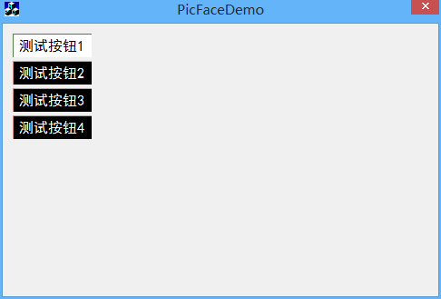

1. 使用方法

添加位图资源：

1. 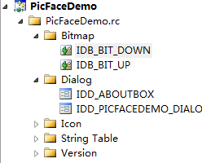ID分别为IDB_BIT_DOWN,IDB_BIT_UP，用以作为按钮被按下，和弹上时显示的按钮背景图片。
2. 放置按钮，并为之添加关联控件变量，将控件类型改成CRxButton类型。
3. 将按钮的属性中Owner Draw项改成True;