Programmer’s Calculator

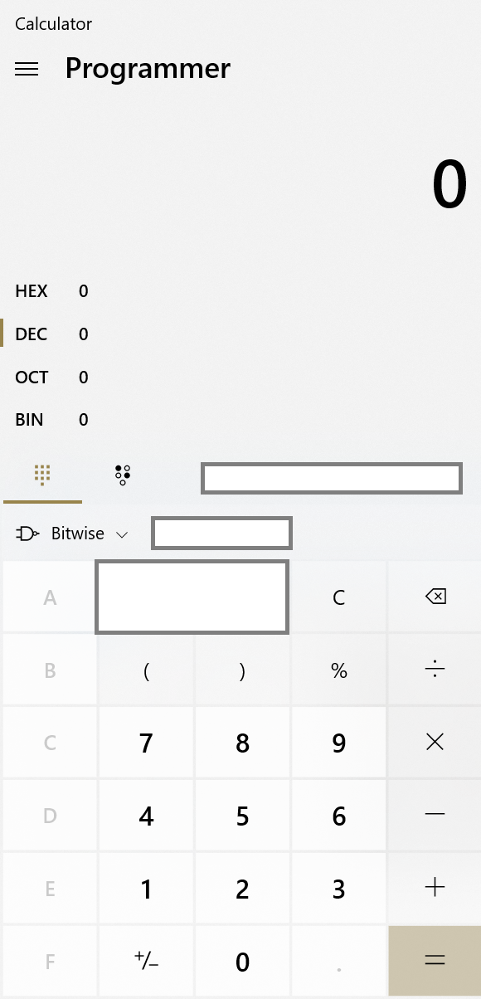

Features

1. Basic arithmetic (5 marks)
   * Addition, subtraction
   * Division, multiplication
   * % means modulus
2. Convert to other bases (8 marks)
   * By default, all entries are treated as DEC (see Fig 1)
   * The user can select which base to use (see Fig 2)
3. Bitwise operations (12 marks)

The image is a screenshot of the default Windows 10 calculator.

You can redesign your calculator to make it more intuitive and friendly.

Look and feel : 5 marks

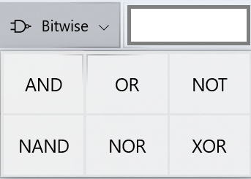

Fig 1

|  |  |  |
| --- | --- | --- |
|  |  |  |

Fig 2

(user selects OCT)

|  |  |  |
| --- | --- | --- |
| Certain numbers are disabled |  |  |