**Boggle Game**

“The game begins by shaking a covered tray of 16 cubic dice, each with a different letter printed on each of its sides. The dice settle into **a 4×4 tray** so that only the top letter of each cube is visible. After they have settled into the grid, a three-minute sand timer is started, and all players simultaneously begin the main phase of play.

Each player searches for words that can be constructed from the letters of sequentially adjacent cubes, where "adjacent" cubes are those horizontally, vertically, and diagonally neighboring. Words must be at least three letters long, may include singular and plural (or other derived forms) separately, but may not use the same letter cube more than once per word. Each player records all the words they find by writing on a private sheet of paper. After three minutes have elapsed, all players must immediately stop writing and the game enters the scoring phase.” – from **https://en.wikipedia.org/wiki/Boggle**

**Rules**

* <https://www.wikihow.com/Play-Boggle>

**Word list Generator**

* <https://onlinerandomtools.com/generate-random-csv>
* Use the word list generator to create a random list of 150 words
  + Save as wordlist_yourStudentId.csv
  + You need to read and load the data into a Collection (List, Set, and/or Map). Analyze the requirements and decide
  + This would serve as your **dictionary**

**Research by playing the game**

* <https://www.boggle.online/>
* Image below is a sample web version of the game. You create your own layout that is more intuitive and user friendly

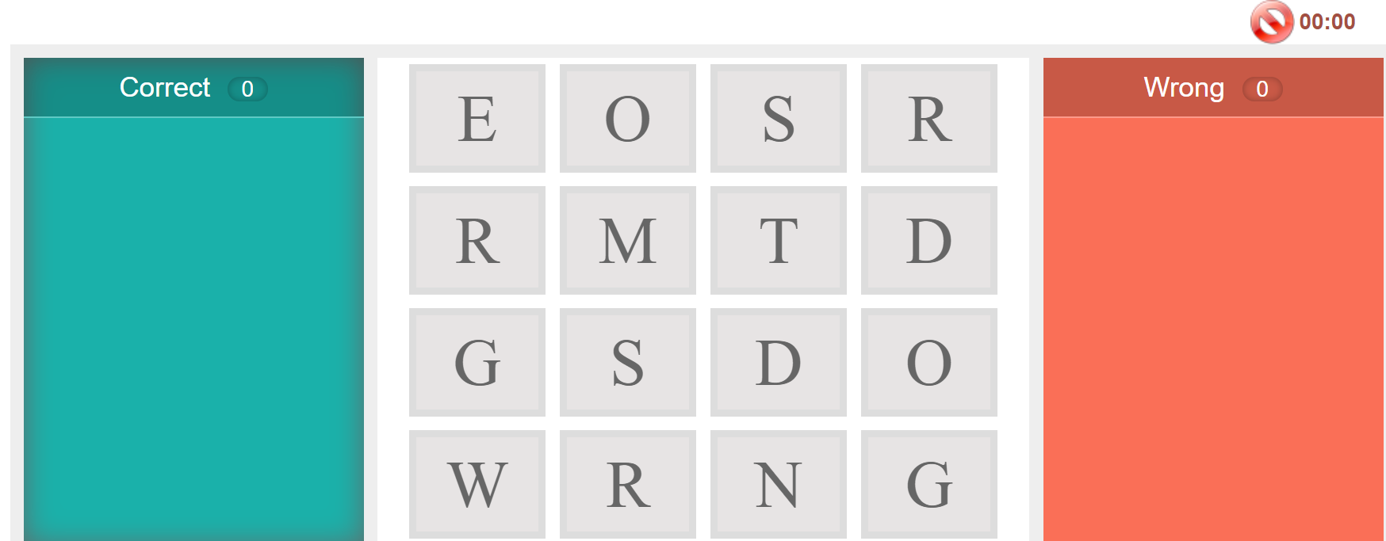

**Features**

1. Two player game 1
   * Users should be asked to enter their names
2. Create a 4 x 4 matrix with randomly assigned letters 2
   * Playable – make sure that the user can form a word
3. Keep track of the words entered 2
4. Validate the words entered against the words in the **dictionary 3**
5. **Timer** – let one of the players decide how long the game is 3
   * **Counts down by 1 minute**
   * The game ends once the timer hits 0:00
6. Keep track of the points and made available to the users 2
7. determine the winner 2
8. Landscape mode 2

Do not use external database or sqlite at this point.