Technologies

* 1. Android w/ Kotlin
  2. Flask

Using Python w/ Flask, create the following routes and functionalities

1. /team [method=Get]
   1. Returns the student names (your team members)
2. /data [method=Get]
   1. Use <https://mockaroo.com/> to create a json file
      1. Filename: customer.json
      2. Fields:

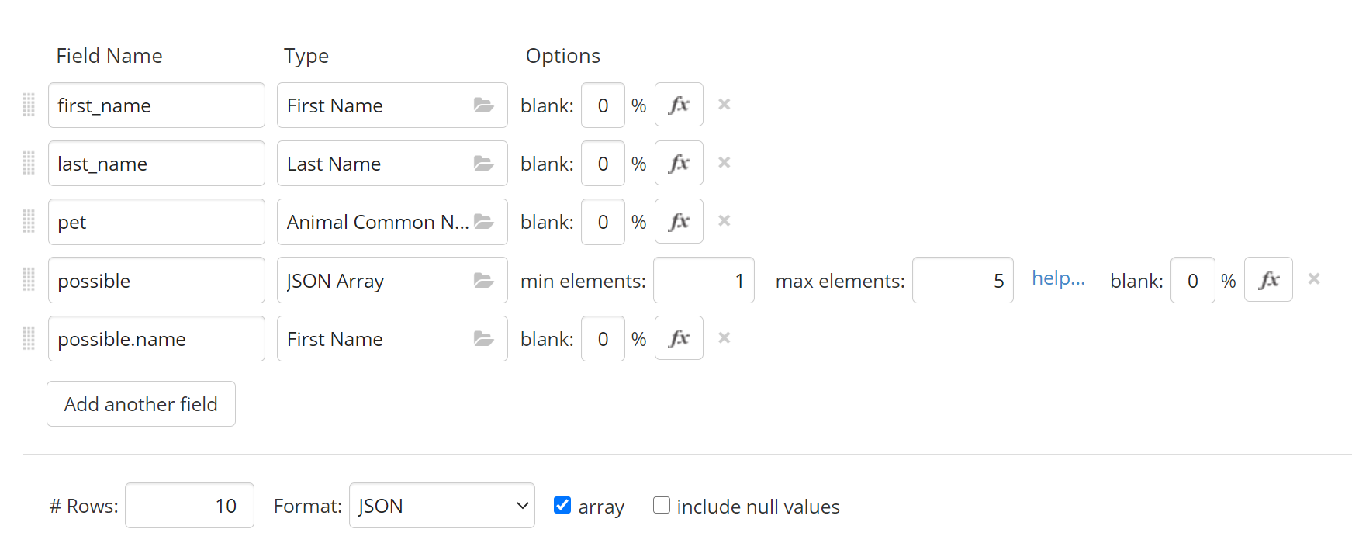

Sample data (preview only, you generate your own data)

“possible” is a JSON Array (see definition)

“possible.name” creates a field or fields of name inside “possible”

If you have “possible.gender”, this would create field “gender” inside “possible”

Example:

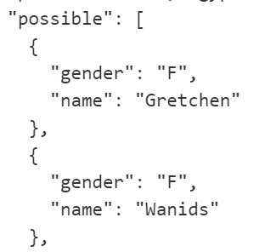

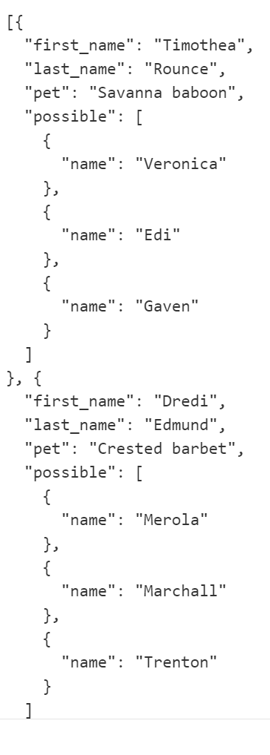

* 1. Returns the contents of the file and display to a browser

1. /add [method=POST]
   1. the “client” sends a json formatted data to the server
      1. the data contains first_name and last_name
   2. the data should be saved to a file on the server (filename: dummyData.json)
      1. update/append the new data (don’t override the previously saved data)

Using Android w/ Kotlin

1. Create an android application that would allow the user to access all the routes you created
   1. In the assets folder, create a text or json file that contains the url and port of your server. Your program should read the file to know which server and port to connect.

What to submit

1. Android application [6 marks]
2. .py file(s) [6 marks]
3. customer.json file