# Specifications of Influenza Serology Model

9 Feb 2015

Hsiang-Yu Yuan

Version: isltr-1.4

isl: influenza serological model

t: time series

r: the extension of SIR model

Notes: Finish the document for this version and make a clean version for isltr version 1.4

Notes:

The codes are originally written in R. The document that explains the procedures in stevensRfunction.R should be found in the previous version.

Use java as the running module.

## Project

### Source Codes

Files structure

- main

- calculate_R0

* + calR0_bypar(theta_beta,par)
  + calR0_byT(theta_beta,par,mean_posterior)

- extract_antibody_titres

* + main_producetitres_bytime
  + extract_titres_exvac
  + extract_titres_table
  + extract_titres_table_paired
  + extract_titrestable
  + main_producetitres_bytime

- immune_boosting

* + plot_boosting
  + plot_protection_2pars
  + plot_susc_2pars
* job
  + main01.job

- likelihood_estimation

* + main_pointestimatelikelihood_hk_java
  + main_findmin_sera_age_java

- mcmc

* + calDIC
  + main_MCMC

- plot

* + main_plot_serology
  + mcmc_multipars_plot
  + mcmc_noagepars_plot
  + plot_dynamics
  + plot_dynamics_byage
  + plot_dynamics_bypar
  + plot_dynamics_bypar_hist
  + plot_dynamics_bypar_noage_hist
  + plot_dynamics_bypar_noage_seramap
  + plot_dynamics_bypar_seramap
  + plot_dynamics_fromposterior
  + plot_dynamics_fromposterior_bymean
  + plot_dynamics_immesbyage
  + plot_histogram_hk
  + plot_infected_distribution

- lib

- chart

* + plot_grid
  + plot_line
  + retrieve_histogram

- model

- llh

* + calculateConstant
  + calculateLogLikelihood
  + estimatelikelihood
  + get_titres_prob (<-estimatelikelihood.m)

- rt

* + cal_NGM_bybeta
  + cal_NGM_bybeta2
  + cal_NGM_bybetaByT

getMOF_byS (<-cal_NGM.m)

- susc

* + getSusc
  + make_f_simple
  + make_h
  + make_g
  + make_M
  + ztpoisspdf
  + get_popweights_4_hk
  + InitParameters
  + make_ics_fromtitres_byage
  + make_ics_naive
  + odef_islmodjava
  + setParameters

- optim

* + getNegLLHAgejava
  + getNegLLHbyArrayjava

- sys

* + initialModel
  + runMCMC
  + set_projectoutput

### Flow

* main scripts:

1. main_producetitres_bytime: extract and save antibody titres

2. main_estimatelikelihood_hk: read the samples and calculate the likelihood surface

3. main_findmin_sera_age_java: estimate ML using java component

4. metropolis_multipars_main_java: estimate posterior using MCMC

main_producetitres_bytime

     -> extract_titres_table_paired

-> extract_titres_exvac

-> extract_titres_table

      -> extract_titres_exvac;

       -> save

main_mcmc

-> InitParameters

make_M

make_f_simple

make_h

make_g

-> setParameters

-> initialModel

-> matlabjava

-> make_ics_naive

get_popweights_4_hk

initial_prev_Xu_uniform

-> run_MCMC

getNegLLHbyArrayjava

setParameters

matlabjava

ode23(@(t,x)odef_islmodjava

gen_strain_titres

calculateLogLikelihood

-> set_projectoutput

Export to text file: writetable(PosteriorSamples,'posterior.csv','Delimiter','\t')

main_estimatelikelihood_hk

-> simulate (lib/model)

-> odef_islmod (lib/model)

-> estimatelikelihood (lib/model)

main_findmin_sera_age_java

->initialModel

-> fmincon

-> getNegLLHAgejava

-> matlabjava.jar

-> save('maxllh.mat')

The Old code, but keep it now as a reference to make sure I include how I plot, how I test effective sample size, and where I save my output files.

metropolis_multipars_main_java

-> getNegLLHAgejava

-> matlabjava.jar

-> save('mcmc/mcmc_6pars.mat')

-> run plot/mcmc_10pars_plot.m (plot mcmc histogram)

-> run plot/plot_dynamics_frompost (plot model dynamics from posterior)

-> test effect sample size

Export to text file: writetable(PosteriorSamples,'posterior.csv','Delimiter','\t')

### Models:

Models with contact proportion factors

Model testing 1

10 parameters

|  |  |  |  |  |  |  |  |  |  |
| --- | --- | --- | --- | --- | --- | --- | --- | --- | --- |
| β | AbB1 | AbB2 | AbB3 | AbB4 | C2 | C3 | C4 | iα | iβ |

Purpose: To see whether MCMC trajectories can reach stable states.

On 20141010, model was running. Iβ reaches an unreasonable high value. C3 reaches an unreasonable low value. ESS are too low for few parameters. The model is not good for data fitting.

Model testing2

7 parameters

|  |  |  |  |  |  |  |
| --- | --- | --- | --- | --- | --- | --- |
| β | AbB1 | AbB2 | AbB3 | AbB4 | C2 | iα |

Purpose: To see whether MCMC trajectories can reach stable states.

On 20141010, model was running. C2 can’t reach stable states. The value changes rapidly from 0 to 8. ESS is 13.7. What I suggest is to fix contact parametes.

Model without age group

Model with fixed age group mixing

Model2

7 parameters

|  |  |  |  |  |  |
| --- | --- | --- | --- | --- | --- |
| β | AbB1 | AbB2 | AbB3 | AbB4 | iα |

Model3

9 parameters

|  |  |  |  |  |  |  |  |  |
| --- | --- | --- | --- | --- | --- | --- | --- | --- |
| β | AbB1 | AbB2 | AbB3 | AbB4 | iα1 | iα2 | iα3 | iα4 |

Model4

|  |  |  |  |  |  |
| --- | --- | --- | --- | --- | --- |
| β | AbB1 | AbB2 | AbB3 | AbB4 | immune_alpha |

Model3 (9 parameters)

|  |  |  |  |  |  |  |  |  |
| --- | --- | --- | --- | --- | --- | --- | --- | --- |
| β | AbB1 | AbB2 | AbB3 | AbB4 | C2 | C3 | C4 | immune_alpha |

Model4

11 parameters:

|  |  |  |  |  |  |  |  |  |  |  |
| --- | --- | --- | --- | --- | --- | --- | --- | --- | --- | --- |
| β | AbB1 | AbB2 | AbB3 | AbB4 | A1 | A2 | A3 | A4 | immune_alpha | immune_beta |

Read the papers labelled immune protection to know how immune protection can change by age

the elderly do not have the same ability as younger subjects to mount an antibody response

http://link.springer.com/article/10.1007%2FBF03324202

# (Evaluation of Anti-Hemagglutinin (Anti-HA) Antibodies as Protection From the Flu in Healthy People

http://clinicaltrials.gov/show/NCT01971255)

### Diagram of Model New

Goal: To make a clean version of code

This version should be able to run 4 tasks

MCMC, PointEstimates, CalculateRt, mplot, extract_titres

Write down all the m files that are used in the program flows

1. main_mcmc

main_mcmc

InitParameters

make_M

make_f_simple

make_h

make_g

setParameters

initialModel

matlabjava

make_ics_naive

get_popweights_4_hk

initial_prev_Xu_uniform

run_MCMC

getNegLLHbyArrayjava

setParameters

matlabjava

ode23(@(t,x)odef_islmodjava

gen_strain_titres

calculateLogLikelihood

set_projectoutput

1. calculateRt
2. main_findmin_sera_age_java( model )
3. mplot

### Diagram of Model

simulate(@model,pars,Y,A,T)

simulate

Initial parameters for sero-level model. Define a set of scalars. Create lookup arrays for each of the aux functions. Create lookup for state variables S and I.

InitParameters

setParameters

pars

make_ics_fromtitres_byage

Setup the initial conditions from previously collected samples.

plot_dynamics_bypar

Plot of proportion of susceptible individuals with different serology levels and age groups.

Antibody

ode23(@odef_islmod)

x

The model is written in ODE to calculate the dynamics of the state variables.

pa.matM = lib/model/susc/make_M();

pa.arrf = make_f_simple();

pa.arrg = lib/model/susc/make_g();

pa.arrh = lib/model/susc/make_h();

[Slu Ilu CIlu ] = make_S_I_lookups();

odef_islmod

make_ics

InitParameters

#### Schema of disease and serological dynamics

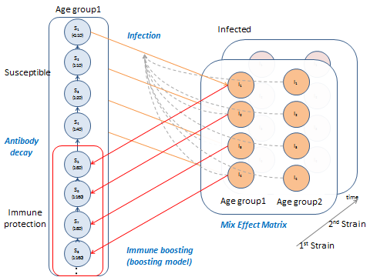

#### Data: HongKong Serological Data

The data source is described in Incidence and severity of the first and second waves of pandemic H1N1 compared with seasonal H3N2: a longitudinal study.

What are the methodology for generating this figure.



Blood

time1 07/2009 – 09/2009

time2 11/2009 – 01/2010

time3 12/2010 – 03/2011

time4 08/2011 – 12/2011

### Age strcuture

UK prevalence

Age group

[0 18; 19 39; 40 65; 65 100];

*(defined in setParameters::pa.ages)*

Should I change to 0-18; 19-39; 40-64; 65-100?

Age prevalence

|  |  |
| --- | --- |
| Age | Proportion |
| 0-18 | 16.42 |
| 19-39 | 30.29 |
| 40-64 | 39.4 |
| 65-100 | 13.2 |

*(defined in make_ics_fromtitres_byage::pop)*

Here is where I can find HongKong demographic data. http://michellebian3.wordpress.com/2011/10/12/interesting-statistics-of-hong-kong/

The latest one.

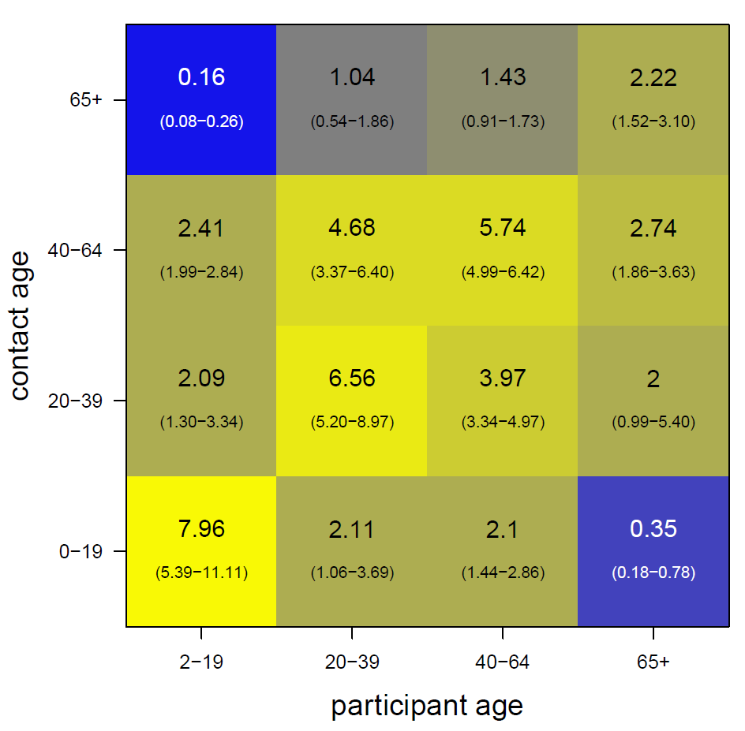

The original contact matrix is

M = [

6.92 0.19 0.42 0.36;

0.25 3.51 0.38 0.44;

0.77 0.57 1.40 1.03;

0.45 0.20 0.17 1.83

];

, which is adapted from Guangzhou(Read, Lessler et al. 2014).

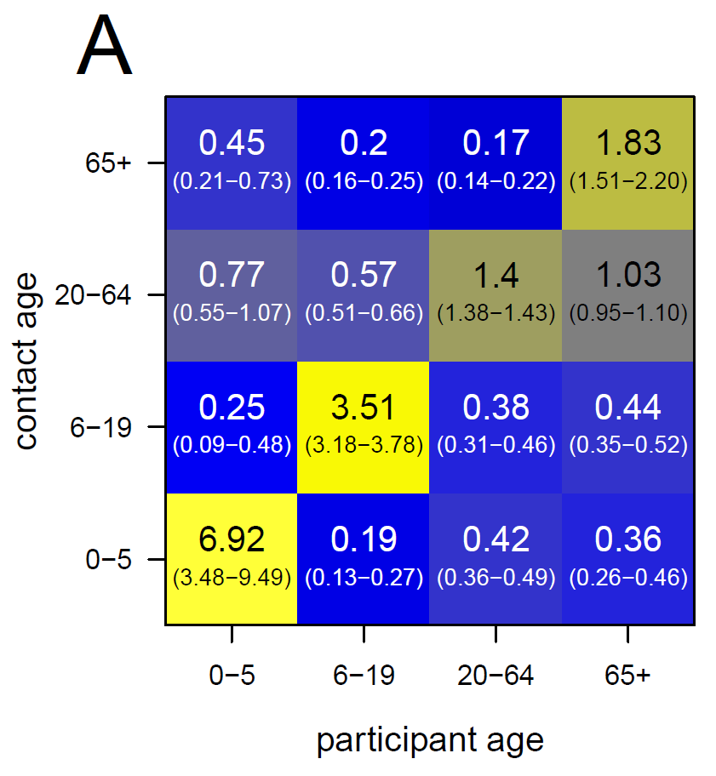

Because the matrix is generated from Guangzhou data,

On provided us the new HongKong based contact matrix.

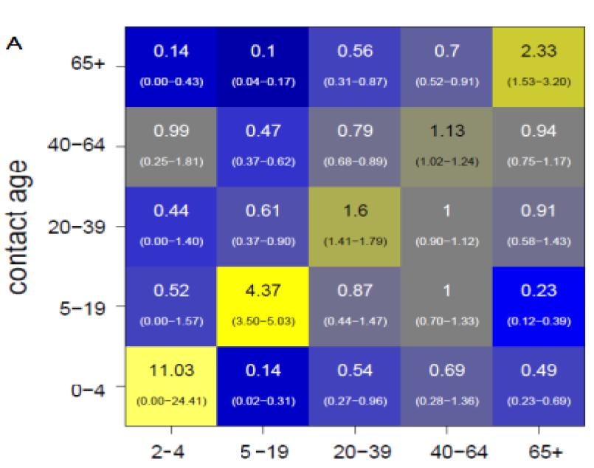

#### Age mixing effect

To estimate key parameters in disease dynamics with age structures, we assume there are 4 age groups in our model.

The prevalence of 4 age groups in HongKong is listed as the following table.

Age prevalence

|  |  |
| --- | --- |
| Age | Proportion |
| 0-18 | 16.42 |
| 19-39 | 30.29 |
| 40-64 | 39.4 |
| 65-100 | 13.2 |

The expected contact number among each age group in listed in the matrix.

|  |  |  |  |
| --- | --- | --- | --- |
| 10.92 | 0.6 | 0.8 | 0.4 |
| 0.5 | 1.6 | 1 | 0.91 |
| 0.6 | 0.79 | 1.13 | 0.94 |
| 0.1 | 0.56 | 0.7 | 2.33 |

The value is not correct. I will need to ask On to produce the matrix in consistent with our age group definition for HK data.

#### Age contact model

Assuming there are 4 age groups and the contact rate is defined as the following matrix M =

[

m11 m21 m31 m41;

m12 m22 m32 m42;

m13 m23 m33 m43;

m14 m24 m34 m44;

];

Is there anyways to add uncertainty to age mixing effects?

Three ways to add uncertainty in mixing array with extra parameters:

1. Differences in proportional rate:

M = [

m11*c1 m21*c2 m31*c3 m41*c4;

m12*c1 m22*c2 m32*c3  m42*c4;

m13*c1 m23*c2 m33*c3  m43*c4;

m14*c1 m24*c2 m34*c3 m44*c4;

];

1. Differences in assortativity:

M = [

m11*a1 m21*1/a2 m31*1/a3 m41*1/a4;

m12*1/a1 m22*a2 m32*1/a3 m42*1/a4;

m13*1/a1 m23*1/a2 m33*a3 m43*1/a4;

m14*1/a1 m24*1/a2 m34*1/a3 m44*a4;

];

(http://en.wikipedia.org/wiki/Assortative_mixing)

1. Differences in each element

M = [

m11±σ112 m21±σ212 m31±σ312 m41±σ412;

m12±σ122 m22±σ222 m32±σ322 m42±σ422;

m13±σ132 m23±σ232 m33±σ332 m43±σ432;

m14±σ142 m24±σ242 m34±σ342 m44±σ442;

];

The first approach changes the proportion of contact in each age group, which requires 4 parameters. The second also requires 4 parameters but changes assortativity in each group. The third requires 16 parameters. **Which way is better?**

Based on On’s opionion, it is worth to use the second approach to include the uncertainty.

### Next Generation Matrix for Aged structure



T transmission matrix

|  |  |  |  |  |
| --- | --- | --- | --- | --- |
|  | CW | CS | AW | AS |
| CW |  |  |  |  |
| CS |  |  |  |  |
| AW |  |  |  |  |
| AS |  |  |  |  |







Framework

Output file name correct?

Should correspond to next section tasks.

Susceptibility?

make_h.m

susceptibility 

csv file

Estimate Likelihood

Produce Ab Titres

h1n1_titres.mat

h3n2_titres.mat

output.mat

(Likelihood)

Visualize Immune Dynamics

### Procedures:

1. Define parameters and variables
   1. Epidemiological:

R0

Tg

alpha

N

Seed

beta

novars

maxi = 9

maxj = 1

maxk = 1

maxa = 5

maxX = 3

* 1. Serological:

Age dependent boosting rate

AbB1, AbB2, AbB3, AbB4

* 1. Auxiliary variables:

Contact mixture: **matM**

Infectivity array: **arrf**

Immune Boosting array: **arrg**

Susceptibility (immune protection) array: **arrh**

1. Define age mixing array
2. Calculate the force of infection
   1. infectivity of individual f(b,I,j,k)
   2. Lookup the index of Infecteds Ilu
   3. Lookup mixing array matM
   4. Calculate the force of infection
3. Update the immune status
   1. Calculate the product of Infecteds and immune boosting array g(X,a,l,m,n,I,j,k)
4. Update Susceptible and Infected state variables

#### Arrays and lookups:

matM: mixing matrix

maxi maxj

4 4

arrf: the infectivity array

(R code: dim(su$arr.f))

maxa maxi maxj maxk

5 2 1 1

arrg: the proportion of individuals with initial antibody titres (l,m,n) infected by strain X who had antibody states (i,j,k).

dim(su$arr.g)

maxX maxa maxi maxj maxk maxi maxj maxk

3 5 2 1 1 2 1 1

Values: following Poisson distribution

arrh: susceptibility of individual h(X,a,I,j,k) to strain X

dim(su$arr.h)

maxX maxa maxi maxj maxk

3 5 2 1 1

#### Antibody Boosting

k = boosting level

λ = average boosting level

The probability of antibody boosting is modelled by Poisson truncated distribution.

\!f(k; \lambda)= \Pr(X=k)= \frac{\lambda^k e^{-\lambda}}{k!},

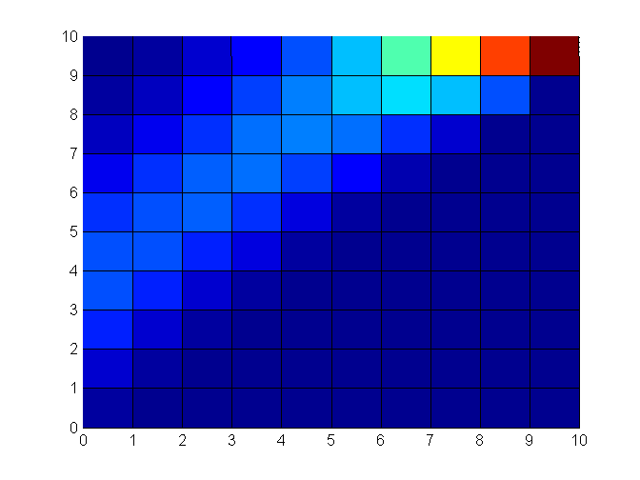

Besides Poisson, we should also consider semi-mechanistic model based on negative binomial.

If antibody titres represents the probability of viruses clearance, the probability of viruses clearance is P(k), where k is the antibody titres. k increases along time until viruses are cleared.

Ref: correlation between antibody and viral load

<http://www.virologyj.com/content/11/1/57>

Two variables present negatively correlations. If we assume the antibody titres represents the clearance within host, then we can think about using negative binomial to represent the final titres.

(see also p.20)

#### Classify antibody titres and susceptibility

|  |  |  |
| --- | --- | --- |
| Titres | Levels | H (susceptibility) |
| <1:10 | 0 | 1 |
| 1:10 | 1 | 0.6703 |
| 1:20 | 2 | 0.4493 |
| 1:40 | 3 | 0.3012 |
| 1:80 | 4 | 0.2019 |
| 1:160 | 5 | 0.1353 |
| 1:320 | 6 | 0.0907 |
| 1:640 | 7 | 0.0608 |
| 1:1280 | 8 | 0.0408 |

I should use logistic function.

Estimated parameters

x_opt = [0.2000

5.6884

5.6329

4.3631

4.1780

1.5840

1.1160

0.1000

5.9862

4.1774

80.2141];

## Tasks

### Parameter Estimation: Maximum Likelihood Approaches

Produce Antibody Titres

Estimate Likelihood using Java

Estimate Likelihood using MCMC  
metropolis_multipars_main

Output

Posterior

Output

Parameter values

Visualize Immune dynamics

Visualize posterior

1. Produce Antibody Titres
   1. main_producetitres_hk
2. Estimate Likelihood
   1. main_estimatelikelihood_hk
3. Visualize Immune Dynamics
   1. plot_main_dynamics_hk, 2 subfigures: a) time series population herd immunity at 4 sampling time. b) proportion of naive and non-naive individuals
   2. plot_lhsurf (1 figure)
   3. plot_dynamics ( R0, AbB, alpha ), 5 subfigures: a) disease dynamics, b) heat map of immune dynamics, c) histogram of antibody level, d) HK sera(final) after outbreak and e) HK sera(final) after outbreak
   4. plot_dynamics_byage, 3 subfigures for each age group: a) disease dynamics, b) heat map of immune dynamics, c) histogram of sera from empirical and model output

Major goal:

To estimate R0 and Boosting.

With cross sectional analysis -> predict Boosting

Poisson distribution

Semi-mechanistic

With longitudinal analysis -> predict R0

Need to create age structures.

#### Produce Antibody Titres

csv file

*main_producetitres_hk*

./dat/part_R14_2013_07_22_sr.csv

lib/plot_histogram_hk

lib/extract_titres

plot_dynamics

titres.mat

titres.mat: {Antibody, params}

#### Likelihood Estimation

titres.mat

*main_estimatelikelihood_hk*

make_ics_naive

InitParameters

getMOF

Model

simulate

getImmBoost

estimatelikelihood

meshgrid

Output:

likelihood_2params.mat'

##### Visualize Immune Dynamics

1. Main dynamics

Plot (a)antibody titres distribution and (b)proportion of naïve individuals from HK.

Code: plot_main_dynamics_hk

1. Plot likelihood surface

The figure plots likelihood surface on two dimensional grids. One dimension represents R0, and the other represents Antibody boosting level.

Code: plot_lhsurf

1. Plot Disease and Immunity dynamics

The figure plots 5 subfigures. a) disease dynamics, b) heat map of immune dynamics, c) histogram of antibody levels, d) HK sera(final) after outbreak and e) HK sera(final) after outbreak.

Code: plot_dynamics(R0, AbB, alpha), plot_dynamics_byage(R0, AbB, alpha)

titres

plot_line

plot_dynamics

plot_grid

plot_infecteds_distribution_deter

#### Optim

Derive maximum likelihood using maximization appraoch

#### Calculate R0

Derive next generation matrix

age groups: a1->young, a2->adults

antibody titres: i1->naïve, i2->fully protected.

Matrix T = [p0.beta.*p0.M.*S_max/p0.N];

Sigma = [-p0.gamma-p0.mu 0; 0 -p0.gamma-p0.mu];

NGM = -T*inv(Sigma);

#### Immune Boosting

***Other codes***

main_estimatelikelihood_para.m: Testing for parallel programming.

main_dynamics_hk.m

* antibody levels at 4 time slots
* proportion of naïve individuals
* output titres.mat
  + params
  + Antibody{samplesize,Abl}

main_estimatelikelihood_hk.m (script)

* Pick a parameter value
* Run ODE model
* Calculate the likelihood
* Where to save???

estimatelikelihood_hk.m (function)

* Update R0 and AbB value
* Update depended parameter values (g array)
* Calculate the likelihood
* Where to save???

### Simulate Disease and Serological Dynamics

First I determine the parameters that produce maximum likelihood.

Using that parameters, I plot the disease dynamics, serological dynamics and

beta = 0.5

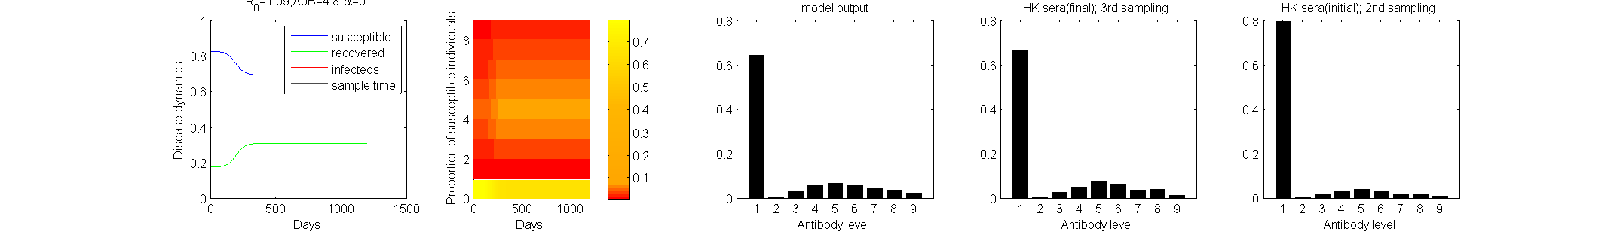R0 = 1.09

Antibody Boosting Rate =

Ref: correlation between antibody and viral load

<http://www.virologyj.com/content/11/1/57>

Two variables present negatively correlations. If we assume the antibody titres represents the clearance within host, then we can think about using negative binomial to represent the final titres.

#### Simulate Titres

Draw samples from population

1. Simulate Titres
   1. main_simulate_titres

Simulate Titres

plot_line

plot_grid

plot_infecteds_distribition_stoch

titres.mat

Testing the procedures for likelihood estimation.

Code: main_simulate_titres

-> make initial condition (make_ics.m)

-> model simulation (odef_islmod.m)

-> plot SIR dynamocs (plot_line.m)

-> plot serological map (plot_grid.m)

-> plot serological histogram (plot_infecteds_distribution_stoch.m)

-> obtain antibody levels data (draw_infecteds_distribution.m, replaced by getSerology.m). Output: titres.mat {Antibody, params}

#### Parameters

Antibody boosting rates

setParameters.m

Susceptibility

make_h.m

Transmission rate

Age mixing array

setParameters.m

**Data Sheet**

|  |  |  |
| --- | --- | --- |
| sr.index  Old_id  order  New_id  X3rd_presence  X4th_presence  sex  relation  Age_1  Age_2  Age_3  Age_4  blood_1  blood_1_date  blood_2  blood_2_date  blood_3  blood_3_date  blood_4  blood_4_date  hh_size  profession  profession_text  education  education_text | indoor  indoor_text  bldg  bldg_text  coworker_num_min  coworker_num_max  coworker_num_text  school  school_text  classmate_num_min  classmate_num_max  classmate_num_text  eversmoked  smoking quit_y_min  quit_y_max  quit_m  smoke_num  chronic  adultdis  adultdis_text  childdis  childdis_text  westmed suppl  chinmed  med_text | vac1011  vac1011_cleaned  vac0910  vac0910_cleaned  vac0910_h1n1  vac0910_h1n1_cleaned  vac0809  vac0708  coldnum_min  District.5  H1N1.T1  H1N1.T2  H1N1.T3  H1N1.T4  H3N2.T1  H3N2.T2  H3N2.T3  H3N2.T4  H3N2.T4_old  pH1N1.T1  pH1N1.T2  PH1N1_com_result_tbase  sample  Mode  pre_titre  pre_titre_agg  post_titre  post_titre_agg  ph1n1.T1.Raw  ph1n1.T2.Raw |

## Future works

1. Estimate the seroprevalence with different age groups.
2. How to reproduce 2nd peak in pH1N1:
   1. The susceptibility among different age groups should be different. (Relates to the 1st future work)
   2. The contact between different age group would also affect whether there is 2nd peak. What kinds of contact would generate 2nd peak?

## Supplementary

### Definitions of Parameters

The parameters are grouped as Epidemiological parameters, Auxiliary variables and Lookup table.

Epidemiological parameters

|  |  |
| --- | --- |
| R0 | the basic reproduction number (No R0) |
| beta | transmission rates |
| Tg | The average duration of infectiousness |
| α | Immune waning rate |
| maxi | maximum categories of observed antibody concentration for strainA |
| maxj | maximum categories of observed antibody concentration for strain |
| maxk | maximum categories of observed antibody concentration for strain |
| maxa | maximum age |
| maxX | maximum number of the strains |
| N | total population size |
| seed | ? |
| trickle | ? |
| age_flag |  |
| semi_mechanistic |  |
| matM |  |
| AbB | Immune boosting rate |
| arrf |  |
| arrf_ |  |
| arrg |  |
| arrg_ |  |
| arrh |  |
| arrSlu |  |
| arrIlu |  |
| arrCIlu |  |
| novars | number of variables |
| Antibody | Input variables for antibodies |
| prevK | sampling index for pre-epidemic (1-3) |
| currK | sampling index for post-epidemic (2-4) |
| ages | [4 x 2] matrix; defines the boundaries of age groups |
| alpha | Immune waning rate |

Parameters to be estimated

Serological parameters

|  |  |
| --- | --- |
| Beta | Disease Transmission Rate |
| AbB1 | Antibody boosting rate for age group1 |
| AbB2 | Antibody boosting rate for age group2 |
| AbB1 | Antibody boosting rate for age group3 |
| AbB1 | Antibody boosting rate for age group4 |
| Cont1 |  |
| Cont2 |  |

Auxiliary variables

|  |  |
| --- | --- |
| matM | the mixing matrix to represent contact rates |
| arrf | the infectivity of individuals with detectable antibodies |
| arrg | the proportion of individuals with initial antibody titres (l,m,n) infected by strain X who had antibody states (i,j,k) after infection is defined as g(X,a,l,m,n,I,j,k) |
| arrh | susceptibility of individual h(X,a,I,j,k) to strain X dependent on their age and their antibody level. |

Lookup table for state variables

|  |  |
| --- | --- |
| arrSlu | lookup array for number of susceptible individuals |
| arrIlu | lookup array for number of infected individuals |
| arrCIlu | lookup array for number of accumulated infected individuals |

Age structure

pa.ages = [0 18; 19 39; 40 65; 65 100];

### Definitions of Functions

Functions in Matlab code

|  |  |
| --- | --- |
| plot_histogram_hk | return the **titres** |
| InitParameters | return the initial condition |
| InitParameters.make_f_simple | return the infectivity array |
| InitParameters.make_g_simple | return the antibody boosting array g(X,a,l,m,n,I,j,k) |
| InitParameters.make_h_simple | return the susceptibility array for h(X,a,i,j,k) |
| InitParameters.make_S_I_lookups | return lookup array Slu, Ilu and CIlu for population |
| odef_islmod | return individuals by times |
| getImmBoost |  |
| getMOF |  |
| plot_infecteds_distribution | Return serodist_mat |
| getTotalInfect | Return serodist_mat and total_infecteds |

The above functions perform the same purpose as the following codes in R.

|  |  |
| --- | --- |
| isl.make.m.null() | return the mixing matrix |
| isl.make.f.null() | return the infectivity array |
| isl.make.g.simple() | return the array for g(X,a,l,m,n,I,j,k) |
| isl.make.h.simple() | return the array for h(X,a,i,j,k) |
| isl.make.S.I.lookups() | lookup array for number of infected individuals |
| isl.S.lu() | return the index for Susceptibles |
| isl.I.lu() | return the index for Infecteds |
| isl.pop.weights.null() | ? |
| isl.initial.prev.null() | ? |
| isl.make.ics() | setup the initial conditions |

Variables Definition

X: strain (Read, Lessler et al. 2014)

a: age

(l,m,n): initial antibody states to strain A,B,C

(i,j,k): final antibody states to strain A,B,C

How lookup table work?

e.g, given the array arrf = [5 x 2 x 1 x 1], the array indices represent the value of the parameters. The array arrf(b,i,j,k) returns the value of infectivity of individuals with (age=b,ab=i,ab=j,ab=k).

Model 1 (10 parameters)

20141016

with new Contact Mixing

|  |  |  |  |  |  |  |  |  |  |
| --- | --- | --- | --- | --- | --- | --- | --- | --- | --- |
| β | AbB1 | AbB2 | AbB3 | AbB4 | C2 | C3 | C4 | immune_alpha | immune_beta |
| 0.3677 | 6.2478 | 5.7680 | 4.2857 | 5.0588 | 0.01 | 0.01 | 3.1691 | 3.6520 | 2.1020 |

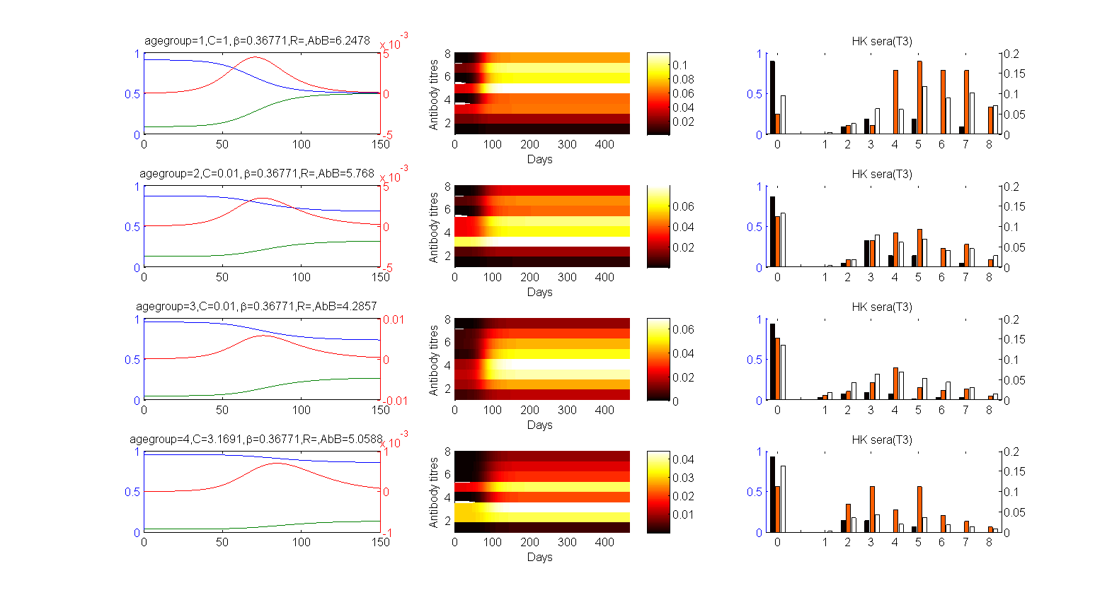

20140924

with old Contact Mixing (check setParameters.m)

|  |  |  |  |  |  |  |  |  |  |
| --- | --- | --- | --- | --- | --- | --- | --- | --- | --- |
| β | AbB1 | AbB2 | AbB3 | AbB4 | C2 | C3 | C4 | immune_alpha | immune_beta |
| 0.3249 | 5.9349 | 5.8309 | 4.4784 | 4.3625 | 0.7599 | 0.0100 | 3.8758 | 3.5052 | 2.1020 |

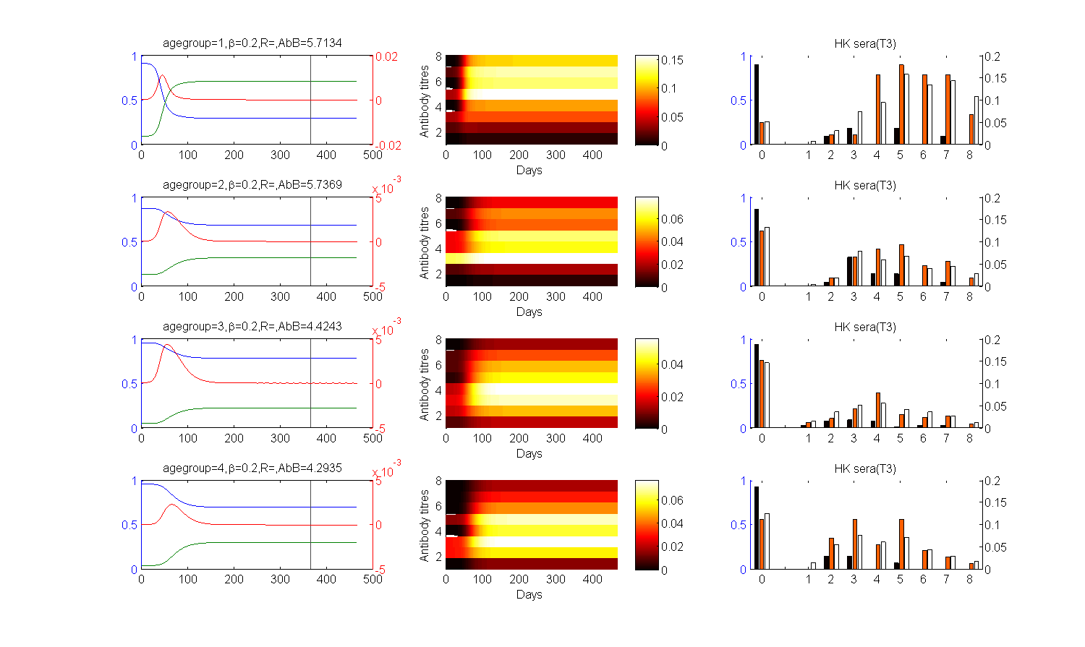

References:

Incidence and severity of the first and second waves of pandemic H1N1 compared with seasonal H3N2: a longitudinal study

Read, J. M., et al. (2014). "Social mixing patterns in rural and urban areas of southern China." Proc Biol Sci **281**(1785): 20140268.

A dense population, global connectivity and frequent human-animal interaction give southern China an important role in the spread and emergence of infectious disease. However, patterns of person-to-person contact relevant to the spread of directly transmitted infections such as influenza remain poorly quantified in the region. We conducted a household-based survey of travel and contact patterns among urban and rural populations of Guangdong, China. We measured the character and distance from home of social encounters made by 1821 individuals. Most individuals reported 5-10 h of contact with around 10 individuals each day; however, both distributions have long tails. The distribution of distance from home at which contacts were made is similar: most were within a kilometre of the participant's home, while some occurred further than 500 km away. Compared with younger individuals, older individuals made fewer contacts which tended to be closer to home. There was strong assortativity in age-based contact rates. We found no difference between the total number or duration of contacts between urban and rural participants, but urban participants tended to make contacts closer to home. These results can improve mathematical models of infectious disease emergence, spread and control in southern China and throughout the region.