# 

# ESG521 Group Report

# Case Study of Energy Market Practices

**Supervisor: Prof. Lyu Cheng**

**Group member(SID):**

1 Huang Meixin (302xxxx): Summary

2 Ye Yufeng(302 xxxx): China Energy Market

3 Wu Yuxuan(302 xxxx): China Energy Market

4 Wang Yixuan(302 xxxx): Europe Energy Market

5 Wang Zihan(302 xxxx): Europe Energy Market

Contents

Abstract 1

1 Background 2

2 Literature Review 3

3 China Energy Market 5

4 Europe Energy Market 15

5 Discussion and Summary 21

6 Future and Trends 22

References 23

# 

# Abstract

Under the dual pressures of economic growth and climate change, the global energy market is facing a critical period of low-carbon transformation. Renewable energy sources (such as solar and wind energy) are rapidly rising, more and more countries (like Europe, China, and the United States) are turning to renewable energy as a key alternative to traditional fossil fuels. However, traditional energy sources (such as oil, coal, and natural gas) are still the global main source of energy, accounting for approximately 80% of the world’s total energy consumption.

Driven by environmental, social, and governance (ESG) considerations, countries are introducing carbon-neutrality policies to green their energy structures. Europe, a leader in global climate action, introduced the European Green Deal, aiming for carbon neutrality by 2050. The plan covers sectors like energy, transportation, and agriculture, emphasizing renewable energy, electrification, and carbon trading. China, another major carbon emitter, has also set ambitious targets, aiming to peak emissions by 2030 and achieve carbon neutrality by 2060. China is investing significantly in clean energy and scaling up wind and solar generation while exploring carbon capture and storage technologies.

However, the transition faces challenges. First, the required investment in energy infrastructure is substantial, particularly for economies heavily reliant on traditional energy, where transformation costs are high. Second, clean energy has limitations in storage and stability, necessitating advances in energy storage to ensure reliability. Global cooperation and policy alignment are also essential, as countries differ in resources, economic development stages, and policy priorities, making consensus on energy transitions crucial.

This report analyzes energy market trends and future pathways from an ESG perspective, focusing on Europe and China’s practices and challenges in promoting energy transition and examining their implications for global low-carbon development. By providing in-depth ESG analysis, the report aims to support sustainable energy market development and assist countries in formulating feasible energy transition strategies under carbon neutrality goals. A global low-carbon transition is essential not only to combat climate change but also to foster shared economic and social prosperity, contributing to a more sustainable ecological future.

# 1 Background

The global energy market has experienced rapid growth and change over the past few decades. As the economic development and the population grows, energy demand is rising. Traditional fossil fuels such as oil, coal, and natural gas becoming the main source of energy. However, the widespread use of traditional energy sources has led to a series of environmental problems such as global warming and air pollution. [1]

With the intensification of climate problems, the international community's demand for energy transition is becoming more and more urgent. More and more countries have begun to seek low-carbon and sustainable energy development paths, and countries have introduced carbon neutrality goals and low-carbon policies, which have promoted the development of renewable energy, and clean and low-carbon renewable energy has gradually become the mainstream choice.

At the same time, Environmental, Social and Governance (ESG) factors are increasingly being taken seriously in the global energy market. Governments and capital markets have guided energy companies to raise their awareness of environmental protection through policies and investments, prompting them to pay more attention to social responsibility and environmental impact in energy production and management, and promoting the transformation of the market to sustainable development.

In this context, Europe and China have an important influence in the global energy transition: Europe has vigorously promoted renewable energy through the "Green New Deal" and set strict carbon reduction targets to actively promote the low-carbon economy; On the other hand, China is committed to achieving the goals of carbon peak and carbon neutrality, continuously optimizing its energy structure, and increasing the development of renewable energy.[2]

Overall, the global energy market landscape is undergoing a major transformation. The role of traditional energy and renewable energy is constantly adjusting, and the exploration of energy policy, technological innovation and sustainability in various countries has made the global energy market present a diversified development pattern, bringing new opportunities and challenges for the sustainable development of the global energy market in the future. With the advancement of low-carbon technologies, policy-driven and financial support, the global energy market will evolve in a greener, smarter and more sustainable direction.

# 2 Literature Review

##### 2.1 Introduction

###### The threat of global climate change is intensifying, prompting countries to accelerate the energy transition to reduce reliance on fossil fuels and achieve a clean, low-carbon energy system.[3]In recent years, clean energy investment and technologies have grown significantly, but regional disparities in deployment, policy uncertainty, and financial bottlenecks still constrain the achievement of global Sustainable Development Goals.[4]

This report aims to summarize the current research findings on the global energy market, with a focus on analyzing the key actions and challenges faced by China and the European Union in promoting global energy market sustainability, providing a theoretical foundation and practical guidance for future research.

##### 2.2 Literature Review[5]

###### 2.2.1 Theoretical Foundation and Research Methods

Research on global energy transition is mainly based on theories of low-carbon economy, sustainable development, and energy security. The theory of low-carbon economy advocates reducing carbon emissions through policy and technological means. The sustainable development theory calls for meeting current needs while preserving natural resources for future generations. Energy security emphasizes ensuring the reliability and price stability of energy supply during the transition process.

Related studies employ methods such as data analysis, scenario modeling, and case studies. Through data models, researchers were able to predict energy demand and the potential of clean energy under different scenarios. In addition, the case studies reveal the practices of various countries in policy and financial arrangements, providing a reference for future policy-making.

###### 2.2.3 Research Findings

1. Acceleration of Clean Energy Transition[3]

In recent years, investments in clean energy have significantly increased, nearing $2 trillion annually, nearly twice the total investment in oil, natural gas, and coal supply. This growth is driven by the decreasing cost of clean technologies, especially the expansion of solar PV and battery manufacturing capacity.

2. Energy Security and Market Balance[6]

With increasing uncertainty in the Middle East and Ukraine, global energy security faces significant challenges. According to the report, the vulnerability of the energy system lies in the high concentration of traditional fuel markets and clean energy supply chains. In recent years, global energy crises have shown the potential risks of over-reliance on a single energy source or market poses. Therefore, future energy systems must not only transition to low-carbon energy but also ensure supply chain diversity and resilience to enhance risk resilience.

3. Technological Progress and Energy Efficiency[7]

In the field of clean energy, technologies such as electric vehicles, green hydrogen, and CCUS (Carbon Capture, Utilization, and Storage) have been significantly developed. However, the pace of energy efficiency improvement remains insufficient, particularly in energy-intensive sectors. The data show that the global target of doubling energy efficiency by 2030 still needs to overcome policy obstacles and technological bottleneck.

###### 2.2.4 Research Gaps

Although there are differences in policies and technologies among countries, energy market research mainly focuses on high-income countries or emerging markets, with relatively little attention given to low-income countries. Differences in policy orientation in advanced economies, which focus more on energy efficiency and market reforms, and in developing countries, which face greater challenges in financing and technology. These differences limit the global adoption of clean energy.

##### 2.3 Conclusion

The global energy market is undergoing a rapid transformation, with climate policies, advancements in clean technologies, and investment and financing growth as the main driver. Although countries differ significantly in policy execution and technology application, the transition to clean energy is irreversible, and low-carbon has become the main theme of future development.

With the further development of clean energy technologies and green finance, the global energy market will evolve toward a more low-carbon and intelligent direction. In the future, policymakers and businesses need to continue strengthening investment in technology research and development, supply chain resilience, and international cooperation to address the multiple challenges posed by global climate change and achieve a sustainable transformation of energy systems.[8]

# 3 China Energy Market

##### 3.1 Background and Market Overview

###### 3.1.1 Energy Market Situation

The current energy market is divided into two major sectors, the 1 is fossil fuels composed of coal, oil, and natural gas, that is, non-renewable energy; the 2 is renewable energy composed of solar energy, wind energy, and tidal energy.

Today, China is the world largest energy producer, with a total primary energy production of 4.83 billion tons of standard coal in 2023 [9], an increase of 202.6 times over 1949 and an average annual increase of 7.4 per cent. At present, China has established a diversified energy security system, continuously improving the level of safety and resilience, and providing reliable support for the healthy development of the economy and society.

At the end of 2023, China participated in the United Nations Climate Change Conference in Dubai (COP28), which reached a consensus to "reduce the dependence of the energy system on fossil fuels in a just, orderly and equitable manner". Today, China is facing energy transformation and upgrading, with the goal of non-fossil energy accounting for more than 80% by 2060. It is easy to see from Table 1-1 that coal consumption is decreasing slightly year by year, oil consumption has increased by about 1% in recent years, and natural gas consumption is increasing slightly year by year. From this, it can be seen that my country's fossil energy consumption will not disappear in the short term, and it still appears in the market [10].

According to the data mentioned in China Renewable Energy Development Report 2023 [11], it can be seen that the development and application of renewable energy in China presents several new characteristics, 1 large-scale development, with the use of renewable energy generating capacity accounting for about 1/3 of the electricity consumption of the whole society. 2 is a high proportion of development, energy and electricity consumption has changed from a supplementary role to a main role. The 3 is the initial increase in the proportion of market consumption, according to the data in 2023, the new energy market accounts for 47.3 per cent of its total power generation; 4 is high-quality development, not only large-scale development, but also high-level consumption, in which the utilization rate of wind power and photovoltaic can be maintained at 97.3 per cent and 98 per cent, respectively, to ensure the stability of power supply. It can be seen from Table 1-2 that from 2014 to 2023, the proportion of renewable energy consumption in total energy consumption has increased year by year. It is not difficult to see that my country's energy structure is actively transforming to clean energy.

|  |  |
| --- | --- |
| Table1-1 Fossil energy as a percentage of total energy consumption | Table1-2 Renewable energy as a percentage of total energy consumption |
|  |  |

(Source: National Bureau of Statistics)

###### 3.1.2 Policy Background

The development of China's energy market is closely related to the promulgation of China's relevant policies. The following will analyze its impact on China's energy market from the background of “carbon neutral, carbon peak” policy and the “14th 5” plan.

1. Impact of the "Double Carbon" Policy on Energy Markets

Under the influence of the "double carbon" policy, China has changed the fossil energy market by levying carbon tax. [12] Tong Niu etal. In 2008, by developing a model , we assumed that environmental taxes can stimulate the introduction of renewable energy, so that the proportion of fossil energy in the market will be reduced. [13] Zhengquan Guo etal. also analyzed that environmental taxes can reduce fossil energy consumption through relevant model studies.

Since 2020, China has been committed to actively explore the use of renewable energy, which shows that the renewable energy market will enter a new chapter. It is estimated that the proportion of new energy installed capacity will exceed 40% by 2030. Driven by the "double carbon" policy, China will rationally allocate resources, continuously expand the construction of new energy bases, and jointly promote the combination of centralized (large-scale wind power photovoltaic base) and distributed (regional power supply, micro grid construction). In addition, implement a new energy consumption guarantee system, improve market mechanisms, promote the transition to renewable energy, and establish its dominant position. [14]

1. Impact on the energy market under the "14th 5" plan

From the energy production structure, compared with in 2020, coal's share of one-time energy production decreased by 0.9 per cent in 2023; crude oil's share decreased by 0.6 per cent; natural gas's share was the same as in 2020; and primary electricity and other energy's share increased by 1.5 per cent. From the perspective of energy consumption structure, coal's share of total energy consumption in 2023 decreased by 1.6 percentage points compared with the year in 2020; oil's share decreased by 0.5 percentage points; natural gas's share increased by 0.1 percentage points; primary electricity and other energy's share increased by 2.0 percentage points.

###### 3.1.3 market participants

The energy market of China is highly competitive, thanks to its diversified structure, which promotes cooperation. State-owned enterprises are the core, ensuring energy security and implementing national policies; private enterprises innovate flexibly and expand rapidly in the emerging energy field; foreign-funded enterprises bring technology and management to accelerate the internationalization and modernization of the market. Specific enterprises include: state-owned coal giant China Shenhua, oil and gas giants CNPC, Sinopec, CNOOC; private enterprises BYD, Ningde era; foreign-funded enterprises BP, Shell and so on. In addition, Sino-foreign joint ventures in the market have enhanced the overall competitiveness and promoted industry innovation and progress.

##### 3.2 Energy Market Reforms

###### 3.2.1 Electric Power System Reform

China's power system reform has made remarkable achievements in the construction of the power wholesale market, the pilot of the power in stock market and the marketization of electricity prices, so as to promote the healthy and sustainable development of the power industry. [15]

1. Onstruction of wholesale electricity market

In 2015, China launched a new round of power system reform, since then, China's power market construction pace gradually steady, to achieve the market-oriented trading scale of rapid expansion, the national market trading power significantly increased, greatly stimulated the market inherent potential.

1. Power in stock Market Pilot

The pilot work of the power in stock market continues to deepen. In Guangdong, Shanxi and other regions, the transition to formal operation or regional settlement trial operation has been successfully completed. This has effectively improved the rational allocation of power resources and ensured the accurate transmission of real price signals.

1. Electricity price marketization

The marketization of electricity prices has broadened the floating range of market-traded electricity prices and liberalized the feed-in tariff for coal-fired power generation in an orderly manner. At the same time, the electricity price formation mechanism is closer to the market principle than before, and can accurately reflect the relationship between power supply and demand and its cost changes.

###### 3.2.2 Natural Gas Market Reform

1. Changes in pricing mechanisms

The reform of natural gas pricing mechanism is the key. In the past, it was strictly controlled by the government and the market flexibility was limited. With the deepening of the reform, it is gradually becoming market-oriented, which is reflected in 3 aspects: prices are determined by market supply and demand, reflecting real value, and promoting rational resource planning; enhancing price transparency, helping participants to make wise decisions, and enhancing market fairness and competitiveness; long-term contracts and Short-term transactions coexist, providing more choices, taking into account stability and flexibility.

2.Opening of pipeline network

In the past, the traditional natural gas pipeline network was always controlled by a single operator, thus lacking market competitiveness. With the opening of the pipeline network, more and more different suppliers enter the market, enhancing market vitality and competitiveness.

3.Market-oriented reform

First of all, the market-oriented reform of the natural gas market has improved its own efficiency, which helps to allocate resources rationally, reduce production costs, and improve the profitability of market participants. In addition, market-oriented reforms provide impetus for technological innovation and promote industrial upgrading. At the same time, market-oriented reforms are also reflected in improving market transparency, reducing the occurrence of fraud, and enhancing market fairness and feasibility. Moreover, market-oriented reforms have promoted the sustainable development of natural gas, encouraging companies to improve efficiency and reduce costs, thereby achieving steady development of the industry.

###### 3.2.3 Energy Trading Platform

[16] taking the carbon emissions trading market as an example, the Beijing carbon emissions trading market, since2013 officially opened in, across power generation, petrochemical and other industries, as well as the development of a variety of trading products, has formed a diversified market trading structure, at the same time, in2024 its turnover and turnover increased significantly in, with a higher average transaction price; the Guangzhou carbon emissions market, in 2012 it has been started in, involving nine high energy-consuming industries, providing a trading platform for air-exhaust enterprises.

##### 3.3 Renewable energy development

Nowadays, the world attaches great importance to the sustainable development of energy, thus, wind power and photovoltaic power generation are developing rapidly. In China, they become an important part of new energy. Wind power has certain competitiveness due to technological progress and cost reduction. Therefore, it is necessary to expand its base construction and improve the localization rate; at the same time, the cost of photovoltaic power generation is reduced, and the installed capacity and power generation continue to increase, which is conducive to energy structure adjustment and energy conservation and emission reduction. Taking the Northwest [17] as an example, under the "14th 5" plan, wind power and photovoltaic power generation in Northwest China will achieve leapfrog development, as shown in Table 1-3. (Data source: Northwest provinces (regions) energy, power-related planning)

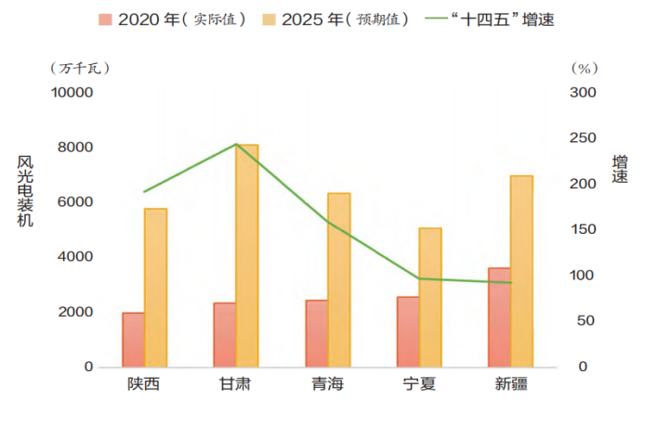

Table 1-3 Northwest provinces (regions) “14th 5”

wind power and photovoltaic power generation development goals

###### 3.3.1 Photovoltaic Parity Internet Policy

It is intended to emphasize that the cost of photovoltaic power generation should not rely on state subsidies, and should be comparable to or lower than the local coal-fired electricity price, so as to achieve grid parity. The policy has promoted the healthy development of the photovoltaic industry, reduced costs and enhanced market competitiveness. With policy support, the photovoltaic industry can continue technological innovation and industrial upgrading.

Renewable energy quota system:

Electricity suppliers or consumers are required to reach the renewable energy consumption ratio set by the government within a specified period of time. The policy aims to promote the consumption and application of renewable energy and optimize the structure. As a result, suppliers and consumers pay more attention to renewable energy, use investment in construction and purchase of renewable energy power to fulfill quota obligations, promote its development, and enhance market competitiveness.

###### 3.3.2 Technology Innovation and Application

1. Smart Grid Technology

Smart grids incorporate cutting-edge technologies for real-time monitoring, in-depth analysis and optimization. This improves the flexibility and stability of the power grid, accurately predicts and adjusts the power load, and responds to the instability of renewable energy. It promotes the seamless connection of intelligent devices and enhances the intelligence of the power grid.

2. Energy Storage Technology

[18] Energy storage technology can balance the supply and demand of electricity and promote the efficient use of renewable energy. Today, lithium batteries and other significant progress, to ensure the stability of the power grid. In addition, when combined with smart grid technology, it can better optimize energy allocation and improve efficiency.

##### 3.4 China carbon market

###### 3.4.1Current Status of China's Carbon Emissions Trading Market[21]

At the macro level, from the perspective of the country's development strategy, the Chinese government attaches great importance to the impact of climate change. In the "dual carbon" plan, the Chinese government is committed to adopting a series of policies and measures to achieve the goals of carbon peak in 2030 and carbon neutrality in 2060, which is a key factor in controlling greenhouse gas emissions through the use of market adjustment mechanisms, and is also an important starting point for promoting the construction of ecological civilization and achieving high-quality development in the national strategy.

At the micro level, the Chinese government has stepped into the world's largest greenhouse gas emitter, including the power generation industry, which accounts for a large proportion of carbon emissions, into the online rights trading market, with a total of more than 2,000 units, accounting for more than 40% of the country's carbon dioxide emissions. At the same time, under the planning and operation of the past three years, the institutional framework of the national carbon emission trading market has obviously begun to improve, and at the same time, with the continuous improvement of technical specifications, it has laid a solid foundation for the smooth and orderly operation of the market.

Legally, on January 25, the State Council promulgated the Interim Regulations on the Administration of Carbon Emission Trading, which clearly stipulates the main aspects of carbon emission market trading, while clearly dividing the legal responsibilities of each entity, and emphasizing the government's strict supervision and management and relevant penalties for violations(Figure 1).

Figure 1 Framework for the Interim Regulations for the Management

of Carbon Emission Trading

In terms of system, the Ministry of Ecology and Environment (MEE) has issued the Administrative Measures for Carbon Emission Trading (Trial) (Figure 2), which covers three rules of registration, trading and settlement, and has revised the accounting report, verification guidelines and allocation plan of carbon emissions, forming a sound system covering a multi-tier system(Figure 3).

图示

Figure 2 Policies and regulatory framework for the National ETS

Figure 3 Architecture of the National ETS

##### 3.5 New Energy Enterprises

Driven by the " double carbon " strategy, China 's new energy vehicle and energy storage market has made great progress in technology, industrial policy, market development and other aspects, especially in the fields of lithium iron phosphate and power battery[22][23].

###### 3.5.1 Industry Development Status

1.New energy battery materials

In the past few years, lithium iron phosphate batteries have successfully surpassed ternary lithium batteries and become the mainstream choice in the market due to their safety and low cost advantages. In 2023, global battery manufacturers will continue to increase investment in lithium iron phosphate technology routes. This trend reflects the growing market demand for battery solutions with low cost and high safety. Leading enterprises such as CATL Times and BYD have continuously promoted the wide application and further expansion of lithium iron phosphate batteries in the electric vehicle market through continuous technological innovation[24].

2.New energy battery enterprises

As one of the world 's largest battery manufacturers, CATL has ensured the stability of its supply chain with its rich investment and technical layout and BYD is the second in recent years（as shown in Table 1-4）. Especially in the supply of key raw materials, such as nickel, lithium and other resources, the strategic investment of the CATL era is spread throughout Indonesia and other regions to ensure that the production of ternary lithium batteries is not affected. At the same time, BYD focused on the technological innovation and application of lithium iron phosphate batteries and announced that it would stop producing fuel vehicles and go all out to promote the development of pure electric and hybrid vehicles.

Table 1-4 Global Battery Installation Trend

3.Policy and market environment

With the adjustment and reduction of state subsidies, new energy automobile enterprises will face a more market-oriented test in 2024. With the support of the “double-point system” and local policies, the promotion and popularization of new energy vehicles is accelerating, gradually occupying a large market share. Although the government has cut subsidies, the demand for electric vehicles is growing.

From the Table 1-5，according to data released by SNE Research, the global total battery usage of registered electric vehicles (EV，PHEV，HEV) reached 434.4 GWh between January and July 2024, up 22.4% from a year earlier. The top 10 in order: CATL, BYD, LG New Energy, SK on, CALB, Samsung SDI, Panasonic, Yi Wei Li Energy, Guo Xuan Tech, Xin Wanda[25].

The power battery market in the world has shown a pattern of 37%, which means China produces more than 70% of the power battery. CATL had 37.6% of the market, more than double the market share of BYD. South Korean battery companies LG New Energy, SK On and Samsung SDI combined load 93.2 GWh, market share of 21.5%, down 3.1%. Panasonic is the only Japanese manufacturer to make the top 10, but its sales are down in the top 10, down 25.4% from January to July last year.

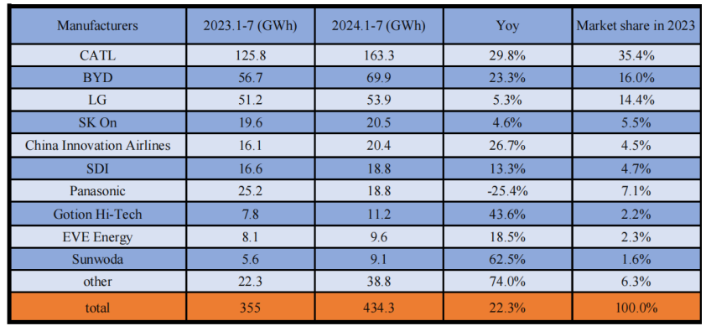

Table 1-5 Global installed capacity of power batteries from January to July 2024

##### 3.6 The challenges and development of China 's energy market in the future

1.Technological research and development and energy storage technology breakthrough. China is a country with high-carbon fossil energy as the main energy consumption country, and the pressure to deal with climate change in the international arena will increase. Therefore, the government and companies need to invest more in scientific and technological research and development to develop more efficient energy storage technology, so as to effectively solve the stability problem of new energy systems and improve the economy and energy utilization efficiency of the project.

2.Improve the transparency of policy decisions. In order to promote energy transformation, China urgently needs to build a transparent and convenient energy information disclosure and sharing system, so that the public can understand and recognize the connotation of energy system reform, and fully understand its benefits with the state in terms of energy use channels, energy use costs, energy use quantity and quality, in order to achieve better response to policies.

3.International cooperation and experience sharing. China will continue to deepen cooperation with other countries in the field of sustainable development, learn from the successful experience of developed countries such as Europe in carbon emissions trading and renewable energy subsidies, and improve China 's relevant policies.

In the face of these unprecedented challenges, China has shown strong adaptability and forward-looking thinking, and is expected to continue to play a leading role in the global green finance field and promote the development of the energy market in a low-carbon and sustainable direction.

# 4 Europe Energy Market

##### 4.1 Background of the European Carbon Emissions Trading System

The 1997 Kyoto Protocol laid the foundation for the establishment of a global carbon market, and the European Union established the European Carbon Emissions Trading System (ECETS) in 2005 as its active advocate. As global climate change poses a great threat to the ecological environment, economy and human health, Europe has set energy-saving and emission reduction targets in response to climate change, and hopes to promote the realization of the targets through the European Carbon Emission Trading System. Through the carbon market, the European Union hopes to incentivize enterprises to carry out scientific and technological innovation, promote green economic transformation and reduce greenhouse gas emissions.

##### 4.2 Objectives of the European Carbon Emissions Trading System

The core objective of the EU ETS is not only to control the total amount of carbon emissions, but also to achieve specific objectives such as the following:

1.Achieving specific GHG reduction targets: The EU has proposed to reduce GHG emissions by at least 55% from 1990 levels by 2030, and the carbon market is one of the main policy instruments to achieve this goal.The EU ETS sets yearly decreasing emission caps, forcing high emitting industries to reduce their emissions.

2.Promoting low-carbon technology innovation and clean energy use: Carbon markets incentivize companies to invest in clean technology and clean energy by raising the cost of carbon emissions. For example, in the power sector, as the price of carbon rises, high-emission energy sources such as coal are being phased out of the market, and natural gas and renewable energy are replacing coal in the market.

3.Maintaining the EU’s global climate leadership, the EU has established the world's first carbon market, hoping to lead the world in exchanges and cooperation in the field of climate change, and to promote the establishment of carbon markets in more countries or regions to participate in international carbon trading.

##### 4.3 Policy Provisions of the European Carbon Emissions Trading System

1.Allowance and Trading Mechanism: EU ETS has set up a total emission allowance covering high emission industries such as airlines and electricity, and reduces the allowance year by year in order to realize the goal of reducing emissions. Meanwhile, after obtaining emission allowances, enterprises can buy and sell insufficient or excess allowances in the market. Since 2005, the EU ETS has helped reduce emissions from power plants and industrial plants by 37 percent[26] .

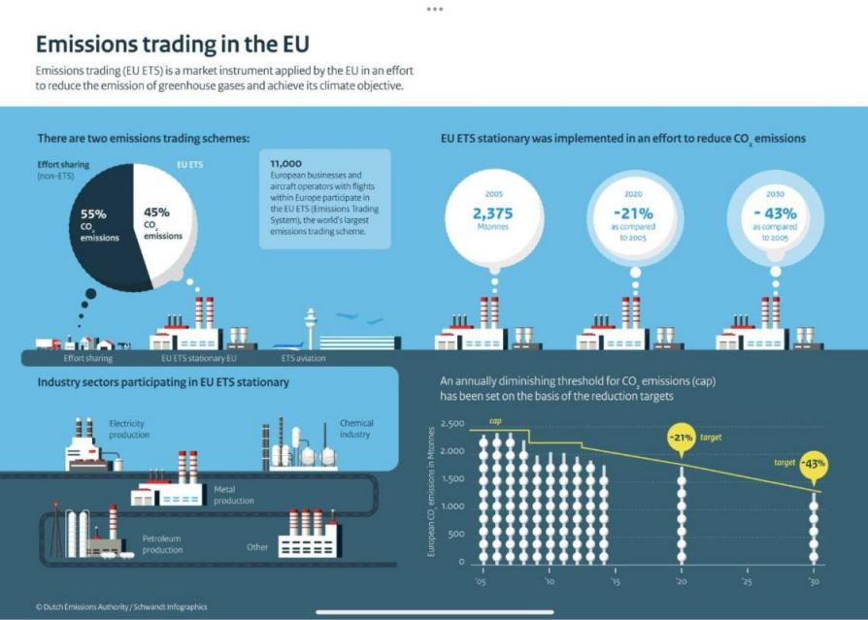

Figure 4 Emissions trading in the EU

2.Quota allocation method: For some industries with high risk of carbon leakage, such as the chemical industry, free quotas are provided to reduce costs and improve their competitiveness in the international market. For other industries, quotas will be obtained through auctions to promote low-carbon transition at market prices.

3.Market Stabilization Reserve (MSR) Mechanism: Through the MSR, excess quota in the market is recovered to keep the carbon price stable, and vice versa, quota is released to keep the market stable.

4.Carbon Border Adjustment Mechanism (CBAM): The CBAM policy reduces the risk of “carbon leakage” by requiring imports to pay a carbon tax and preventing companies from shifting high-emission production to other countries with fewer carbon regulations. Although carbon leakage is less likely to occur in the aviation industry, the imposition of quotas only on domestic airlines could jeopardize the fairness of domestic consumers, and only by expanding the system globally could countries regulate carbon emissions in the aviation industry and achieve a truly global reduction in carbon emissions from aviation.[27] Only by expanding the system globally can countries jointly regulate carbon emissions in the aviation industry, thereby realizing a truly global aviation carbon reduction.

5.Extended coverage

The EU ETS is progressively covering more sectors, and from 2021 onwards it is planned to extend the coverage from the aviation sector to the maritime sector, in order to achieve the carbon neutrality target in a more comprehensive way.

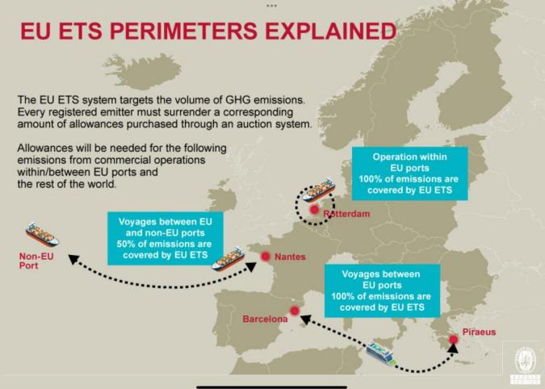

Figure 5 EU ETS Perimeters Explained

##### 4.4 Key stakeholders in the European carbon emissions trading system

1.European Union institutions: The European Commission is responsible for developing, coordinating and monitoring the European Carbon Emissions Trading System (ECTS) to ensure that member states comply with energy efficiency and emissions reduction targets. The European Parliament and the Council of the European Union are responsible for enacting and amending regulations and ensuring a balance of interests.

2.Member Governments: Individual member Governments are responsible for the allocation of domestic quotas and support low-carbon development through relevant policies at the national level, promoting the in-depth implementation of low-carbon policies in their countries.

3.Industry and business: The main industries participating in the European Carbon Emissions Trading System (ECTS) are: power, aviation, steel and other industries. These industries are the main contributors to carbon emissions, and at the same time are subject to the carbon market constraints, which can promote technological innovation by reducing carbon emissions.

4.Financial institutions and investors: Financial institutions and investors are mobile in the carbon market, and fluctuations in carbon prices simultaneously provide new financial investment opportunities for investors.

##### 4.5 Implementation steps

The EU ETS is divided into four phases, each of which has been adapted to suit different market conditions and environmental policy needs:

1.Phase I (2005-2007): Pilot phase, mainly used to test and verify the feasibility and market impact of carbon trading. This phase is more pilot-based, as it mainly allocates free allowances and the carbon price is more volatile.

2.Phase II (2008-2012): In parallel with the Kyoto Protocol's emission reduction commitments, covered sectors such as aviation were added and a stricter monitoring and verification system was introduced. Carbon prices began to stabilize during this phase, but still fluctuated considerably.

3.Phase III (2013-2020): The auction mechanism is used as the main allocation method, while the MSR mechanism is implemented to stabilize the carbon price. This phase is a more mature phase of the EU ETS and lays the foundation for realizing the EU’s emission reduction targets.

4.Phase IV (2021-2030): This phase strengthens the market stabilization reserve mechanism and sets more stringent coverage and emission reduction intensity. It is expected that by 2026, industries such as construction and road transportation will be gradually included in the system to further enhance the effect of emission reduction. The European Green Deal, the European Climate Act and other policies and regulations, as well as the “Fit for 55” action plan package together constitute the top-level design of the EU’s current climate governance. On the basis of policy constraints, the EU gives full play to the flexibility of the market mechanism, and comprehensively promotes the process of carbon neutrality through multi-faceted actions.[28] The EU has been fully utilizing the flexibility of the market mechanism on the basis of policy constraints.

##### 4.6 Effectiveness

Effectively reduce carbon emissions, since the launch of the EU ETS, the European region's carbon emissions have been reduced significantly, since 2020, Europe's carbon emissions fell by about 40% compared with 2005, to achieve significant emission reduction, especially in the power generation sector, and gradually shifted from high-emission fossil fuels to low-emission or even zero-emission renewable energy transformation.

In addition, EU ETS promotes international climate cooperation, the EU and other countries and regions to explore the cooperation of the carbon market, and the EU's carbon border adjustment mechanism will further expand its influence, so that more countries pay attention to carbon emissions. The EU ETS is in the experimental stage, although not perfect, but as an important public policy, taking into account that the system needs to coordinate the actions of 27 sovereign countries, and from the initial construction to implementation, only three years can be said that in fact the implementation effect is more than the other total trading mechanism.[29] The system has been implemented more effectively than other aggregate trading mechanisms.

##### 4.7 Challenges

The first is the fluctuation of the price. When the price of carbon is too low, enterprises will lack sufficient managerial motivation to implement energy saving and emission reduction. If the carbon price is too high, it may increase the operating costs of enterprises and affect the stability of the market.

The second is the technical difficulties and the cost of industrial transformation, some industrial sectors are difficult to achieve substantial emission reductions such as iron and steel, cement, etc, facing high transformation costs and technical bottlenecks. In addition, as the price of carbon rises, some enterprises pass on carbon costs to consumers, resulting in higher commodity prices and impacting the lives of residents.

Finally, the development of the global carbon market is uneven, although the EU has achieved positive results on the global carbon market, but the degree of acceptance of the carbon market varies from country to country, and different carbon prices have brought about inequality in competition, increasing the pressure on EU enterprises.

##### 4.8 Future prospects

In the future, the EU ETS will continue to play an important role in EU climate policy. With the planned introduction of the Carbon Border Adjustment Mechanism (CBAM), the EU will impose a carbon price on imports, thereby reducing the risk of carbon leakage and exerting pressure to reduce emissions in international trade. The introduction of this mechanism will further enhance the emission reduction effect of the EU ETS, while promoting the improvement of the global carbon market.

In addition, it is expected that by 2026, the coverage of the EU ETS will be further extended to buildings and road transportation. This will have a profound impact on the EU's overall carbon reduction targets. The future EU ETS is likely to continue to optimize the MSR mechanism to respond more flexibly to fluctuations in market supply and demand, and to set more scientific criteria for the allocation of carbon allowances and the use of auction revenues, so as to ensure that it achieves emission reductions while promoting the sustainable development of the green economy.

The European Parliament sees maritime transportation as an important tool to enhance the EU ETS’s ability to reduce emissions and boost its ambition to combat climate change, and will continue to advocate for the adoption of higher trading and regulatory standards in the future, so as to make the trading system more comprehensively cover all sectors of economic life in the EU.[30]

# 5 Discussion and Summary

##### 5.1 Multiple Opportunities in the Global Energy Market

1. Rapid Growth of Renewable Energy[3]

As countries promote clean energy, renewable sources like solar, wind, and hydroelectric power are expanding rapidly. Technological advancements and supportive policies, especially in Europe and China, are driving market growth and creating new investment opportunities.

2. Adoption of Emerging Technologies

Technologies like energy storage, smart grids, EVs, and hydrogen are reshaping the energy market, improving efficiency, and supporting low-carbon transitions, while creating significant business opportunities.

3. Rising Emphasis on ESG in Capital Markets

Increasing ESG investment has boosted capital inflows into clean energy sectors, giving environmentally responsible companies easier financing access and enhancing their market competitiveness.

##### 5.2 Challenges in the Global Energy Transition

1. Energy Price Volatility and Supply Chain Risks

Fluctuating energy prices and supply chain instability create market uncertainties, particularly for import-dependent countries, impacting investors and companies.

2. Technological Lag and Infrastructure Gaps

The adoption of new energy technologies requires advanced infrastructure like energy storage and smart grids, but many regions lag, limiting efficiency and new energy integration.

The global energy market is at a critical stage in the transition from traditional fossil fuels to clean energy. Despite challenges in technology, economics, and the environment, the growth of clean energy, technological innovations, and interregional connectivity are creating new market opportunities. In this process, the experiences of Europe and China provide important lessons for the global energy market transformation. As international cooperation strengthens, the future energy market will become more low-carbon and diversified, driving the world toward a more sustainable and cleaner energy system.

# 6 Future and Trends

The global energy market is undergoing a profound transformation, with the following key trends emerging:

1. Dominance of Renewable Energy

With technological advancements and declining costs, renewable energies such as solar, wind, and hydropower are set to play an increasingly significant role in the global energy market. By 2030, renewable energy is expected to capture a larger share of global energy supply. This trend will be accelerated, especially in Europe and China, by sustained policy support and green investment.[31]

2. Intelligent and Digital Transformation

Digital technologies will play an increasingly vital role in energy management and distribution. Smart grids, big data, and artificial intelligence (AI) will optimize energy production and consumption processes, enhancing energy efficiency and flexibility. Distributed energy systems will also be widely used in the future, empowering users to generate, store, and manage energy more autonomously.

3. Sustained Growth of Green Finance

The ESG investment philosophy will continue to channel capital into clean energy and sustainable development projects. Financial tools such as green bonds, carbon credit markets, and climate funds will further support the energy sector, advancing the transition to a low-carbon economy. As financial markets place greater emphasis on climate change, green investment will become an important part of the global economy.

4. Global Coordination of Policies and Regulations

Countries will continue to strengthen cooperation and alignment on climate and energy policies. Global carbon pricing mechanisms, international climate agreements, and green trade barriers will gradually take shape, providing stronger policy support for the energy transition. National carbon emissions targets will become more stringent, driving the global energy market toward low-carbon development.

The global energy market of the future will evolve towards being more low-carbon, intelligent, and green. Renewable energy will become mainstream, while the adoption of new technologies such as energy storage and hydrogen will further drive the energy transition. Green finance and global policy coordination will provide necessary support for this transition, while the social and economic challenges arising from the energy shift will need to be properly addressed. With ongoing technological advancement, policy support, and capital investment, the future energy market will be more sustainable, intelligent, and diversified.

# References

1. 赵坤,冯聪聪,王可.“能源转型是全球互通的‘语言’”[N].中国电力报,2024-10-28(002).
2. 李慧.全球能源转型正进入关键阶段[N].中国能源报,2024-10-28(005).
3. 刘刚.全球清洁能源产业跑出“加速度”[N].人民日报海外版,2024-11-07(006).
4. 程熙琼.世界能源市场不确定性进一步加剧[J].世界石油工业,2022,29(02):81-
5. International Energy Agency. (2024). World Energy Outlook 2024: Executive Summary. International Energy Agency.
6. 冯永晟. 能源危机、能源转型与电力市场 [J]. 财经智库, 2022, 7 (05): 5-34+145. DOI:10.20032/j.cnki.cn10-1359/f.2022.05.005.
7. 邱燕超.数字化和电气化是推动能源转型的关键[N].中国电力报,2024-10-28(003).
8. 李洪言,于淼,郑一鸣,等.基于情景的2050年世界能源供需展望分析——基于《bp世界能源展望(2023年版)》[J].天然气与石油,2023,41(05):131-137
9. 国家统计局.《能源供给保障有力 节能降碳成效显著——新中国75年经济社会发展成就系列报告之十三》
10. 郑丹.被嫌弃的化石燃料，被安排了结局[J].中国石油石化,2024,(06):48-51.
11. 《中国可再生能源发展报告2023年度》发布[J].节能与环保,2024,(07):1.
12. Tong, N., Xilong, Y., Shuai, S., Ding, L., Wenxi, W. (2018). Environmental tax shocks and carbon emissions: An estimated DSGE model[. Structural Change and Economic Dynamics,9-17.
13. 曹霞.碳达峰碳中和背景下我国新能源产业发展与升级[J].中国市场,2022,(34):60-62.DOI:10.13939/j.cnki.zgsc.2022.34.060.
14. 中国科学技术协会，《解码电价及电力市场体系，看电力市场化改革路在何方》
15. 全国碳排放权交易市场现状及趋势-北极星大气网
16. 潘荔,梁志宏,刘志强,等.我国西北地区风电、光伏发电发展形势分析[J].中国能源,2022,44(10):56-62.
17. 华志坚.智能电网技术在电力系统中的应用与发展趋势[J].农机使用与维修,2024,(10):41-44.DOI:10.14031/j.cnki.njwx.2024.10.010.
18. 智能电网技术在可再生能源集成中的应用与挑战_电力网
19. 大规模可再生能源并网关键技术装备战略-龙图腾网
20. 可再生能源电网稳定性分析与控制 - 百度文库
21. Ministry of Ecology and Environment of the People’s Republic of China, Progress Report of China’s National Carbon Market (2024)
22. 陈静纯“双碳”目标下我国新能源汽车产业面临的挑战及对策[J].时代汽车,2023,(24):119-121.
23. 万正坤.“双碳”目标下新能源汽车电池行业发展现状及前景分析[J].现代工业经济和信息化,2023,13(10)
24. 丁钰雯,曾耀锐,曾湘钰.“双碳”目标下新能源电池行业发展研究[J].合作经济与科技,2023,(01):8-10.DOI:10.13665/j.cnki.hzjjykj.2023.01.040.
25. 《动力电池行业周报：全球动力电池 TOP10 数据出炉， 中国制造占据半壁江山— 2024.08.31-2024.09.06》2024-09-09
26. 双碳与ESG专题系列（五）：欧盟碳排放交易体系（TU ETS）制度解析 China, European Union April 19 2024
27. SeeJ.Meltzer,Climate Change and Trade -The EU Aviation Directive and the WTO, Journal of International Economic Law,Vol.15,2012,p.113.
28. 刘颖.欧盟气候治理政策框架、现实挑战及对中国的启示[J].价格理论与实践,2024,(05):134-139+223.DOI:10.19851/j.cnki.CN11-1010/F.2024.05.145.
29. 李布.欧盟碳排放交易体系的特征、绩效与启示[J].重庆理工大学学报(社会科学),2010,24(03):1-5.
30. 龚伽萝.欧盟碳排放交易体系指令修订案立法最新进展与影响[J].中国远洋海运,2022,(11):62-65.
31. 金观平.可再生能源替代意义重大[N].经济日报,2024-11-08(001)