Day 2 must-run extra command in terminal(for the placement part):

bash <(curl -s https://raw.githubusercontent.com/ZimengXiong/bASICs-openlane-apple-silicon-vm/refs/heads/main/patch-2/patch-2.sh)

***Floorplan***

// Before running floorplan, has to run all the command ran in the launcher yesterday

//Then, run the below:

run_floorplan

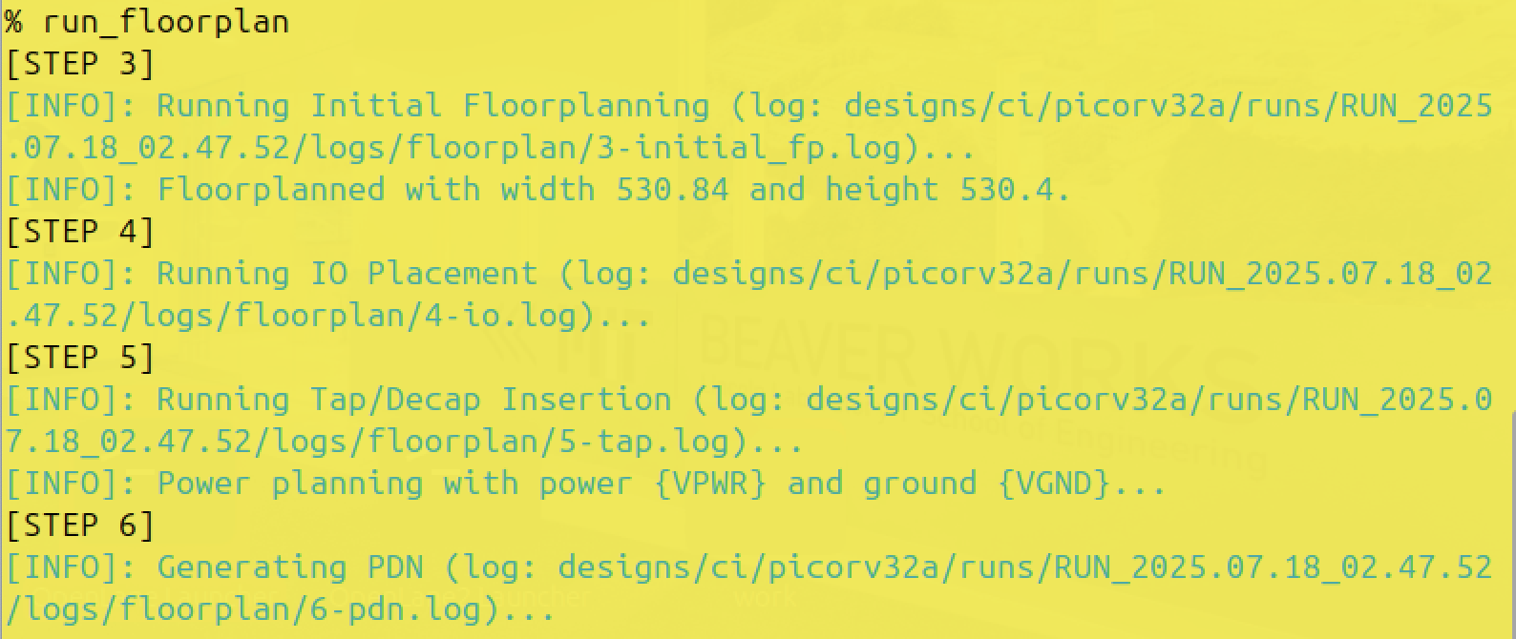

/’To calculate the die area in microns, can open the file under step3 (For the reason, I think it is because the floorplan isn’t totally shown, but the die area information should be shown after running floorplan. Just right, step three says “Running Initial Floorplanning”, I consider it as, “if you run this file, you can see what should be here while running floorplanning”)

‘/

cat designs/ci/picorv32a/runs/RUN_2025.07.18_02.47.52/logs/floorplan/3-initial_fp.log

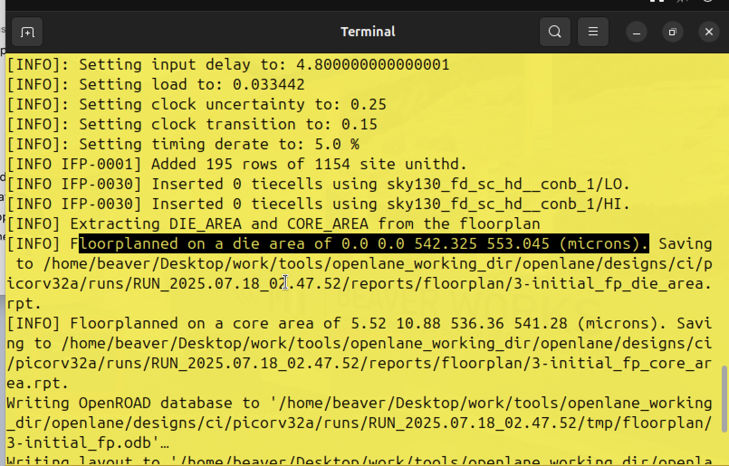

/’ You can find this after doing the command.

die width = 542.325, die height = 553.045

die area = 543.325 * 553.045 = 300483.175

‘/

//Now, load the floorplan def in magic

/’ First, make sure you goes to the right directory: /home/beaver/Desktop/work/tools/openlane_working_dir/openlane/designs/ci/picorv32a/runs/RUN xxx_xx/results/floorplan

‘/

//If not sure which directory you are currently in, do ‘pwd’ to see your location

//when in ‘runs’, you can ‘ls’ to see all the RUN, and I always use the most recent one

//Time to load floorplan def!

magic -T /home/beaver/Desktop/work/tools/openlane_working_dir/pdks/sky130A//libs.tech/magic/sky130A.tech lef read ../../tmp/merged.nom.lef def read picorv32.def &

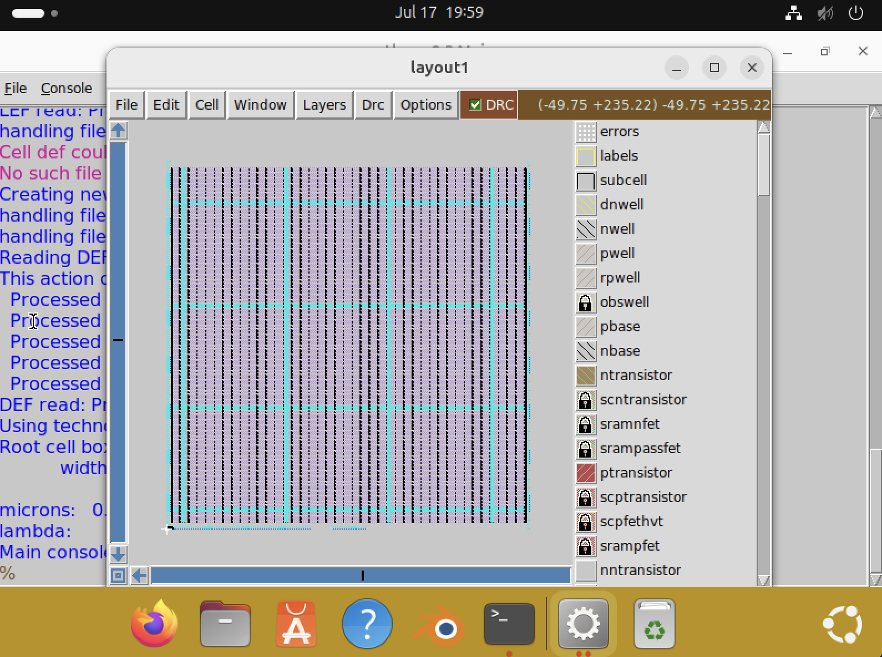

If the image isn’t in the center, hover mouse above the image, press ‘s’ to select the entire thing, and press ‘v’ to centralize it

To select a part: Hover your mouse above the part and press ‘s’

To zoom in: press ‘z’

To get information of a certain part: Select ( Hover your mouse above the part and press ‘s’ ), type ‘what’ in the **window**

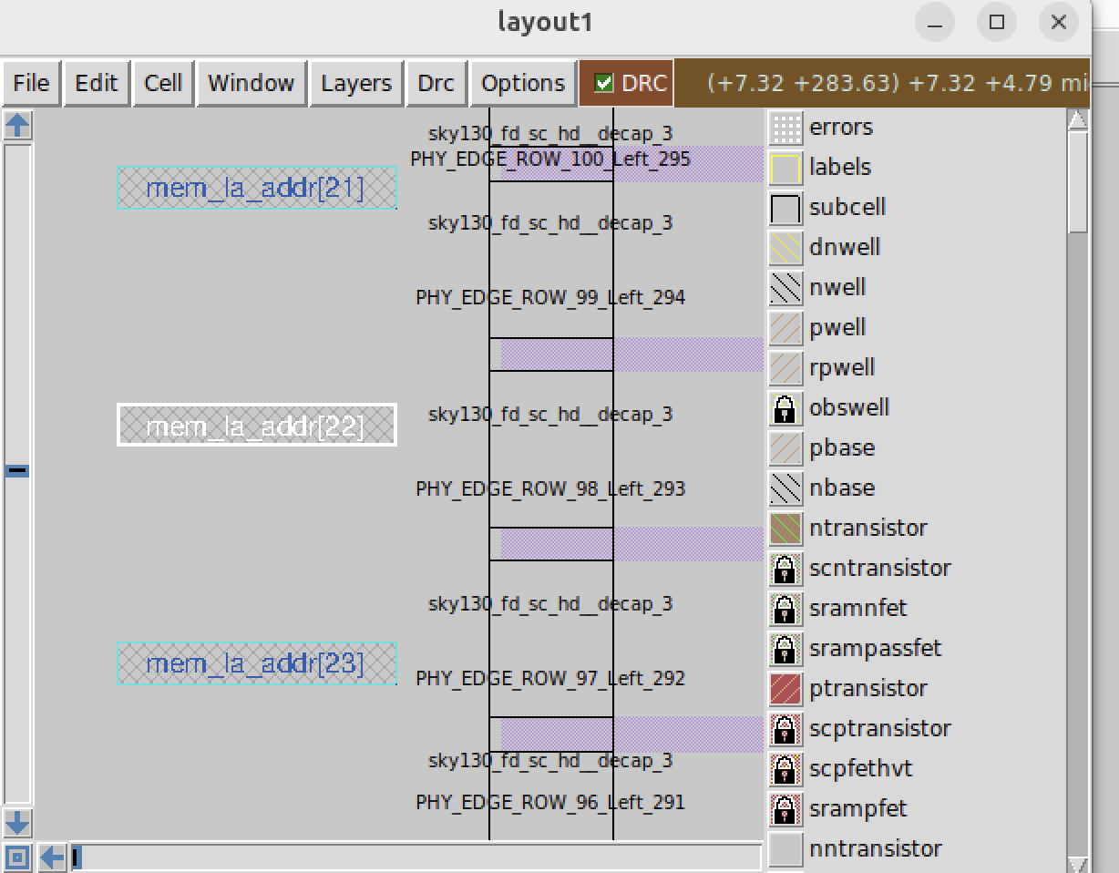

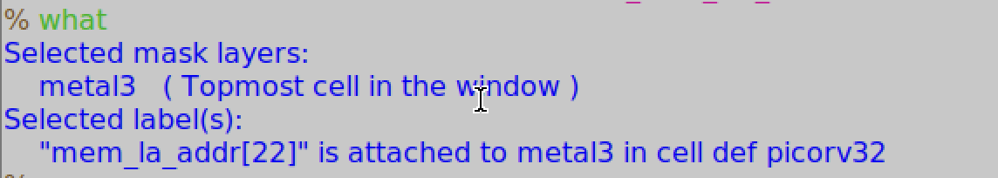

***Placement***

//Should be ran after run_floorplan

run_placement

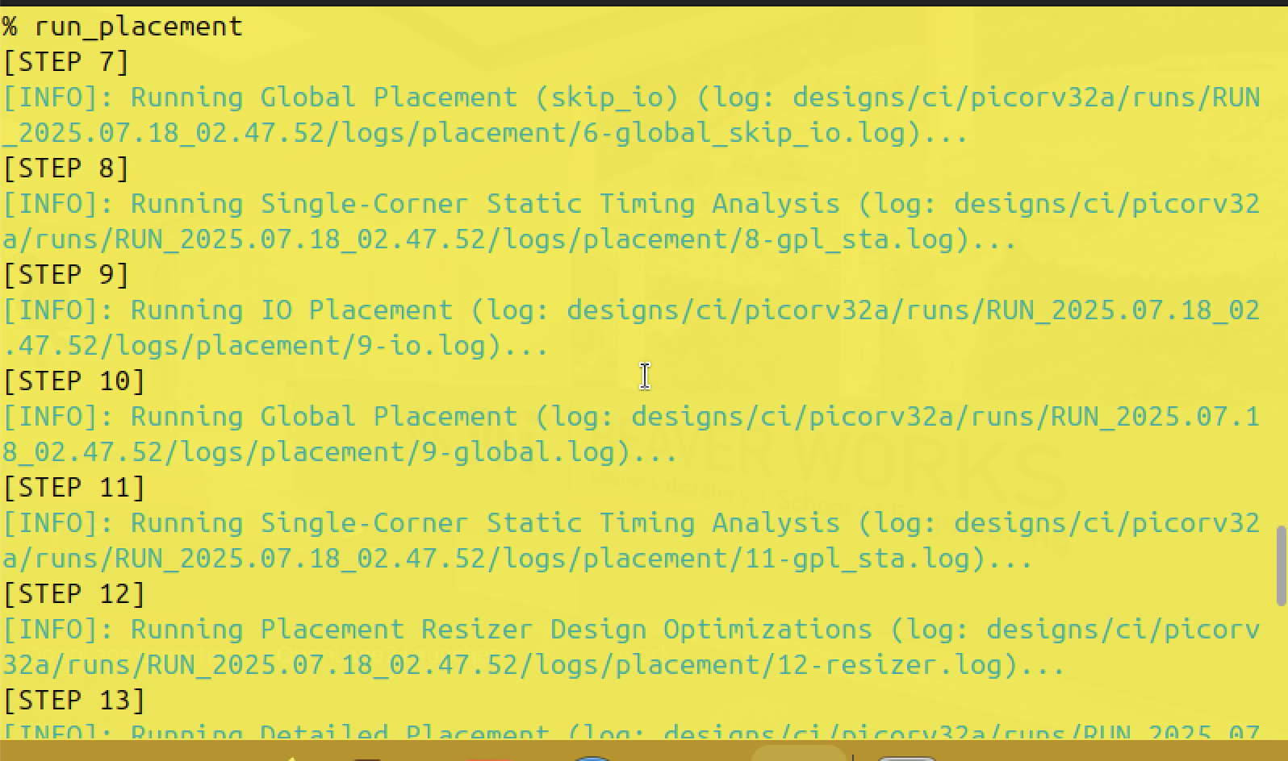

//To load placement def in magic

magic -T ../pdks/sky130A/libs.tech/magic/sky130A.tech lef read designs/ci/picorv32a/runs/RUN_2025.07.17_18.18.01/tmp/merged.nom.lef def read designs/ci/picorv32a/runs/RUN_2025.07.17_18.18.01/results/placement/picorv32.def &

// !!!Should go to the right directory before running the command: /home/beaver/Desktop/work/tools/openlane_working_dir/openlane

