***IO Place Revision***

./flow.tcl -interactive

set ::env(FP_IO_MODE) 2 // change the IOs to equidistant in mode 2

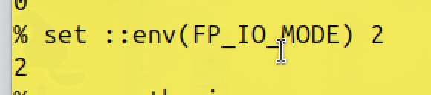

Then, run floorplan and load it in magic (as mentioned in section2)

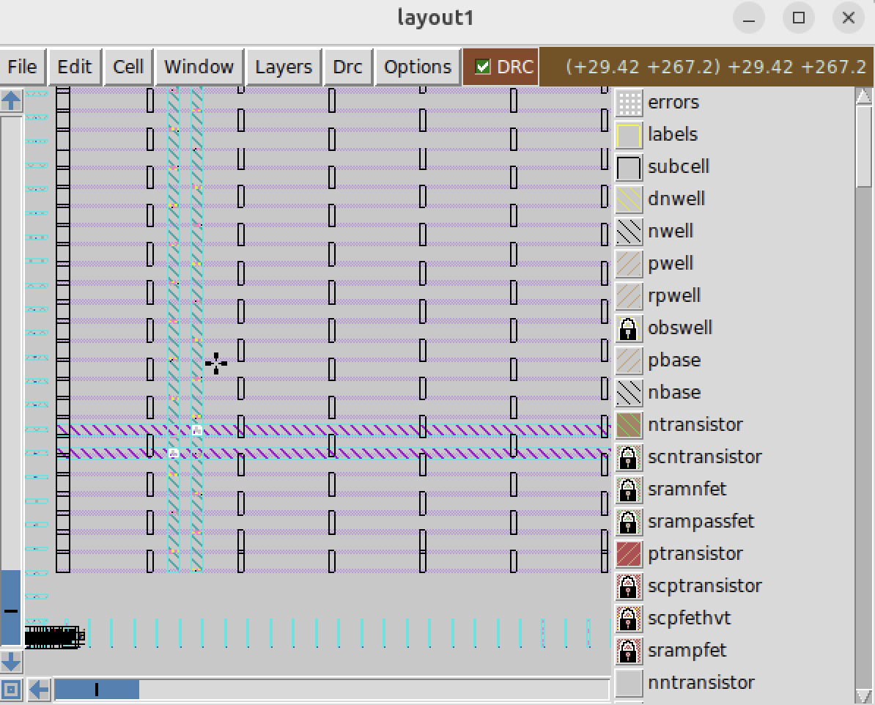

***Clone custom inverter standard cell design***

//make sure is now in the right directory ‘openlane’

git clone <https://github.com/nickson-jose/vsdstdcelldesign> // clone the design from github repository

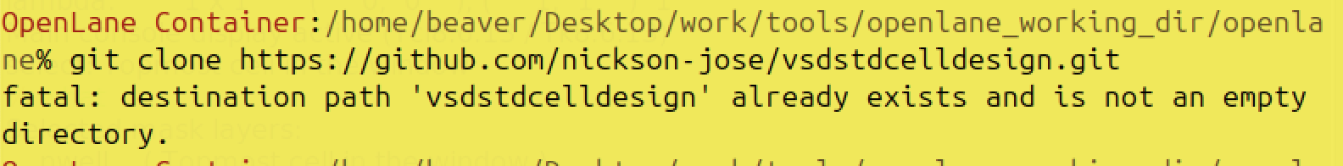

//find out that it already exist

//Go to the right directory

cd vsdstdcelldesign

//copy

cp /home/beaver/Desktop/work/tools/openlane_working_dir/pdks/sky130A/libs.tech/magic/sky130A.tech

//check if everything exist

ls

//load the custom inverter in magic

Magic -T sky130A.tech sky130_inv.mag

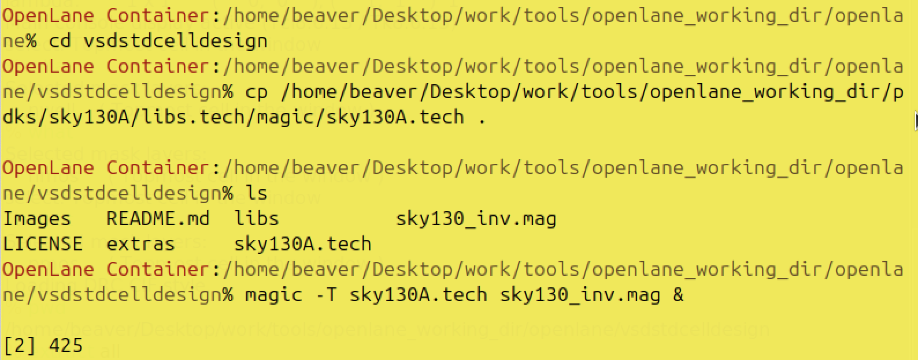

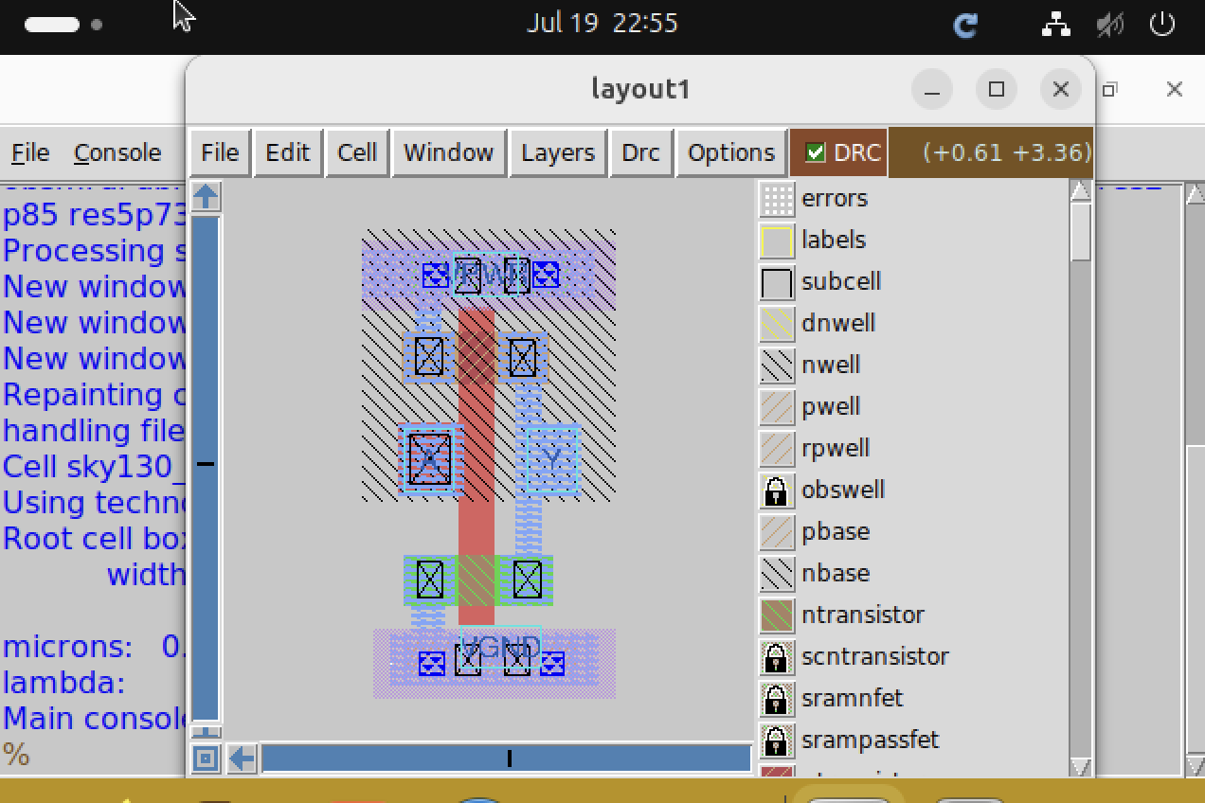

Press ‘s’ the second time to see which part the selected part is connected to

As mentioned in section2, use what to identify pmos and nmos

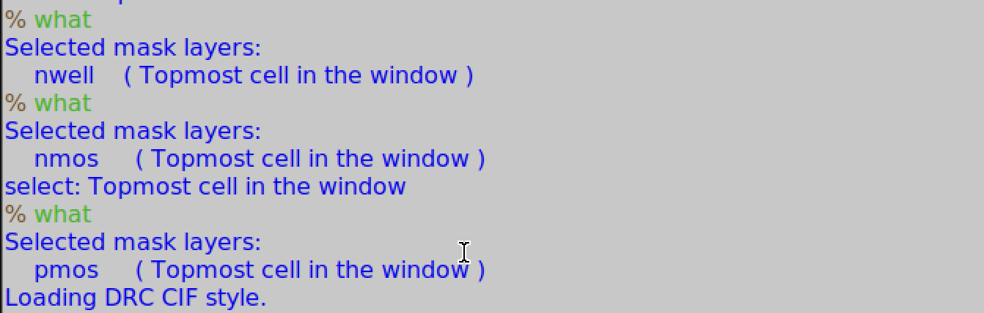

***Spice extraction of inverter in magic***

pwd

extract all //extraction command to extract to .ext format

ext2spice cthresh 0 rthresh0 // extracts the parasitic information

ext2spice // converting ext to spice

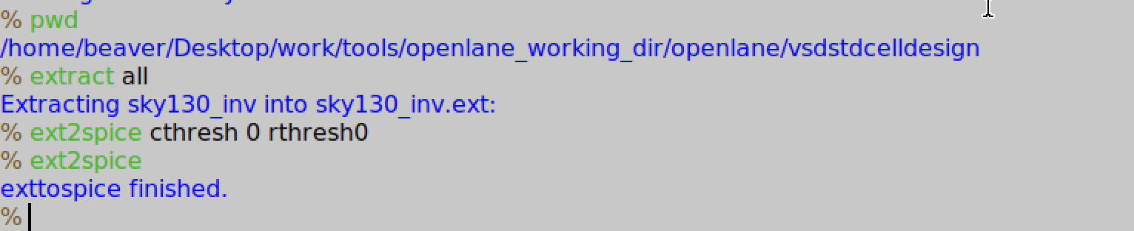

//check if the sky130_inv.spice now exist

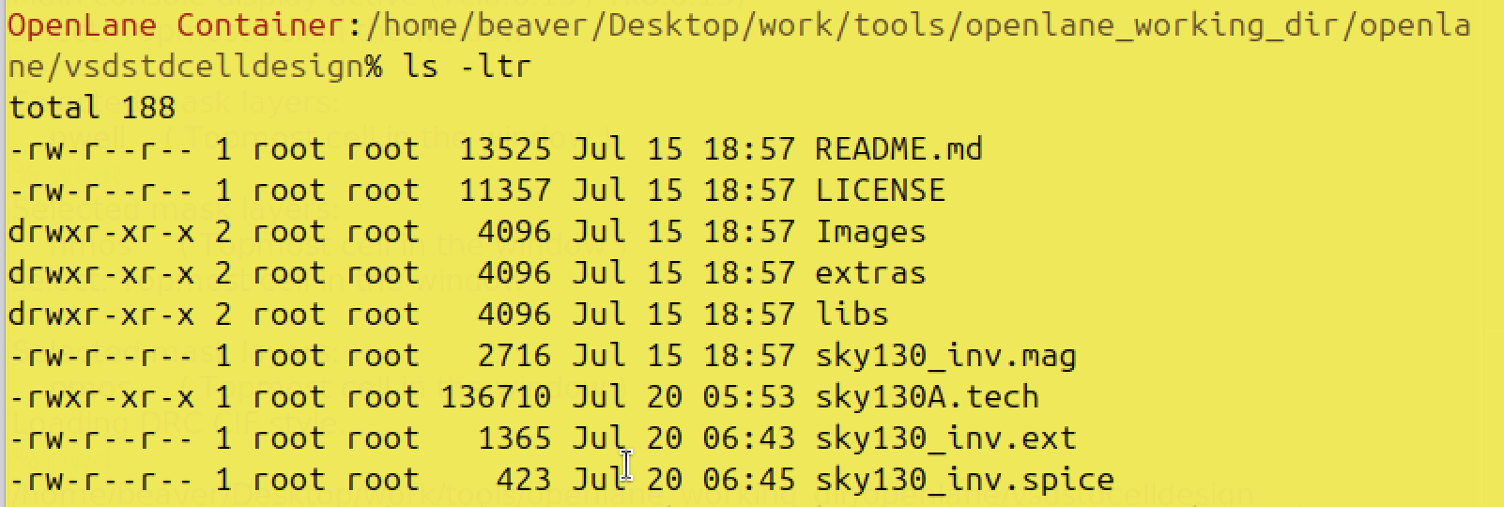

/’can’t directly use vim to edit sky130_inv.spice, copy it to a new file

cp sky130_inv.spice temp.spice

//open the file

sudo vim temp.spice

/’go to the very bottom, press ‘i’ to edit it

When finish, press ‘esc’ to exit writing mode

Then, press ‘:wq’ to save and exit

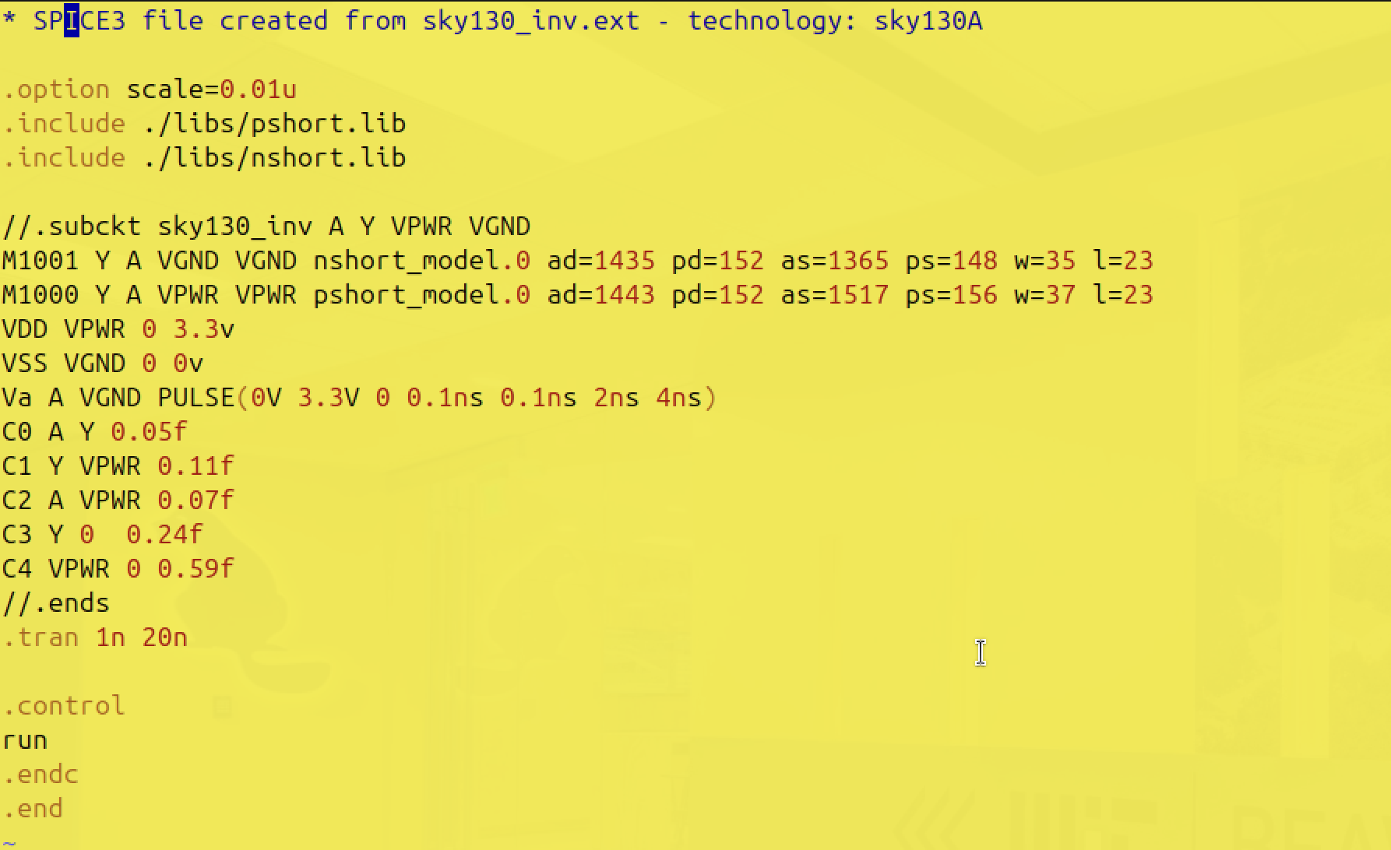

//edit all the information and make it finally shows like this

//generate the graph

ngspice temp.spice

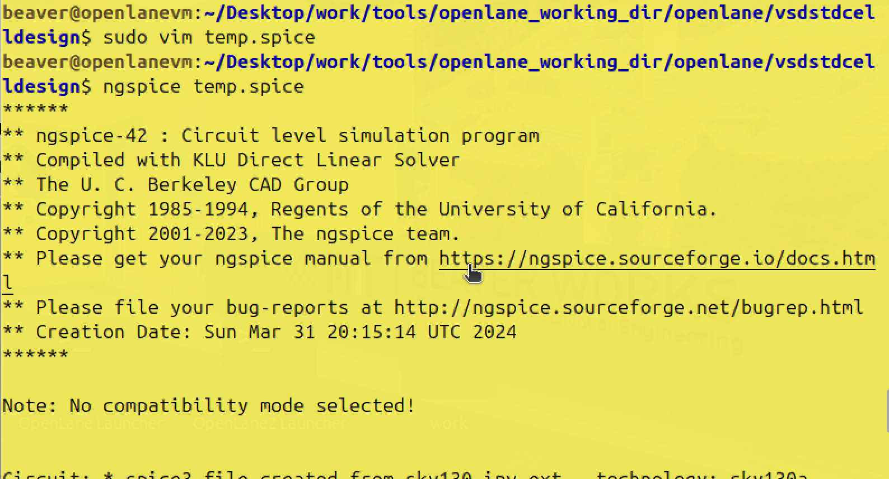

//At the end, to get the plot:

Plot y vs time a

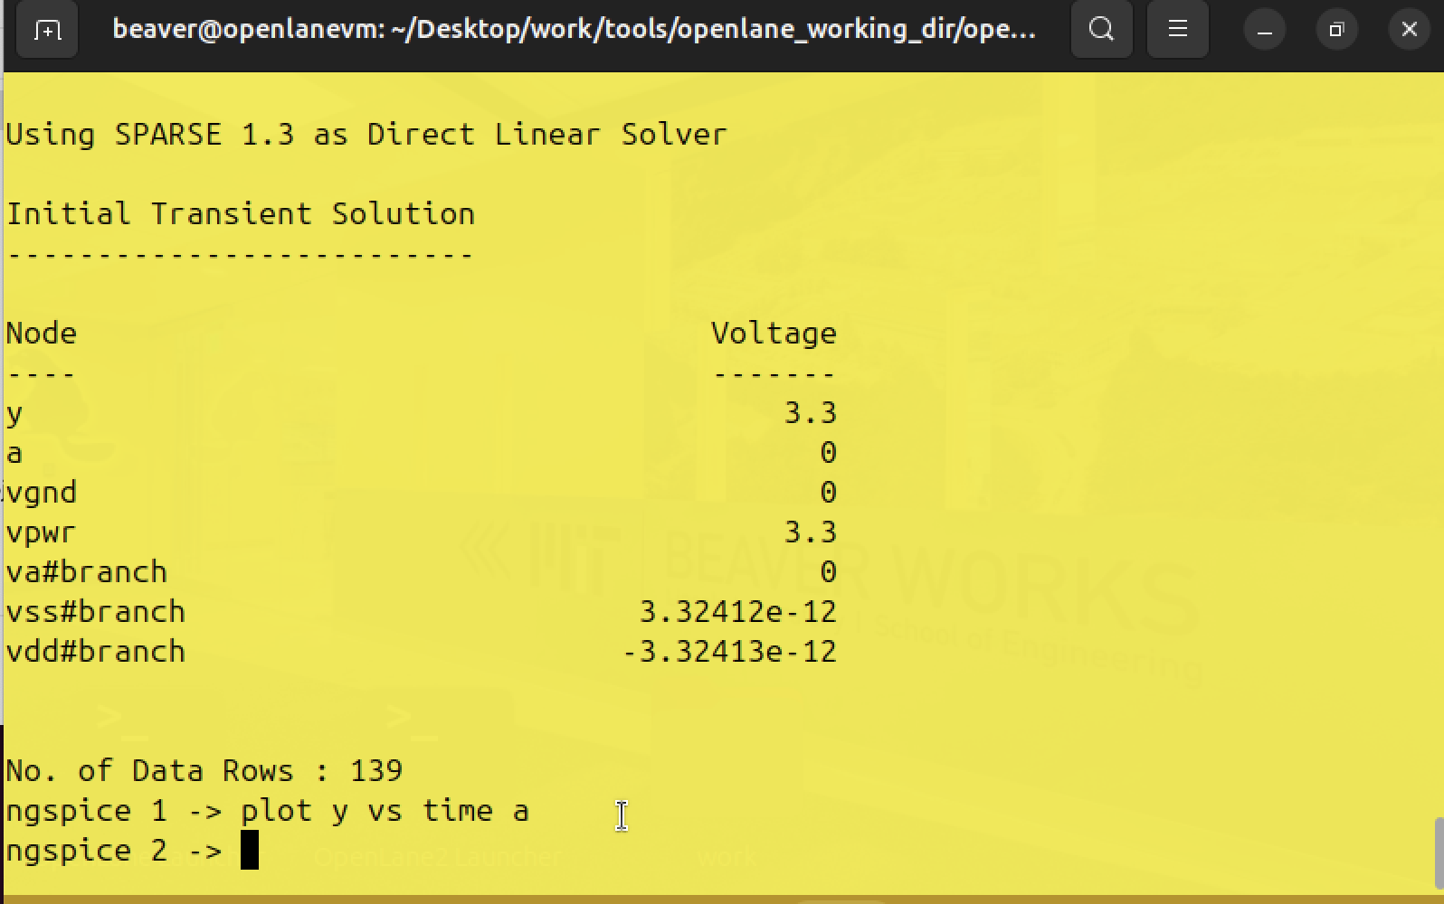

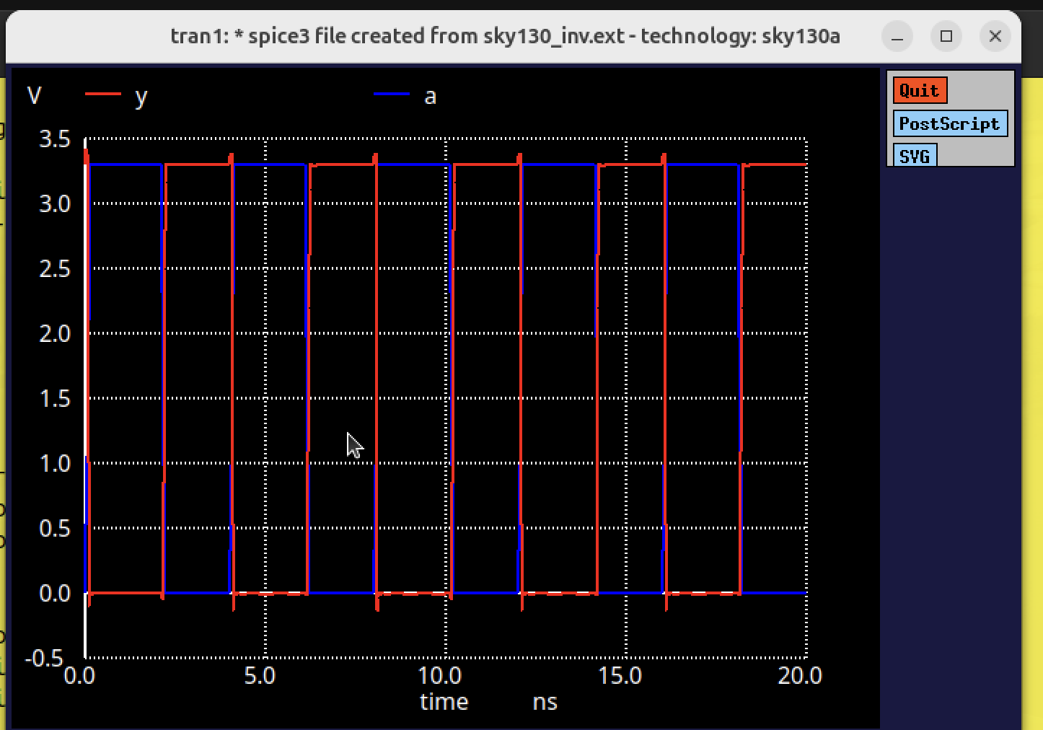

Rise transition time = Time taken for output to rise to 80% - Time taken for output to rise to 20%

(value of 80% is 0.8*3.3 = 2.64)

(value of 20% is 0.2*3.3 = 0.66)

= 4.04167ns - 4ns = 0.04167ns

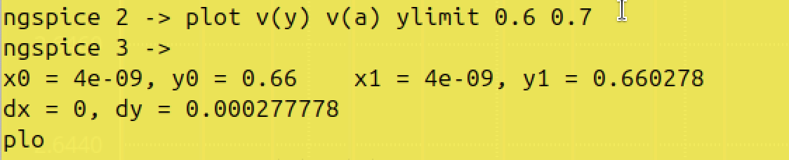

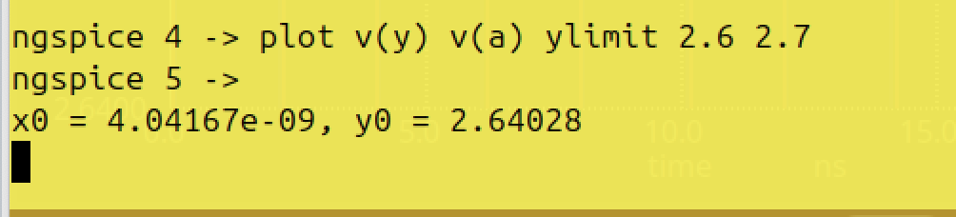

Rise cell delay = time taken for output to rise to 50% - time taken for input to fall to 50%

(50% is 0.5*3.3 = 1.65)

=4.05424 - 4.04989 = 0.00435

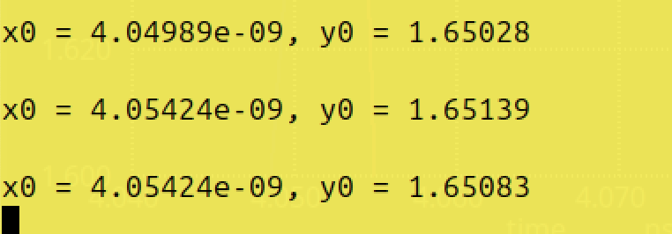

#### ***Find problem in the DRC section of the old magic tech file for the skywater process and fix them***

// Change to home directory

cd

//download

wget <http://opencircuitdesign.com/open_pdks/archive/drc_tests.tgz>

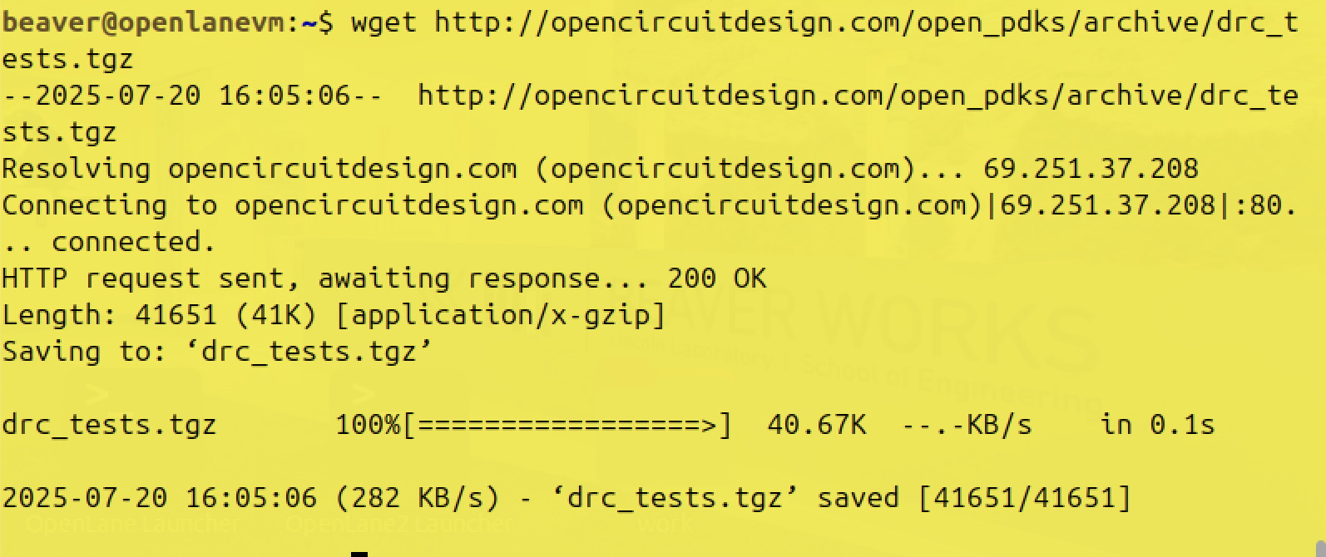

tar xfz drc_tests.tgz //extract the files

cd drc_tests

ls -al

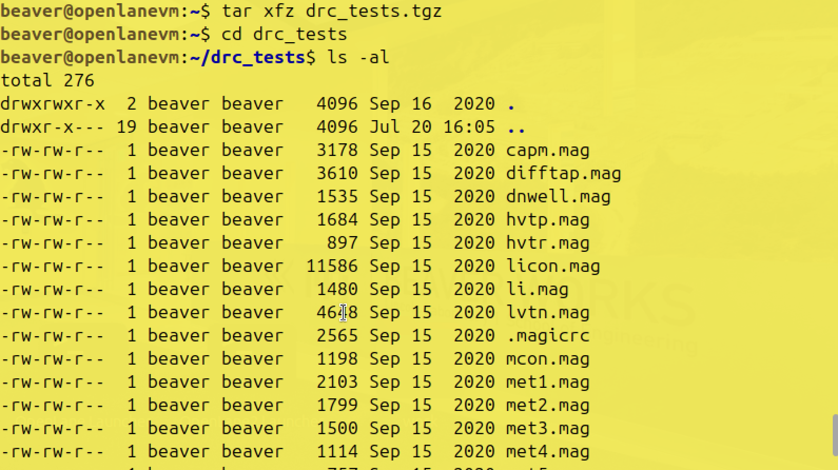

vi .magicrc //doesn’t have gvim, used vi to view the file

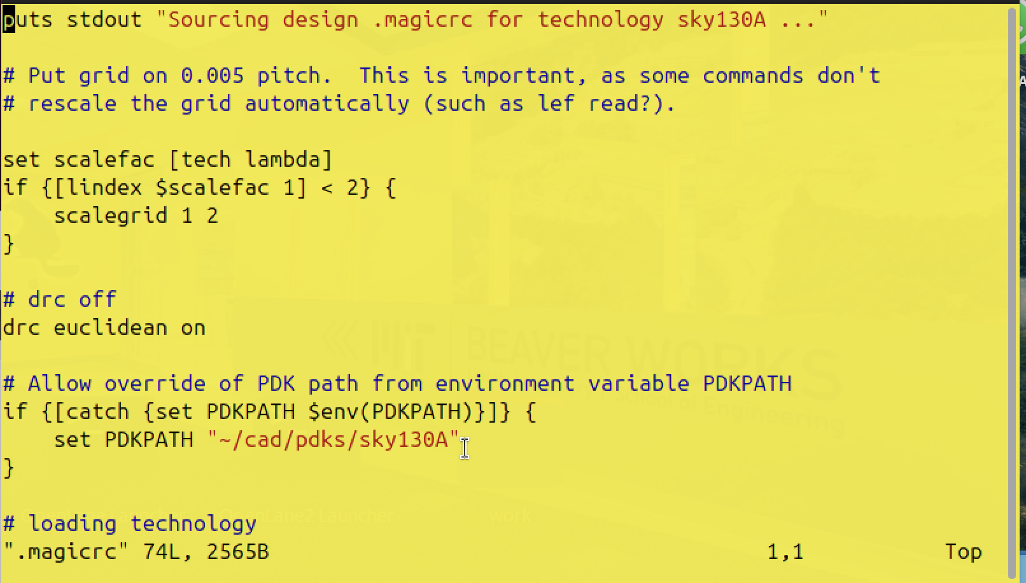

magic -d XR &



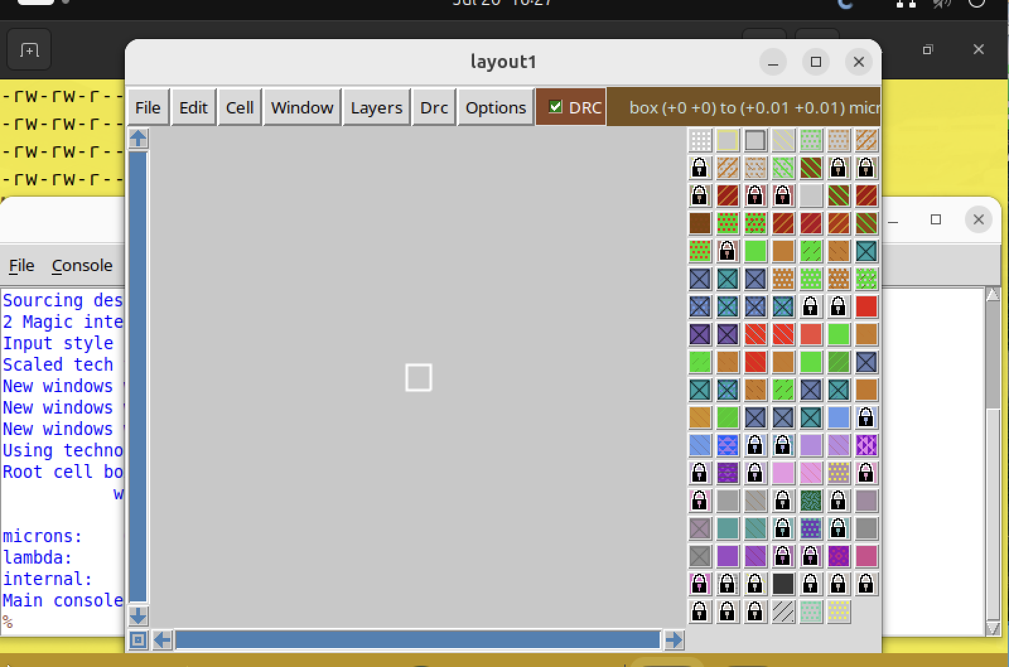

***Poly***

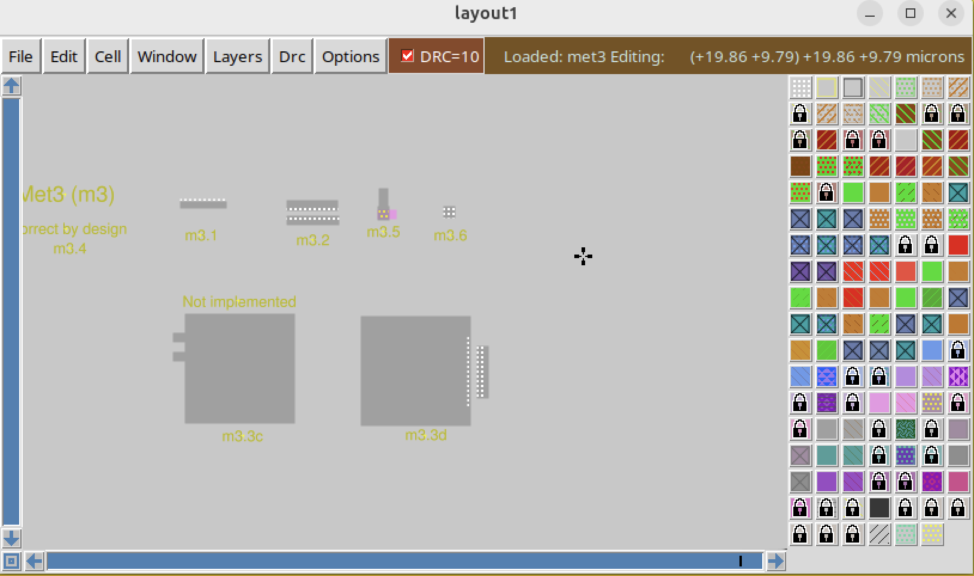

Load poly//load the poly layout

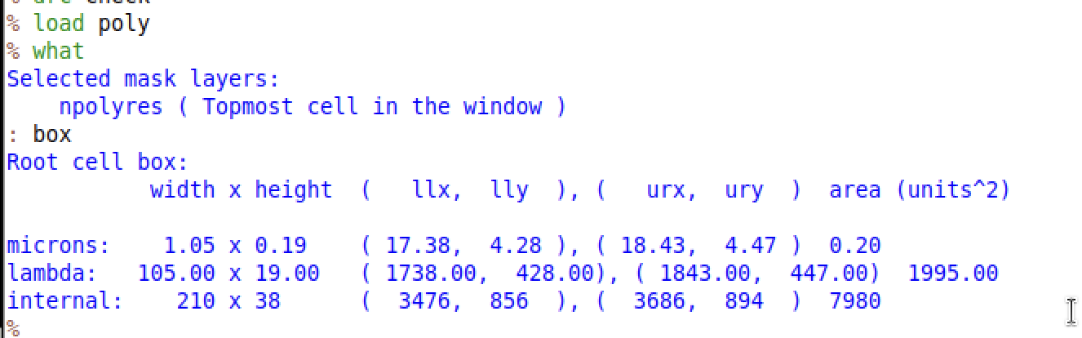

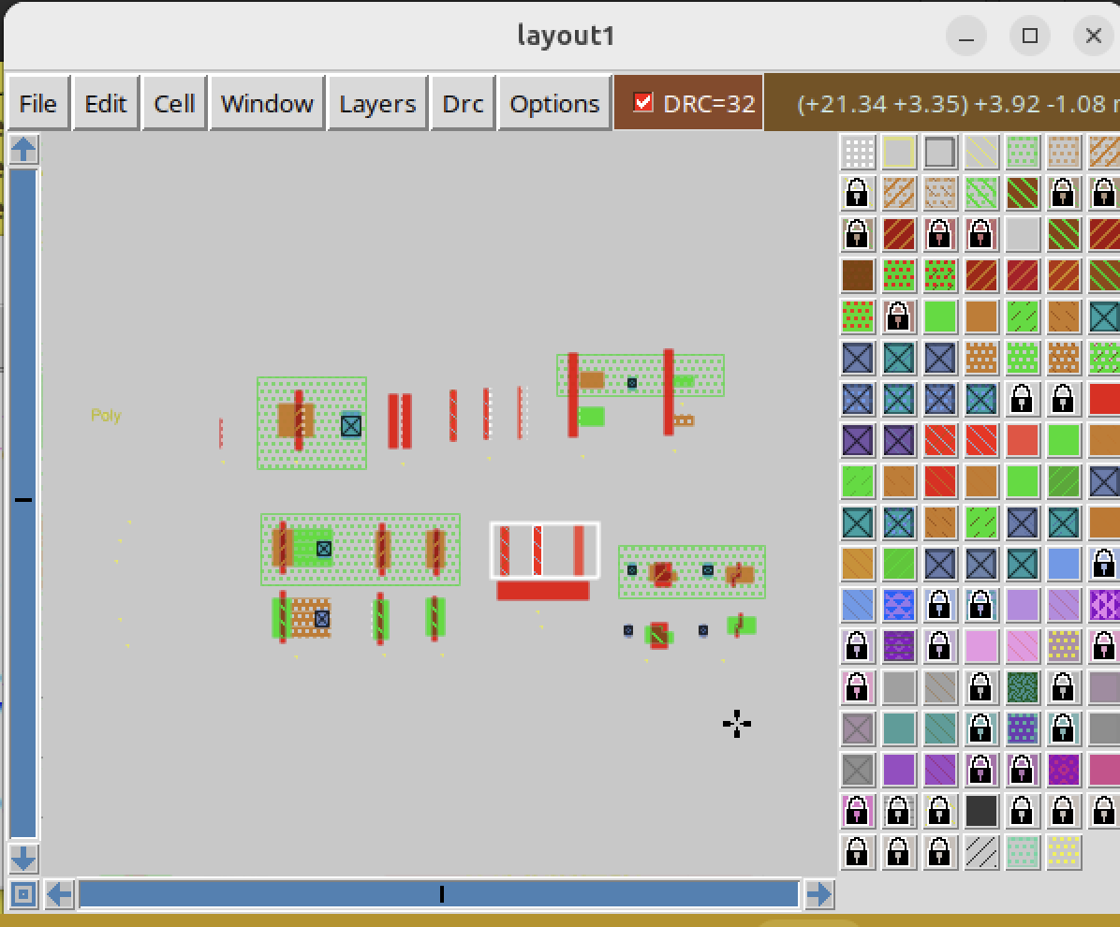

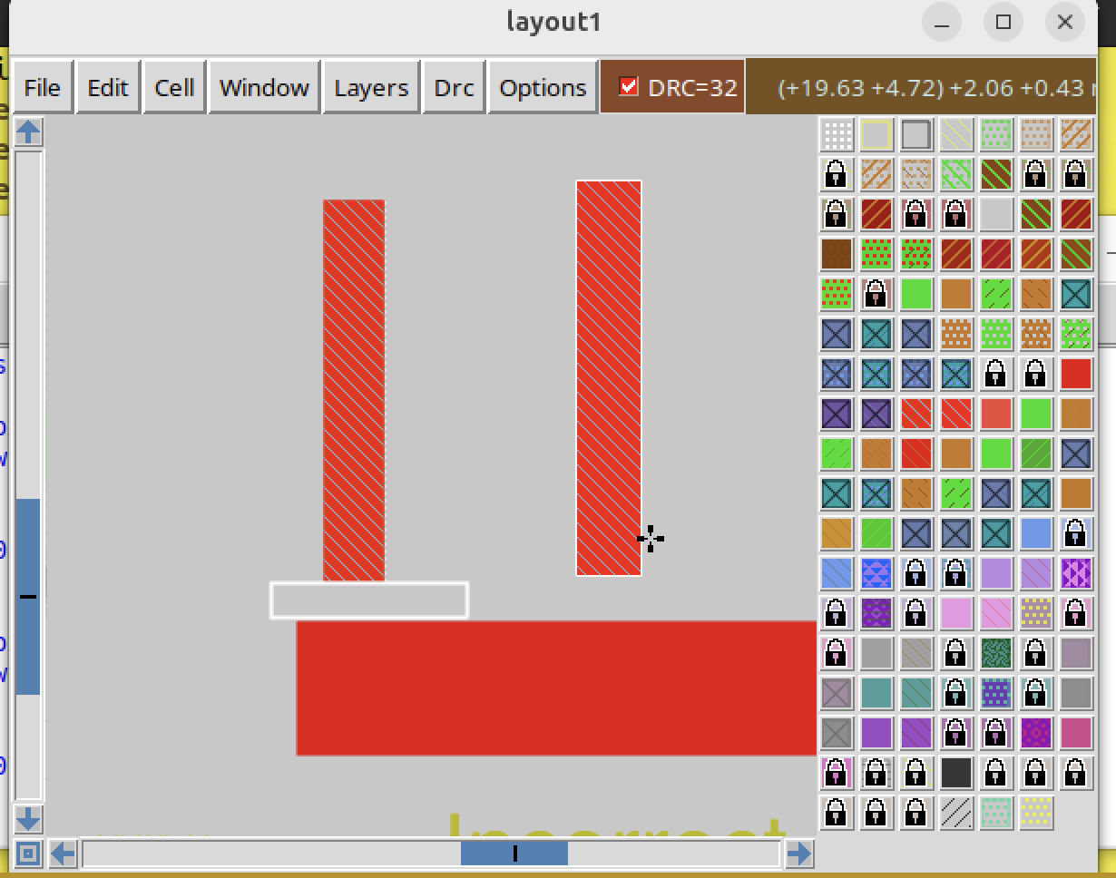

Edit the file to correct it



Press ‘/poly’ to find our target

Press ‘i’ to edit the file

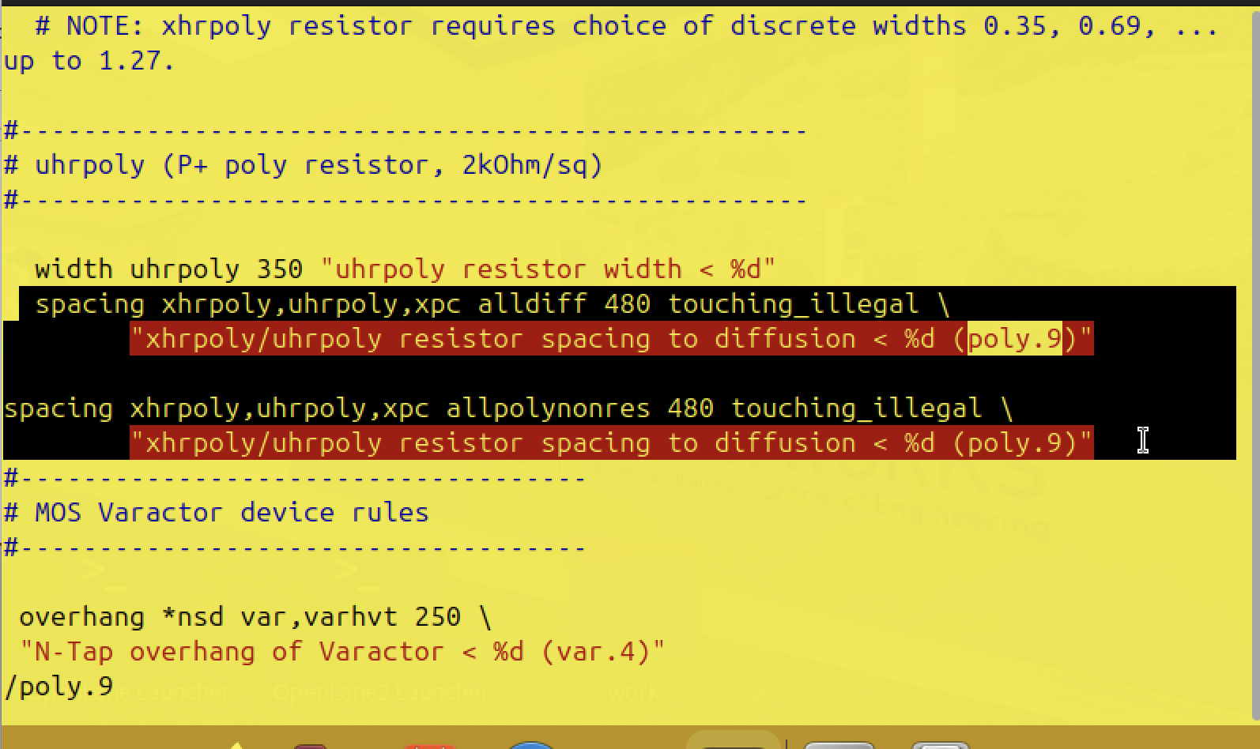

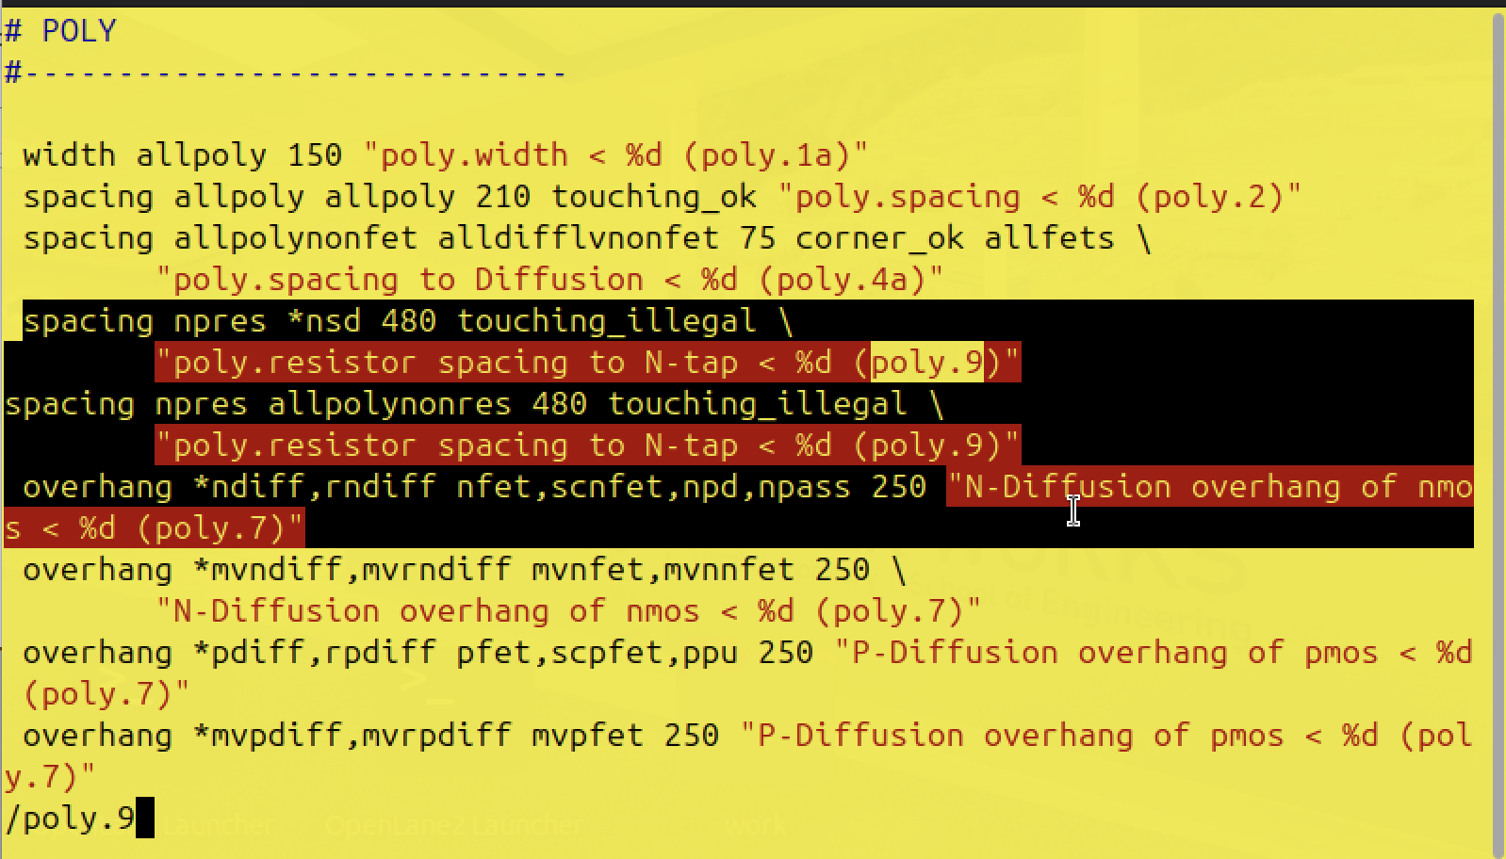

After editing, go back to tkcon, run the command and see the changes

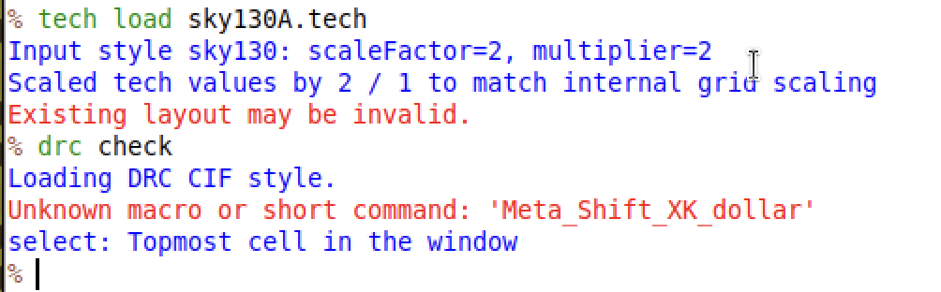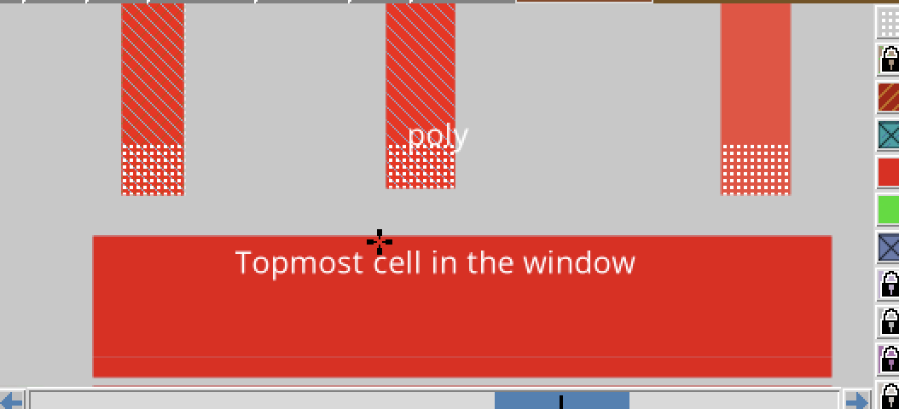

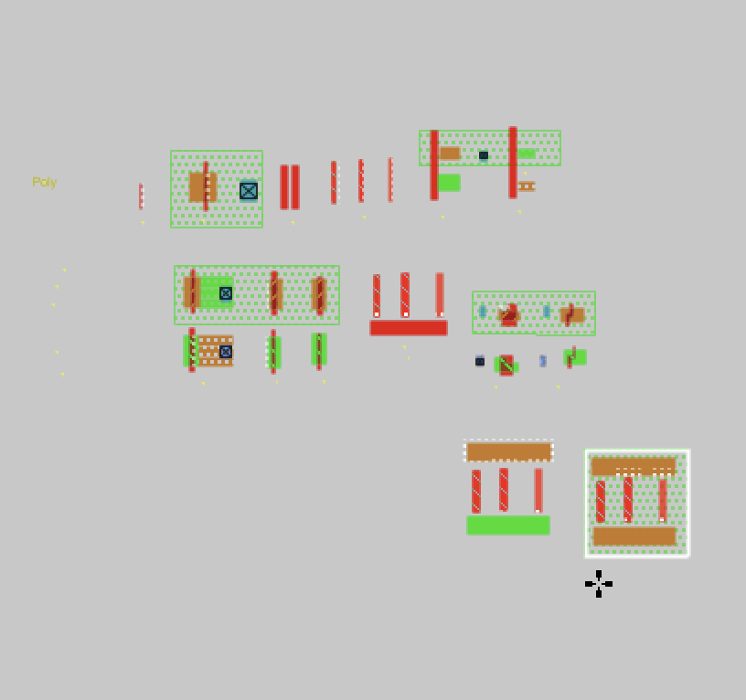

***Difftap***

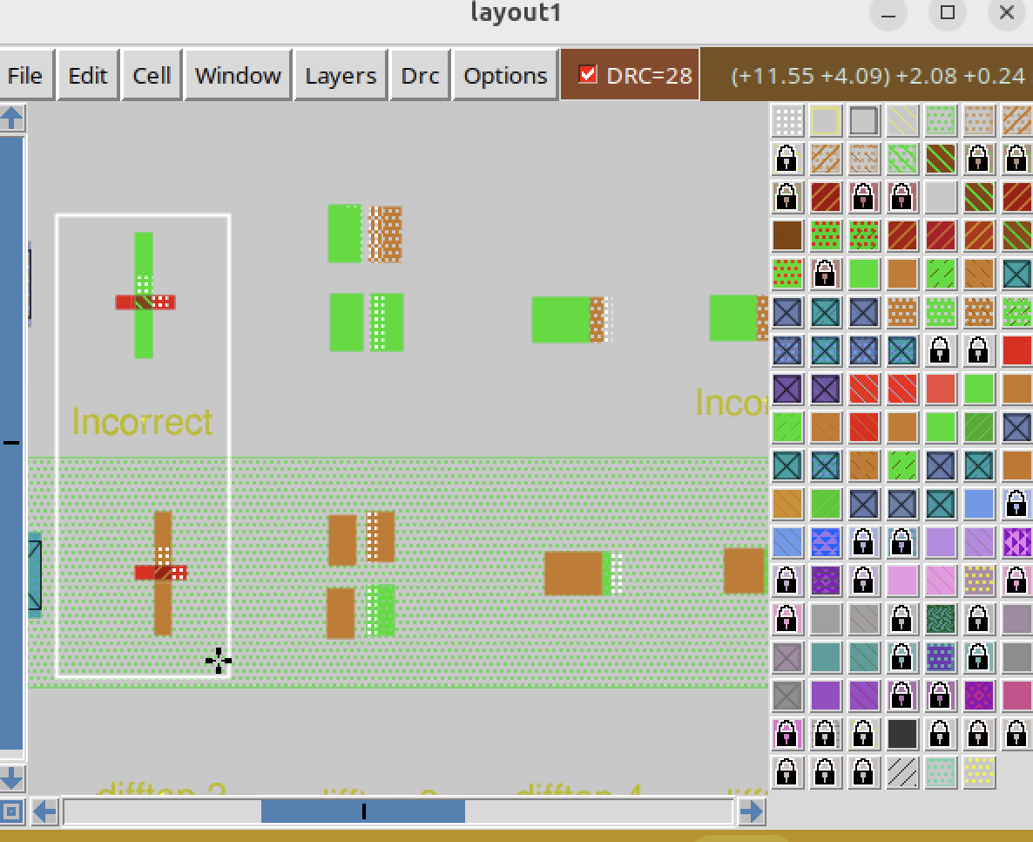

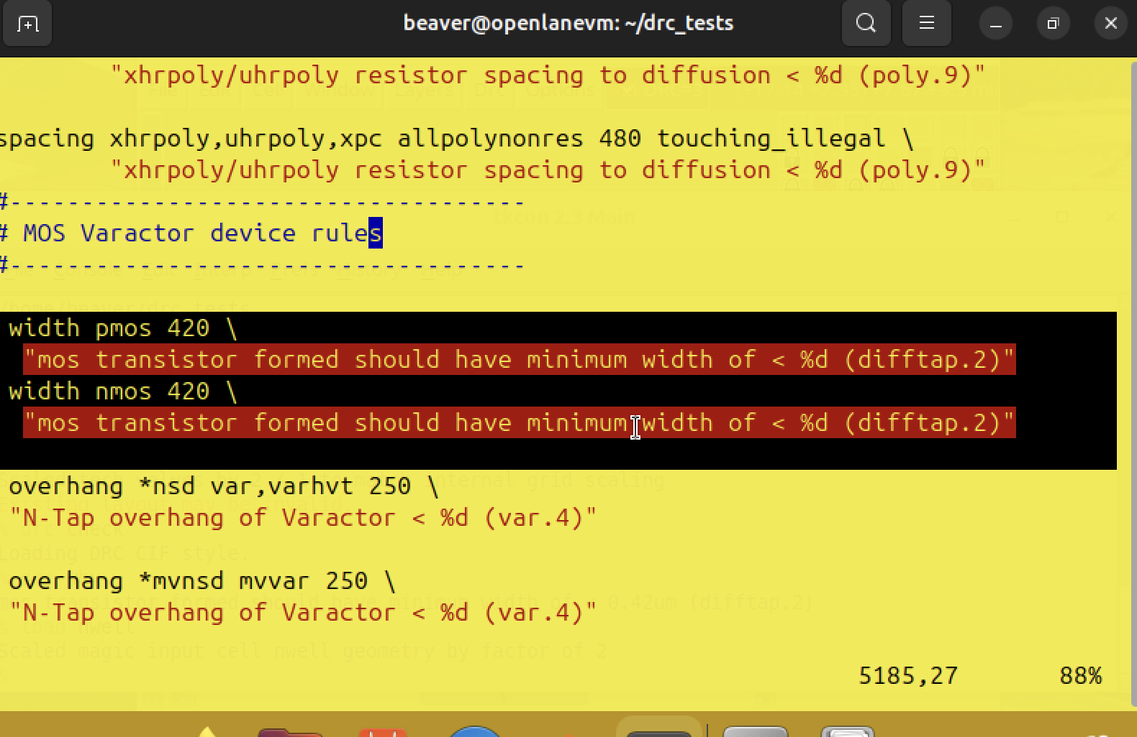

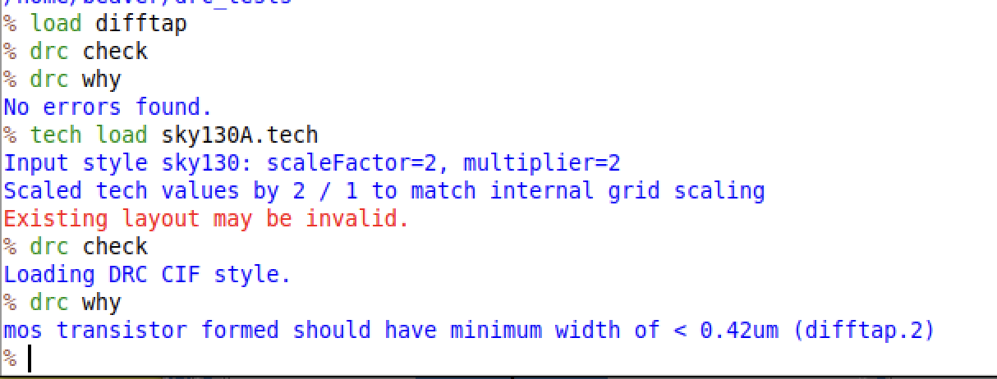

***nwell***

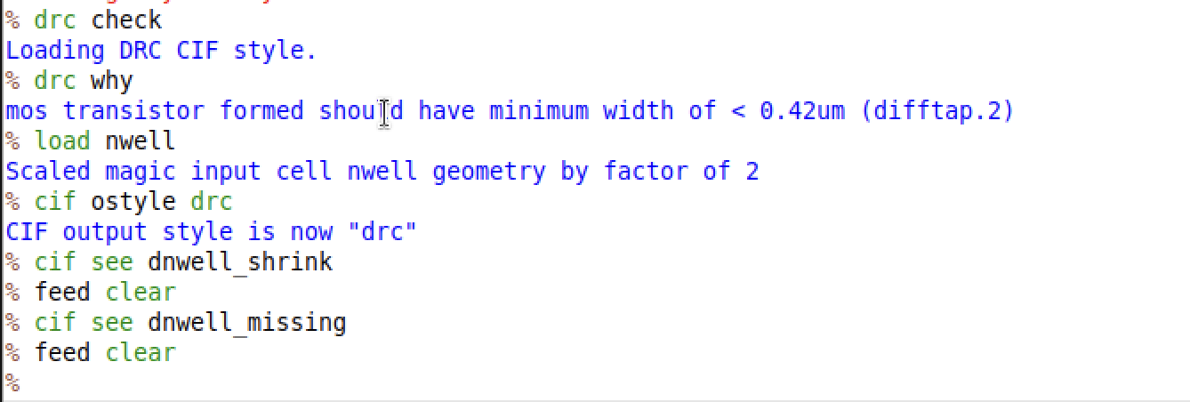

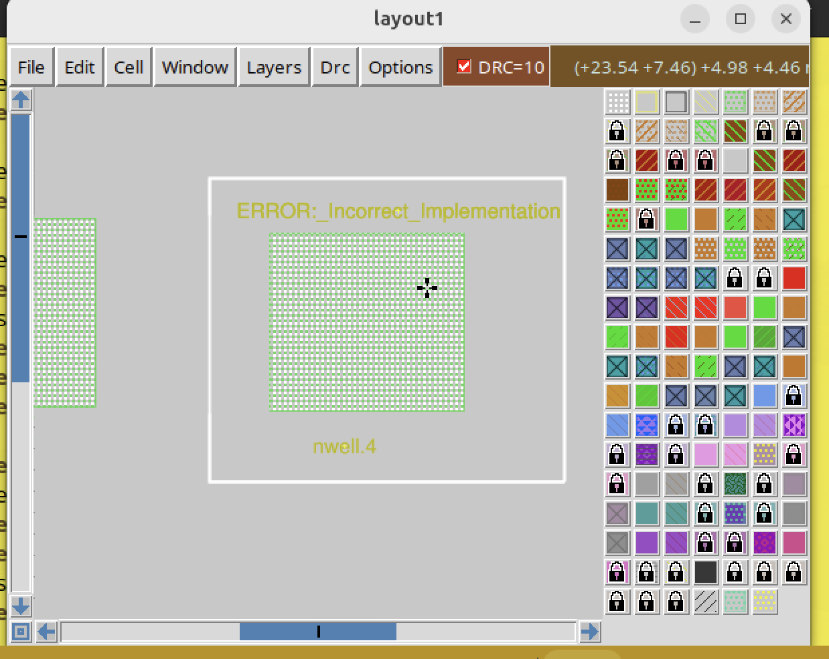

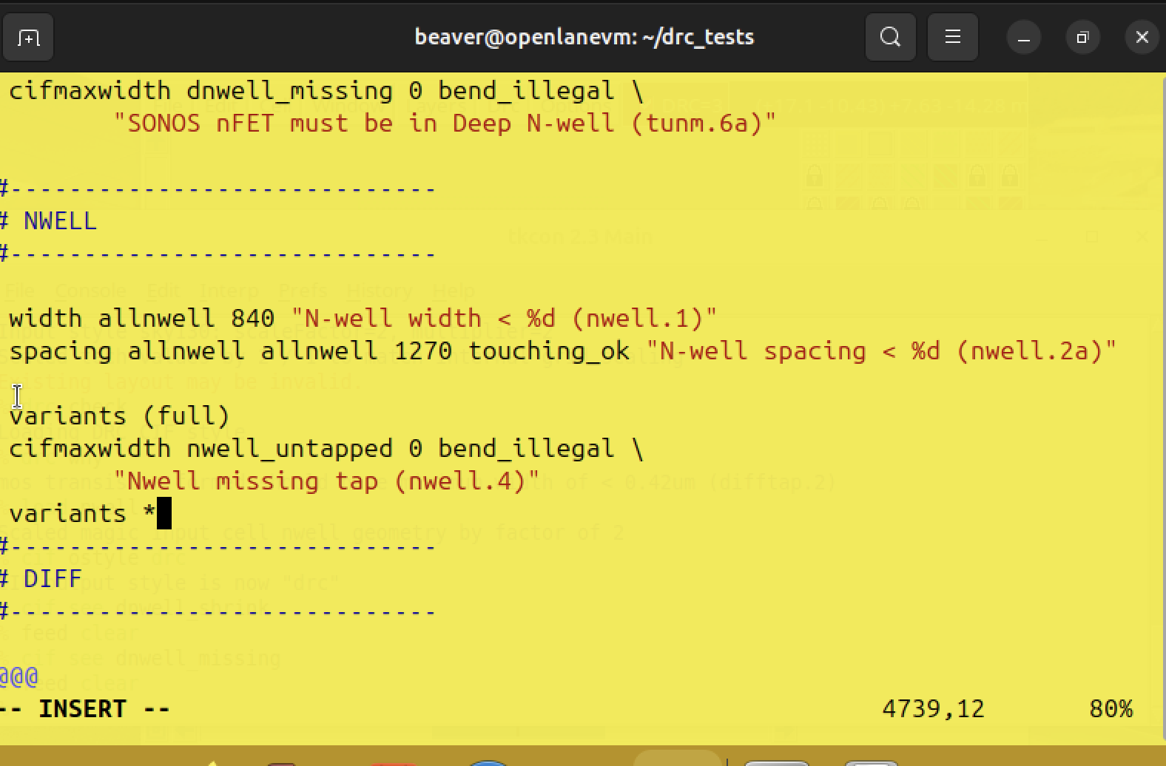

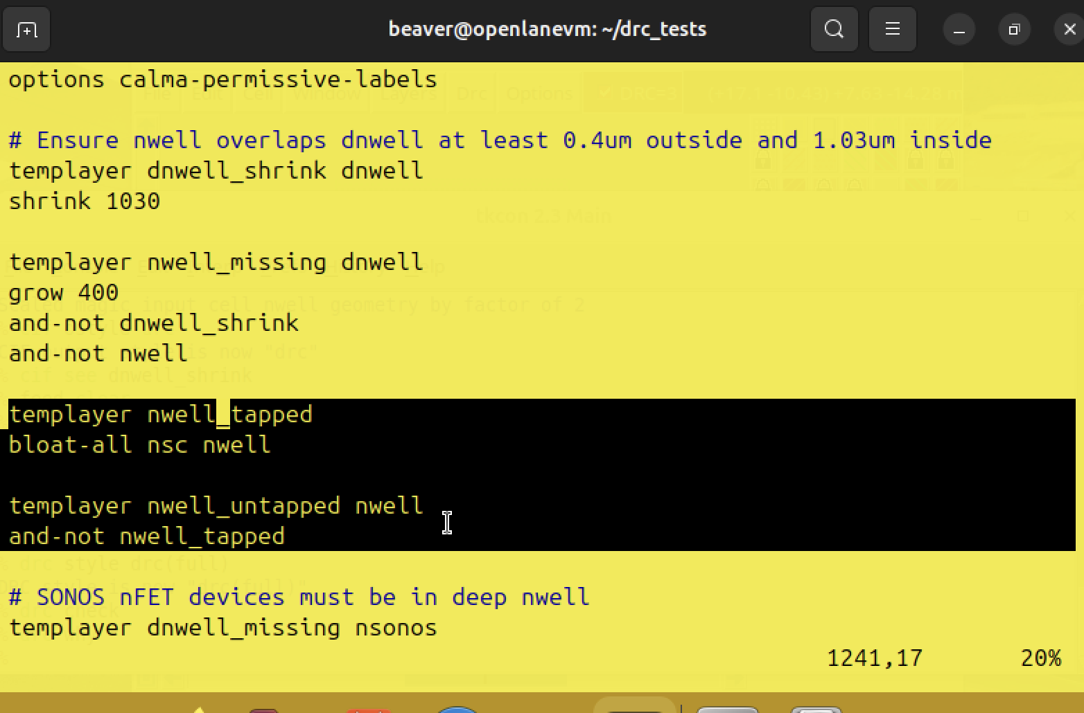

//have to select the nwell.4 before checking

