Assignment: Python Requirements Intake → Spreadsheet
This section describes the full technical assignment requirements, learning outcomes, deliverables, grading rubric, and starter guidance.

Team Role Assignments and Responsibilities
This section assigns responsibilities for the assignment to four team roles to support collaboration and accountability.

Environment Setup and Required Python Modules
This section explains how to install and configure all required Python modules so that the application file (app.py) runs correctly. Students must complete these steps before running the project.

1. Verify Python Installation
Ensure Python 3.9 or newer is installed on your system:
python3 --version

2. Create and Activate a Virtual Environment (Recommended)
Using a virtual environment prevents dependency conflicts and is considered best practice.
Create the environment:
python3 -m venv venv
Activate the environment:
Linux / macOS:
source venv/bin/activate
Windows (PowerShell):
.\venv\Scripts\Activate.ps1

3. Install Required Python Modules
The following Python modules are required for app.py:
- flask (web framework)
- sqlite3 (included with Python standard library)
- datetime (included with Python standard library)
Install Flask using pip:
pip install flask

4. Optional: Install from requirements.txt
If a requirements.txt file is provided, install all dependencies at once:
pip install -r requirements.txt

5. Verify Installation
You can verify Flask is installed by running:
python -c "import flask; print(flask.__version__)"

6. Run the Application
Once dependencies are installed, start the application:
python app.py
Then open your browser and navigate to:
http://127.0.0.1:5000/

7. Troubleshooting
- If 'flask not found', ensure the virtual environment is activated.
- If port 5000 is in use, stop other services or change the port in app.py.
- If database errors occur, ensure the application has write permissions.
Section added on: January 27, 2026

OS-Specific Setup Screenshots (Guided)
The following sections indicate where students should reference or capture screenshots for their specific operating system. Instructors may replace these placeholders with actual screenshots or provide them separately in the LMS.

Windows (PowerShell)
- Verify Python installation: python --version
- Create virtual environment: python -m venv venv
- Activate environment: .\venv\Scripts\Activate.ps1
- Install Flask: pip install flask
- Run application: python app.py
- Open browser: http://127.0.0.1:5000/
📸 Screenshot Placeholder (Insert image here)

macOS (Terminal)
- Verify Python installation: python3 --version
- Create virtual environment: python3 -m venv venv
- Activate environment: source venv/bin/activate
- Install Flask: pip install flask
- Run application: python app.py
- Open browser: http://127.0.0.1:5000/
📸 Screenshot Placeholder (Insert image here)

Linux (Terminal)
- Verify Python installation: python3 --version
- Create virtual environment: python3 -m venv venv
- Activate environment: source venv/bin/activate
- Install Flask: pip install flask
- Run application: python app.py
- Open browser: http://127.0.0.1:5000/
📸 Screenshot Placeholder (Insert image here)

Note to students: Include screenshots of each step above for your operating system as part of your submission.
Added on: January 27, 2026

Windows (PowerShell)
Example setup screenshot (illustrative):
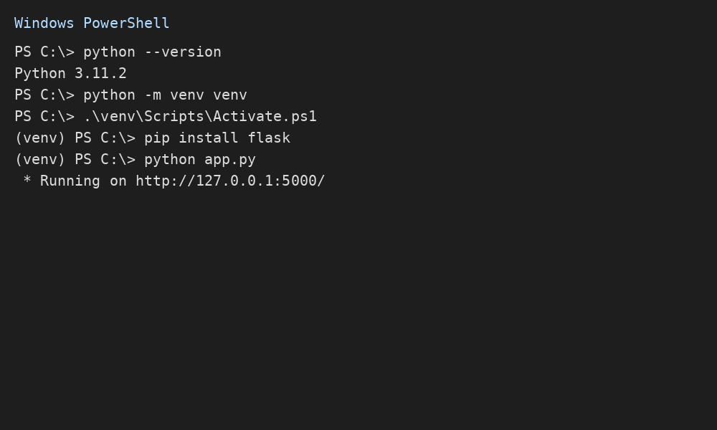

macOS (Terminal)
Example setup screenshot (illustrative):
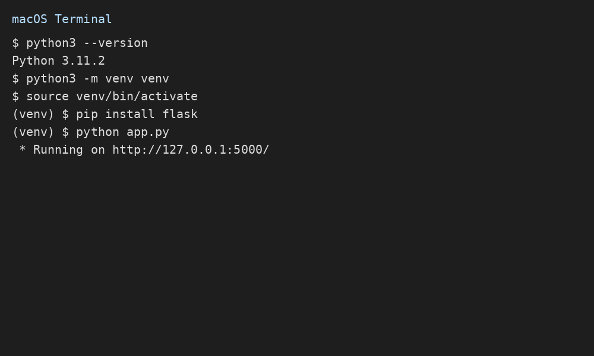

Linux (Terminal)
Example setup screenshot (illustrative):
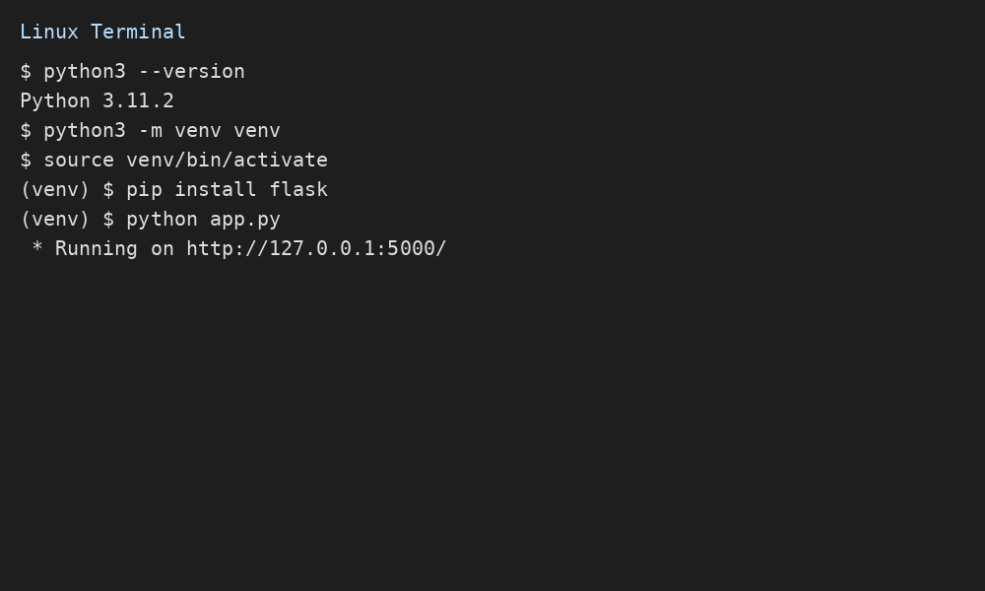
Assignment: Online Requirements Intake Form → Python Storage → Spreadsheet View
HTML/CSS Form + POST → Python Persistent Storage (SQLite) → Spreadsheet-Style Display
Date: January 27, 2026

1. Overview
You will build a small web application that collects requirement records through an online HTML/CSS form. Your form will POST the data to a Python back end that stores the data in persistent storage, then displays all saved records in a spreadsheet-style table (web page).

2. Fields to Collect (Required)
- ID (internal record ID or auto-generated)
- Requirements ID (e.g., REQ-001)
- Date (YYYY-MM-DD)
- Requirement Description
- Spearhead (person or role driving the requirement)
- Stakeholder (who needs/requests it)

3. Learning Outcomes
- Create a usable HTML/CSS form for data collection
- Use HTTP POST to send form data to a Python web server
- Implement persistent storage using SQLite (or another instructor-approved option)
- Render stored records in a spreadsheet-like table view
- Apply validation and basic secure coding practices

4. Technical Requirements
Your solution must include the following:
- Front end: an HTML form styled with CSS (clean and readable).
- Back end: Python web server using Flask (recommended) or FastAPI (allowed).
- Persistent storage: SQLite database (recommended).
- POST handling: server must accept form submissions and store records.
- Spreadsheet display: a page that lists all stored records in a table, newest first.
- Validation: client-side and server-side validation for required fields.
- Sanitization: safely handle user input (e.g., escape HTML when rendering).
- Optional extension (extra credit): export the table to CSV or Excel.

5. Deliverables
- Source code folder (zip) including: app.py (or main.py), templates/, static/
- SQLite database schema (SQL or Python migration/initialization code)
- README with setup and run instructions
- Screenshots: (1) form page, (2) spreadsheet/table page, (3) database showing stored rows

6. Grading Rubric (100 points)
Category | Points
Form completeness and field correctness | 15
POST handling and persistent storage works | 25
Spreadsheet-style table display works | 20
Validation (client + server) and error handling | 15
Code quality (organization, comments, readability) | 10
README and screenshots | 15

7. Recommended Implementation Plan (Student Task List)
- Create a new project folder and Python virtual environment.
- Install Flask and dependencies.
- Design the database table schema for requirement records.
- Create a route to display the form page (GET).
- Create a route to accept form POST and insert into SQLite.
- Create a route to display the table/spreadsheet view (GET).
- Add validation: required fields, date format, and ID format (REQ-###).
- Add basic styling with CSS.
- Test with at least 10 sample requirement entries.
- Write README and include screenshots.

8. Starter Template (Barebones Example)
You may use this minimal starter template. You may modify it, but your final solution must meet all requirements above.

8.1 app.py (Flask + SQLite skeleton)
from flask import Flask, render_template, request, redirect, url_for
import sqlite3
from datetime import datetime
app = Flask(__name__)
DB_PATH = "requirements.db"
def init_db():
with sqlite3.connect(DB_PATH) as conn:
conn.execute("""
CREATE TABLE IF NOT EXISTS reqs (
id INTEGER PRIMARY KEY AUTOINCREMENT,
requirements_id TEXT NOT NULL,
date TEXT NOT NULL,
description TEXT NOT NULL,
spearhead TEXT NOT NULL,
stakeholder TEXT NOT NULL,
created_at TEXT NOT NULL
);
""")
@app.before_first_request
def setup():
init_db()
@app.get("/")
def form():
return render_template("form.html")
@app.post("/submit")
def submit():
requirements_id = (request.form.get("requirements_id") or "").strip()
date = (request.form.get("date") or "").strip()
description = (request.form.get("description") or "").strip()
spearhead = (request.form.get("spearhead") or "").strip()
stakeholder = (request.form.get("stakeholder") or "").strip()
# Basic server-side validation
if not all([requirements_id, date, description, spearhead, stakeholder]):
return "Missing required field(s).", 400
created_at = datetime.utcnow().isoformat()
with sqlite3.connect(DB_PATH) as conn:
conn.execute(
"INSERT INTO reqs (requirements_id, date, description, spearhead, stakeholder, created_at) "
"VALUES (?, ?, ?, ?, ?, ?)",
(requirements_id, date, description, spearhead, stakeholder, created_at)
)
return redirect(url_for("sheet"))
@app.get("/sheet")
def sheet():
with sqlite3.connect(DB_PATH) as conn:
conn.row_factory = sqlite3.Row
rows = conn.execute(
"SELECT id, requirements_id, date, description, spearhead, stakeholder "
"FROM reqs ORDER BY id DESC"
).fetchall()
return render_template("sheet.html", rows=rows)
if __name__ == "__main__":
app.run(debug=True)

8.2 templates/form.html (HTML form)
<!doctype html>
<html lang="en">
<head>
<meta charset="utf-8" />
<meta name="viewport" content="width=device-width, initial-scale=1" />
<title>Requirement Intake</title>
<link rel="stylesheet" href="{{ url_for('static', filename='styles.css') }}">
</head>
<body>
<main class="container">
<h1>Requirement Intake Form</h1>
<form action="/submit" method="post">
<label>Requirements ID
<input name="requirements_id" placeholder="REQ-001" required>
</label>
<label>Date
<input type="date" name="date" required>
</label>
<label>Requirement Description
<textarea name="description" rows="4" required></textarea>
</label>
<label>Spearhead
<input name="spearhead" required>
</label>
<label>Stakeholder
<input name="stakeholder" required>
</label>
<button type="submit">Submit</button>
</form>
<p><a href="/sheet">View Spreadsheet</a></p>
</main>
</body>
</html>

8.3 templates/sheet.html (spreadsheet table view)
<!doctype html>
<html lang="en">
<head>
<meta charset="utf-8" />
<meta name="viewport" content="width=device-width, initial-scale=1" />
<title>Requirements Spreadsheet</title>
<link rel="stylesheet" href="{{ url_for('static', filename='styles.css') }}">
</head>
<body>
<main class="container">
<h1>Requirements Spreadsheet</h1>
<p><a href="/">Add New</a></p>
<table>
<thead>
<tr>
<th>ID</th>
<th>Requirements ID</th>
<th>Date</th>
<th>Description</th>
<th>Spearhead</th>
<th>Stakeholder</th>
</tr>
</thead>
<tbody>
{% for r in rows %}
<tr>
<td>{{ r['id'] }}</td>
<td>{{ r['requirements_id'] }}</td>
<td>{{ r['date'] }}</td>
<td>{{ r['description'] }}</td>
<td>{{ r['spearhead'] }}</td>
<td>{{ r['stakeholder'] }}</td>
</tr>
{% endfor %}
</tbody>
</table>
</main>
</body>
</html>

8.4 static/styles.css (simple styling)
:root { font-family: system-ui, Arial, sans-serif; }
body { margin: 0; background: #f7f7fb; color: #111; }
.container { max-width: 900px; margin: 40px auto; background: #fff; padding: 24px; border-radius: 12px; }
label { display:block; margin: 12px 0; }
input, textarea { width: 100%; padding: 10px; margin-top: 6px; border: 1px solid #d9d9e3; border-radius: 8px; }
button { padding: 10px 14px; border: 0; border-radius: 10px; cursor: pointer; }
table { width: 100%; border-collapse: collapse; margin-top: 16px; }
th, td { border: 1px solid #ddd; padding: 10px; text-align: left; vertical-align: top; }
th { background: #fafafa; }

9. Submission Notes
Do not submit passwords to public repositories. Use a local SQLite file for this assignment. If you use MySQL instead, document your setup clearly and avoid sharing credentials.

Role-Based Task Assignments
Python Requirements Intake → Spreadsheet Project
Course Use: College-Level Software Engineering
Team Size: 4 Students
Date: January 27, 2026

Project Overview
This document divides the tasks for the Python-based Requirements Intake Form project among four defined team roles. Each role has primary responsibility for specific tasks while supporting collaboration across the team.

1. Technical Lead
Responsible for backend implementation, data persistence, and overall system integration.

Primary Responsibilities
- Set up Python virtual environment and install dependencies
- Implement Flask application (routes, POST handling)
- Design and create SQLite database schema
- Implement persistent storage and data retrieval
- Ensure application runs end-to-end without errors
- Support debugging and integration testing

Deliverables / Evidence
__________________________________________________________
__________________________________________________________

2. Designer
Responsible for front-end layout, usability, and visual presentation.

Primary Responsibilities
- Design HTML form layout for data entry
- Ensure all required fields are present and clearly labeled
- Create spreadsheet-style table layout for display page
- Implement CSS styling for readability and usability
- Ensure responsive behavior for different screen sizes
- Support user experience testing

Deliverables / Evidence
__________________________________________________________
__________________________________________________________

3. Requirements Lead
Responsible for defining and validating the data being collected and how it is used.

Primary Responsibilities
- Define required fields and validation rules
- Specify naming conventions for Requirements ID
- Ensure requirements traceability through stored records
- Define acceptance criteria for form submission and display
- Verify correctness of stored and displayed data
- Review sample data for completeness and clarity

Deliverables / Evidence
__________________________________________________________
__________________________________________________________

4. Documentation Lead
Responsible for written artifacts, instructions, and final submission packaging.

Primary Responsibilities
- Write and maintain the project README
- Document setup and execution steps
- Capture screenshots of form, spreadsheet view, and database
- Document known issues and future improvements
- Compile final submission package
- Ensure clarity and professionalism of all documentation

Deliverables / Evidence
__________________________________________________________
__________________________________________________________

Shared Team Responsibilities
- Participate in testing and validation
- Review each other’s work for accuracy
- Approve final submission
- Reflect on lessons learned

Task Completion Checklist
[ ] HTML/CSS form implemented
[ ] POST handling works correctly
[ ] SQLite database persists data
[ ] Spreadsheet-style table displays records
[ ] Validation rules enforced
[ ] README completed
[ ] Screenshots captured
[ ] Final ZIP submitted

