**PHYSICS**

**PART I**

**TEXTBOOK FOR CLASS XI**



राष्ट्रीय शैक्षिक अनुसंधान और प्रशिक्षण परिषद

**NATIONAL COUNCIL OF EDUCATIONAL RESEARCH AND TRAINING**

**FOREWORD**

The National Curriculum Framework (NCF), 2005 recommends that children’s life at school must be linked to their life outside the school. This principle marks a departure from the legacy of bookish learning which continues to shape our system and causes a gap between the school, home and community. The syllabi and textbooks developed on the basis of NCF signify an attempt to implement this basic idea. They also attempt to discourage rote learning and the maintenance of sharp boundaries between different subject areas. We hope these measures will take us significantly further in the direction of a child-centred system of education outlined in the National Policy on Education (1986).

The success of this effort depends on the steps that school principals and teachers will take to encourage children to reflect on their own learning and to pursue imaginative activities and questions. We must recognise that, given space, time and freedom, children generate new knowledge by engaging with the information passed on to them by adults. Treating the prescribed textbook as the sole basis of examination is one of the key reasons why other resources and sites of learning are ignored. Inculcating creativity and initiative is possible if we perceive and treat children as participants in learning, not as receivers of a fixed body of knowledge.

These aims imply considerable change is school routines and mode of functioning. Flexibility in the daily time-table is as necessary as rigour in implementing the annual calendar so that the required number of teaching days are actually devoted to teaching. The methods used for teaching and evaluation will also determine how effective this textbook proves for making children’s life at school a happy experience, rather than a source of stress or boredom. Syllabus designers have tried to address the problem of curricular burden by restructuring and reorienting knowledge at different stages with greater consideration for child psychology and the time available for teaching. The textbook attempts to enhance this endeavour by giving higher priority and space to opportunities for contemplation and wondering, discussion in small groups, and activities requiring hands-on experience.

The National Council of Educational Research and Training (NCERT) appreciates the hard work done by the textbook development committee responsible for this book. We wish to thank the Chairperson of the advisory group in science and mathematics, Professor J.V. Narlikar and the Chief Advisor for this book, Professor A.W. Joshi for guiding the work of this committee. Several teachers contributed to the development of this textbook; we are grateful to their principals for making this possible. We are indebted to the institutions and organisations which have generously permitted us to draw upon their resources, material and personnel. We are especially grateful to the members of the National Monitoring Committee, appointed by the Department of Secondary and Higher Education, Ministry of Human Resource Development under the Chairpersonship of Professor Mrinal Miri and Professor G.P. Deshpande, for their valuable time and contribution. As an organisation committed to systemic reform and continuous improvement in the quality of its products, NCERT welcomes comments and suggestions which will enable us to undertake further revision and refinement.

Director

New Delhi National Council of Educational

20 December 2005 Research and Training

––

**TEXTBOOK DEVELPOMENT COMMITTEE**

**CHAIRPERSON, ADVISORY GROUP FOR TEXTBOOKS IN SCIENCE AND MATHEMATICS**

J.V. Narlikar, Emeritus Professor, Chairman, Advisory Committee, Inter University Centre for Astronomy and Astrophysics (IUCAA), Ganesh hind, Pune University, Pune

**CHIEF ADVISOR**

A.W. Joshi, Professor, Honorary Visiting Scientist, NCRA, Pune (Formerly at Department of Physics, University of Pune)

**MEMBERS**

Anuradha Mathur, PGT , Modern School, Vasant Vihar, New Delhi

Chitra Goel, PGT, Rajkiya Pratibha Vikas Vidyalaya, Tyagraj Nagar, Lodhi Road, New Delhi

Gagan Gupta, Reader, DESM, NCERT, New Delhi

H.C. Pradhan, Professor, Homi Bhabha Centre of Science Education, Tata Institute of Fundamental Research, V.N. Purav Marg, Mankhurd, Mumbai

N. Panchapakesan, Professor (Retd.), Department of Physics and Astrophysics, University of Delhi, Delhi

P.K. Srivastava, Professor (Retd.), Director, CSEC, University of Delhi, Delhi

P.K. Mohanty, PGT, Sainik School, Bhubaneswar

P.C. Agarwal, Reader, Regional Institute of Education, NCERT, Sachivalaya Marg, Bhubaneswar

R. Joshi, Lecturer (S.G.), DESM, NCERT, New Delhi

S. Rai Choudhary, Professor, Department of Physics and Astrophysics, University of Delhi, Delhi

S.K. Dash, Reader, DESM, NCERT, New Delhi

Sher Singh, PGT, NDMC Navyug School, Lodhi Road, New Delhi

S.N. Prabhakara, PGT, DM School, Regional Institute of Education, NCERT, Mysore

Thiyam Jekendra Singh, Professor, Department of Physics, University of Manipur, Impha

V.P. Srivastava, Reader, DESM, NCERT, New Delhi

**MEMBER-COORDINATOR**

B.K. Sharma, Professor, DESM, NCERT, New Delhi

**ACKNOWLEDGEMENTS**

The National Council of Educational Research and Training acknowledges the valuable contribution of the individuals and organisations involved in the development of Physics textbook for Class XI. The Council also acknowledges the valuable contribution of the following academics for reviewing and refining the manuscripts of this book: Deepak Kumar, Professor, School of Physical Sciences, Jawaharlal Nehru University, New Delhi; Pankaj Sharan, Professor, Jamia Millia Islamia, New Delhi; Ajoy Ghatak, Emeritus Professor, Indian Institute of Technology, New Delhi; V. Sundara Raja, Professor, Sri Venkateswara University, Tirupati, Andhra Pradesh; C.S. Adgaonkar, Reader (Retd), Institute of Science, Nagpur, Maharashtra; D.A. Desai, Lecturer (Retd), Ruparel College, Mumbai, Maharashtra; F.I. Surve, Lecturer, Nowrosjee Wadia College, Pune, Maharashtra; Atul Mody, Lecturer (SG), VES College of Arts, Science and Commerce, Chembur, Mumbai, Maharashtra; A.K. Das, PGT, St. Xavier’s Senior Secondary School, Delhi; Suresh Kumar, PGT, Delhi Public School, Dwarka, New Delhi; Yashu Kumar, PGT, Kulachi Hansraj Model School, Ashok Vihar, Delhi; K.S. Upadhyay, PGT, Jawahar Navodaya Vidyalaya, Muzaffar Nagar (U.P.); I.K. Gogia, PGT, Kendriya Vidyalaya, Gole Market, New Delhi; Vijay Sharma, PGT, Vasant Valley School, Vasant Kunj, New Delhi; R.S. Dass, Vice Principal (Retd), Balwant Ray Mehta Vidya Bhawan, Lajpat Nagar, New Delhi and Parthasarthi Panigrahi, PGT, D.V. CLW Girls School, Chittranjan, West Bengal. The Council also gratefully acknowledges the valuable contribution of the following academics for the editing and finalisation of this book: A.S. Mahajan, Professor (Retd), Indian Institute of Technology, Mumbai, Maharashtra; D.A. Desai, Lecturer (Retd), Ruparel College, Mumbai, Maharashtra; V.H. Raybagkar, Reader, Nowrosjee Wadia College, Pune, Maharashtra and Atul Mody, Lecturer (SG), VES College of Arts, Science and Commerce, Chembur, Mumbai, Maharashtra. The council also acknowledges the valuable contributions of the following academics for reviewing and refining the text in 2017: A.K. Srivastava, DESM, NCERT, New Delhi; Arnab Sen, NERIE, New Delhi; L.S. Chauhan, RIE, Bhopal; O.N. Awasthi (Retd.), RIE., Bhopal; Rachna Garg, DESM, NCERT, New Delhi; Raman Namboodiri, RIE, Mysuru; R.R. Koireng, DCS, NCERT, New Delhi; Shashi Prabha, DESM, NCERT, New Delhi; and S.V. Sharma, RIE, Ajmer. Special thanks are due to M. Chandra, Professor and Head, DESM, NCERT for her support. The Council also acknowledges the efforts of Deepak Kapoor, Incharge, Computer Station, Inder Kumar, DTP Operator; Saswati Banerjee, Copy Editor; Abhimanu Mohanty and Anuradha, Proof Readers in shaping this book. The contributions of the Publication Department in bringing out this book are also duly acknowledged.

**A NOT FOR THE TEACHERS**

To make the curriculum learner-centred, students should be made to participate and interact in the learning process directly. Once a week or one out of every six classes would be a good periodicity for such seminars and mutual interaction. Some suggestions for making the discussion participatory are given below, with reference to some specific topics in this book.

Students may be divided into groups of five to six. The membership of these groups may be rotated during the year, if felt necessary.

The topic for discussion can be presented on the board or on slips of paper. Students should be asked to write their reactions or answers to questions, whichever is asked, on the given sheets. They should then discuss in their groups and add modifications or comments in those sheets. These should be discussed either in the same or in a different class. The sheets may also be evaluated.

We suggest here three possible topics from the book. The first two topics suggested are, in fact, very general and refer to the development of science over the past four centuries or more. Students and teachers may think of more such topics for each seminar.

**1 . Idea that changed the civilization**

Suppose human beings are becoming extinct. A message has to be left for future generations or alien visitors. Eminent physicist R P Feynman wanted the following message left for future beings, if any.

**“ Matters is made up of atoms “**

A lady student and teacher of literature, wanted the following message left:

**“Water existed, so human beings could happen”.**

Another person thought it should be: **“Idea of wheel for motion”**

Write down what message each one of you would like to leave for future generations. Then discuss it in your group and add or modify, if you want to change your mind. Give it to your teacher and join in any discussion that follows.

**2. Reductionism**

Kinetic Theory of Gases relates the Big to the Small, the Macro to the Micro. A gas as a system is related to its components, the molecules. This way of describing a system as a result of the properties of its components is usually called Reductionism. It explains the behaviour of the group by the simpler and predictable behaviour of individuals. Macroscopic observations and microscopic properties have a mutual interdependence in this approach. Is this method useful . This way of understanding has its limitations outside physics and chemistry, may be even in these subjects. A painting cannot be discussed as a collection of the properties of chemicals used in making the canvas and the painting. What emerges is more than the sum of its components.

**Question:** Can you think of other areas where such an approach is used?

Describe briefly a system which is fully describable in terms of its components. Describe one which is not. Discuss with other members of the group and write your views. Give it to your teacher and join in any discussion that may follow.

**3. Molecular approach to heat**

Describe what you think will happen in the following case. An enclosure is separated by a porous wall into two parts. One is filled with nitrogen gas (N2) and the other with CO2. Gases will diffuse from one side to the other.

**CONTENTS**

FORWARD

A NOT FOR THE TEACHERS

**C H A P T E R 1**

**PHYSICAL WORLD**

**1.1 What is physics ? 1**

**1.2 Scope and excitement of physics 2**

**1.3 Physics, technology and society 5**

**1.4 Fundamental forces in nature 6**

**1.5 Nature of physical law 10**

**C H A P T E R 2**

**UNITS AND MEASUREMENTS**

**2.1 Introduction 16**

**2.2 The international system of units 16**

**2.3 Measurement of length 18**

**2.4 Measurement of mass 21**

**2.5 Measurement of time 22**

**2.6 Accuracy, precision of instruments and errors in measurement 22**

**2.7 Significant figures 27**

**2.8 Dimensions of physical quantities 31**

**2.9 Dimensional formulae and dimensional equations 31**

**2.10 Dimensional analysis and its application 32**

**C H A P T E R 3**

**MOTION IN A STRAIGHT LINE**

**3.1** Introduction 39

**3.2** Position, path length and displacement 39

**3.3** Average velocity and average speed 42

**3.4** Instantaneous velocity and speed 43

**3.5** Acceleration 45

**3.6** Kinematic equations for uniformly accelerated motion 47

**CHAPTER ONE**

**PHYSICAL WORLD**

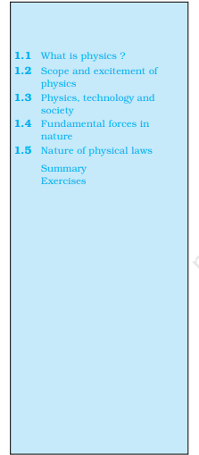**1.1 WHAT IS PHYSICS?**

**Humans have always been curious about the world around them. The night sky with its bright celestial objects has fascinated humans since time immemorial. The regular repetitions of the day and night, the annual cycle of seasons, the eclipses, the tides, the volcanoes, the rainbow have always been a source of wonder. The world has an astonishing variety of materials and a bewildering diversity of life and behaviour. The inquiring and imaginative human mind has responded to the wonder and awe of nature in different ways. One kind of response from the earliest times has been to observe the physical environment carefully, look for any meaningful patterns and relations in natural phenomena, and build and use new tools to interact with nature. This human endeavour led, in course of time, to modern science and technology.**

**The word Science originates from the Latin verb Scientia meaning ‘to know’. The Sanskrit word Vijnan and the Arabic word Ilm convey similar meaning, namely ‘knowledge’. Science, in a broad sense, is as old as human species. The early civilisations of Egypt, India, China, Greece, Mesopotamia and many others made vital contributions to its progress. From the sixteenth century onwards, great strides were made in science in Europe. By the middle of the twentieth century, science had become a truly international enterprise, with many cultures and countries contributing to its rapid growth.**

**What is Science and what is the so-called Scientific Method? Science is a systematic attempt to understand natural phenomena in as much detail and depth as possible, and use the knowledge so gained to predict, modify and control phenomena. Science is exploring, experimenting and predicting from what we see around us. The curiosity to learn about the world, unravelling the secrets of nature is the first step towards the discovery of science. The scientific method involves several interconnected steps: Systematic observations, controlled experiments, qualitative an**

**PHYSICS**

quantitative reasoning, mathematical modelling, prediction and verification or falsification of theories. Speculation and conjecture also have a place in science; but ultimately, a scientific theory, to be acceptable, must be verified by relevant observations or experiments. There is much philosophical debate about the nature and method of science that we need not discuss here. The interplay of theory and observation (or experiment) is basic to the progress of science is ever dynamic. There is no ‘final’ theory in science and no unquestioned authority among scientists. As observations improve in detail and precision or experiments yield new results, theories must account for them, if necessary, by introducing modifications. Sometimes the modifications may not be drastic and may lie within the framework of existing theory. For example, when Johannes Kepler (1571-1630) examined the extensive data on planetary motion collected by Tycho Brahe (1546-1601), the planetary circular orbits in heliocentric theory (sun at the centre of the solar system) imagined by Nicolas Copernicus (1473–1543) had to be replaced by elliptical orbits to fit the data better. Occasionally, however, the existing theory is simply unable to explain new observations. This causes a major upheaval in science. In the beginning of the twentieth century, it was realised that Newtonian mechanics, till then a very successful theory, could not explain some of the most basic features of atomic phenomena. Similarly, the then accepted wave picture of light failed to explain the photoelectric effect properly. This led to the development of a radically new theory (Quantum Mechanics) to deal with atomic and molecular phenomena. Just as a new experiment may suggest an alternative theoretical model, a theoretical advance may suggest what to look for in some experiments. The result of experiment of scattering of alpha particles by gold foil, in 1911 by Ernest Rutherford (1871–1937) established the nuclear model of the atom, which then became the basis of the quantum theory of hydrogen atom given in 1913 by Niels Bohr (1885–1962). On the other hand, the concept of antiparticle was first introduced theoretically by Paul Dirac (1902–1984) in 1930 and confirmed two years later by the experimental discovery of positron (antielectron) by Carl Anderson.

Physics is a basic discipline in the category of Natural Sciences, which also includes other disciplines like Chemistry and Biology. The word Physics comes from a Greek word meaning nature. Its Sanskrit equivalent is Bhautiki that is used to refer to the study of the physical world. A precise definition of this discipline is neither possible nor necessary. We can broadly describe physics as a study of the basic laws of nature and their manifestation in different natural phenomena. The scope of physics is described briefly in the next section. Here we remark on two principal thrusts in physics : unification and reduction. In Physics, we attempt to explain diverse physical phenomena in terms of a few concepts and laws. The effort is to see the physical world as manifestation of some universal laws in different domains and conditions. For example, the same law of gravitation (given by Newton) describes the fall of an apple to the ground, the motion of the moon around the earth and the motion of planets around the sun. Similarly, the basic laws of electromagnetism (Maxwell’s equations) govern all electric and magnetic phenomena. The attempts to unify fundamental forces of nature (section 1.4) reflect this same quest for unification. A related effort is to derive the properties of a bigger, more complex, system from the properties and interactions of its constituent simpler parts. This approach is called reductionism and is at the heart of physics. For example, the subject of thermodynamics, developed in the nineteenth century, deals with bulk systems in terms of macroscopic quantities such as temperature, internal energy, entropy, etc. Subsequently, the subjects of kinetic theory and statistical mechanics interpreted these quantities in terms of the properties of the molecular constituents of the bulk system. In particular, the temperature was seen to be related to the average kinetic energy of molecules of the system.

**PHYSICAL WORLD**

**1.2** **SCOPE AND EXCITEMENT OF PHYSIC**

We can get some idea of the scope of physics by looking at its various sub-disciplines. Basically, there are two domains of interest: macroscopic and microscopic. The macroscopic domain includes phenomena at the laboratory, terrestrial and astronomical scales. The microscopic domain includes atomic, molecular and nuclear phenomena*. Classical Physics deals mainly with macroscopic phenomena and includes subjects like Mechanics, Electrodynamics, Optics and Thermodynamics. Mechanics founded on Newton’s laws of motion and the law of gravitation is concerned with the motion (or equilibrium) of particles, rigid and deformable bodies, and general systems of particles. The propulsion of a rocket by a jet of ejecting gases, propagation of water waves or sound waves in air, the equilibrium of a bent rod under a load, etc., are problems of mechanics. Electrodynamics deals with electric and magnetic phenomena associated with charged and magnetic bodies. Its basic laws were given by Coulomb, Oersted, Ampere and Faraday, and encapsulated by Maxwell in his famous set of equations. The motion of a current-carrying conductor in a magnetic field, the response of a circuit to an ac voltage (signal), the working of an antenna, the propagation of radio waves in the ionosphere, etc., are problems of electrodynamics. Optics deals with the phenomena involving light. The working of telescopes and microscopes, colours exhibited by thin films, etc., are topics in optics. Thermodynamics, in contrast to mechanics, does not deal with the motion of bodies as a whole. Rather, it deals with systems in macroscopic equilibrium and is concerned with changes in internal energy, temperature, entropy, etc., of the system through external work and transfer of heat. The efficiency of heat engines and refrigerators, the direction of a physical or

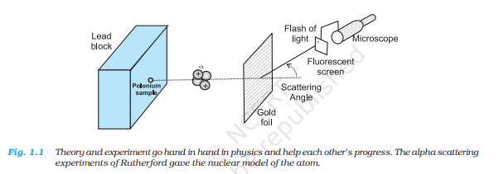

chemical process, etc., are problems of interest in thermodynamics. The microscopic domain of physics deals with the constitution and structure of matter at the minute scales of atoms and nuclei (and even lower scales of length) and their interaction with different probes such as electrons, photons and other elementary particles. Classical physics is inadequate to handle this domain and Quantum Theory is currently accepted as the proper framework for explaining microscopic phenomena. Overall, the edifice of physics is beautiful and imposing and you will appreciate it more as you pursue the subject. You can now see that the scope of physics is truly vast. It covers a tremendous range of magnitude of physical quantities like length, mass, time, energy, etc. At one end, it studies phenomena at the very small scale of length (10-14 m or even less) involving electrons, protons, etc.; at the other end, it deals with astronomical phenomena at the scale of galaxies or even the entire universe whose extent is of the order of 1026 m. The two length scales differ by a factor of 1040 or even more. The range of time scales can be obtained by dividing the length scales by the speed of light : 10–22 s to 1018 s. The range of masses goes from, say, 10–30 kg (mass of an electron) to 1055 kg (mass of known observable universe).

**PHYSICS**

Physics is exciting in many ways. To some people the excitement comes from the elegance and universality of its basic theories, from the fact that a few basic concepts and laws can explain phenomena covering a large range of magnitude of physical quantities. To some others, the challenge in carrying out imaginative new experiments to unlock the secrets of nature, to verify or refute theories, is thrilling. Applied physics is equally demanding. Application and exploitation of physical laws to make useful devices is the most interesting and exciting part and requires great ingenuity and persistence of effort. What lies behind the phenomenal progress of physics in the last few centuries? Great progress usually accompanies changes in our basic perceptions. First, it was realised that for scientific progress, only qualitative thinking, though no doubt important, is not enough. Quantitative measurement is central to the growth of science, especially physics, because the laws of nature happen to be expressible in precise mathematical equations. The second most important insight was that the basic laws of physics are universal — the same laws apply in widely different contexts. Lastly, the strategy of approximation turned out to be very successful. Most observed phenomena in daily life are rather complicated manifestations of the basic laws. Scientists recognised the importance of extracting the essential features of a phenomenon from its less significant aspects. It is not practical to take into account all the complexities of a phenomenon in one go. A good strategy is to focus first on the essential features, discover the basic principles and then introduce corrections to build a more refined theory of the phenomenon. For example, a stone and a feather dropped from the same height do not reach the ground at the same time. The reason is that the essential aspect of the phenomenon, namely free fall under gravity, is complicated by the presence of air resistance. To get the law of free fall under gravity, it is better to create a situation where in the air resistance is negligible. We can, for example, let the stone and the feather fall through a long evacuated tube. In that case, the two objects will fall almost at the same rate, giving the basic law that acceleration due to gravity is independent of the mass of the object. With the basic law thus found, we can go back to the feather, introduce corrections due to air resistance, modify the existing theory and try to build a more rea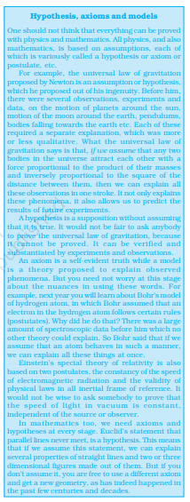listic theory of objects falling to the earth under gravity.

**PHYSICAL WORLD**

**1.3 PHYSICS, TECHNOLOGY AND SOCIETY**

The connection between physics, technology and society can be seen in many examples. The discipline of thermodynamics arose from the need to understand and improve the working of heat engines. The steam engine, as we know, is inseparable from the Industrial Revolution in England in the eighteenth century, which had great impact on the course of human civilisation. Sometimes technology gives rise to new physics; at other times physics generates new technology. An example of the latter is the wireless communication technology that followed the discovery of the basic laws of electricity and magnetism in the nineteenth century. The applications of physics are not always easy to foresee. As late as 1933, the great physicist Ernest Rutherford had dismissed the possibility of tapping energy from atoms. But only a few years later, in 1938, Hahn and Meitner discovered the phenomenon of neutron-induced fission of uranium, which would serve as the basis of nuclear power reactors and nuclear weapons. Yet another important example of physics giving rise to technology is the silicon ‘chip’ that triggered the computer revolution in the last three decades of the twentieth century. A most significant area to which physics has and will contribute is the development of alternative energy resources. The fossil fuels of the planet are dwindling fast and there is an urgent need to discover new and affordable sources of energy. Considerable progress has already been made in this direction (for example, in conversion of solar energy, geothermal energy, etc., into electricity), but much more is still to be accomplished. Table1.1 lists some of the great physicists, their major contribution and the country of origin. You will appreciate from this table the multi-cultural, international character of the scientific endeavour. Table 1.2 lists some important technologies and the principles of physics they are based on. Obviously, these tables are not exhaustive. We urge you to try to add many names and items to these tables with the help of your teachers, good books and websites on science. You will find that this exercise is very educative and also great fun. And, assuredly, it will never end. The progress of science is unstoppable! Physics is the study of nature and natural phenomena. Physicists try to discover the rules that are operating in nature, on the basis of observations, experimentation and analysis. Physics deals with certain basic rules/laws governing the natural world. What is the nature

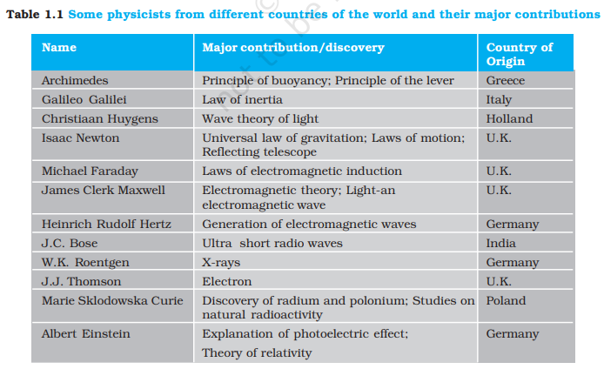

**PHYSICS**

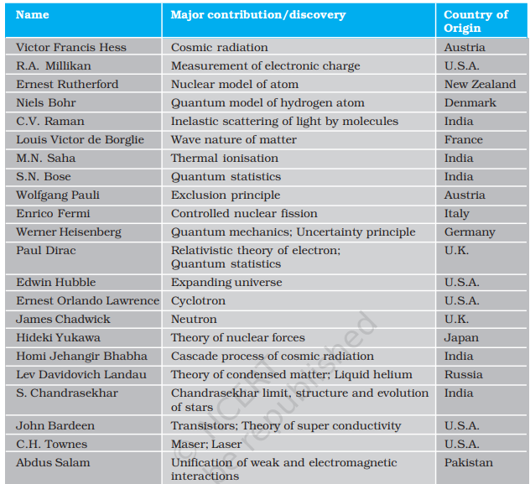

of physical laws? We shall now discuss the nature of fundamental forces and the laws that govern the diverse phenomena of the physical world.

**1.4 FUNDAMENTAL FORCES IN NATURE\***

We all have an intuitive notion of force. In our experience, force is needed to push, carry or throw objects, deform or break them. We also experience the impact of forces on us, like when a moving object hits us or we are in a merry-goround. Going from this intuitive notion to the proper scientific concept of force is not a trivial matter. Early thinkers like Aristotle had wrong ideas about it. The correct notion of force was arrived at by Isaac Newton in his famous laws of motion. He also gave an explicit form for the force for gravitational attraction between two bodies. We shall learn these matters in subsequent chapters. In the macroscopic world, besides the gravitational force, we encounter several kinds of forces: muscular force, contact forces between bodies, friction (which is also a contact force parallel to the surfaces in contact), the forces exerted by compressed or elongated springs and taut strings and ropes (tension), the force of buoyancy and viscous force when solids are in

**PHYSICAL WORLD**

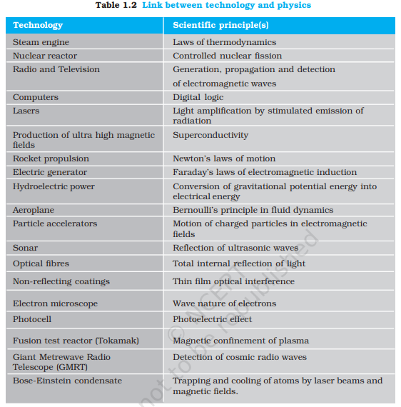

contact with fluids, the force due to pressure of a fluid, the force due to surface tension of a liquid, and so on. There are also forces involving charged and magnetic bodies. In the microscopic domain again, we have electric and magnetic forces, nuclear forces involving protons and neutrons, interatomic and intermolecular forces, etc. We shall get familiar with some of these forces in later parts of this course. A great insight of the twentieth century physics is that these different forces occurring in different contexts actually arise from only a small number of fundamental forces in nature. For example, the elastic spring force arises due to the net attraction/repulsion between the neighbouring atoms of the spring when the spring is elongated/compressed. This net attraction/repulsion can be traced to the (unbalanced) sum of electric forces between the charged constituents of the atoms. In principle, this means that the laws for ‘derived’ forces (such as spring force, friction) are not independent of the laws of fundamental forces in nature. The origin of these derived forces is, however, very complex. At the present stage of our understanding, we know of four fundamental forces in nature, which are described in brief here :

**PHYSICS**

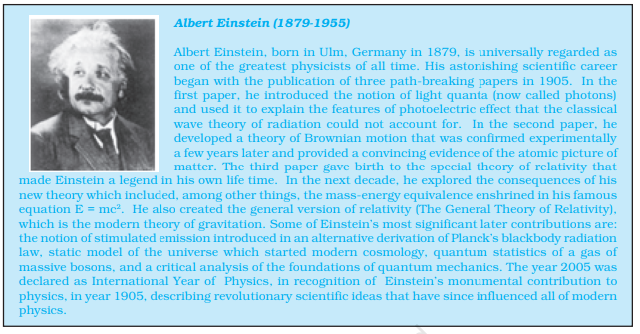

**1.4.1 Gravitational Force**

The gravitational force is the force of mutual attraction between any two objects by virtue of their masses. It is a universal force. Every object experiences this force due to every other object in the universe. All objects on the earth, for example, experience the force of gravity due to the earth. In particular, gravity governs the motion of the moon and artificial satellites around the earth, motion of the earth and planets around the sun, and, of course, the motion of bodies falling to the earth. It plays a key role in the large-scale phenomena of the universe, such as formation and evolution of stars, galaxies and galactic clusters.

**1.4.2 Electromagnetic Force**

Electromagnetic force is the force between charged particles. In the simpler case when charges are at rest, the force is given by Coulomb’s law : attractive for unlike charges and repulsive for like charges. Charges in motion produce magnetic effects and a magnetic field gives rise to a force on a moving charge. Electric and magnetic effects are, in general, inseparable – hence the name electromagnetic force. Like the gravitational force, electromagnetic force acts over large distances and does not need any intervening medium. It is enormously strong compared to gravity. Theelectric force between two protons, for example, is 1036 times the gravitational force between them, for any fixed distance. Matter, as we know, consists of elementary charged constituents like electrons and protons. Since the electromagnetic force is so much stronger than the gravitational force, it dominates all phenomena at atomic and molecular scales. (The other two forces, as we shall see, operate only at nuclear scales.) Thus it is mainly the electromagnetic force that governs the structure of atoms and molecules, the dynamics of chemical reactions and the mechanical, thermal and other properties of materials. It underlies the macroscopic forces like ‘tension’, ‘friction’, ‘normal force’, ‘spring force’, etc. Gravity is always attractive, while electromagnetic force can be attractive or repulsive. Another way of putting it is that mass comes only in one variety (there is no negative mass), but charge comes in two varieties : positive and negative charge. This is what makes all the difference. Matter is mostly electrically neutral (net charge is zero). Thus, electric force is largely zero and gravitational force dominates terrestrial phenomena. Electric force manifests itself in atmosphere where the atoms are ionised and that leads to lightning.

**PHYSICAL WORLD**

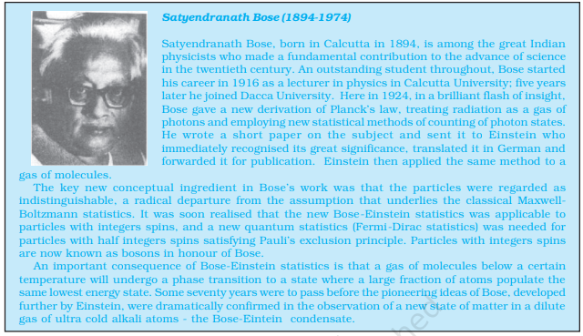

If we reflect a little, the enormous strength of the electromagnetic force compared to gravity is evident in our daily life. When we hold a book in our hand, we are balancing the gravitational force on the book due to the huge mass of the earth by the ‘normal force’ provided by our hand. The latter is nothing but the net electromagnetic force between the charged constituents of our hand and the book, at the surface in contact. If electromagnetic force were not intrinsically so much stronger than gravity, the hand of the strongest man would crumble under the weight of a feather ! Indeed, to be consistent, in that circumstance, we ourselves would crumble under our own weight !

**1.4.3 Strong Nuclear Force**

The strong nuclear force binds protons and neutrons in a nucleus. It is evident that without some attractive force, a nucleus will be unstable due to the electric repulsion between its protons. This attractive force cannot be gravitational since force of gravity is negligible compared to the electric force. A new basic force must, therefore, be invoked. The strong nuclear force is the strongest of all fundamental forces, about 100 times the electromagnetic force in strength. It is charge-independent and acts equally between a proton and a proton, a neutron and a neutron, and a proton and a neutron. Its range is, however, extremely small, of about nuclear dimensions (10–15m). It is responsible for the stability of nuclei. The electron, it must be noted, does not experience this force.

Recent developments have, however, indicated that protons and neutrons are built out of still more elementary constituents called quarks.