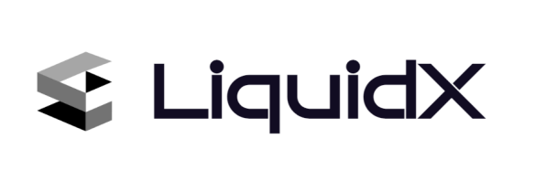

LiquidX Protocol

Yuang Huang

[3116337144@qq.com(hyahhhhjj@gmail.com)](mailto:3116337144@qq.com(hyahhhhjj@gmail.com))

**1 Introduction**

LiquidX Protocol is credit leverage market making protocol powered by TradeJoeV2 Liquidity Book. The protocol targets people who want to earn top-tier market maker profits but lack the time or ability to manage positions by providing a “Deposit&&Earn” option. On the other hand, it offers a credit-based, zero-interest lending option to top-tier market makers or those with top-tier market-making capabilities but insufficient capital to quickly expand their market-making profits. Together, it create a truly transparent and decentralized structured risk investment platform, with the potential to achieve the highest APR of any Defi protocol. Comparing with other leverage market-making protocol or [concentrated](javascript:;) liquidity pool, it has following features:

* The protocol uses a new investment model rather than the traditional lending model, which means individual market makers do not need to pay interest on borrowed funds, but instead, a portion of their earnings is returned to the stake pool as a bonus.
* There is a flexible liquidation mechanism in place, which is not immediate, with a line of credit calculation mechanism that is positively correlated with market makers’ profitability and risk management capabilities.
* The *TraderJoe Liquidity book* [1]is used as the market-making tool. It allows for custom liquidity distribution, allows for one-sided liquidity provision, and gives individual market makers unprecedented flexibility.

**2 Protocol Design**

The protocol can be divided into three parts. The first part is the investment pool. Users can use native assets on the chain to mint shares of the LiquidXStakePool, whose price fluctuates with market maker’s earnings and liquidation conditions.

The second part is the aggregator, LiquidXAggregator, which connects market maker accounts and the stake pools, enabling the borrowing and liquidation of assets.

The third part is the market maker account, which implements mathematical calculations of market maker profitability.

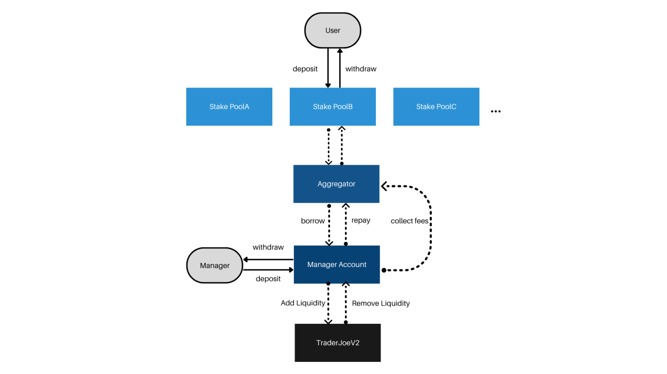

**Figure 1:Protocol Structure**

**2.1 LiquidX Stake Pool**

**2.1.1 Share Price Calculation**

The stake pool share token has similar minting method with *Uniswap LP*[2] token. It can be calculated by following formula:

$price = \left\{\begin{aligned}1 , totalSupply = 0 \\ totalRserve / totalSupply, totalSupply > 0\end{aligned}\right.$

***totalRserve***is the total amount of native asset staked in the pool, for example, USDT. And ***totalSupply*** is the total amount of corresponding LiquidX version asset, lx-USDT. Therefore, we can calculate minted shares using following formula.

(1.2) $amountOut =\left\{\begin{aligned}amounttIn, totalSupply=0 \\ amountIn × \frac{totalSupply}{totalRserve}, totalSupply>0 \end{aligned}\right.$

It is designed in this way because I always believe that high returns are accompanied by high risks. If there is a Defi protocol that provides high returns without exposing high enough risks, it does not mean that the risks disappear, but that the risks are delayed and the consequences are even more devastating.

**2.2 Manager Account**

**2.1.1 Combination return**

Combination return refers to the total return on a portfolio or investment that includes multiple assets . Traditionally, It is a measure of the performance of a diversified investment strategy. And it is adopted as the core mechanism for calculating credit points in LiquidX Protocol. By definition, it can be calculated by following formula:

(2.1) ${return}_{combination} =\sum_{0}^{n}{{return}_{i}}× {weight}_{i}$*(n is the total amount of assets)*

**2.1.2 Credit Calculation**

As we can not simply set a weight to each asset on chain , we need a new method to measure market makers’ profitability. That is why the geometric mean return has been introduced into the protocol.

(2.2) ${return}_{average} =\sqrt[n]{\frac{x_{t1}}{x_{t0}}×\frac{y_{t1}}{y_{t0}}×\frac{z_{t1}}{z_{t0}}...}−$ 1

In the above formula, x, y, and z represent the amount of different tokens in a series, while t0 and t1 represent two discrete moments. With this formula, we can calculate the combination returns of market makers . However, there are two issues with this formula. First, the computational complexity will increase sharply as the number of assets grows. Secondly, We want to obtain information about the balance of assets in the market maker’s portfolio. Considering the following situation.

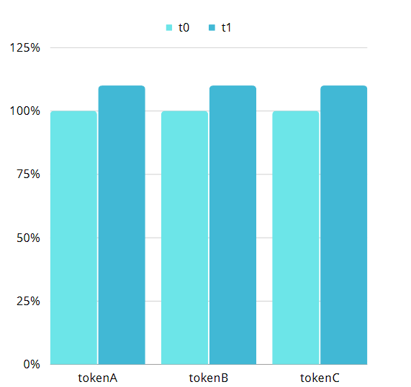

**Figure 2:Portfolio01**

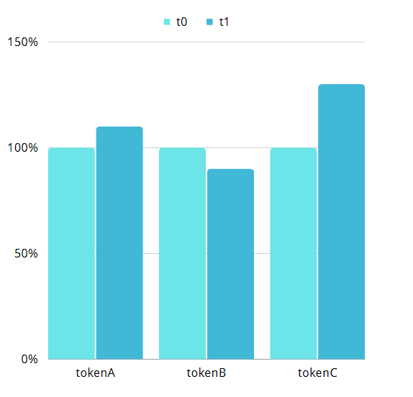

**Figure 3:Portfolio02**

The above two bar charts show the token portfolio of two market makers at two different times, t0 and t1. The return of first market maker can be calculated using formula (2.2), which is $\sqrt[3]{1.1×1.1 × 1.1}−1 = 0.1$. The return of second market maker can be also calculated: $\sqrt[3]{1.1×0.9×1.3}−1= 0.287$.However, it is obvious that market maker No.2 does not balance its asset portfolio properly and suffers loss on token B. If the average return is the only indicator we focus on,the market makers will not be motivated to balance its portfolio and it may turns out undermining user trust in protocol.

Thus, the more effective method of measuring market maker’s profitability is designed.

(2.3) ${return}_{min}(t0, t1)≡Min(\frac{x_{t1}}{x_{t0}},\frac{y_{t1}}{y_{t0}},\frac{z_{t1}}{z_{t0}}...)−$*1*

(2.4) $Credit = \sum_{i=1}^{n}{{return}_{min}(∆t)×∆t}$

In the same situation above, the new return of first portfolio is 0.1, whereas the return of second portfolio is -0.1.

Now, we can measure each market maker’s profitability, but we still don’t know how to link line of credit with market maker’s profitability.

2.1.3 Valuation of market maker’s profitability

With the calculated credit, we still don’t know how many tokens can a market maker borrow. We can apply $Credit ×Balance$ to each market maker, but it will cost several years for a market maker to gain $1×l$ everage, which is unrealistic. Thus, a multiplier is introduced to line of credit calculation.

(2.5) $limit = \left\{\begin{aligned}Multiplier×Balance, Credit>=1 \\ Multiplier × Credit ×Balance Credit<1\end{aligned}\right.$

By default, multiplier is 10. It is a proper valuation comparing with most financial enterprise.

**2.3 Aggregator**

**2.3.3 Aggregation**

As most trading pairs and tokens do not have a one-to-one relationship, LiquidXAggregator is designed to aggregate and manage the discrete single-token investment pools in LiquidX Protocol and different trading pairs on TraderJoe, serving as a bridge of the protocol.

**2.3.4 Liquidation**

The liquidation function can be only called by *AccountGuard[3].*  It plays a role that has the power to force manger remove all liquidity and liquidate managers’ assets.

**2.3.4 Margin**

Managers on LiquidX Protocol would not pay any time cost of borrowed capital. Instead, Margin system is introduced to LiquidX Protocol to act as a safety net for investors. And it can be calculated by following formula:

(2.6) $Margin = Borrowed / minLeverage()$

(2.7) $minLeverage()≡Min(LeveragePoolMax, LeverageManagerMax)$

**3 Conclusion**

LiquidX Protocol combines features of credit lending and leveraged market-making to structure the risk and return of liquidity provision, providing a new investment experience for those who prefer high-risk, high-rewarded investments and offering a unique profit expansion option for capable market makers.

1. https://github.com/traderjoe-xyz/LB-Whitepaper/blob/main/Joe%20v2%20Liquidity%20Book%20Whitepaper.pdf
2. https://github.com/Uniswap/v2-core/blob/master/contracts/UniswapV2Pair.sol
3. Accounts Guard is separate from owner of the contract.