This doc will show you how to open up and interact with LiquidX front end.

PART 1

Before you start, you should get some tokens to test with.

(TBUSD):0x6658081AbdAA15336b54763662B46966008E8953

To get this token, you need manually call

function swapExactAVAXForTokens(  
 uint256 amountOutMin,  
 uint256[] memory pairBinSteps,  
 IERC20[] memory tokenPath,  
 address to,  
 uint256 deadline  
)

Using ILBRouter.sol interface. This file can be found in TraderJoeV2(Not V2.1).

If you are using Brownie, you can copy these code:

router = interface.ILBRouter("0xf7C6d73336f333b63144644944176072D94128F5")  
router.swapExactAVAXForTokens(0, [15], ["0xae13d989daC2f0dEbFf460aC112a837C89BAa7cd", "0x6658081AbdAA15336b54763662B46966008E8953"], "0x381836196E04eAb47504225E106f85ce86174983", 1693399470,  
 {"from": get\_account(), "value": amount})

And run brownie run scripts/deploy.py --network bsc-test. Then you will get some of these tokens.

If you are not using Brownie, here’s some information you need:

LBRouter:0xf7C6d73336f333b63144644944176072D94128F5

Pair: 0x5f79ABacC763A61AD7ffEaa01a8b6Fd9F1856C2e

tokenX(TBUSD): 0x6658081AbdAA15336b54763662B46966008E8953

tokenY(WBNB): 0xae13d989daC2f0dEbFf460aC112a837C89BAa7cd

binstep:15

The second token is

(WBNB):0xae13d989daC2f0dEbFf460aC112a837C89BAa7cd

If you send some of testnet BNB to this address, you will automatically receive some of WBNB.

PART 2

Congratulations ! You have enough tokens to test with. Now open up “vite-project” folder:

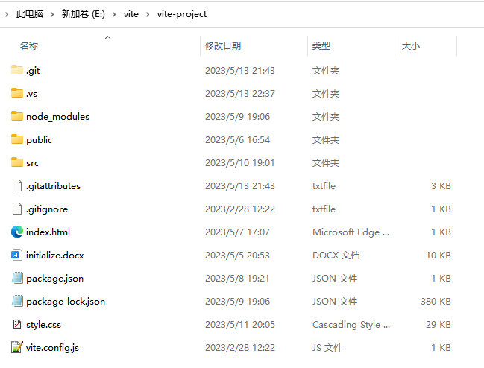

You will see these files.

Now type “cmd” here:

*)QPMABNWQXR20}F(Q[_HJGJ*

Then type “npm run dev”

Finally you will see:

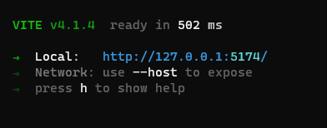

Copy and paste this url to your browser and have fun testing!