**Yuang Huang**

**Program guide**

**“Hedged Grid Strategy”**

**Chengdu 2022**

**Contents**

1.Introduction 3

2 General information about the program 3

2.1 Basic concepts 3

2.2 Getting start 6

2.3 Maximize your profit 8

**1. Introduction**

This strategy is designed for bear market, utilizing traditional grid strategy, hedging tools, as well automated money management algorithm, to derive maximum benefits in the bear market. Before we start, there are a few concepts you need to be aware of.

**2. general information about the program**

**2.1.1 Grid strategy**

Generally, there are two different types of grid strategy. The first one is buying fixed amount of cryptocurrency when price falls back and there is no lower boundary or upper boundary in this strategy.

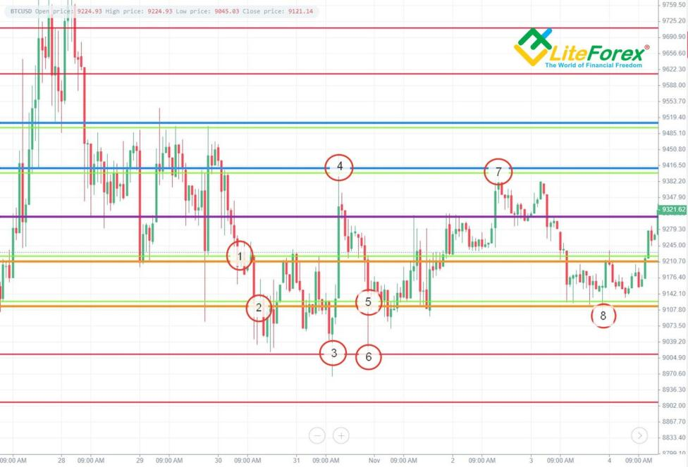

Graph 1. Grid strategy of first kind①

The second strategy has fixed boundaries.

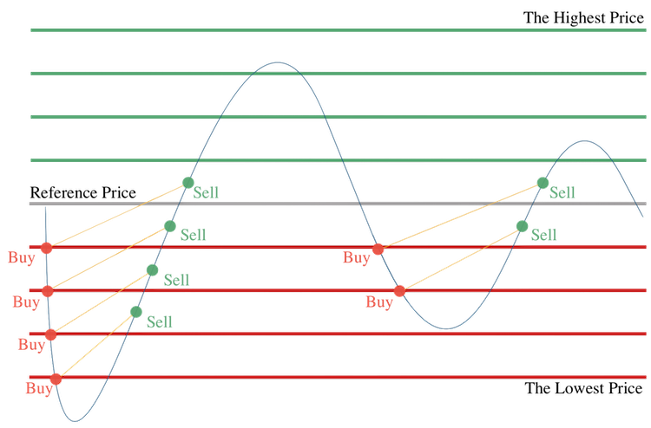

Graph 2. Grid strategy of second kind②

The difference between the two types of strategies is that, with boundaries, you can control your maximum investment and do money management to improve capital efficiency. This is why I prefer the second one as my core strategy.

**2.1.2 Fundamentals of hedging**

As I illustrated before, with boundaries, you can calculating your maximum investment. Therefore, if you hedge at the beginning, you don’t need to worry about paper losses when price falls back through lower boundary. The exact number of what amount of cryptocurrency need to be hedged can be calculated by this formula.

$y =\frac{D(C−1)}{2}$, when x = a

Here , **x** means cost price of opening a short position. **a** means the price of upper boundary. **y** means the money value of cryptocurrency you want to short. **D** means the money you prepare to invest in one grid. **C** means the total number of grids. **D*(C-1)** can also be presented as your spot balance. And remember, this only works when you hedge at the upper boundary of the grid. However, if you want hedge at the mid position of a grid, the formula can be replaced by $y =D(C−1)$, when x=0.5*(a+b). I personally would not advise you to do so, as it could be more difficult to do money management.

If you have trouble understanding this, you don’t need to worry. As the program would calculate the size of a short position automatically. Just remember to deposit enough money in your perpetual account. This can be calculated by a simple formula **perpetual balance = spot balance / leverage.**

**2.1.3 Market order**

By default, the strategy use market order to open a short position as there is a time limit and it is not what I’m focused on. However, if you are experienced in developing high frequency trading system, you can build a similar one yourself. The advantage of limit order is the low slippage and lower fees comparing with market order, while the deficiency is that you never know when the order will be filled

**2.1.4 Execution algorithm**

This is used when you have a relatively large capital and you don’t want suffer from a high slippage of a market order. The fundamental of execution algorithm in this program is TWAP. To be specific, it would split your order into pieces. Each time, it would fill a optimal bid offer until your order is finished. You can choose to call or not call this function in hedging_trader module.

**2.1.4 Manage your risks**

By default, your maximum loss is the money you deposit in your perpetual account. However, you can control your losses by placing stop-market order or stop-limit order manually.

**2.2 Getting start**

**2.2.1 Preparation**

**Make sure your computer has a good connection with exchange.** This is because this program is not designed to work in poor connection condition. Beisdes, **Deposit enough money in perpetual accounts.** As I mentioned before, it can be calculated by a simple formula **perpetual balance = spot balance / leverage.**

**2.2.2 Configuration**

Firstly, open up binance_config.json. All configuration are listed in this file.

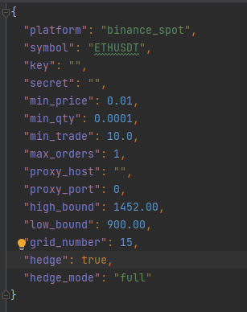

Parameters need to be modified:

“symbol”: (spot symbol)

“key”: (your API_key)

“secret”: (your secret)

“min_price”:(in accordance with symbol)

“min_qty”: (in accordance with symbol)

“high_bound”: (upper boundary of grid)

“low_bound”: (lower boundary of grid)

After that , you need to enable **two-way mode** of your perpetual account.

**2.2.3 Run strategy**

Run binance_main.py or start.sh if you are linux user. The log file will be stored as binance_grid_trader_log.txt.

**2.3 Maximize your profit**

Generally, a wider and denser grid would perform better, but trading fees should also be considered.

**Reference:**

①:https://www.litefinance.com/blog/for-professionals/grid-trading-a-complete-overview-of-forex-grid-trading-method/

②:https://quantpedia.com/a-primer-on-grid-trading-strategy/