UM-SJTU Joint Institute

Physics Laboratory

(Vp141)

Laboratory Report

Exercise 5

Damped and Driven Oscillations

Mechanical Resonance

Name: Wenxin He ID: 518370910117 Group: 2

Name: Yuanchen Bai ID: 518370910183 Group:2

Date: 12 July 2019

**1. Introduction**

The objective of this experiment is to use the Pohl resonator to study damped and driven oscillations in mechanical systems. We will study the property of mechanical resonance by analyzing the figure based on our experimental data.

**2. Theoretical Background**

If a force which varies periodically is exerted on a damped harmonic oscillator, the motion is called forced (or driven) oscillations. Suppose the form of the driving force is

Where is the amplitude and is the angular frequency.

When the oscillator reaches the steady state, its angular frequency will be the same as

The amplitude of the steady-state oscillation depends on the relationship between the natural angular frequency and the driving frequency, and the damping coefficient. When the amplitude becomes quite large, the phenomenon is called mechanical resonance.

There will be a phase lag between the driving force and the displacement from equilibrium of the oscillating particle. When equals the natural frequency, the phase lag is

In this experiment, we will use angular counterparts to replace the linear quantities.

When a driving torque and a damping torque and a restoring force acted upon the balance wheel, its equation of motion is

(2)

where I is the moment of inertia of the balance wheel, is the amplitude of the driving torque, and is angular frequency of the driving torque.

Introducing the following symbols, 2 ,Eq.2 can be written as:

(3)

Solving eq.3 we get

(4)

where denotes the transient solution and (5)

The phase shift satisfies the equation:

(6)

where -, which is independent of the initial conditions.

By finding the maximum value of, we can find the resonance angular frequency

C:\Users\thinkpad\AppData\Roaming\Tencent\Users\1165008570\QQ\WinTemp\RichOle\F}V(PUQNSVW)901LIWFV0$O.png, (7) and the corresponding amplitude is (8)

The dependence of the amplitude and the phase on the driving angular frequency is shown in figure 1. When damping increases, the resonance frequency will move away from the natural frequency to a smaller value and the amplitude of the steady-state oscillation decreases.

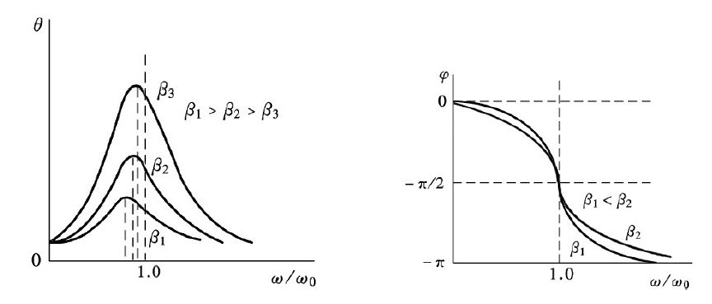

Figure 1 The dependence of the amplitude (left) and phase shift (right) of steady-state

driven oscillations.

**3. Experimental Setup**

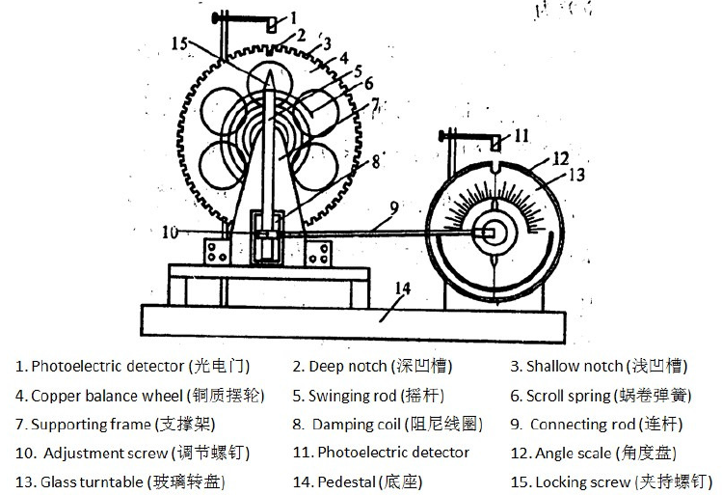

Figure 2 The vibrometer

The BG-2 Pohl resonator consists of two main parts: a vibrometer (Figure 2) and a control box(Figure 3). The scroll spring provides an elastic restoring torque so that the wheel can rotate about an equilibrium state.

There are notches on the edge of the wheel, and one of them is deeper than the others. When this notch passes the photoelectric detector(1), the period of oscillations can be measured. The amplitude can also be measured by counting the notches and will be displayed. Another photoelectric detector(11) is set above the turntable and can measure the period of the driving force. When the Period Selection switch is at position “1”, a single oscillation period will be displayed; when it is at position “2”, the time of 10 period will be displayed.

The damping comes from the pair of coils at the bottom of the supporting frame. When the coils carry current, the electromagnetic force will serve as the damping torque. Its magnitude can be changed by changing the current. The Damping Selection knob can be used to change the current and it has 6 options ranging from 0 to 0.6A.

A motor and an electric wheel are used to drive the wheel.

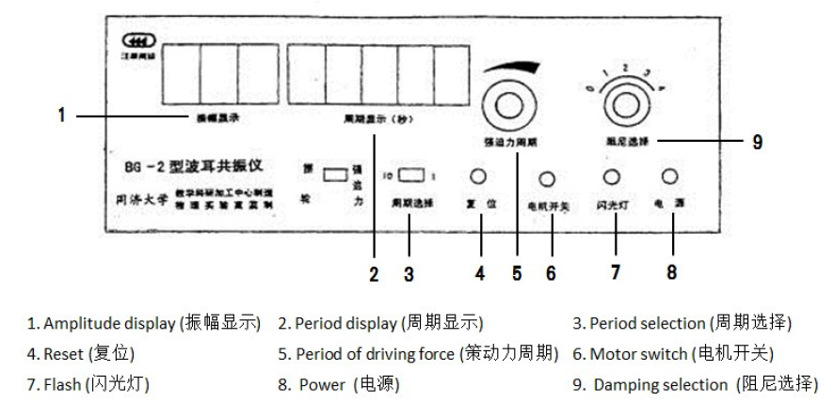

Figure 3 The front panel of the control box.

As for the control box, a Period Selection switch and a Period of Driving Force can be used to control the speed of the motor precisely.

To measure the phase shift, the glass turntable with an angle scale and a strobe light are used. When the deep notch passes the detector, a line on the scale will be highlighted and can be read.

The information of each measuring scale is shown in Table 1.

|  |  |  |  |
| --- | --- | --- | --- |
| apparatus | range | Minimum scale of value | Maximum uncertainty |
| Vibrometer-period | / | 0.001s | 0.001s |
| Vibrometer-angle | 0~180 | 1 | 1 |
| Vibrometer-amplitude | / |  | 1 |

Table 1 Information of Each Measuring scale

**4. Measurements**

**4.1 Natural Angular Frequency**

1. Turn the Damping Selection knob to "0".

2. Rotate the wheel to a degree of about 150and release it, and record the time of 10 periods.

3. Repeat step 2 and record 4 sets of data and calculate the natural angular frequency.

**4.2 Damping Coefficient**

1. Turn the Damping Selection knob to "2" and do not change it.

2. Rotate the wheel to a degree of about 150and release it, and record the second value of amplitude each period and the time of 10 intervals.

3. Repeat step 2 ten times.

3. The damping coefficient can be calculated using the equation

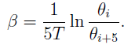

where T is the average period

**4.3 vs. and vs. Characteristics of Forced Oscillations**

1. Keep the Damping Selection at "2" and set the speed of the motor.

2. Wait until the oscillation reaches its steady state where the amplitude doesn’t change. Record the amplitude, the period T and the phase shift

3. Repeat step 2 for 15-20 times. Change the speed of motor slowly and collect more data when phase shift is near

4. Choose Damping Selection "1" or "3". Repeat the above steps.

5. Plot the characteristics, set the horizontal axis and the vertical axis. Plot the data of two different modes on the same graph.

6. Plot the characteristics, set the horizontal axis and the vertical axis. Plot the data of two different modes on the same graph.

**5. Results**

**5.1 Natural Angular Frequency**

|  |  |
| --- | --- |
|  | 10T [s] |
| 1 | 15.814 |
| 2 | 15.797 |
| 3 | 15.800 |
| 4 | 15.808 |

Table 2 Measurement of the natural frequency.

From table 2 we get the average value of the time of 10 periods:

Divide this value by 10 and we get the time of one period: T=1.58

The natural frequency can be calculated as

**5.2 Damping Coefficient**

**5.2.1 The diameter of the ball**

|  |  |  |  |  |
| --- | --- | --- | --- | --- |
| Amplitude[] | | Amplitude[] | | q=ln(/ |
|  | 113 |  | 68 | 0.508 |
|  | 102 |  | 62 | 0.498 |
|  | 92 |  | 56 | 0.496 |
|  | 83 |  | 50 | 0.507 |
|  | 75 |  | 46 | 0.489 |
| The average value of ln(/ | | | | 0.500 |

Table 3 Measurement of the damping coefficient.

The measured time of ten periods is 10T=15.862 so T= 1.5862

The last data in table 3 is calculated by:

Use the equation =

**5.3 vs. and vs. Characteristics of Forced Oscillations**

**5.3.1 Damping Selection 2**

We introduce symbols Q=, and Q=.

|  |  |  |  |  |  |
| --- | --- | --- | --- | --- | --- |
|  | 10T[s] |  |  | Q |  |
| 1 | 16.422 | -27 | 58 | 0.962 | 6 |
| 2 | 16.304 | -31 | 68 | 0.969 | 6 |
| 3 | 16.214 | -36 | 78 | 0.975 | 6 |
| 4 | 16.080 | -47 | 97 | 0.983 | 6 |
| 5 | 15.998 | -56 | 109 | 0.988 | 6 |
| 6 | 15.918 | -68 | 121 | 0.993 | 6 |
| 7 | 15.873 | -76 | 127 | 0.996 | 6 |
| 8 | 15.845 | -79 | 129 | 0.997 | 6 |
| 9 | 15.784 | -95 | 131 | 1.001 | 6 |
| 10 | 15.738 | -106 | 127 | 1.004 | 6 |
| 11 | 15.721 | -110 | 125 | 1.005 | 6 |
| 12 | 15.695 | -116 | 119 | 1.007 | 6 |
| 13 | 15.665 | -121 | 113 | 1.009 | 6 |
| 14 | 15.638 | -127 | 106 | 1.011 | 6 |
| 15 | 15.614 | -131 | 102 | 1.012 | 6 |
| 16 | 15.544 | -140 | 84 | 1.017 | 6 |

Table 4 vs. and vs. Characteristics of 5.3.1

Take data 1 for example, Q=

**5.3.2 Damping Selection 1**

|  |  |  |  |  |  |
| --- | --- | --- | --- | --- | --- |
|  | 10T[s] |  |  | Q |  |
| 1 | 16.487 | -21 | 54 | 0.959 | 6 |
| 2 | 16.432 | -23 | 58 | 0.962 | 6 |
| 3 | 16.324 | -27 | 69 | 0.968 | 6 |
| 4 | 16.065 | -44 | 105 | 0.984 | 6 |
| 5 | 15.974 | -55 | 121 | 0.989 | 6 |
| 6 | 15.861 | -72 | 142 | 0.996 | 6 |
| 7 | 15.818 | -81 | 149 | 0.999 | 6 |
| 8 | 15.801 | -85 | 150 | 1.000 | 6 |
| 9 | 15.795 | -86 | 151 | 1.001 | 6 |
| 10 | 15.784 | -88 | 151 | 1.001 | 6 |
| 11 | 15.774 | -91 | 151 | 1.002 | 6 |
| 12 | 15.745 | -97 | 150 | 1.004 | 6 |
| 13 | 15.732 | -103 | 147 | 1.005 | 6 |
| 14 | 15.709 | -109 | 143 | 1.006 | 6 |
| 15 | 15.668 | -122 | 128 | 1.008 | 6 |
| 16 | 15.628 | -131 | 117 | 1.011 | 6 |
| 17 | 15.563 | -142 | 94 | 1.016 | 6 |
| 18 | 15.438 | -154 | 68 | 1.024 | 7 |
| 19 | 15.360 | -156 | 60 | 1.029 | 7 |

Table 5 vs. and vs. Characteristics of 5.3.2

Take data 1 for example, Q=

**5.3.3 Comparing Figures**

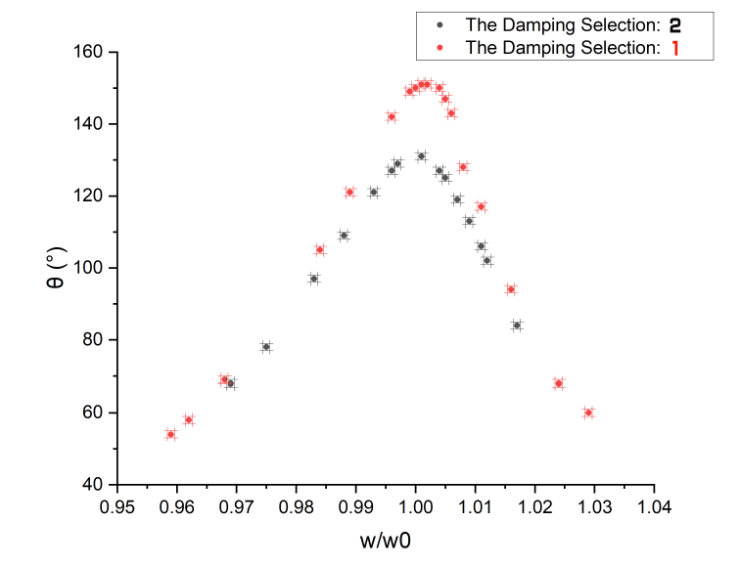

Figure 4 characteristics

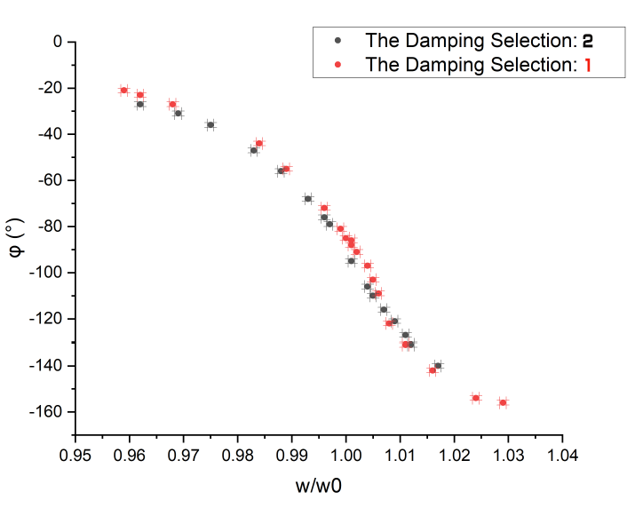

Figure 5 characteristics

**6. Conclusions and discussion**

**6.1 Conclusions**

The natural frequency is

The damping coefficient is

The relative uncertainties are 0.06% and 6.35% respectively, which are small enough to prove the accuracy of our measurements.

From the figure we can conclude:

* When the driving frequency is near the natural frequency, the steady-state amplitude will peak.
* When damping increases, the resonance frequency will move away from the natural frequency to a smaller value and the amplitude of the steady-state oscillation decreases.

From the figure we can conclude:

* The phase lag becomes larger when the driving frequency increases.
* When the driving frequency is near the natural frequency, the phase lag is near and there’s a sharp change in the phase lag within this range

**6.2 Discussions**

The errors might exist because:

* The air drag and friction inside the wheel will disturb the oscillation.
* It’s hard to tell whether the oscillation has reached its steady state because the amplitude might be changing even if we think that it stays still.
* When reading the phase lag, the instantaneous flash light is hard to catch because it disappears too fast. Also, we observed that the phase lag was not stable, switching between two adjacent values. Therefore, the reading of phase lag might be inaccurate.

**6.3 Improvements**

* The accuracy of the device can be improved. As can be seen from table 5 data 9,10,11, the value ofare the same due to the limitation of the precision of the vibrometer. This will result in a flat slope on the figure. It will be better if the minimum scale of value can be small enough to distinguish these data.
* Use another method to read the phase lag since reading when the light flashes is not optimal.

**7.Reference**

[1]Exercise 5-Lab Manual [rev 4.3], University of Michigan-Shanghai Jiao Tong University Joint Institute VP141, 2019.

**A. Measurement uncertainty analysis**

**B. Data sheet**

