UM-SJTU Joint Institute

Physics Laboratory

(Vp141)

Laboratory Report

Exercise 3

Simple Harmonic Motion:

Oscillations in Mechanical Systems

Name: Wenxin He ID: 518370910117 Group: 2

Name: Yuanchen Bai ID:518370910183 Group:2

Date: 22 June 2019

**1. Introduction**

The objective of this experiment is to study properties of a simple harmonic oscillation. We will first apply Hooke’s law to find out the spring constant. Then, we will do several control experiments on the air track to study the relationship between the oscillation period and the mass, the period and the amplitude, and the maximum speed and the amplitude.

**2. Theoretical Background**

**2.1 Hooke’s Law**

Within the elastic limit of deformation, the restoring force of the spring has the direction opposite to the deformation and its magnitude is directly proportional to the distance. Hooke’s Law can be expressed by:

$$F_{x}=kx (1)$$

Where k is the spring constant and can be found using the Jolly balance.

**2.2 Equation of Motion of the Simple Harmonic Oscillator**

An object with mass M is placed on an air track which serves to eliminate the frictional force, as shown in Figure 1.



Figure 1 Mass-spring system

The two ends of the object are fixed to the air track using two springs whose spring constants are k1 and k2. Neglecting the masses of the springs and the damping and applying Newton’s second law, the equation of motion of the object is:

$$M\frac{d^{2}x}{dt^{2}}+\left(k1+k2\right)x=0 (2)$$

The solution of Eq.2 is

$$x\left(t\right)=Acos\left(ω_{0}t+φ_{0}\right) (3)$$

where $ω_{0}=\sqrt{(k1+k1)/M}$, which is the natural angular frequency of the oscillations and is determined by the parameters of the system itself. A is the amplitude and $φ_{0}$ is the initial phase which is determined by initial conditions.

The natural period of oscillation is:

$$T=\frac{2π}{ω_{0}}=2π\sqrt{\frac{M}{k1+k2}} (4)$$

**2.3 Mass of the Spring**

When the mass of springs cannot be ignored, we consider the effective mass of the spring, which is 1/3 of the actual mass of the spring. The oscillator with object of mass M and spring of effective mass $m_{0}$ has the angular frequency:

$$ω_{0}=\sqrt{\frac{k1+k2}{M+m_{0}}} (5)$$

**2.4 Mechanical Energy in Harmonic Motion**

The elastic potential energy of the spring-mass system is $U=kx^{2}/2$ and the kinetic energy of an oscillating mass m is $K=mv^{2}/2$.

The speed of the mass is maximized at the equilibrium position x=0, where the total mechanical energy equals to maximum kinetic energy. At maximum displacement, the mass has no speed and has maximum potential energy as the total mechanical energy. Therefore, as there are only conservative forces, Kmax = Umax, and we get:

$$k=\frac{m{v_{max}}^{2}}{A^{2}} (6)$$

**3. Experimental Setup**

The measurement equipment consists of: springs, Jolly balance, air track, electronic timer, electronic balance, and masses.

**3.1 Jolly Balance**

The scale on the Jolly balance is used to measure the deformation of the spring, from which we can calculate the spring constant.



Figure 2 Jolly balance

First, put the initial 20g mass on the bottom end of the spring, read the scale L1. Then add mass m to it and read L2. The spring constant can be found as:

$$k=\frac{mg}{L2-L1} (7)$$

Read the readings only if the three lines coincide: the line on the mirror, the line on the glass tude and its reflection in the mirror.

**3.2 Photoelectric Measuring System**

For period measurement, we use the I-shape shutter on the moving object to block the light emitted from the photoelectric gate. Each time the light is blocked, half a period is counted.

For speed measurement, we use a U-shape shutter so that the light is blocked twice during a pass. The time interval $∆t$ is measured by the timer, and we use a caliper to measure the distance $x_{in}$ and $x_{out} to get ∆x=\frac{1}{2}$ (${x_{in}+x}_{out}$). Therefore, the instantaneous speed can be expressed by $v=\frac{∆x}{∆t}$.

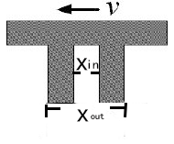

Figure 3 the U-shape shutter



Figure 4 the experimental setup

**3.2 Device Information**

The information of each measurement device is shown in Table 1.

|  |  |  |  |
| --- | --- | --- | --- |
| apparatus | range | Minimum scale of value | Maximum uncertainty |
| Electronic timer | / | 0.0001s | $±$ 0.0001s |
| Electronic balance | / | 0.01g | $±$ 0.01g |
| calliper | 0~125mm | 0.02mm | $±$ 0.02mm |
| Jolly balance | 0~100cm | 0.01cm | $±$ 0.01cm |
| Air track | / | 0.1cm | $±$ 0.1cm |

Table 1 Information of Each Measurement Device

**4. Measurements**

**4.1 Spring Constant**

1. Adjust the Jolly balance to be vertical, and add a 20g preload to the bottom end of the spring. Make sure the mirror can move freely.

2. Adjust the position of the tube to set the initial position L0 within 5.0~10.0cm and record L0.

3. Add mass m1 and record L1.

4. Keep adding masses in order and record 7 sets of positions in total.

5. Use the least square method to estimate the spring constant k1.

6. Replace spring1 with spring2 and repeat the above steps to get spring constant k2.

7. Remove the preload and repeat the measurement for springs1 and 2 connected in series and calculate k3. Compare k3 with theoretical value.

**4.2 Relation between the Oscillation Period T and Oscillator’s Mass M**

**4.2.1 Adjustment of the air track**

1. Adjust the air track to be horizontal.

2. Turn on the air pump and check if there are any holes blocked.

3. Place the cart on the track without initial velocity and adjust the single knob until the object moves slowly back and forth in both directions.

Caution: Don’t place anything on the track when it’s off.

**4.2.2 Horizontal air track**

1. Attach the I-shape shutter to the cart and attach springs to the sides of the cart to connect it to the air track. Make sure the photoelectric gate is at the equilibrium position.

2. Add weight m1 and let the cart oscillate about the photoelectric gate. Use a pen to release the cart and ensure that the amplitude is about 5cm. Set the timer into ‘T’ mode and it will automatically record the time of 10 oscillation periods. Record both the total time and the mass of cart.

3. Add weights to the cart. Repeat step 2 and take the measurements for 5 times.

4. Plot a graph to analyze the relation between T and M.

**4.2.3 Inclined air track**

1. Place three plastic plates under one side of the air track. Repeat steps in 4.2.2.

2. Add three plastic plates under that side and repeat steps in 4.2.2.

3. Plot a graph to analyze the relation between T and M.

**4.3 Relation between the Oscillation Period T and the Amplitude A**

1. Fix the mass of the cart and measure the period under 6 different values of the amplitude. The recommended amplitude is 5.0/10.0/…/30.0cm.

2.Apply linear fit to the data and analyze the relation between T and A based on the correlation coefficient γ.

**4.4 Relation between the Maximum Speed and the Amplitude**

1. Use a caliper to measure $x_{in}$ and $x_{out}$ of the U-shape shutter. Calculate the distance().

2. Replace the I-shape shutter with the U-shape shutter. Set the timer into ‘S2’mode.

3. Measure the maximum speed of the cart under 6 different values of amplitude. The recommended amplitude is 5.0/10.0/…/30.0cm. Record the second readings of the time interval only if the two subsequent readings show the same digits to the left of the decimal point.

4. Apply the data to calculate the spring constant k in Eq. 6 and compare this result to that in 4.1.

**4.5 Mass Measurement**

1. Adjust the electronic balance every time before you use it. The level bubble should be in the center of the circle.

2. First weigh the cart with the I-shape shutter, then the cart with the U-shape shutter. Then measure the mass of spring1 together with spring2.

**5. Results**

**5.1 Measurement of Spring Constants**

**5.1.1 Weight Measurement**

|  |  |
| --- | --- |
|  | m[kg] $±{10}^{-5}$ [kg] |
| 1 | 4.88 $×{10}^{-3}$ |
| 2 | 9.70 $×{10}^{-3}$ |
| 3 | 1.45 $×{10}^{-2}$ |
| 4 | 1.923 $×{10}^{-2}$ |
| 5 | 2.404 $×{10}^{-2}$ |
| 6 | 2.883 $×{10}^{-2}$ |

Table 2 Weight measurement data 1

The acceleration due to gravity given by instructor is 9.794m/ $s^{2}$, we use the formula w=mg to calculate the weight:

Take 1 as example, w=mg=4.88 $×{10}^{-3}×9.794=0.0478±$ 9.794 $×{10}^{-5}N$.

|  |  |
| --- | --- |
|  | w[N] $±$ 9.794 $×{10}^{-5}$ [N] |
| 1 | 0.0478 |
| 2 | 0.0950 |
| 3 | 0.1420 |
| 4 | 0.1883 |
| 5 | 0.2354 |
| 6 | 0.2824 |

Table 3 Weight measurement data 2

**5.1.2 Spring constant $k_{1}$**

|  |  |
| --- | --- |
|  | Spring1 length [m] $±{10}^{-4}$ [m] |
| L0 | 7.10 $×{10}^{-2}$ |
| L1 | 9.01 ${×10}^{-2}$ |
| L2 | 11.52 ${×10}^{-2}$ |
| L3 | 13.34 ${×10}^{-2}$ |
| L4 | 15.40 ${×10}^{-2}$ |
| L5 | 17.48 ${×10}^{-2}$ |
| L6 | 19.45 ${×10}^{-2}$ |

Table 4 spring constant k1 measurement data 1

By using the data in table 4 and the formula $∆L=L-L0$ we can calculate the deformation:

Take 1 as example, $∆L=L-L0$ =9.01 ${×10}^{-2}$-7.10 $×{10}^{-2}=$ 1.91 ${×10}^{-2}±1.4×{10}^{-4}m.$

|  |  |  |
| --- | --- | --- |
|  | Spring1 deformation $∆L$ [m] $±1.4×{10}^{-4}$ [m] | w[N] $±$ 9.794 $×{10}^{-5}$ [N] |
| 1 | 1.91 ${×10}^{-2}$ | 0.0478 |
| 2 | 4.42 ${×10}^{-2}$ | 0.0950 |
| 3 | 6.24 ${×10}^{-2}$ | 0.1420 |
| 4 | 8.30 ${×10}^{-2}$ | 0.1883 |
| 5 | 10.38 ${×10}^{-2}$ | 0.2354 |
| 6 | 12.35 ${×10}^{-2}$ | 0.2824 |

Table 5 spring constant k1 measurement data 2

We use the data and apply linear fit to w and $∆L$, shown in figure 5.

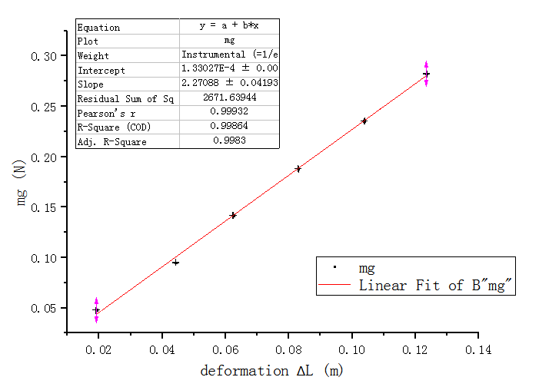

Figure 5 Linear fit of mg v.s. $∆L$ of the first spring

From the figure we obtain the slope is 2.27088 $±0.04193$ N/m; therefore, the spring constant is:

k1= 2.27088 $±0.04193$ N/m.

**5.1.3 Spring constant $k_{2}$**

|  |  |
| --- | --- |
|  | Spring2 length [m] $±{10}^{-4}$ [m] |
| L0 | 7.42 $×{10}^{-2}$ |
| L1 | 9.60 ${×10}^{-2}$ |
| L2 | 11.60 ${×10}^{-2}$ |
| L3 | 13.68 ${×10}^{-2}$ |
| L4 | 15.68 ${×10}^{-2}$ |
| L5 | 17.75 ${×10}^{-2}$ |
| L6 | 19.36 ${×10}^{-2}$ |

Table 6 spring constant k2 measurement data 1

Using the data in table 4 and the formula $∆L=L-L0$ we calculate the deformation:

|  |  |  |
| --- | --- | --- |
|  | Spring2 deformation $∆L$ [m] $±1.4×{10}^{-4}$ [m] | w[N] $±$ 9.794 $×{10}^{-5}$ [N] |
| 1 | 2.18 ${×10}^{-2}$ | 0.0478 |
| 2 | 4.18 ${×10}^{-2}$ | 0.0950 |
| 3 | 6.26 ${×10}^{-2}$ | 0.1420 |
| 4 | 8.26 ${×10}^{-2}$ | 0.1883 |
| 5 | 10.33 ${×10}^{-2}$ | 0.2354 |
| 6 | 11.94 ${×10}^{-2}$ | 0.2824 |

Table 7 spring constant k2 measurement data 2

We use the data and apply linear fit to w and $∆L$, which is shown in figure 6:

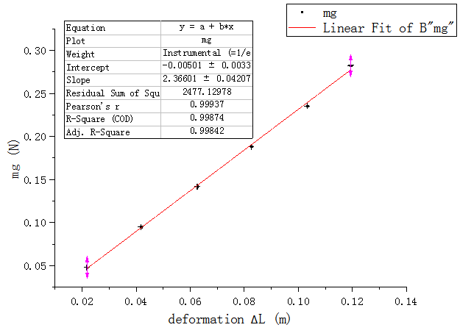

Figure 6 Linear fit of mg v.s. $∆L$ of the second spring

From the figure we obtain the slope is 2.36601 $±0.04207$ N/m; therefore, the spring constant is:

k2=2.36601 $±0.04207$ N/m.

**5.1.3 Spring constant $k_{s}$**

|  |  |
| --- | --- |
|  | Spring3 length [m] $±{10}^{-4}$ [m] |
| L0 | 6.19 $×{10}^{-2}$ |
| L1 | 9.99 ${×10}^{-2}$ |
| L2 | 14.13 ${×10}^{-2}$ |
| L3 | 18.28 ${×10}^{-2}$ |
| L4 | 22.32 ${×10}^{-2}$ |
| L5 | 26.14 ${×10}^{-2}$ |
| L6 | 30.31 ${×10}^{-2}$ |

Table 8 spring constant ks measurement data 1

Using the data in table 4 and the formula $∆L=L-L0$ we can calculate the deformation:

|  |  |  |
| --- | --- | --- |
|  | Spring1 deformation $∆L$ [m] $±1.4×{10}^{-4}$ [m] | w[N] $±$ 9.794 $×{10}^{-5}$ [N] |
| 1 | 3.80 ${×10}^{-2}$ | 0.0478 |
| 2 | 7.94 ${×10}^{-2}$ | 0.0950 |
| 3 | 12.09 ${×10}^{-2}$ | 0.1420 |
| 4 | 16.13 ${×10}^{-2}$ | 0.1883 |
| 5 | 19.95 ${×10}^{-2}$ | 0.2354 |
| 6 | 24.12 ${×10}^{-2}$ | 0.2824 |

Table 9 spring constant ks measurement data 2

We use the data and apply linear fit to w and $∆L$, shown in figure 7:

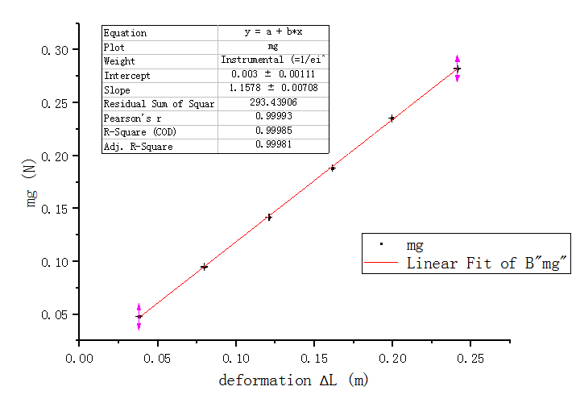

Figure 7 Linear fit of mg v.s. $∆L$ of the spring series

From the figure we obtain the slope is 1.1578 $±0.00708$ N/m; therefore, the equivalent spring constant is:

ks=1.1578 $±0.00708$ N/m.

Compared to the theoretical value of spring constant ks= $\frac{k1k2}{k1+k2}=\frac{2.27088×2.36601}{2.27088+2.36601}=1.15873±0.014N/m$, the experimental result is relatively accurate.

**5.2 Mass Measurement**

Object with I-shape $m_{obj}=173.19g±0.01g$ =0.17319 $±{10}^{-5}$ kg

Object with U-shape $m_{obj}=184.12g±0.01g$ =0.18412 $±{10}^{-5}$ kg

Mass of springs 1&2 $m_{spr1\&2}=21.33g±0.01g$ =0.02133 $±{10}^{-5}$ kg

Therefore, we calculate the following values:

Equivalent mass $M_{0}=m_{obj}$ + $\frac{1}{3}m_{spr1\&2}$

I-shape: $M_{0}=m_{obj}$ + $\frac{1}{3}m_{spr1\&2}$

=173.19+ $\frac{1}{3}×21.33=180.30±0.015g=0.18030±1.05×{10}^{-5}$ kg

U-shape: $M_{0}=m_{obj}$ + $\frac{1}{3}m_{spr1\&2}$

=184.12+ $\frac{1}{3}×21.33=191.23±0.015g=0.19123±1.05×{10}^{-5}$ kg

**5.3 Relation between the Oscillation Period T and Oscillator’s Mass M**

**5.3.1 The Mass of the Oscillator**

We use the data from table 2 to calculate the total mass $M_{tot}=M_{0}$ + $m$

$M_{tot1}=M_{0}$ + $m$ 1=0.1803+4.88 $×{10}^{-3}=0.18518±1.45×{10}^{-5}kg$

$M_{tot2}=M_{0}$ + $m$ 1=0.1803+9.70 $×{10}^{-3}=0.19000±1.45×{10}^{-5}kg$

$M_{tot3}=M_{0}$ + $m$ 1=0.1803+1.45 $×{10}^{-2}=0.19480±1.45×{10}^{-5}kg$

$M_{tot4}=M_{0}$ + $m$ 1=0.1803+1.923 $×{10}^{-2}=0.19953±1.45×{10}^{-5}kg$

$M_{tot5}=M_{0}$ + $m$ 1=0.1803+2.404 $×{10}^{-2}=0.20434±1.45×{10}^{-5}kg$

$M_{tot6}=M_{0}$ + $m$ 1=0.1803+2.883 $×{10}^{-2}=0.20913±1.45×{10}^{-5}kg$

**5.3.2 Horizontal track**

|  |  |
| --- | --- |
|  | Ten periods T’ [s] $±{10}^{-4}$ [s] |
| m1 | 12.5737 |
| m2 | 12.7343 |
| m3 | 12.9004 |
| m4 | 13.0552 |
| m5 | 13.2145 |
| m6 | 13.3681 |

Table 10 Original data 1

We calculate the time of one period T and $T^{2}$, which is shown in the table below:

Take trial 1 for example,

T= $\frac{T'}{10}=\frac{12.5737}{10}=1.25737±{10}^{-5}s$

$$T^{2}=1.25737×1.25737=1.58098{±2.5×{10}^{-5}s}^{2}$$

|  |  |  |  |  |
| --- | --- | --- | --- | --- |
|  | one period T [s] $±{10}^{-5}$ [s] | $T^{2}$ [$s^{2}$] | Uncertainty of $T^{2}$ [$s^{2}$] | Total mass[kg] $±1.45×{10}^{-5}$ [kg] |
| m1 | 1.25737 | 1.58098 | $$±2.5×{10}^{-5}$$ | $$0.18518$$ |
| m2 | 1.27343 | 1.62162 | $$±2.5×{10}^{-5}$$ | 0.19000 |
| m3 | 1.29004 | 1.66420 | $$±2.6×{10}^{-5}$$ | 0.19480 |
| m4 | 1.30552 | 1.70438 | $$±2.6×{10}^{-5}$$ | 0.19953 |
| m5 | 1.32145 | 1.74623 | $$±2.6×{10}^{-5}$$ | 0.20434 |
| m6 | 1.33681 | 1.78706 | $$±2.7×{10}^{-5}$$ | 0.20913 |

Table 11 Data set 1

We apply linear fit to m and $T^{2}$ to study the relationship of them, which is shown in the figure:

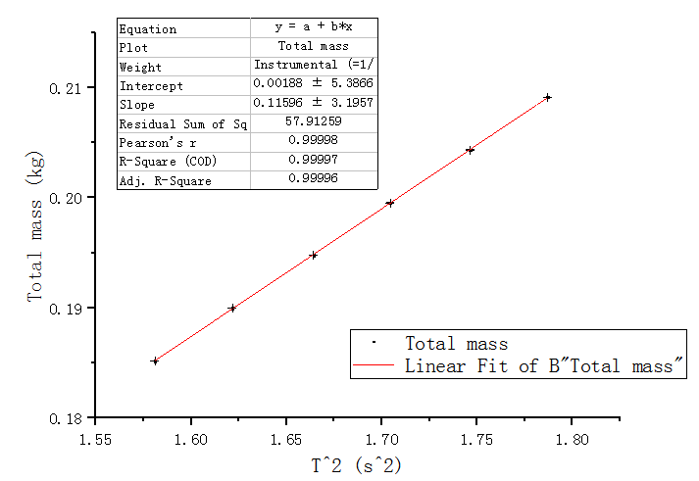

Figure 8 Linear fit of m v.s T^2 of cart on horizontal track

The Pearson’s r is close to 1 and the intercept is close to 0 so that we can conclude that m is directly proportional to $T^{2}$, which is in line with equation 4.

**5.3.2 First Inclined track**

|  |  |
| --- | --- |
|  | Ten periods T’ [s] $±{10}^{-4}$ [s] |
| m1 | 12.5733 |
| m2 | 12.7317 |
| m3 | 12.8929 |
| m4 | 13.0473 |
| m5 | 13.2064 |
| m6 | 13.3606 |

Table 12 Original data 2

We calculate the time of one period T and $T^{2}$, which is shown in the table below:

|  |  |  |  |  |
| --- | --- | --- | --- | --- |
|  | one periods T [s] $±{10}^{-5}$ [s] | $T^{2}$ [$s^{2}$] | Uncertainty of $T^{2}$ [$s^{2}$] | Total mass[kg] $±1.45×{10}^{-5}$ [kg] |
| m1 | 1.25733 | 1.58088 | $$±2.5×{10}^{-5}$$ | $$0.18518$$ |
| m2 | 1.27317 | 1.62096 | $$±2.5×{10}^{-5}$$ | 0.19000 |
| m3 | 1.28929 | 1.66227 | $$±2.6×{10}^{-5}$$ | 0.19480 |
| m4 | 1.30473 | 1.70232 | $$±2.6×{10}^{-5}$$ | 0.19953 |
| m5 | 1.32064 | 1.74409 | $$±2.6×{10}^{-5}$$ | 0.20434 |
| m6 | 1.33606 | 1.78506 | $$±2.7×{10}^{-5}$$ | 0.20913 |

Table 13 Data set 2

We apply linear fit to m and $T^{2}$ to study the relationship of them, which is shown in the figure:

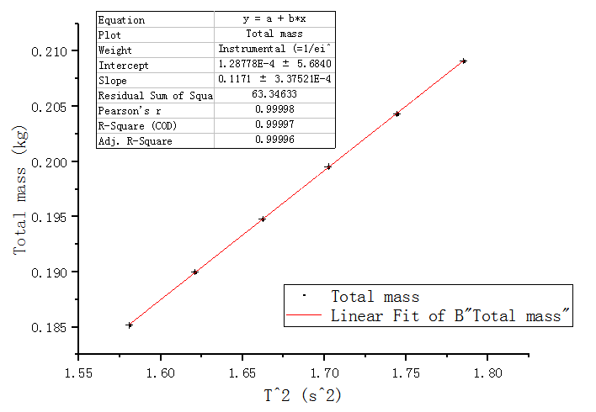

Figure9 Linear fit of m v.s T^2 of cart on first inclined track

**5.3.3 Second Inclined track**

|  |  |
| --- | --- |
|  | Ten periods T’ [s] $±{10}^{-4}$ [s] |
| m1 | 12.5665 |
| m2 | 12.7318 |
| m3 | 12.8929 |
| m4 | 13.0446 |
| m5 | 13.1988 |
| m6 | 13.3572 |

Table 14 Original data 3

We calculate the time of one period T and $T^{2}$, which is shown in the table below:

|  |  |  |  |  |
| --- | --- | --- | --- | --- |
|  | one periods T [s] $±{10}^{-5}$ [s] | $T^{2}$ [$s^{2}$] | Uncertainty of $T^{2}$ [$s^{2}$] | Total mass[kg] $±1.45×{10}^{-5}$ [kg] |
| m1 | 1.25655 | 1.57892 | $$±2.5×{10}^{-5}$$ | $$0.18518$$ |
| m2 | 1.27318 | 1.62098 | $$±2.5×{10}^{-5}$$ | 0.19000 |
| m3 | 1.28929 | 1.66227 | $$±2.6×{10}^{-5}$$ | 0.19480 |
| m4 | 1.30446 | 1.70162 | $$±2.6×{10}^{-5}$$ | 0.19953 |
| m5 | 1.31988 | 1.74208 | $$±2.6×{10}^{-5}$$ | 0.20434 |
| m6 | 1.33572 | 1.78415 | $$±2.7×{10}^{-5}$$ | 0.20913 |

Table 15 Data set 3

We apply linear fit to m and $T^{2}$ to study the relationship of them, which is shown in the figure:

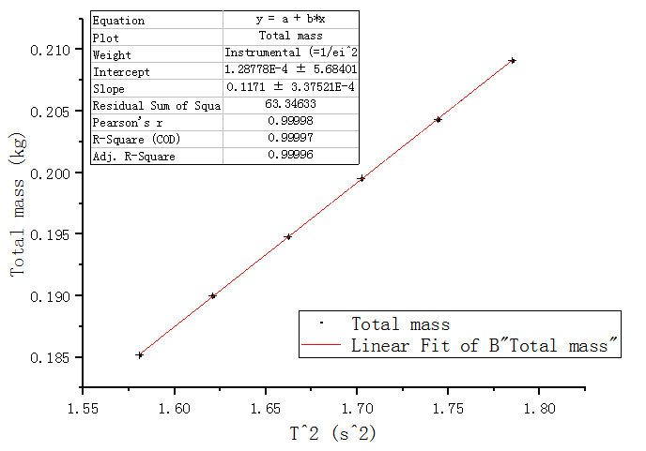

Figure 10 Linear fit of m v.s T^2 of cart on second inclined track

Compare the result figures of the three tracks and we can see that the slopes have no big

difference. We can conclude that the inclination will not affect the relationship between T and M.

**5.4 Relation between the Oscillation Period T and the Amplitude A**

|  |  |
| --- | --- |
|  | Ten periods T’ [s] $±{10}^{-4}$ [s] |
| A1 | 12.5702 |
| A2 | 12.5661 |
| A3 | 12.5674 |
| A4 | 12.5693 |
| A5 | 12.5704 |
| A6 | 12.5729 |

Table 16 Original data

|  |  |  |
| --- | --- | --- |
|  | Amplitude A[m] $±{10}^{-3}[m]$ | One period T [s] $±{10}^{-5}$ [s] |
| 1 | 0.05 | 12.5702 |
| 2 | 0.10 | 12.5661 |
| 3 | 0.15 | 12.5674 |
| 4 | 0.20 | 12.5693 |
| 5 | 0.25 | 12.5704 |
| 6 | 0.30 | 12.5729 |

Table 17 Data set

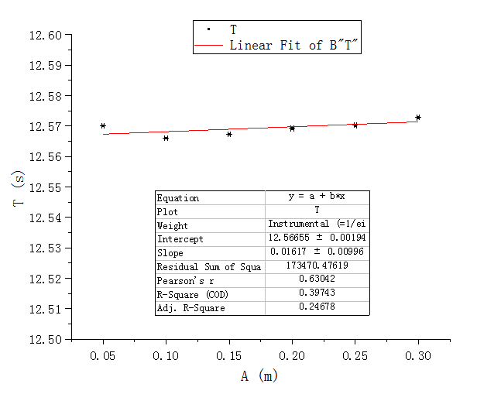

Figure 11 Relationship between A and T

We apply linear fit to A and T. We can see that the slope is very close to 0, which means T is

almost independent from A. However, we find out that the Pearson’s r is 0.63042, which is not

small enough to indicate the independence. The possible reasons are analyzed in discussion.

**5.5 Relation between the Maximum Speed $V_{max}$ and the Amplitude A**

**5.5.1 Measurement of $∆x$**

|  |  |
| --- | --- |
| $$x_{in}[m]±2×{10}^{-5}[m]$$ | $$x_{out}[m]±2×{10}^{-5}[m]$$ |
| 4.72 $×{10}^{-3}$ | 1.498 $×{10}^{-2}$ |
| 4.82 $×{10}^{-3}$ | 1.500 $×{10}^{-2}$ |
| 4.76 $×{10}^{-3}$ | 1.498 $×{10}^{-2}$ |

Table18 Measurement of $x_{in}$ and $x_{out}$

$$\overline{x_{in}}=\frac{1}{3}\sum_{n=1}^{3}{x_{in}n=\frac{4.72×{10}^{-3}+4.82×{10}^{-3}+4.76×{10}^{-3}}{3}=4.77×{10}^{-3}}m$$

Consider the uncertainty, we get $x_{in}$ =4.77 $×{10}^{-3}±1.27×{10}^{-4}m.$

$$\overline{x_{out}}=\frac{1}{3}\sum_{i=1}^{3}{x_{out}i=\frac{1.498×{10}^{-2}+1.500×{10}^{-2}+1.498×{10}^{-2}}{3}=1.499×{10}^{-2}m}$$

Consider the uncertainty, we get $x_{out}$ = $1.498×{10}^{-2}±3.64×{10}^{-5}m$.

Therefore, $\overline{∆x}=\frac{\overline{x_{in}}+\overline{x_{out}}}{2}$ = $\frac{4.77×{10}^{-3}+1.499×{10}^{-2}}{2}=9.88×{10}^{-3}m$

Consider the uncertainty, we get $∆x=9.88×{10}^{-3}±$ 6.61 $×{10}^{-5}m.$

**5.5.2 Measurement of $v_{max}$**

|  |  |  |
| --- | --- | --- |
|  | A[m] $±{10}^{-3}[m]$ | $$∆t[s]±{10}^{-4}[s]$$ |
| 1 | 0.05 | 0.046 |
| 2 | 0.10 | 0.022 |
| 3 | 0.15 | 0.0142 |
| 4 | 0.20 | 0.0134 |
| 5 | 0.25 | 0.0082 |
| 6 | 0.30 | 0.0068 |

Table19 Original data of $∆t with corresponding amplitude$

We apply $v_{max}=\frac{∆x}{∆t}$ and get the value of $v_{max}$ in each trial, shown in the table below:

|  |  |  |
| --- | --- | --- |
|  | $v_{max}$ [m/s] | $uncertainty of v_{max}$ [m/s] |
| 1 | 0.215 | $$±1.42×{10}^{-3}$$ |
| 2 | 0.449 | $$±2.97×{10}^{-3}$$ |
| 3 | 0.696 | $$±4.60×{10}^{-3}$$ |
| 4 | 0.737 | $$±4.88×{10}^{-3}$$ |
| 5 | 1.205 | $$±7.97×{10}^{-3}$$ |
| 6 | 1.453 | $$±9.61×{10}^{-3}$$ |

Table 20 Value of $v_{max}$ and its uncertainty

**5.5.3 Relationship between $v_{max}$ and A**

The total mass $M_{tot}$ equals $M_{0}+m2$ (Since we put six masses on the cart)

= $0.19123+0.02883=0.22006±1.45×{10}^{-5}$ kg

We calculate the value of $M_{tot}{v_{max}}^{2}$ and $A^{2}$:

Take trial 1 as example, $M_{tot}{v_{max}}^{2}=0.22006×{0.215}^{2}=0.01017±1.344×{10}^{-4}kg∙m^{2}/s^{2}$.

$A^{2}$ =0.05 $×0.05=0.0025m^{2}$.

|  |  |  |  |  |
| --- | --- | --- | --- | --- |
|  | $$A^{2}$$ [$m^{2}$] | $$M_{tot}{v_{max}}^{2}$$ [kg $∙m^{2}/s^{2}$] | Uncertainty of $A^{2}$ [$m^{2}$] | Uncertainty of $M_{tot}{v_{max}}^{2}$   [kg $∙m^{2}/s^{2}$] |
| 1 | 0.0025 | 0.01017 | $${10}^{-4}$$ | $$1.344×{10}^{-4}$$ |
| 2 | 0.0100 | 0.04436 | $$2×{10}^{-4}$$ | $$5.869×{10}^{-4}$$ |
| 3 | 0.0225 | 0.10656 | $$3×{10}^{-4}$$ | $$1.409×{10}^{-3}$$ |
| 4 | 0.0400 | 0.11949 | $$4×{10}^{-4}$$ | $$1.583×{10}^{-3}$$ |
| 5 | 0.0625 | 0.31958 | $$5×{10}^{-4}$$ | $$4.227×{10}^{-3}$$ |
| 6 | 0.0900 | 0.46459 | $$6×{10}^{-4}$$ | $$6.146×{10}^{-3}$$ |

Table21 Dataset of $M_{tot}{v_{max}}^{2}$ and $A^{2}$

Apply linear fit to $M_{tot}{v_{max}}^{2}$ and $A^{2}$:

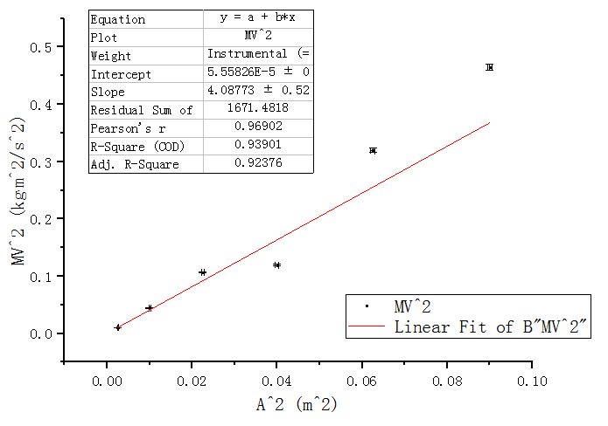

Figure12 Relationship between $M_{tot}{v_{max}}^{2}$ and $A^{2}$

The Pearson’s r is 0.96902, which is very close to 1. The intercept is 5.55826 $×{10}^{-5}$, which is very close to 0. Therefore, we conclude that $M_{tot}{v_{max}}^{2}$ is directly proportional to $A^{2}$, which is inline

with equation (6).

**6. Conclusions and discussion**

**6.1 Conclusions**

In this experiment, we apply the knowledge of Hooke’s law and use the Jolly balance to measure the spring constant. Then we do a series of control experiment to explore the relationship of T&M, T&A, Vmax&A and get the following conclusions:

* k1= 2.27088 $±0.04193$ N/m, k2=2.36601 $±0.04207$ N/m, ks=1.1578 $±0.00708$ N/m.
* $T^{2}$ is directly proportional to M. The inclination of the air track will not affect the slope.
* In our measurement range, T and A are almost independent.
* $M{v_{max}}^{2}$ is directly proportional to $A^{2}$.

**6.2 Error Analysis**

* In the measurement of string length, we judged whether three lines coincide with each other before reading. There might exist errors since it’s hard to compare the positions of the three lines.
* Vmax should be measured at the equilibrium position. However, since U-shape shutter has width, we cannot ensure the photoelectric gate is fixed at the equilibrium position.
* In 5.5.2, for the first two trials we made a mistake in the reading of $∆t$. We forget to record the fourth digit after the decimal. This might reduce the accuracy in calculation.
* In 5.5, the standard mass of the object should be only the cart and the U-shape shutter. However, we added masses to the cart. Although it does not affect the conclusion, it results in an extra uncertainty factor and increases the uncertainty range.
* In the analysis of the relationship between T and A. Although theoretically they are independent, the Pearson’s r is not small enough to indicate this fact. However, the r is affected by the number of trials. We only did 6 trials so that the data seems to fluctuate largely. When the sample size is too small, it is not scientific to determine the correlation between two variables by analyzing r. If we continue to do more trials, the Pearson’s r will be closer to 0 and the result will be clearer.
* In 5.5, the slope of mv^2 v.s.A^2 is the equivalent spring constant, which is 4.08773N/m from the figure. However, the theoretical value of the two springs in parallel is k1+k2=2.27+2.36=4. 63N/m. Our experimental result is smaller, and the error might come from the inaccuracy in the reading of A from the air track.

**6.3 Improvements**

* When measuring spring constant, uncertainty exists in the step of measuring the weight put on the spring because there is a step multiplying m and g. To increase the accuracy, we can use a forcemeter to replace the mass so that the weight can be directly read.
* Do more trials in section 5.5
* According to research[1], the effective mass of the spring is not always exactly 1/3 of its mass. When the mass of the object is increased, the error brought by the effective mass can be reduced. Therefore, use a heavier cart might bring more accurate and realistic results.

**7. Reference**

[1]Cheng, Meihua, ”The Error Analysis of the Vibration Angle-Frequency of the Spring Oscillator

with Spring Mass. ” Jiaying University.

**A. Measurement uncertainty analysis**

**A.1 Uncertainty in Measurement of Spring Constant**

**A.1.1 Uncertainty of the weight measurement**

$$w=mg$$

$$\frac{∂w}{∂m}=g=9.794m/s^{2}$$

$$\frac{∂v}{∂g}=m$$

$$u_{m}=∆_{A}=0.01g$$

$$u_{g}=0$$

$$u_{w}=\sqrt{{(\frac{∂w}{∂m})}^{2}{u_{m}}^{2}+{(\frac{∂w}{∂g})}^{2}{u_{g}}^{2}}=\sqrt{{(9.794)}^{2}×{0.01}^{2}+m^{2}×0^{2}}=0.09794N$$

**A.1.2 Uncertainty of the spring deformation measurement**

$$∆L=L-L0$$

According to the uncertainty propagation formula,

$$u_{∆L}=\sqrt{{u_{L}}^{2}+{u_{L}}^{2}}=\sqrt{{0.01}^{2}+{0.01}^{2}}=0.014cm=1.4×{10}^{-4}m$$

**A.1.3 Uncertainty of the theoretical value of ks**

$$k1=2.27088±0.04193N/m$$

$$k2=2.36601±0.04207N/m$$

$$ktheo,s=\frac{k1k2}{k1+k2}$$

$$\frac{∂ktheo,s}{∂k1}=\frac{{k2}^{2}}{{\left(k1+k2\right)}^{2}}=\frac{{2.36601}^{2}}{{\left(2.27088+2.36601\right)}^{2}}=0.26036$$

$$\frac{∂ktheo,s}{∂k2}=\frac{{k1}^{2}}{{\left(k1+k2\right)}^{2}}=\frac{{2.27088}^{2}}{{\left(2.27088+2.36601\right)}^{2}}=0.23985$$

$$u_{w}=\sqrt{{(\frac{∂ktheo,s}{∂k1})}^{2}{u_{k1}}^{2}+{(\frac{∂ktheo,s}{∂k2})}^{2}{u_{k2}}^{2}}=0.014N/m$$

**A.2 Uncertainty of the mass $M_{0}$**

$M_{0}=m_{obj}$ + $\frac{1}{3}m_{spr1\&2}$

According to the uncertainty propagation formula,

$$u_{M_{0}}=\sqrt{{u_{m_{obj}}}^{2}+{(\frac{1}{3}u_{m_{spr1\&2}})}^{2}}=\sqrt{{({10}^{-5})}^{2}+{(\frac{{10}^{-5}}{3})}^{2}}=1.05×{10}^{-5}kg$$

**A.3 Uncertainty in the Analysis of Relation between the Oscillation Period T and the Mass of the Oscillator M**

**A.3.1 Uncertainty of the total mass $M_{tot}$**

$M_{tot}=M_{0}$ + $m$

According to the uncertainty formula,

$$u_{M_{tot}}=\sqrt{{u_{M_{0}}}^{2}+{u_{m}}^{2}}=\sqrt{{({1.05×10}^{-5})}^{2}+{({10}^{-5})}^{2}}=1.45×{10}^{-5}kg$$

**A.3.2 Uncertainty of one period T**

T= $\frac{T'}{10}$

According to the uncertainty propagation formula,

$$u_{T}=\frac{1}{10}u_{T'}={10}^{-5}s$$

**A.3.2 Uncertainty of $T^{2}$**

$$\frac{∂T^{2}}{∂T}=2T$$

$$u_{T^{2}}=\sqrt{{(\frac{∂T^{2}}{∂T})}^{2}{u_{T}}^{2}}=\sqrt{{(2T)}^{2}×{({10}^{-5}s)}^{2}}=2×{10}^{-5}Ts$$

For horizontal air track:

$$u_{{T1}^{2}}=2×{10}^{-5}×1.25737=2.5×{10}^{-5}s^{2}$$

$$u_{{T2}^{2}}=2×{10}^{-5}×1.27343=2.5×{10}^{-5}s^{2}$$

$$u_{{T2}^{2}}=2×{10}^{-5}×1.29004=2.6×{10}^{-5}s^{2}$$

$$u_{{T2}^{2}}=2×{10}^{-5}×1.30552=2.6×{10}^{-5}s^{2}$$

$$u_{{T2}^{2}}=2×{10}^{-5}×1.32145=2.6×{10}^{-5}s^{2}$$

$$u_{{T2}^{2}}=2×{10}^{-5}×1.33681=2.7×{10}^{-5}s^{2}$$

For the first inclined air track:

$$u_{{T1}^{2}}=2×{10}^{-5}×1.25733=2.5×{10}^{-5}s^{2}$$

$$u_{{T2}^{2}}=2×{10}^{-5}×1.27317=2.5×{10}^{-5}s^{2}$$

$$u_{{T2}^{2}}=2×{10}^{-5}×1.28929=2.6×{10}^{-5}s^{2}$$

$$u_{{T2}^{2}}=2×{10}^{-5}×1.30473=2.6×{10}^{-5}s^{2}$$

$$u_{{T2}^{2}}=2×{10}^{-5}×1.32064=2.6×{10}^{-5}s^{2}$$

$$u_{{T2}^{2}}=2×{10}^{-5}×1.33606=2.7×{10}^{-5}s^{2}$$

For the second inclined air track:

$$u_{{T1}^{2}}=2×{10}^{-5}×1.25665=2.5×{10}^{-5}s^{2}$$

$$u_{{T2}^{2}}=2×{10}^{-5}×1.27318=2.5×{10}^{-5}s^{2}$$

$$u_{{T2}^{2}}=2×{10}^{-5}×1.28929=2.6×{10}^{-5}s^{2}$$

$$u_{{T2}^{2}}=2×{10}^{-5}×1.30446=2.6×{10}^{-5}s^{2}$$

$$u_{{T2}^{2}}=2×{10}^{-5}×1.31988=2.6×{10}^{-5}s^{2}$$

$$u_{{T2}^{2}}=2×{10}^{-5}×1.33572=2.7×{10}^{-5}s^{2}$$

**A.4 Uncertainty of $∆x$**

**A.4.1 Uncertainty of $x_{in}$**

$$\overline{x_{in}}=4.77×{10}^{-3}m$$

As the maximum uncertainty of the calliper is 2 $×{10}^{-5}m$, $∆_{B}=2×{10}^{-5}m$

n=3, so $∆_{A}={\frac{t_{0.95}}{\sqrt{n}}S}_{t}=\frac{t_{0.95}}{\sqrt{n}}\sqrt{\frac{1}{n-1}\sum_{i=1}^{n}{{({x_{in}}_{i}-\overline{x_{in}})}^{2}}}=1.25×{10}^{-4}m$

The total uncertainty $u_{x_{in}}=\sqrt{{∆_{A}}^{2}+{∆_{B}}^{2}}=1.27×{10}^{-4}m$

The corresponding relative uncertainty $u_{rt}=\frac{u_{x_{in}}}{\overline{x_{in}}}×100\%=2.66\%$

Therefore, the experimental found time the ball travels $x_{in}$ =4.77 $×{10}^{-3}±1.27×{10}^{-4}m$

**A.4.2 Uncertainty of $x_{out}$**

$$\overline{x_{out}}=1.498×{10}^{-2}m$$

As the maximum uncertainty of the calliper is 2 $×{10}^{-5}m$, $∆_{B}=2×{10}^{-5}m$

n=3, so $∆_{A}={\frac{t_{0.95}}{\sqrt{n}}S}_{t}=\frac{t_{0.95}}{\sqrt{n}}\sqrt{\frac{1}{n-1}\sum_{i=1}^{n}{{({x_{out}}_{i}-\overline{x_{out}})}^{2}}}=3.037×{10}^{-5}m$

The total uncertainty $u_{x_{out}}=\sqrt{{∆_{A}}^{2}+{∆_{B}}^{2}}=3.64×{10}^{-5}m$

The corresponding relative uncertainty $u_{r,out}=\frac{u_{x_{out}}}{\overline{x_{out}}}×100\%=0.24\%$

Therefore, the experimental found time the ball travels $x_{out}$ = $1.498×{10}^{-2}±3.64×{10}^{-5}m$.

**A.4.3 Uncertainty of $∆x$**

$$∆x=\frac{x_{in}+x_{out}}{2}$$

$$\frac{∂∆x}{∂x_{in}}=\frac{∂∆x}{∂x_{out}}=\frac{1}{2}$$

$$u_{x_{in}}=1.27×{10}^{-4}m$$

$$u_{x_{out}}=3.64×{10}^{-5}m$$

$u_{∆x}=\sqrt{{(\frac{∂∆x}{∂x_{in}})}^{2}{u_{x_{in}}}^{2}+{(\frac{∂∆x}{∂x_{out}})}^{2}{u_{x_{out}}}^{2}}=$ 6.61 $×{10}^{-5}m.$

Therefore, $∆x=9.88×{10}^{-3}±$ 6.61 $×{10}^{-5}m$

**A.5 Uncertainty of $V_{max}$**

$$v_{max}=\frac{∆x}{∆t}$$

$$\frac{∂v_{max}}{∂∆x}=\frac{1}{∆t}$$

$$\frac{∂v_{max}}{∂∆t}=\frac{-∆x}{{(∆t)}^{2}}$$

$u_{∆x}=$ 6.61 $×{10}^{-5}m$

$$u_{∆t}={10}^{-4}s$$

$$u_{v_{max}}=\sqrt{{(\frac{∂v_{max}}{∂∆x})}^{2}{u_{∆x}}^{2}+{(\frac{∂v_{max}}{∂∆t})}^{2}{u_{∆t}}^{2}}=\sqrt{\frac{4.27041×{10}^{-9}}{{(∆t)}^{2}}}$$

Therefore, $u_{v_{max}1}=1.42×{10}^{-3}m/s$

$$u_{v_{max}2}=2.97×{10}^{-3}m/s$$

$$u_{v_{max}3}=4.60×{10}^{-3}m/s$$

$$u_{v_{max}4}=4.88×{10}^{-3}m/s$$

$$u_{v_{max}5}=7.97×{10}^{-3}m/s$$

$$u_{v_{max}6}=9.61×{10}^{-3}m/s$$

**A.6 Uncertainty in the Analysis of Relation between the Maximum Speed and the Amplitude**

**A.6.1 Uncertainty of the total mass $M_{tot}$**

$M_{tot}=M_{0}$ + $m$ 6

According to the uncertainty formula,

$$u_{M_{tot}}=\sqrt{{u_{M_{0}}}^{2}+{u_{m2}}^{2}}=\sqrt{{({1.05×10}^{-5})}^{2}+{({10}^{-5})}^{2}}=1.45×{10}^{-5}kg$$

**A.6.2 Uncertainty of the total mass $A^{2}$**

$$\frac{∂A^{2}}{∂T}=2A$$

$$u_{A^{2}}=\sqrt{{(\frac{∂A^{2}}{∂A})}^{2}{u_{A}}^{2}}=\sqrt{{(2A)}^{2}×{({10}^{-3}m)}^{2}}=2×{10}^{-3}Am$$

For horizontal air track:

$$u_{{A1}^{2}}=2×{10}^{-3}×0.05={10}^{-4}m^{2}$$

$$u_{{A2}^{2}}=2×{10}^{-3}×0.1=2×{10}^{-4}m^{2}$$

$$u_{{A3}^{2}}=2×{10}^{-3}×0.15=3×{10}^{-4}m^{2}$$

$$u_{{A4}^{2}}=2×{10}^{-3}×0.2=4×{10}^{-4}m^{2}$$

$$u_{{A5}^{2}}=2×{10}^{-3}×0.25=5×{10}^{-4}m^{2}$$

$$u_{{A6}^{2}}=2×{10}^{-3}×0.3=6×{10}^{-4}m^{2}$$

**A.6.3 Uncertainty of the total mass $M_{tot}{v_{max}}^{2}$**

$$\frac{∂M_{tot}{v_{max}}^{2}}{∂M_{tot}}{{=v}_{max}}^{2}$$

$$\frac{∂M_{tot}{v_{max}}^{2}}{∂v_{max}}=2M_{tot}v_{max}$$

$$u_{M_{tot}{v_{max}}^{2}}=\sqrt{{\left(\frac{∂M_{tot}{v_{max}}^{2}}{∂M_{tot}}\right)}^{2}{u_{M_{tot}}}^{2}+{\left(\frac{∂M_{tot}{v_{max}}^{2}}{∂v_{max}}\right)}^{2}{u_{v_{max}}}^{2}}$$

= $\sqrt{{v_{max}}^{4}×2.1025×{10}^{-10}+{\left(0.44012×v_{max}\right)}^{2}×{u_{v_{max}}}^{2}}$

$$u_{M_{tot}{v_{max1}}^{2}}=1.344×{10}^{-4}kg∙m^{2}/s^{2}$$

$$u_{M_{tot}{v_{max2}}^{2}}=5.869×{10}^{-4}kg∙m^{2}/s^{2}$$

$$u_{M_{tot}{v_{max3}}^{2}}=1.409×{10}^{-3}kg∙m^{2}/s^{2}$$

$$u_{M_{tot}{v_{max4}}^{2}}=1.583×{10}^{-3}kg∙m^{2}/s^{2}$$

$$u_{M_{tot}{v_{max5}}^{2}}=4.227×{10}^{-3}kg∙m^{2}/s^{2}$$

$$u_{M_{tot}{v_{max6}}^{2}}=6.146×{10}^{-3}kg∙m^{2}/s^{2}$$

**B. Data sheet**

