UM-SJTU Joint Institute

Physics Laboratory

(Vp141)

Laboratory Report

Exercise 4

Measurement of the Speed of Sound

Name: Wenxin He ID: 518370910117 Group: 2

Name: Yuanchen Bai ID:518370910183 Group:2

Date: 28 June 2019

**1. Introduction**

The objective of this experiment is to use three methods to measure the speed of the sound in air: the resonance method, the phase comparison method and the time difference method. The methods of operating a function generator and an oscilloscope are also studied.

**2. Theoretical Background**

**2.1 Basic Quantitative Characteristics of Sound Waves**

Sound is a longitudinal wave propagating through a compressible medium as the direction of the medium vibrations is the same as that of propagation. The frequency of sound perceptible to human ears is within the range of 20Hz to 20000Hz. In this experiment, we use ultrasonic wave because its wavelength is short enough to be measured in a teaching lab.

The formula of the phase speed v, the frequency f, and the wavelength $λ$ is:

$$v=λf (1)$$

For motion with constant speed v along a straight line with distance L over time t, we have:

$$v=\frac{L}{t} (2)$$

**2.2 Measurement Method**

**2.2.1 Resonance Method**

The distance between the wave source(s1) and the receiver(s2) is L. when arranged parallel to each other, the sound wave will be reflected. If L satisfies:

$$L=n\frac{λ}{2} (3)$$

Where n=1, 2,…. , standing waves will form as the distance is a multiple of half of the wavelength. Under this circumstance, a maximum output power will be observed in the oscillography. As shown in figure 1, the interval between two maximum points is $\frac{λ}{2}$. Therefore, $λ$ can be measured from the oscillography. By reading the frequency f from the signal generator, we can calculate the wavelength using equation (1).

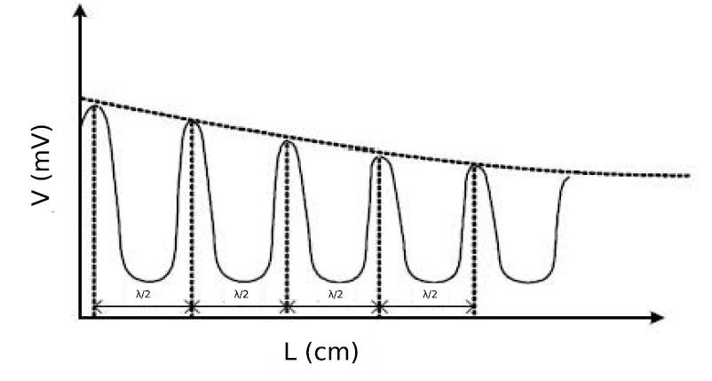

Figure 1 Relationship between the signal voltage and the distance between the transducers

**2.2.2 Phase-comparison Method**

Lissajous figures are used to display the trajectories of a particle moving simultaneously in two perpendicular directions. On x direction the wave function is $A_{x}cos⁡(ω_{x}t+ϕ_{x})$ and on y direction the wave function is $A_{y}\cos\left(ω_{y}t+ϕ_{y}\right).$ Therefore, the trajectory of the particle is $r\left(t\right)=(A_{x}\cos\left(ω_{x}t+ϕ_{x}\right),A_{y}\cos\left(ω_{y}t+ϕ_{y}\right))$. When the two superimposed harmonic motions have identical frequency $ω_{x}=ω_{y}$ and ||=n $π$ (n=0,1,2…), the Lissajous figure will show a straight line. For other phase difference values the figure will show corresponding elliptical shapes.

In this experiment, we find different values of L when a line of the same slope is displayed. When the distance increases by $λ$, $ϕ$ increases by 2 $π,$ and the superimpose figure can be the same. Therefore, the slope of the linear fit of L v.s. i is $λ.$

**2.2.3 Time-difference Method**

When S2 receives an ultrasonic pulse signal emitted by S1, one can measure the time interval for the sound travelling from S1 to S2. When L and t is known, the speed of sound can be calculated from equation (2).

**3. Experimental Setup**

Shown in figure 2 are the components of the transducer and oscilloscope.

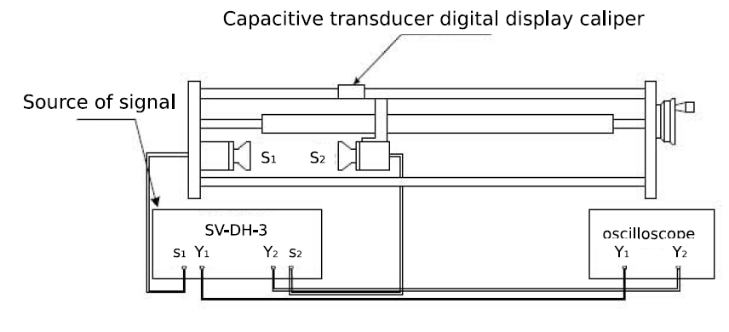

Figure 2 Experimental Setup

The information of each measurement device is shown in Table 1.

|  |  |  |  |
| --- | --- | --- | --- |
| apparatus | range | Minimum scale of value | Maximum uncertainty |
| Thermometer | -40 $℃\sim 50℃$ | 1 $℃$ | $±$ 1 $℃$ |
| Signal generator | / | 0.001kHz | $±$ 0.001kHz |
| Scale on the transducer | 0~300mm | 0.001mm | $±$ 0.001mm |
| Cursor function | / | 0.4 $μs$ | $±$ 0.4 $μs$ |

Table 1 Information of Each Measurement Device

**4. Measurements**

**4.1 Resonance Method**

1. First set the distance between S1 and S2 at about 1cm.

2. Device Initialization: Turn on the signal source and the oscilloscope. Then set the *Method* on the signal source to be *continuous*. Adjust *Signal Strength* until a 10V peak is displayed on the oscilloscope. Adjust *signal frequency* between 34.5 kHz and 40 kHz until the peak-to-peak voltage reaches its maximum. Record the frequency.

3. Move S2 away from S1 to increase L and observe the figure shown on the oscilloscope. Record the position of S2 when the output voltage reaches its maximum.

4. Repeat step 3 to record 12 values of L and apply linear fit to get the value of v.

**4.2 Phase-comparison Method**

1. Set the device to corresponding mode.

2. Increase the distance and record the distance when there is a straight up-right line shown on the screen.

3. Repeat step 2 and collect 12 sets of data in total.

4. Apply linear fit to get the value of v.

**4.3 Time difference Method**

1. Set the device to corresponding mode. Set the initial distance to be larger than 100mm.

2. Set the distance to be different values and record the time the wave needs to propagate.

3. Collect 12 sets of data and apply linear fit to get the value of v.

**5. Results**

**5.1 Initial settings**

The temperature is measured at 21 $±1℃$

The frequency we choose is 39.118 $±0.001kHz$ =39118 $±1Hz$

**5.2 Resonance Method**

|  |  |  |  |
| --- | --- | --- | --- |
| $$L_{i}[mm]±0.001[mm]$$ | | | |
| 1 | 77.298 | 7 | 103.776 |
| 2 | 81.796 | 8 | 108.520 |
| 3 | 85.926 | 9 | 112.746 |
| 4 | 90.302 | 10 | 116.840 |
| 5 | 94.704 | 11 | 121.820 |
| 6 | 99.612 | 12 | 126.123 |

Table 2 Resonance distances

According to equation(3), we want to know the value of $λ,$ so we apply linear fit of L v.s. I, shown

in figure3.

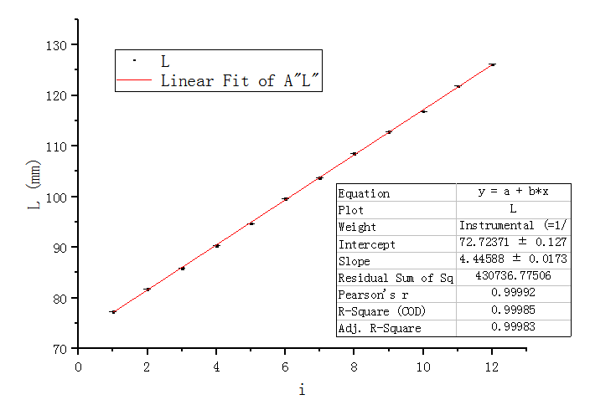

Figure 3 Linear fit of L v.s. i

Obtained from the figure, the slope is 4.44588mm and the standard error is 0.0173mm. The CI

harf-width is 0.0173 $×t_{10,0.95}=$ 0.0173 $×2.228=$ 0.0385mm, rounded to be $4×{10}^{-2}$ mm.

Therefore, the uncertainty of the slope is $4×{10}^{-2}$ mm. Since the slope equals $\frac{λ}{2}$, we obtain the

rounded $λ=2×4.44588=$ 8.89 $±8×{10}^{-2}mm$ =8.89 $×{10}^{-3}±{8×10}^{-5}m.$

According to equation(1), $v=λf=8.89×{10}^{-3}×39118=347.76±3m/s$.

**5.3 Phase-comparison Method**

|  |  |  |  |
| --- | --- | --- | --- |
| $$L_{i}[mm]±0.001[mm]$$ | | | |
| 1 | 128.780 | 7 | 182.630 |
| 2 | 137.823 | 8 | 190.430 |
| 3 | 146.896 | 9 | 199.310 |
| 4 | 155.902 | 10 | 208.061 |
| 5 | 164.966 | 11 | 217.849 |
| 6 | 173.876 | 12 | 226.731 |

Table 3 Distance of the same phase

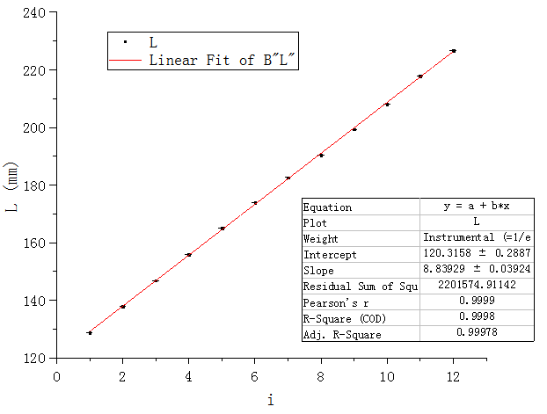

Figure 4 Linear fit of L v.s. i

Obtained from the figure, the slope is 8.83929mm and the standard error is 0.03924mm. The CI

harf-width is 0.03924 $×t_{10,0.95}=$ 0.03924 $×2.228=$ 0.08743mm, rounded to be $9×{10}^{-2}$ mm.

Therefore, the uncertainty of the slope is $9×{10}^{-2}$ mm. Since the slope equals λ, we obtain the

rounded $λ=$ 8.84 $±9×{10}^{-2}mm$ =8.84 $×{10}^{-3}±{9×10}^{-5}m.$

According to equation(1), $v=λf=8.84×{10}^{-3}×39118=346.63±4m/s$.

**5.4 Time Difference Method**

|  |  |  |
| --- | --- | --- |
|  | $$t_{i}[μs]±0.4[μs]$$ | $$L_{i}[mm]±0.001[mm]$$ |
| 1 | 97.6 | 135.639 |
| 2 | 102.6 | 142.315 |
| 3 | 107.2 | 148.820 |
| 4 | 112.4 | 156.360 |
| 5 | 117.6 | 164.415 |
| 6 | 123.6 | 177.325 |
| 7 | 130.0 | 181.680 |
| 8 | 134.4 | 189.300 |
| 9 | 139.2 | 196.500 |
| 10 | 145.2 | 205.270 |
| 11 | 151.6 | 214.320 |
| 12 | 158.4 | 224.250 |

Table 4 distance

As t depends on L, we apply linear fit to t v.s. L, shown in figure 5.

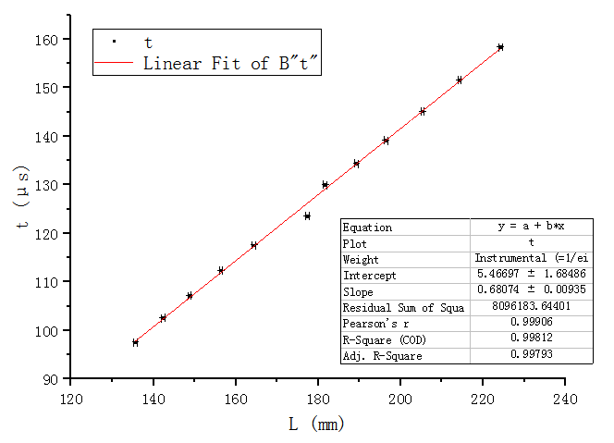

Figure 5 Linear fit of t v.s. L

Obtained from the figure, the slope is 0.68074 $μs$/mm and the standard error is 0.00935 $μs$/mm.

The CI harf-width is 0.00935 $×t_{10,0.95}=$ 0.00935 $×2.228=$ 0.02083 $μs$/mm, rounded to be

$2×{10}^{-2}μs$/mm.

Therefore, the uncertainty of the slope is $2×{10}^{-2}μs$/ $mm$. Since the slope equals $\frac{ 1}{v}$, we obtain the rounded $\frac{ 1}{v}=$ 0.681 $±2×{10}^{-2}μs/mm=6.81×{10}^{-4}±2×{10}^{-5}s/m.$

Then we calculate v, which is $\frac{1}{6.81×{10}^{-4}}=1468.43±4×{10}^{1}m/s$.

**6. Conclusions and discussion**

**6.1 Conclusions**

In this experiment, we calculate the speed of sound using three methods. Shown below are the experimental results.

* From the resonance method: $v_{air}=347.76±3m/s$.
* $From the phase-comparison method:v_{air}=346.63±4m/s$.
* From the time difference method: $v_{water}=1468.43±4×{10}^{1}m/s$.

Judging from the uncertainty, the phase-comparison method provides a more accurate result.

According to authorities, the speed of sound in air at 20 $℃=344m/s$, and the speed of sound in water at 20 $℃=1482m/s.$ [1] Our results are all larger than theory, which is reasonable because in both gas and liquid, the higher the temperature, the larger the speed of sound. But our data still have errors, which will be discussed in 6.2.

**6.2 Error Analysis**

* In resonance method, there exist errors in the measurement of L. It is hard to control when to read the readings because we have to take the readings at the exact moment that the amplitude of the V function starts to decrease. There are too many objective judgements in this step.
* In phase-comparison method, we also need to judge when the figure is a straight line by ourselves. Since the figure is changing slightly all the time, the readings are inaccurate.
* In time difference method, due to the use of devices, the temperature of water might increase, which results in change of speed of sound in water.
* There are too many factors that will disturb the sound wave. The shown figure on the oscilloscope might not be the actual one.
* The wave will lose energy when propagating from S1 to S2, so S2 might receive a different wave from the one that S1 emits.

**6.3 Discussions**

* The temperature T must be measured because it is a factor which affects the speed of sound. Take liquid for example, v= $\sqrt{\frac{B}{ρ}},$ where B is the bulk modulus of fluid and $ρ$ is the fluid density, and of course the density is subject to temperature.
* In phase-comparison method, we should use ‘straight line’ Lissajous figures as reference because it is the easiest to judge when the same line appears again. For other elliptical figures, it is hard to find out the exact same pattern as the previous time.
* In time difference method, we should set the initial distance to be larger than 100mm. Since the speed of sound in water is expected to be around 1500m/s, the time needed for sound to propagate 100mm is 6.67 $×{10}^{-5}$ s. If the distance is too small, the device is not precise enough to measure the time interval.
* We have to measure the speed of sound under the resonance frequency. Only under this circumstance can a standing wave be formed so that the transducer can receive the strongest voltage signal and has the highest sensitivity.

**6.4 Improvements**

* Let the machine detect the distance where V reaches its maximum rather than humans.
* Do more experiments, apply more linear fits and take the average value as the speed of sound.
* Use ultrasonic wave of different frequencies in the resonance frequency range.

**7. Reference**

[1]Young, Hugh.A and Freedman, Roger. A. *University Physics*.p.535.

**A. Measurement uncertainty analysis**

**A.1 Uncertainty in Analysis of the Resonance Method**

**A.1.1 Uncertainty of $λ$**

Ths slope k is $\frac{λ}{2}=4.43539±0.06mm$

$$λ=2k$$

$$u_{λ}=2u_{k}=2×0.04=0.08mm=8×{10}^{-5}m$$

**A.1.2 Uncertainty of v**

V= $λf$

$$\frac{∂v}{∂λ}=f=1Hz$$

$$\frac{∂v}{∂f}=λ=8.89×{10}^{-3}m$$

$$u_{v}=\sqrt{{(\frac{∂v}{∂λ})}^{2}{u_{λ}}^{2}+{(\frac{∂v}{∂f})}^{2}{u_{f}}^{2}}=\sqrt{{39118}^{2}×{(8×{10}^{-5})}^{2}+{(8.89×{10}^{-3})}^{2}×1}=3m/s$$

**A.2 Uncertainty in Analysis of the Phase-comparison Method**

**A.2.1 Uncertainty of $λ$**

From 5.3 we know the slope k is $λ$ =8.84 $×{10}^{-3}±{9×10}^{-5}m$.

$$u_{λ}={9×10}^{-5}m$$

**A.2.2 Uncertainty of $v$**

V= $λf$

$$\frac{∂v}{∂λ}=f=39118Hz$$

$$\frac{∂v}{∂f}=λ=8.84×{10}^{-3}m$$

$$u_{v}=\sqrt{{(\frac{∂v}{∂λ})}^{2}{u_{λ}}^{2}+{(\frac{∂v}{∂f})}^{2}{u_{f}}^{2}}=\sqrt{{39118}^{2}×{({9×10}^{-5})}^{2}+{(8.84×{10}^{-3})}^{2}×1}=4m/s$$

**A.2 Uncertainty in Analysis of the Time Difference Method**

$$\frac{1}{v}=6.8×{10}^{-4}±2×{10}^{-5}s/m$$

$$\frac{∂\frac{1}{v}}{∂v}=\frac{-1}{v^{2}}$$

$$u_{v}=\sqrt{{(\frac{∂\frac{1}{v}}{∂v})}^{2}{u_{\frac{1}{v}}}^{2}}=\sqrt{{(\frac{-1}{{(6.81×{10}^{-4})}^{2}})}^{2}×{(2×{10}^{-5})}^{2}}=4×{10}^{1}m/s$$

**B. Data sheet**