*VC211 FALL 2020 Chemistry Lab Report*

**Experiment E1**

**Acids and Bases**

[Han Yibei]

[Dec. 14, 2020]

Student ID: 519370910123

Section #: 3

Group #: 3

Group Members: Shen Kaixin 519370910128

Zhang Zongkai 519370910109

Lu Xinyi 519370910122

Telephone #: 18918329709

Email Address: 1982600614@qq.com

*There are main sections in each report, Pre-lab Exercises and Post-lab Report. Please finish the* ***Pre-lab*** *exercises before your scheduled lab time, which is* ***due at the beginning of each lab****. You need to submit* ***a hard copy*** *(double-sided printing) of your finished Pre-lab exercises (hand-written or typed) to your section TA when meet in the chemistry building. Please print out ‘****DATA SHEET’*** *to fill in raw data during the lab. You have* ***one week*** *to finish the* ***Post-lab*** *section after conducting each experiment (except E2&E5). Submit the hard copy of completed report (double-side printing) to your section TA when meet for the next experiment in the lab.*

**This is for TAs ONLY. DO NOT write in this table.**

|  |  |  |  |  |
| --- | --- | --- | --- | --- |
| **Grades** | | | | **Grader/s** |
| Pre-lab (100 pts) | |  | |  |
| Post-lab  (100+10 pts) | Observation (30 pts) |  |  |  |
| Data Analysis (30 pts) |  |  |
| Discussion (30+10 pts) |  |  |
| Data Sheet (10 pts) |  |  |
| Total |  | |  |

University of Michigan – Shanghai Jiao Tong University Joint Institute (UM-SJTU JI)

**POST-LAB**

*Please finish (hand-written or typed) this report during and/or after the lab and submit it (double-sided printing) to your section TA when meeting for the next experiment. This report consists of OBSERVATION, DATA ANALYSIS, DISCUSSION, and DATA SHEET, and are worth a total of 100 points, counted as 6% of the total course grade. The DATA SHEET is for recording of raw data during your lab work and shall be submitted as it is (the very original copy you filled in during lab). Calculations and data analysis shall use the original data you obtained in the lab. Any alteration to raw data is a serious violation to HONOR CODE and you will receive ‘0’ point for Post-Lab Report.*

OBSERVATION

**Part A. Relative Acidity/Basicity of Common Household Products**

Describe your observations in the experiment briefly. Please provide the pictures of the standard color chart and the used pH strips corresponding to each product you selected.

Attach a table summarizing the colors of the universal indicator paper that you used to test the pH of the selected one or two household products. Put a star next to the household indicator product(s) that you personally tested.

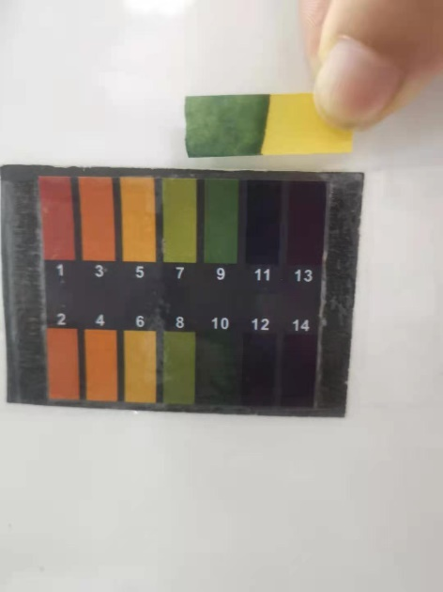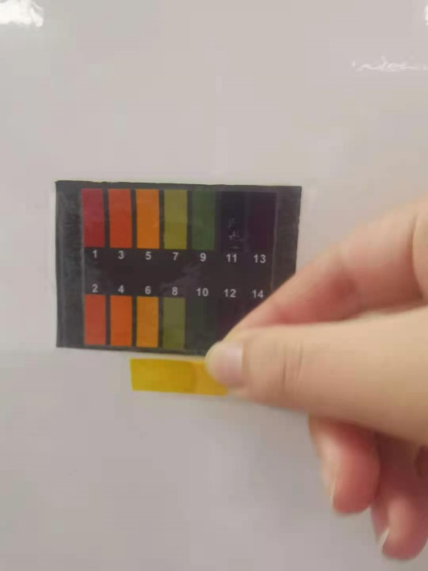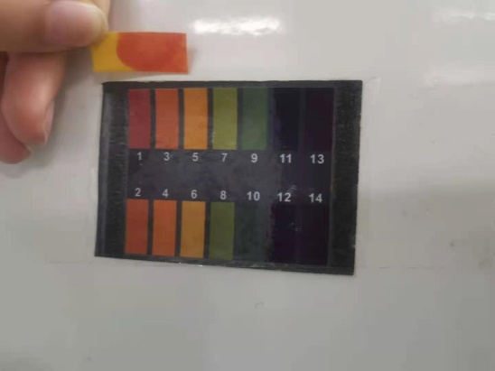

**Figure 1 Color of indicator paper compared with chart**

As is shown in **Figure 1**, we tested three chemicals: vinegar, tapping water and $NH_{3}⋅H_{2}O$. By comparing with the pH chart, we found that the pH of vinegar is 3 and the indicator color is red, tapping water is 7 and the indicator color is yellow, $NH_{3}⋅H_{2}O$ is 9 and the indicator color is green.

|  |  |  |  |
| --- | --- | --- | --- |
| Product | Vinegar | $$NH_{3}⋅H_{2}O$$ | Tapping Water |
| Color | Red | Green | Yellow |
| pH | 3 | 9 | 7 |

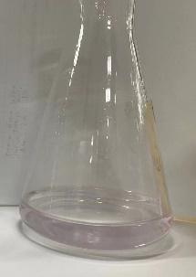

**Part B. Concentration of Unknown Molarity of NaOH Solution**

When the solution turned pale pink, it’s the signal to tell us that the end point is reached.

We made the experiment third time to reduce the possibility that we did not control well and ruin one trial. We can get more accurate concentration

**Figure 2 The solution around the end point**

**Part C. Acid – Base Titration of Vinegar**

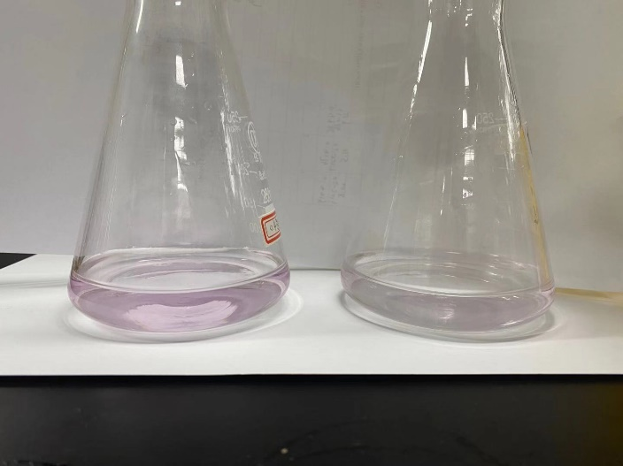

**Figure 3 the vinegar solution before the endpoint and at the endpoint**

We dilute the vinegar before the titration to make the origin concentration of HAC smaller, so it’s easier to find the endpoint.

DATA ANALYSIS

**Part B. Concentration of Unknown Molarity of NaOH Solution**

**Table 1 experimental data**

|  |  |  |  |
| --- | --- | --- | --- |
| Trial | 1 | 2 | 3 |
| mKHP(g) | 0.4425 | 0.4176 | 0.4019 |
| Total Vol. of NaOH (mL) | 21.9 | 21.5 | 20.8 |
| CNaOH(mol/L) = mKHP * 1000 / (MWKHP*VNaOH) | 0.0991 | 0.0952 | 0.0947 |
| Average CNaOH(mol/L) | 0.0963 | | |

Using the equation CNaOH (mol/L) = mKHP *1000/(MWKHP*VNaOH), MWKHP=204g/mol. We calculated the concentration of NaOH in each trial.

For trial 1, CNaOH (mol/L) = $\frac{0.4425g*1000mL/L}{204g/mol*21.9mL}=$ 0.0991mol/L

For trial 2, CNaOH (mol/L) = $\frac{0.4176g*1000mL/L}{204g/mol*21.5mL}=$ 0.0952mol/L

For trial 3, CNaOH (mol/L) = $\frac{0.4019g*1000mL/L}{204g/mol*20.8mL}=$ 0.0947mol/L

The average value of CNaOH in the three trials is 0.0963mol/L

Considering the NaOH solution is labeled 0.1mol/L,

the relative error is $\left(\frac{0.0963mol/L-0.1mol/L}{0.1mol/L}\right)×100\%$ =-3.7%

**Part C. Acid – Base Titration of Vinegar**

|  |  |  |  |
| --- | --- | --- | --- |
|  | Initial Vol. of NaOH (mL) | Final Vol. of NaOH (mL) | Total Vol. of NaOH (mL) |
| Trial 1 | 0.8 | 23.9 | 23.1 |
| Trial 2 | 0.9 | 24.4 | 23.5 |
| Trial 3 | 0.6 | 24.2 | 23.6 |
| Average | 0.8 | 24.2 | 23.4 |

From the equation 10×CNaOHVNaOH = CHACVHAC,

We can get CHAC= $\frac{10×CNaOHVNaOH}{VHAC}$, and we plug the values CNaOH=0.1M and VNaOH=24.2-0.8=23.4mL into this equation.

CHAC= $\frac{10×0.1mol/L×23.4mL}{25mL}=0.94mol/L$

Then we calculate the % by mass of acetic acid in vinegar.

Using the equation %= $\frac{CHACMKHP}{ρ}×100\%=\frac{0.94mol/L×60g/mol}{1050g/L}×100\%=5.3\%$

The value of the bottle of vinegar is 5g/100mL,

which is 100% $×$ 5g/(100mL $×$ 1g/mL) =5%

Therefore, the relative error is $\frac{5.3\%-5\%}{5\%}×100\%=6\%$

DISCUSSION

**Part A: Relative Acidity Basicity of Common Household Products**

In this experiment, I’ve learned the property of acids and bases to change the color of indicator. Also, I’ve learned the differences between strong and weak acids. I use the knowledge to titrate and calculate the concentration of two solutions.

In Part A, we’ve examined the pH of several household chemicals using the universal pH indicator paper. The pH of we found that the pH of vinegar, tapping water, $NH_{3}⋅H_{2}O$ solution is 3,7,9 relatively.

**Part B: Concentration of unknown molarity of NaOH solution using KHP titration**

In Part B, we used the solution of KHP of known mass to titrate NaOH solution of unknown concentration. According to our experiment data and calculation, the concentration is 0.0963mol/L.

The analysis of our experiment data indicates that the measured molarity of NaOH solution is smaller than labeled. During discussion, we’ve come up with several factors causing this error:

1. When the reaction was about to reach the end point, we didn’t control the speed properly so that NaOH was more than needed causing the indicator turning to a deeper color.
2. The volume of consumed NaOH might be misread. The initial volume might be read smaller than reality and the final volume might be read larger than reality.

Also, we can use $HCl and{ H}_{2}SO_{4}$ to titrate NaOH.

**Part C: Acid – Base Titration of Vinegar Solution**

We’ve calculated that the acid concentration of vinegar in mass is 5.3%.

The analysis of our experiment data indicates that the measured % by mass of acetic acid in vinegar is larger than labeled. Here are some possible reasons:

1. The concentration of NaOH is in fact smaller than labeled.
2. The volume of consumed NaOH might be misread. The initial volume might be read smaller than reality and the final volume might be read larger than reality.

I strongly recommend that experimenter should have be familiar with the experiment procedure and the operation of each laboratory apparatus. This will be of good help for saving time and avoiding accidents.

When conducting experiment B&C, experimenters should remember to add phenolphthalein into the solution, or the whole experiment will bear no fruit. Also, experimenters should carefully control the rate of drop. A single extra drop of NaOH solution may cause the indicator to turn to deeper color.

REFERENCE

-1. Peter Atkins, *Chemical Principles The Quest for Insight Seventh Edition*, Macmillan education, 2016.

-2. VC211 Laboratory Manual, UM-SJTU JI &SJTU Chemistry Department, 2019-2020.