*V211 FALL 2020 Chemistry Lab Report*

**Experiment E3**

**Spectrophotometric Analysis: Phosphates in Water**

[Han Yibei]

[Sept. 23, 2020]

Student ID: 519370910123

Section #: 3

Group #: 3

Group Members: Shen Kaixin 519370910128

Zhang Zongkai 519370910109

Lu Xinyi 519370910122

Telephone #: 18918329709

Email Address: 1982600614@qq.com

*There are main sections in each report, Pre-lab Exercises and Post-lab Report. Please finish the* ***Pre-lab*** *exercises before your scheduled lab time, which is* ***due at the beginning of each lab****. You need to submit* ***a hard copy*** *(double-sided printing) of your finished Pre-lab exercises (hand-written or typed) to your section TA when meet in the chemistry building. Please print out ‘****DATA SHEET’*** *to fill in raw data during the lab. You have* ***one week*** *to finish the* ***Post-lab*** *section after conducting each experiment (except E5). Submit the hard copy of completed report (double-side printing) to your section TA when meet for the next experiment in the lab.*

**This is for TAs ONLY!!! DO NOT write in this table!**

|  |  |  |  |  |
| --- | --- | --- | --- | --- |
| **Grades** | | | | **Grader/s** |
| Pre-lab (100 pt) | |  | |  |
| Post-lab  (100+10 pt) | Calculation (30 pt) |  |  |  |
| Data Analysis (30 pt) |  |  |
| Discussion (30+10 pt) |  |  |
| Data Sheet (10 pt) |  |  |
| **Total** |  | |  |

University of Michigan – Shanghai Jiao Tong University Joint Institute (UM-SJTU JI)

**Post-Lab Report**

*.*

*Please finish (hand-written or typed) this report during and/or after the lab and submit it (double-sided printing) to your section TA when meet for the next experiment. This report consists of CALCULATION & OBSERVATION, DISCUSSION, and DATA SHEET, and are worth a total of 100 points, counted as 6% of the total course grade. The DATA SHEET is for recording of raw data during your lab work and shall be submitted as it is (the very original copy you filled in during lab). Calculations and data analysis shall use the original data you obtained in the lab. Any alteration to raw data is a serious violation to HONOR CODE and you will receive ‘0’ point for Post-Lab Report.*

CALCULATION & OBSERVATION

**Part A. Preparation of Standard Solutions**

**A.1 Data Processing**

In this part, we regulate six kinds of phosphate solutions. Then we calculate and prepare three sample solutions with stock phosphate solution. We used 0 mL, 1 mL, 2 mL, 3 mL, 4 mL, 5 mL to drop to the Volumetric flasks to prepare samples. Then we get six samples of different concentrations.

**Table 1: Concentrations of standard solutions**

|  |  |  |  |  |  |  |
| --- | --- | --- | --- | --- | --- | --- |
| Sample | 1# | 2# | 3# | 4# | 5# | 6# |
| Volume (mL) | 0.0 | 1.0 | 2.0 | 3.0 | 4.0 | 5.0 |
| Conc. (M) | 0 | 2.00 $×{10}^{-5}$ | 4.00 $×{10}^{-5}$ | 6.00 $×{10}^{-5}$ | 8.00 $×{10}^{-5}$ | 1.00 $×{10}^{-4}$ |

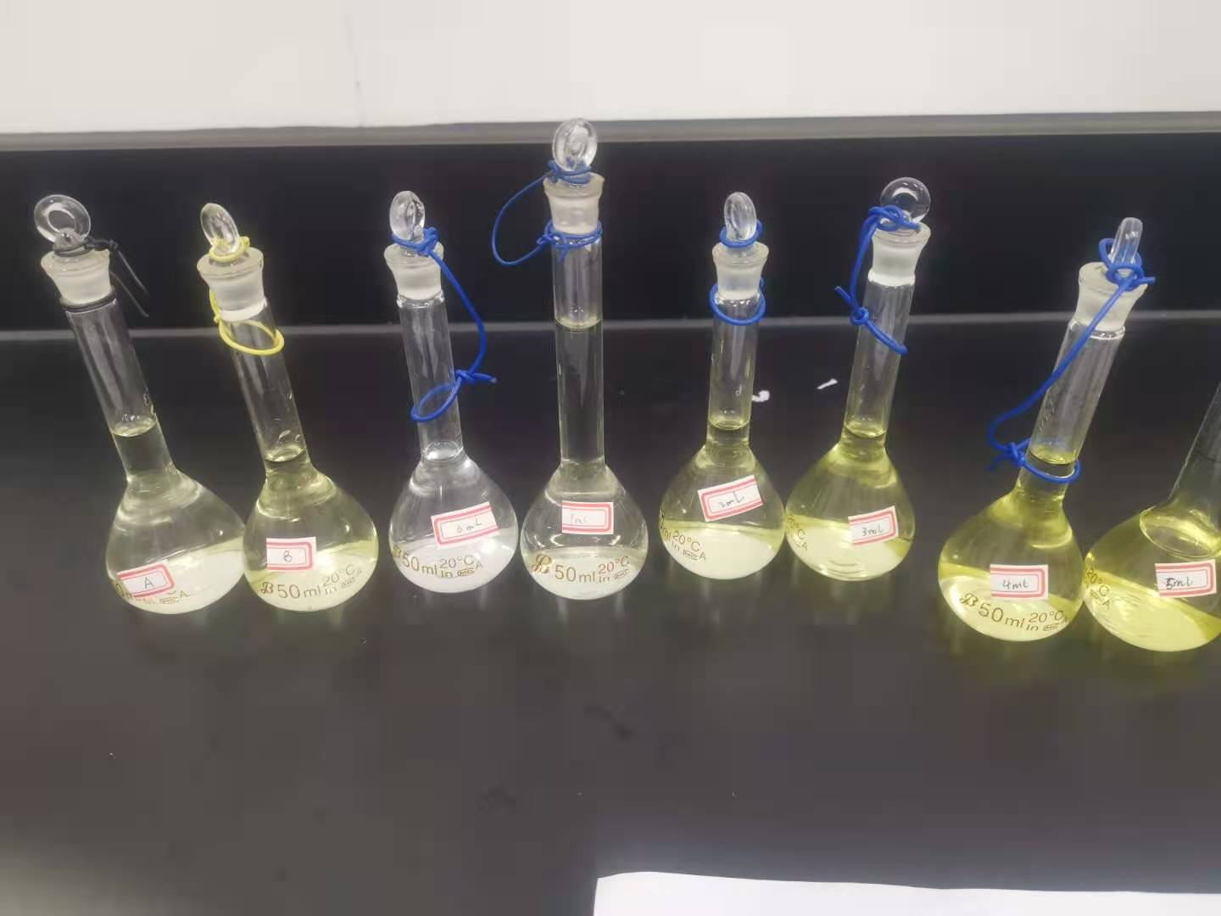

$$C_{2}=C_{0}\frac{V_{origin}}{V_{all}}=0.001M×\frac{1.0mL}{50mL}=2.00×{10}^{-5}M$$

**Figure 1 the color of six sample solution and two unknow solution (A,B,1,2,3,4,5,6)**

**A.2 Observation**

The solution becomes yellow because of the following formula:

$$Mo{O_{4}}^{2-}+NH_{4}VO_{3}+P{O_{4}}^{3-}→{\left(NH_{4}\right)}_{3}PO_{4}∙NH_{4}VO_{3}∙16MoO_{3}$$

Through observing the above picture, we could find that the color deepness of the solution is increase with the increase of the concentration of the solution. Also, we could find that concentration of unknown A is approximately the same as sample #1, while the concentration of unknown B is approximately between sample #1 and #2.

**Part B. Adjusting the Spectrophotometer**

Before each measurement, we should set the mode to T first. Press 0% when the lid is open. Then, set the laser through the sample as 100%. Change the mode to A and record the readout.

**Part C. Making the Absorbance Spectrum & Finding using a Standard Solution**

**C.1 Data Processing**

In this part, we test the absorbance spectrum and find. We test light frequency ranging from 400 nm to 450 nm to find the corresponding absorbance. In the process, we make use of spectrophotometer. Then we choose the light under whose frequency the absorbance reaches the highest level.

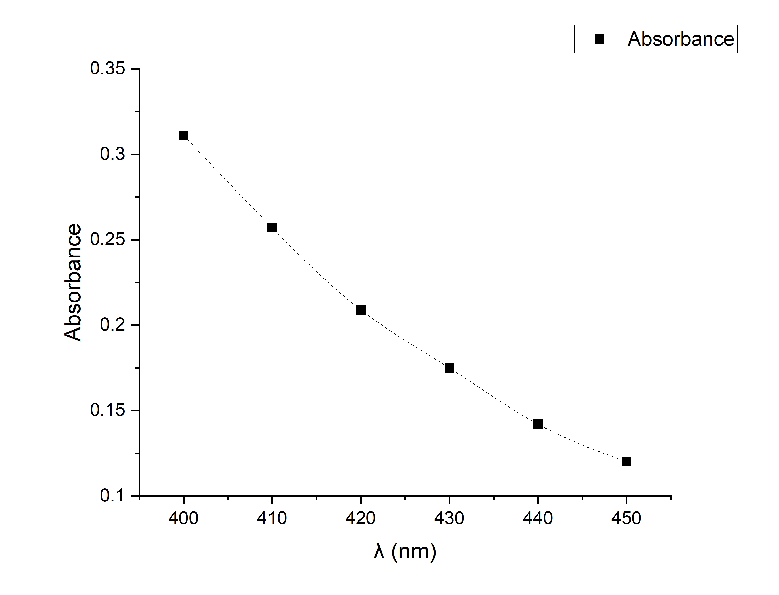**Table 2: Absorbance under light with different frequency**

|  |  |  |  |  |  |  |
| --- | --- | --- | --- | --- | --- | --- |
| (nm) | 400 | 410 | 420 | 430 | 440 | 450 |
| A | 0.311 | 0.257 | 0.209 | 0.175 | 0.142 | 0.120 |

**Figure 2 Absorbance vs. wavelength of light**

**C.2 Observation**

In our measured range, absorbance decreases as λ increases. As 400nm shows the largest absorbance, λopt=400nm.

**Part D. Making the Calibration Curve Using the standard Solutions**

**D.1 Data Processing**

In this part, we construct the calibration curve based on the data got first. We use light with 400 nm to test the absorbance of six standard sample solutions.

**Table 3: Absorbance of six sample solutions**

|  |  |  |  |  |  |  |
| --- | --- | --- | --- | --- | --- | --- |
| Sample | 1# | 2# | 3# | 4# | 5# | 6# |
| Volume (mL) | 0.0 | 1.0 | 2.0 | 3.0 | 4.0 | 5.0 |
| Absorbance (A) | 0.000 | 0.049 | 0.108 | 0.163 | 0.224 | 0.286 |

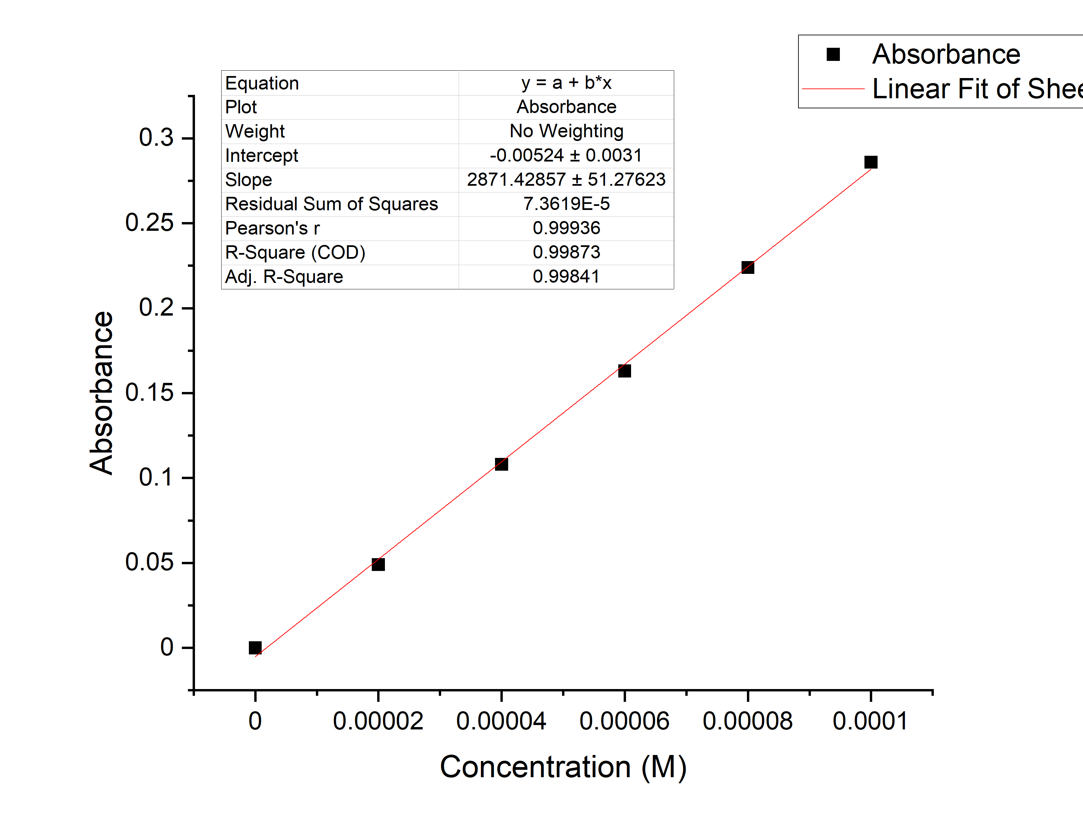Through the help of a software called Origin, we can find the curve is A=2871.4C-0.0052.

**Figure 3 Calibration curve**

**D.2 Analysis**

The multiple correlation coefficient given by the software is very close to 1, so the deviation is relatively small. Also, the uncertainty, CI Half-Width given by the software is 142, so relative uncertainty is $\frac{142}{2871.4}×100\%=4.95\%$, which is relatively small. So we can use this curve to calculate the concentration

**Part E. Determination of Unknown Concentration**

**E.1 Data Processing**

In this part, we measure the absorbance of two samples with unknown concentration. Then we use the constructed calibration curve to determine their concentration.

**Table 4:Absorbance of Unknown solutions**

|  |  |  |
| --- | --- | --- |
| Sample | 7# A | 7# B |
| Absorbance. (A) | 0.060 | 0.092 |

Since A=2871.4C-0.0052, $C=\frac{A+0.0052}{2871.4}$

$$C_{A0}=\frac{0.060+0.0052}{2871.4}=2.27×{10}^{-5}M$$

$$C_{B0}=\frac{0.092+0.0052}{2871.4}=3.39×{10}^{-5}M$$

Since the actual solution we use for measurement was diluted 10 times, the original concentration of sample 7A&B are:

$$C_{A}=2.27×{10}^{-5}M×10=2.27×{10}^{-4}M$$

$$C_{B}=3.39×{10}^{-5}M×10=3.39×{10}^{-4}M$$

DISCUSSION

**A. Preparation of Standard Solutions**

It’s difficult to use the pipet to control the volume of the 0.001M phosphate stock solution. Also, the environment temperature then was 16℃, which is different from the standard temperature(20℃) marked on the pipet and may cause higher concentration. The tiny inaccuracy may result in deviation in the slope of line in PartD. Also, while making the solution, there may exist remaining in the pipet, so the concentration may be lower. Moreover, one may read the pipet from above rather than parallel.

**B. Making the Absorbance Spectrum & Finding using a Standard Solution**

We only measure the absorbance under the range of 400 to 450 nm with an interval of 10 nm. Therefore, we have no idea about the absorbance of λ＜400nm or λ＞450nm. The λopt=400nm we used may not be the most appropriate one. Thus, to make the data more distinguish, we should find a more suitable λopt within a larger range.

**C. Making the Calibration Curve Using the standard Solutions**

Theoretically, the line should pass through the origin. However, from the equation we can see the line has a positive intercept on x-axis, which means the actual concentration of our sample solutions should be higher than recorded. Therefore, when diluting the stock solution, we might have not added enough di-water to reach the mark on the flask, causing the concentration to be higher.

**D. Other**

When using the spectrometer, the machine should be open before to make the laser stable.

We strongly recommend the experimenters to read the manual and listen to the instructor’s lecture carefully to ensure that they know how to operate the spectrophotometer. This will save much time and improve the efficiency.

Also, students should abandon data with a large deviation. These data may be inaccurate and will cause larger error to the process of fitting the line.

There exist many applications of spectrometer. Instead of testing the absorbance of light, we can also test the emission light. Also, rather than visible light, other invisible lights such as UV and infrared can be used as the detecting light. Scatter the light then we may get more data to determine the certain object.

**E. Conclusion**

In this experiment, we’ve practiced preparing solutions and learned how to use the spectrophotometer to measure the absorbance. We’ve also learned to use the fitting line to estimate the concentration of certain solutions.

First, we make 6 sample solutions through confecting 6 sample solutions with different concentrations. Then, use the highest concentration sample to find optimum wave length with highest absorbance. Detect the absorbance of six samples under optimum wavelength to get the calibration curve. Finally, detect the absorbance of unknown and calculate it using calibration curve. In this experiment we get A=2871.4C-0.0052, and the concentration of A equals $2.27×{10}^{-4}M$; B equals $3.39×{10}^{-4}M$.

REFERENCE

-1. Peter Atkins, Chemical Principles The Quest for Insight Seventh Edition, Macmillan education, 2016.

-2. VC211 Laboratory Manual, UM-SJTU JI &SJTU Chemistry Department, 2018-2019.