*VC211 FALL 2020 Chemistry Lab Report*

**Experiment 4**

**Introduction to Kinetics**

[Han Yibei]

[Dec,5, 2020]

Student ID: 519370910123

Section #: 3

Group #: 3

Group Members: Shen Kaixin 519370910128

Zhang Zongkai 519370910109

Lu Xinyi 519370910122

Telephone #: 18918329709

Email Address: 1982600614@qq.com

*There are main sections in each report, Pre-lab Exercises and Post-lab Report. Please finish the* ***Pre-lab*** *exercises before your scheduled lab time, which is* ***due at the beginning of each lab****. You need to submit* ***a hard copy*** *(double-sided printing) of your finished Pre-lab exercises (hand-written or typed) to your section TA when meet in the chemistry building. Please print out ‘****DATA SHEET’*** *to fill in raw data during the lab. You have* ***one week*** *to finish the* ***Post-lab*** *section after conducting each experiment (except E5). Submit the hard copy of completed report (double-side printing) to your section TA when meet for the next experiment in the lab.*

**This is for TAs ONLY. DO NOT write in this table.**

|  |  |  |  |  |
| --- | --- | --- | --- | --- |
| **Grades** | | | | **Grader/s** |
| Pre-lab (100 pts) | |  | |  |
| Post-lab  (100+10 pts) | Observation (30 pts) |  |  |  |
| Data Analysis (30 pts) |  |  |
| Discussion (30+10 pts) |  |  |
| Data Sheet (10 pts) |  |  |
| Total |  | |  |

University of Michigan – Shanghai Jiao Tong University Joint Institute (UM-SJTU JI)

**POST-LAB REPORT**

*Please finish (hand-written or typed) this report during and/or after the lab and submit it (double-sided printing) to your section TA when meeting for the next experiment. This report consists of CALCULATION & OBSERVATION, DISCUSSION, and DATA SHEET, and are worth a total of 100 points, counted as 6% of the total course grade. The DATA SHEET is for recording of raw data during your lab work and shall be submitted as it is (the very original copy you filled in during lab). Calculations and data analysis shall use the original data you obtained in the lab. Any alteration to raw data is a serious violation to HONOR CODE and you will receive ‘0’ point for Post-Lab Report.*

OBSERVATION & CALCULATION

**E4-1. Introduction to Kinetics: Factors that Affect the Rate of Reaction**

**Part A. Effect of Changing the Concentration of Reactants**

In this part, we separately let 1M HCl and 6M HCl react with eggshells. Since the reaction is $CaCO_{3}\left(s\right)+2HCl\left(aq\right)→CaCl_{2}\left(aq\right)+CO_{2}\left(g\right)+H_{2}O(l)$, we observe the rate of bubbling during the reaction to compare the rate of the reaction.

**Table 1: Observations of Part A**

|  |  |  |
| --- | --- | --- |
| Reactant | 6M HCl | 1M HCl |
| Amount of bubbles | Large | Little |
| Rate of reaction (fast/slow) | Fast | Slow |

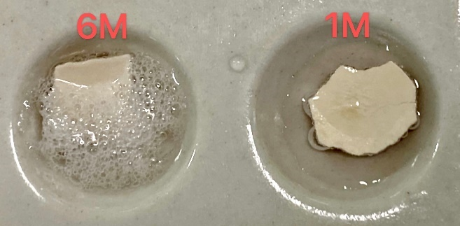**Figure1 Eggshells reacting with HCl**

Both reactions has bubbles out, but the one with 6M(higher concentration) have larger amount of bubbles and react faster.

**Part B. Effect of Changing the Surface Area**

In this part, we let the same mass of iron stick and iron powder react with CuSO4 solution with bath at 80℃. The main reaction is $CuSO_{4}\left(aq\right)+Fe\left(s\right)→FeSO_{4}\left(aq\right)+Cu\left(s\right)$, which leads to color changes. Thus, we record the time for changing color to evaluate the reaction rate.

**Table 2: Observations of Part B**

|  |  |  |
| --- | --- | --- |
| Reactant | Iron powder | Iron stick |
| Time for changing the color | Short | Long |
| Rate of reaction (fast/slow) | Fast | Slow |

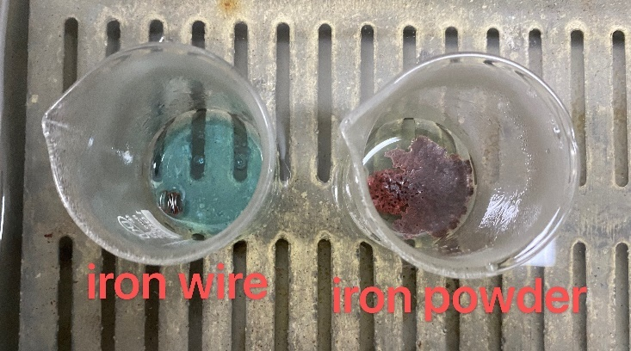**Figure2 CuSO4 reacting with iron powder and iron wire respectively**

After adding the metal, the one with powder has some bubble. After around 30 seconds, the powder beaker becomes shallow green. However, the color of other solution hadn’t change yet.

As the iron powder had a larger surface area, it contacted with CuSO4 more so that the reaction was faster. The produced ${Fe}^{2+}$ is green and the blue ${Cu}^{2+}$ was consumed so that the color of the solution turned green. The phenomenon verifies the theory.

**Part C. Effect of Changing the Temperature**

In this part, we let iron powder react with $CuSO_{4}$ solution in water bath of 80℃ and water bath of 0℃, respectively.

**Table 3: Observations of Part C**

|  |  |  |
| --- | --- | --- |
| Reaction temperature | 80℃ | 0℃ |
| Time for the first color change | Fast | Very slow, slower than 80℃ second change |
| Time for the second color change | Fast but slower than the first change | Haven’t seen |
| Reaction rate | Fast | Slow |

**Figure3 Effect of changing temperature** 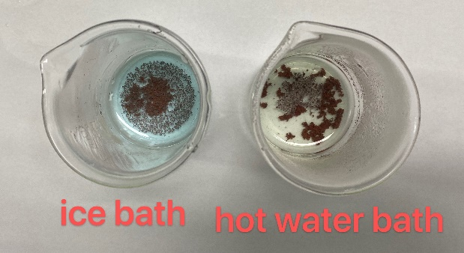

After 30 seconds, the solution in the hot water bath changes from blue to green while the water bath beaker hadn’t shown any change.

According to theory, the higher the temperature, the faster the rate.

**Part D. Modeling the Significance of the Orientation of Collisions**

**Part E. Effect of Adding a Catalyst**

In this part, we let $H_{2}O_{2}$ solution decompose either with 0.2g of $MnO_{2}$ or no catalyst. After 30-45 seconds, we added ice to the solution with the catalyst. The reaction is $2H_{2}O_{2}\left(aq\right)→2H_{2}O\left(l\right)+O_{2}\left(g\right)$. Thus, we observe the occurrence of bubbles to compare the reaction rates.

**Table 4: Observations of Part E**

|  |  |  |  |  |
| --- | --- | --- | --- | --- |
| Group | Room temperature without $MnO_{2}$ | Room temperature with $MnO_{2}$ | Iced without $MnO_{2}$ | Iced with $MnO_{2}$ |
| Amount of bubbles | Little | Huge amount of | Barely no | many |
| Reaction rate | Slow | Very fast | Very slow | Fast |

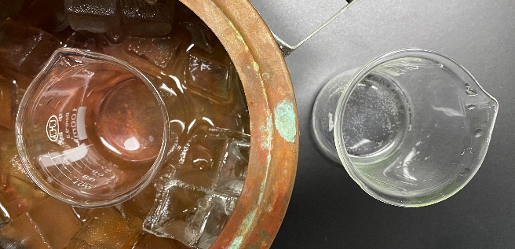**Figure4 H2O2 put in ice bath and room temperature**

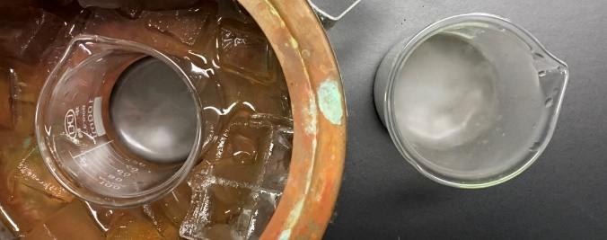**Figure5 H2O2 after added with MnO2**

We have two beakers; one is in the ice bath while one is under room temperature. The observed data is shown in Table 4. MnO2 acted as a catalyst and enhanced the speed of the reaction with no changes of itself.

**E4-2. Determining the Rate Law: A Kinetics Study of Iodination of Acetone**

**Data Processing**

In this part, we study the kinetics of the reaction between acetone and iodine to form iodoacetone and iodide. The reaction equation is $CH_{3}COCH_{3}\left(aq\right)+I_{2}\left(aq\right)→CH_{3}COCH_{2}I\left(aq\right)+H^{+}\left(aq\right)+I^{-}(aq)$. We determine its rate law by varying the concentration of acetone and iodine.

**Table 5: Primary results**

|  |  |  |  |  |
| --- | --- | --- | --- | --- |
| Solution | 1 | 2 | 3 | 4 |
| Volume of 4M acetone solution (mL) | 10 | 10 | 20 | 15 |
| Volume of water (mL) | 20 | 10 | 10 | 10 |
| Volume of 1M HCl solution (mL) | 10 | 10 | 10 | 10 |
| Volume of 0.00118M iodine solution (mL) | 10 | 20 | 10 | 15 |
| Reaction time (s) | 43.12 | 1:21.62 | 18.95 | 42.26 |

We calculate the initial rate for each reaction:

$$Rate=\frac{-∆[I_{2}]}{∆t}=\frac{-({\left[I_{2}\right]}_{final}-{[I_{2}]}_{initial})}{∆t}$$

Reaction 1: Rate= $\frac{-\left(0-\frac{0.00118×10}{50}\right)}{43.12}M/s$ =5.47 $×{10}^{-6}$ M/s

Reaction 2: Rate= $\frac{-(0-\frac{0.00118×20}{50})}{81.62}M/s$ =5.78 $×{10}^{-6}$ M/s

Reaction 3: Rate= $\frac{-(0-\frac{0.00118×10}{50})}{18.95}M/s$ =1.25 $×{10}^{-5}$ M/s

Reaction 4: Rate= $\frac{-(0-\frac{0.00118×15}{50})}{18}M/s$ =8.38 $×{10}^{-6}$ M/s

**Table 6: Summarized results**

|  |  |  |  |
| --- | --- | --- | --- |
| Solution | Acetone (M) | Iodine (M) | Initial rate (M/s) |
| 1 | 0.8 | 2.36 $×{10}^{-4}$ | $$5.47×{10}^{-6}$$ |
| 2 | 0.8 | 4.72 $×{10}^{-4}$ | $$5.78×{10}^{-6}$$ |
| 3 | 1.6 | 2.36 $×{10}^{-4}$ | $$1.25×{10}^{-5}$$ |
| 4 | 1.2 | 3.54 $×{10}^{-4}$ | $$8.38×{10}^{-8}$$ |

**Analysis**

Then we calculate the value of m&n in the general form of the rate law.

Rate $=k{[Acetone]}^{m}{[Iodine]}^{n}$

To calculate m, we compare #1&3:

5.47 $×{10}^{-6}=k{[0.8]}^{m}{[2.36×{10}^{-4}]}^{n}$

1.25 $×{10}^{-5}=k{[1.6]}^{m}{[2.36×{10}^{-4}]}^{n}$

m= $\log_{2}\frac{1.25×{10}^{-5}}{5.47×{10}^{-6}}=1.19≈1$

To calculate n, we first compare #1&2:

$$5.47×{10}^{-6}=k{(0.8)}^{m}{(2.36×{10}^{-4})}^{n}$$

$$5.78×{10}^{-6}=k{(0.8)}^{m}{(4.72×{10}^{-4})}^{n}$$

n= $\log_{2}\frac{5.47×{10}^{-6}}{5.78×{10}^{-6}}=-0.08≈0$

From #1, we can find that

k1 = $\frac{5.47×{10}^{-6}M/s}{{0.8M}^{1}{×(2.36×{10}^{-4}M)}^{0}}$ = 6.84 $×{10}^{-6}s^{-1}$

Also, k2= $\frac{5.78×{10}^{-6}M/s}{{0.8M}^{1}{×(4.72×{10}^{-4}M)}^{0}}$ = 7.23 $×{10}^{-6}s^{-1}$; k3= $\frac{1.25×{10}^{-5}M/s}{{1.6M}^{1}{×(2.36×{10}^{-4}M)}^{0}}$ = 7.81 $×{10}^{-6}s^{-1}$

$$\overline{k}=\frac{k_{1}+k_{2}+k_{3}}{3}=7.29×{10}^{-6}s^{-1}$$

$$Rate_{4}=7.29×{10}^{-6}×{1.2}^{1}×{\left(2.36×{10}^{-4}\right)}^{0}=8.75M/s$$ The relative error is: $\frac{8.38-8.75}{8.75}=4.9\%$, is very small.

Therefore, the rate law is:

Rate $=7.29×{10}^{-6}{s^{-1}[Acetone]}^{1}{[Iodine]}^{0}$

DISCUSSION

1. **Effect of Changing the Concentration of Reactants**

In Part A, as the experiment was designed to study the effect of changing the concentration of the reactant, the surface area of reactants should not change. However, we cannot decide whether the surface area of the eggshells was exactly the same. The experiment was not strictly conducted.

1. **Effect of Changing the Surface Area**

As the iron powder had a larger surface area, it contacted with CuSO4 more so that the reaction was faster. The actual meets the theory that the larger the surface area is, the faster the rate is. Fe+CuSO4 → FeSO4 +Cu. The produced ${Fe}^{2+}$ is green and the blue ${Cu}^{2+}$ was consumed so that the color of the solution turned green. The green color might also result from the combination of blue and yellow. The yellow color might come from ${Fe}^{3+}$ which was produced by ${Fe}^{2+}$ reacting with oxygen.

1. **Effect of Changing the Temperature**

The higher the temperature is, the faster the rate is. The experiment meets the theory.

1. **Effect of Adding a Catalyst**

After adding catalyst, the rate rises. The recorded data confirms the theory. We don’t quite understand the procedure of cooling the solution down in ice bath. Since the temperature went down, the reaction was supposed to slow down, too. It was not sufficient to prove that temperature had any effect on the catalyst.

1. **Rate Law of Iodination of Acetone**

We got Rate $=7.29×{10}^{-6}{s^{-1}[Acetone]}^{1}{[Iodine]}^{0}$. The concentration of Iodine will not change the rate while the concentration of Acetone is proportional to the rate. The reaction order do not need to be integer, but it can be negative. Our experiment output highly verifies the law. Make the solution of 50 mL will reduce the possible interception because of water. The possible formula $I_{2}+H_{2}O⇋I^{-}+H^{+}+HIO.$ Also, since more water will cause lower concentration, the reaction rate will be lower than current.

1. **Conclusion**

From the experiment, we’ve tested the four factors affecting the rate. In Part A, the higher the concentration is, the faster the rate is. In Part B, the larger the surface area is, the faster the rate is. In Part C, the higher the temperature is, the faster the rate is. In Part E, after adding catalyst, the rate rises. The second part is a quantitative experiment so that we have to ensure the accuracy of the data. Although we have paid much attention to the preparing of the solutions and time counting, there still existed some errors. Also, the stirring speed must be controlled at the same rate. Finally, we got Rate $=7.29×{10}^{-6}{s^{-1}[Acetone]}^{1}{[Iodine]}^{0}.$ We strongly recommend the experimenters to pay attention to steadying the beakers which are put in hot water bath. After putting the beaker into the hot water bath for the first time, the beaker couldn’t stand still and felled down because of buoyancy. The solution was dumped into the hot water. Therefore, the concentration of the CuSO4 solution changed and we had to prepare the solution again. Also, this experiment is designed unreasonably in some way. It is hard to determine the starting time and end point just by observation. Some efforts should be made to accurately measure the reaction time.

REFERENCE

-1. Peter Atkins, *Chemical Principles The Quest for Insight Seventh Edition*, Macmillan education, 2016.

-2. VC211 Laboratory Manual, UM-SJTU JI &SJTU Chemistry Department, 2019-2020.