*VC211 FALL 2020 Chemistry Lab Report*

**Experiment E5**

**Precipitation and Water Purity**

[Han Yibei]

[Dec. 14, 2020]

Student ID: 519370910123

Section #: 3

Group #: 3

Group Members: Shen Kaixin 519370910128

Zhang Zongkai 519370910109

Lu Xinyi 519370910122

Telephone #: 18918329709

Email Address: 1982600614@qq.com

*There are main sections in each report, Pre-lab Exercises and Post-lab Report. Please finish the* ***Pre-lab*** *exercises before your scheduled lab time, which is* ***due at the beginning of each lab****. You need to submit* ***a hard copy*** *(double-sided printing) of your finished Pre-lab exercises (hand-written or typed) to your section TA when meet in the chemistry building. Please print out ‘****DATA SHEET’*** *to fill in raw data during the lab. Submit the hard copy of completed report (double-side printing) to your section TA* ***at the end of E5****. Failing to submit the post-lab report in time will result in ‘0’ grade.*

**This is for TAs ONLY. DO NOT write in this table.**

|  |  |  |  |  |
| --- | --- | --- | --- | --- |
| **Grades** | | | | **Grader/s** |
| Pre-lab (100 pts) | |  | |  |
| Post-lab  (100+10 pts) | Observation (40 pts) |  |  |  |
| Lab Discussion (40+10 pts) |  |  |
| Data Sheet (10 pts) |  |  |
| Team Assessment (10 pts) |  |  |
| Total |  | |  |

University of Michigan – Shanghai Jiao Tong University Joint Institute (UM-SJTU JI)

**POST-LAB**

*Please finish (hand-written or typed) this report during the lab and submit it (double-sided printing) to your section TA before you leave the lab. This report consists of OBSERVATION, LAB DISCUSSION, DATA SHEET, and Team Assessment and are worth a total of 100 points, counted as 6% of the total course grade. The DATA SHEET is for recording of raw data during your lab work and shall be submitted as it is (the very original copy you filled in during lab, not a photocopy, not a scan, neither a photo of it). Calculations and data analysis shall use the original data you obtained in the lab. Any alteration to raw data is a serious violation to HONOR CODE and you will receive ‘0’ point for Post-Lab Report.*

OBSERVATION

**Part 1. What is the precipitate?**

*TODO: Please use text and/or photos to describe the observations. And propose testes to identify the reacting ions (refer to pre-lab exercises problem 1 for an example).*

Observations of reactants and product mixture

|  |  |  |
| --- | --- | --- |
| CuSO4 | BaCl2 | Product Mixture |
|  |  |  |

Possible reacting ions:

$$Ba^{2+}+SO_{4}^{2-}⟶BaSO_{4}↓$$

Experimental tests to identify reacting ions

Filtrate observations

**Part 2. Precipitation Studies**

*Team hypothesis and expected observations:*

Four cations least likely to precipitate:

Spectator ions (cation and anion) common to all assigned reactions?

*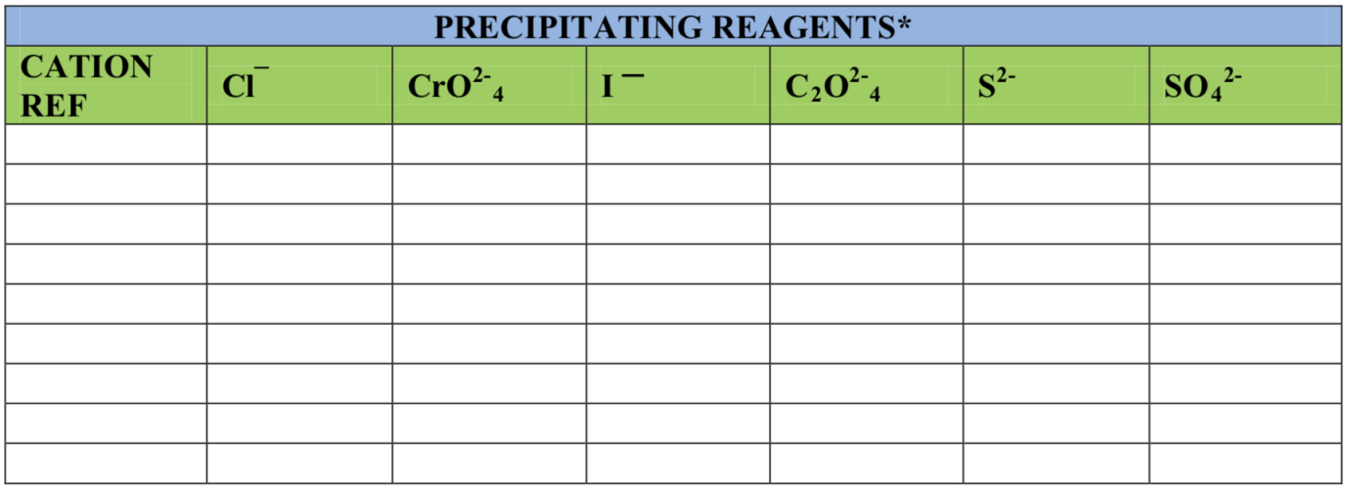Team Observations*

*precipitating reagents are 0.1M sodium salts of the anion.

*Data Analysis (Class Data)*

Attach a copy of the class data your team used for the purpose of data analysis.

Compare the solubility or tendency to precipitate of the cations with elements in families 1, 2, and 12 in the periodic table. Is there an observable pattern? Record your analysis below. Be sure to refer to the attached class data to support any conclusion.

Note: the number of reported tests for varying cations may not be the same. The comparative percentage of precipitates (out of total tests) per cation is more valid than number of precipitates reported. Also note that the number of tested cations per family may not be the same.

**Part 3. Water Purity and Concentration Studies**

*TODO: Please use text and/or photos to describe the observations.).*

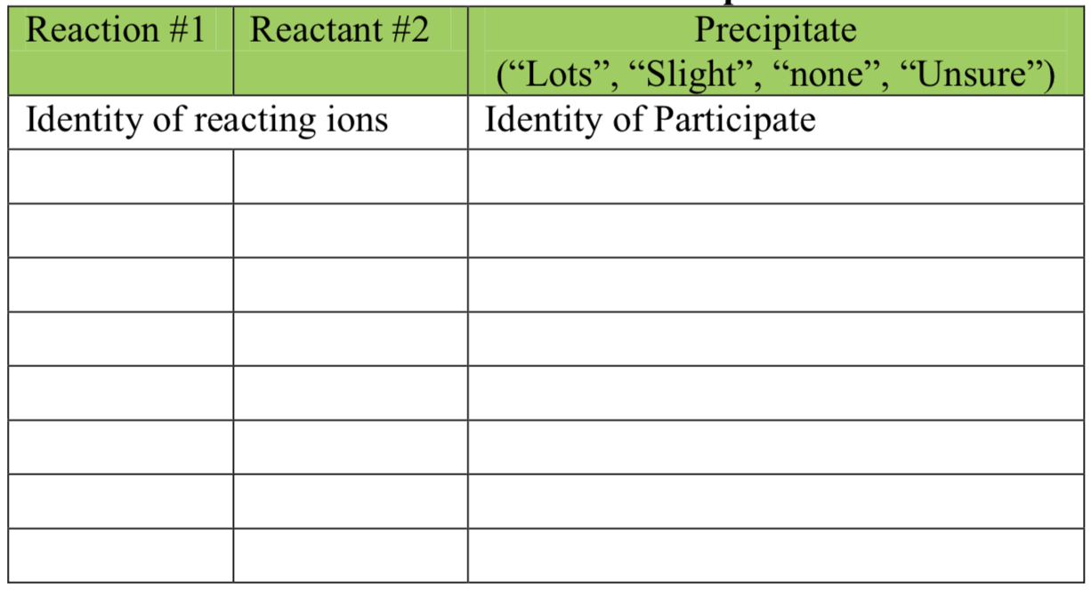**Observations of reactants and products**

*Team hypothesis and expected observations:*

Experimental tests and observations:

Precipitate yield* vs Concentration Reactants

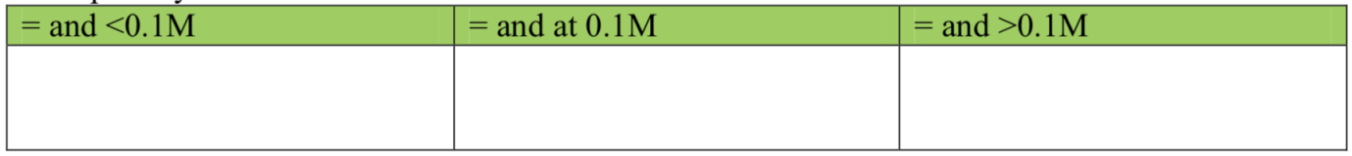

*Record (“lots”.”slight”.”none”,”unsure”)

*Analysis of team results*

1. What do your team results indicate about concentration and precipitation?
2. Does the filtrate contain un-precipitated reactant ions? How do you know?

*Analysis of Class Data*

1. What results are shown in the class data? Use the class data to give specific examples of any patterns.
2. Does the class data validate your hypothesis? Explain.

**Part 4. Solvent Pollution and Precipitation**

*Team hypothesis and expected observations:*

*Team Observations:*

Solubility and Precipitation of Reactants in Solvents of Varying Polarity (next page)

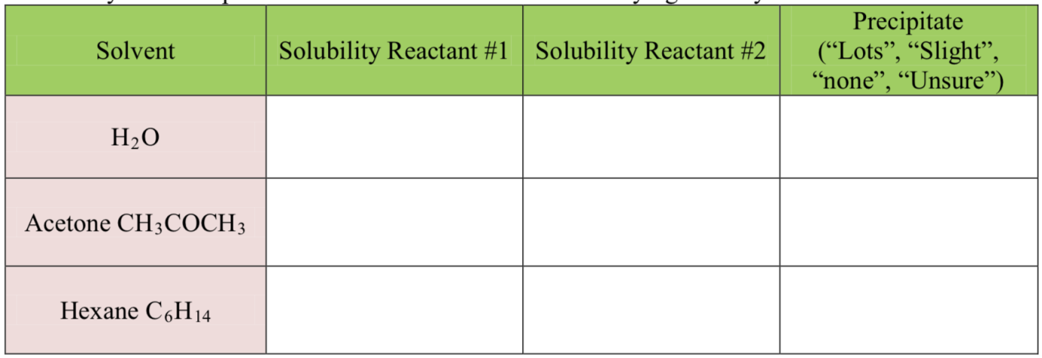

*Data Analysis (class data)*

1. Record any patterns shown in the class data regarding effect of solvent polarity on solubility and precipitation of salts. Give specific examples referring to the class data.
2. Does the class data validate or refute your team hypothesis? Explain your reasoning.

LAB DISCUSSION

*TODO: This section includes, but is not limited to the following points; To get bonus, add whatever you think is necessary to be discussed here; but do keep it brief and concise.*

1. Is it possible to predict if a precipitate will be white or a color other than while bas on the position of the cation's element in the periodic table? Organize the class data (Part 2A) in a graph to answer this question. Based on your answer predict the compound within each pair that is a color other hall white: nickel sulfate or lead sulfate; cobalt oxalate or strontium oxalate?
2. Is there a relationship between precipitation and ion charge? For example, what generalizations can be made about the solubility of ionic compounds, if both the cation and anion are singly or multiply charged? Organize the class data (Part 2A) in a graph to answer this question. Based on your answer select the compound within each pair that is less soluble in water: iron (III) chloride, FeCl3, or iron oxide, Fe2O3; sodium oxalate. Na2C2O4, or calcium oxalate, CaC2O4
3. Is it possible to predict cation solubility based on the position of its element in the periodic table? For example, compare precipitation of family 1, 2, and 12 cations. Organize the class data (Part 2A) in a graph to answer this question. Based on your answer select the compound within each pair that is less soluble in water: nickel bromide, NiBr2 or platinum bromide, PtBr2; zinc iodate, Zn(IO3)2, or mercury iodate. Hg(IO3)2
4. Examine the relationship, if any, between concentration and the amount of precipitate. Organize the class data (Part 3) in the form of a histogram (if time permits during the lab session). For example, compare the amount of hydroxide precipitates of varying cations at the different concentrations. It is a scientific fact that calcium hydroxide is more soluble than zinc hydroxide which is more soluble than lead hydroxide. Does the class data support or refute these scientific facts?
5. You are to remove Hg2+ ions from a contaminated body of water by precipitation and filtration. Will it be possible to completely remove all Hg2+ ions? Will a particular precipitating agent remove more Hg2+ ions than another?
6. What is the relationship, if any, between salt solubility, precipitation, and solvent polarity? Organize the class data from Part 4 (table or graph) to answer this question.
7. [Bonus, Optional] Any suggestions you may have for E5? This can include but not limited to improvement on relative errors, further experimental direction or development on the topics we studied in E5 (that can make the experiment more interesting or allow people dig deeper into the precipitation fact).

REFERENCE

-1. Peter Atkins, *Chemical Principles The Quest for Insight Seventh Edition*, Macmillan education, 2016.

-2. VC211 Laboratory Manual, UM-SJTU JI &SJTU Chemistry Department, 2019-2020.

DATA SHEET

*TODO: Please design your own data sheet for E5. You may consider the data sheet provided in lab manual as a sample.*

