**PRE-LAB EXERCISE**

*Please finish the following exercises before conducting the experiment and bring the answers to the lab section. These exercises consist of 5 questions and are worth a total of 100 points, counted as 3 points of the final grade. These pre-lab exercises cover contents of Experiment E5. Please study the corresponding lab manual and relevant references (e.g. your VC210 textbook) carefully before doing these exercises.*

***Question 1 (30 points)***

When a solution of silver fluoride, 0.1M AgF, is mixed with a solution of barium acetate, 0.1M Ba(C2H3O2)2 a precipitate forms:

AgF + Ba(C2H3O2)2 → precipitate

In order to identify the precipitating ions you conduct some experimental tests.

1) you substitute a solution of 0.1M sodium acetate, NaC2H3O2, for the Ba(C2H3O2)2 solution and mix it with 0.1M AgF

AgF + NaC2H3O2 → ?

What is the purpose of this test?

To test whether the Ag(C2H3O2)2 is the precipitation. If yes, we will observe certain precipitation in this test.

2) What do the test results bellow tell you about the AgF + Ba(C2H3O2)2 reaction?

AgF + Ba(NO3)2 → precipitate*

* The precipitate that forms is identical in properties to that formed in the AgF + Ba(C2H3O2)2 reaction.

To test whether the BaF is the precipitation. If yes, we will observe certain precipitation in this test.

1. 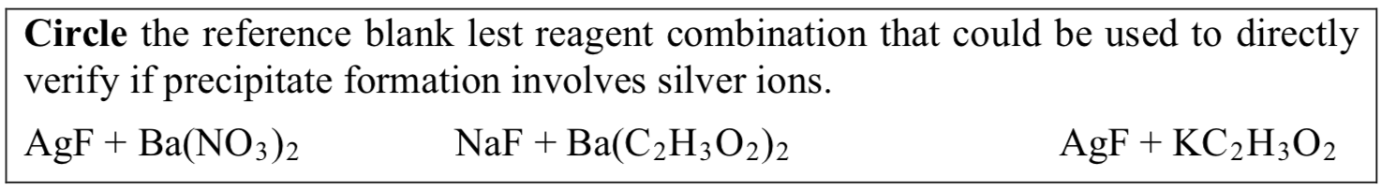Which reference blank test (indicated below) did you to directly test the hypothesis that silver ions are critical to precipitate formation?

***Question 2 (40 points)***

Prepare a data table for Part 2.A (of the experimental) on an 8 1/2× 11 sheet of paper an make a copy to place under the plastic sheet. Note: your instructor will assign you to one cation group to study in lab. In the meantime, leave the cation column blank.

|  |  |  |  |  |  |  |  |  |  |  |
| --- | --- | --- | --- | --- | --- | --- | --- | --- | --- | --- |
| Caution tested | REF Water | $$Cl^{-}$$ | $$CrO_{4}^{2-}$$ | $$I^{-}$$ | $$C_{2}O_{4}^{2-}$$ | $$S^{2-}$$ | $$SO_{4}^{2-}$$ | $$CO_{3}^{2-}$$ | $$CH_{3}COO^{-}$$ | $$PO_{4}^{3-}$$ |
|  |  |  |  |  |  |  |  |  |  |  |
|  |  |  |  |  |  |  |  |  |  |  |
|  |  |  |  |  |  |  |  |  |  |  |
|  |  |  |  |  |  |  |  |  |  |  |
|  |  |  |  |  |  |  |  |  |  |  |
|  |  |  |  |  |  |  |  |  |  |  |
|  |  |  |  |  |  |  |  |  |  |  |
|  |  |  |  |  |  |  |  |  |  |  |

***Question 3 (30 points)***

Record a precise hypothesis and expected observations for Part 2a for suggestions regarding formulating a hypothesis.

I think the precipitation is partially predictable.

We can depart all the base and acid into soft and hard type. The one has larger ion radius and smaller number of nuclear charges is soft, while the one has smaller ion radius and larger number of nuclear charges is hard. When soft base met soft acid, the salt will precipitate. When hard base met hard acid, the salt will not precipitate because water can also be regard as hard. But when hard one met soft one, the precipitation will not be predictable.