UM-SJTU Joint Institute

Physics Laboratory

(Vp241)

Laboratory Report

Exercise 2

The Hall Probe:

Characteristics and Applications

Name: Wenxin He ID: 518370910117 Group: 1

Date: 25 October 2019

**1. Introduction**

In 1879 E.H. Hall observed that when an electric current passes through a sample placed in a magnetic field, electric potential difference proportional to the current and to the magnetic field appears across the material in the direction perpendicular to both the current and the magnetic field. This effect is known as the Hall effect, and since its discovery it has found many practical applications. The principle of the Hall effect is used in devices for magnetic field measurements as well as in position and motion detectors.

In this lab, our objectives are:

* Study the principle of the Hall effect and its applications by using a Hall probe.
* Verify that the Hall voltage is proportional to the magnetic field.
* Study the sensitivity of an integrated Hall probe by calculating the magnetic field at the center of a solenoid. Measure the magnetic field distribution along the axis of the solenoid and compare it with the corresponding theoretical curve.

**2. Theoretical Background**

**2.1 Hall Effect**

When a conducting sheet is placed in a magnetic field so that the direction of the magnetic field B is perpendicular to the plane of the sheet and an electric current I passes through the sheet in the direction parallel with the plane shown in Figure 1, an electric potential difference will appear between the sides a and b of the sheet. This effect is called the Hall effect and the potential difference is called the Hall voltage .

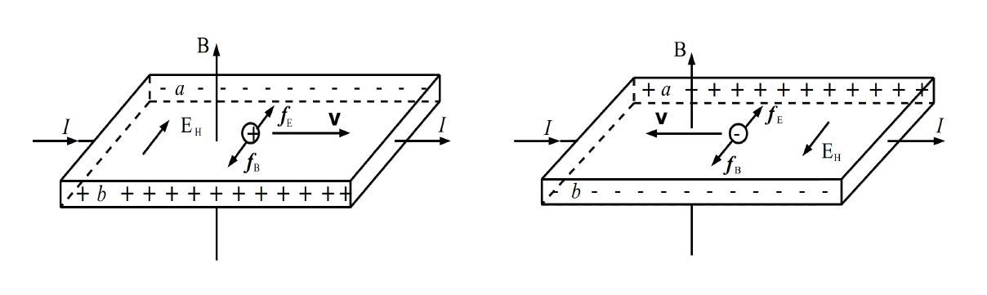

**Figure 1 the illustration of the Hall effect**

The Hall effect is called by the Lorentz force which acts on charges moving in a magnetic field. The Lorentz force causes the moving charges to deflect and accumulate on one side of the sheet, which increases the magnitude of the transverse electric filed (the Hall field). This field will produce an electric force acting on the moving charges whose direction is opposite to . When balance between and is reached, the charges no longer deflect and stabilizes. When B is upward and I is to the right. If the sheet carries positive charge, then the voltage of a is lower than b. We can analyze the sign of and determine the type of the charge carriers in semiconductors.

When the external magnetic field B is not too strong, the Hall voltage is proportional to both the current and the B, and inversely proportional to the thickness of the sheet d:

Where is called the Hall coefficient and K=, where is called sensitivity of the Hall element.

**2.2 Integrated Hall Probe**

When and I are fixed, B can be found by measuring the Hall voltage with a Hall probe. Since the Hall voltage is very small, it should be amplified before the measurement.

The Hall probe and the circuit are designed using silicon. A device called integrated Hall probe is a single device combining both the Hall probe and the electric circuit. The integrated Hall probe SS495A consists of a Hall sensor, an amplifier, and a voltage compensator(Figure 2). The output voltage U can be read ignoring the residual voltage. The working voltage is , and the output voltage is approximately 2.5V when B=0. The relation between the output voltage U and the magnitude of the magnetic field is:

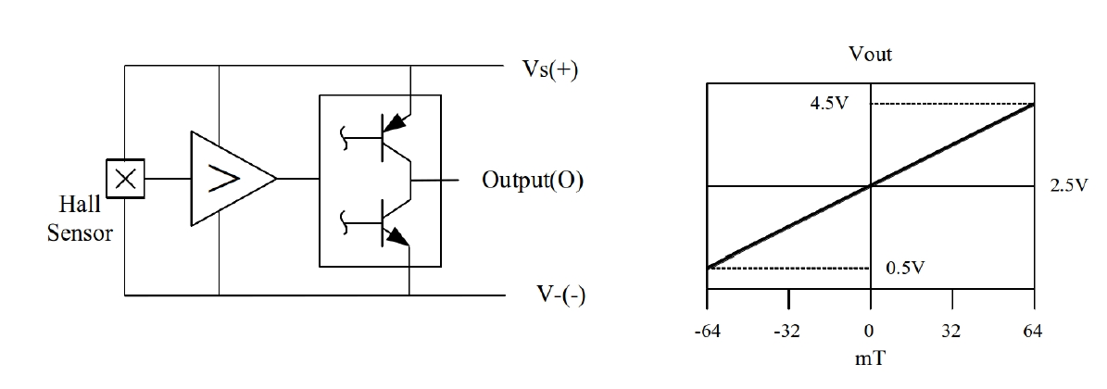

**Figure 2 Figure 3**

**Figure 2 The integrated Hall probe SS495A**

**Figure 3 The relation between the output voltage U and B**

**2.3 Magnetic Field Distribution Inside a Solenoid**

On the axis of a single layer solenoid, the magnetic field distribution can be represented as

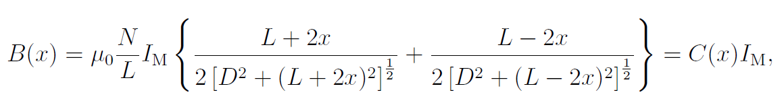 (3)

where N is the number of turns of the solenoid,

L is its length,

is the current through the solenoid wire,

D is the solenoid’s diameter.

The magnetic permeability of vacuum is H/m.

In this lab, the solenoid has ten layers, and the magnetic field B(x) for each layer can be calculated using the equation above. Then the net magnetic on the axis of the solenoid can be found by adding contributions due to all layers. The theoretical value of the magnetic field inside the solenoid with is given in Table 1.

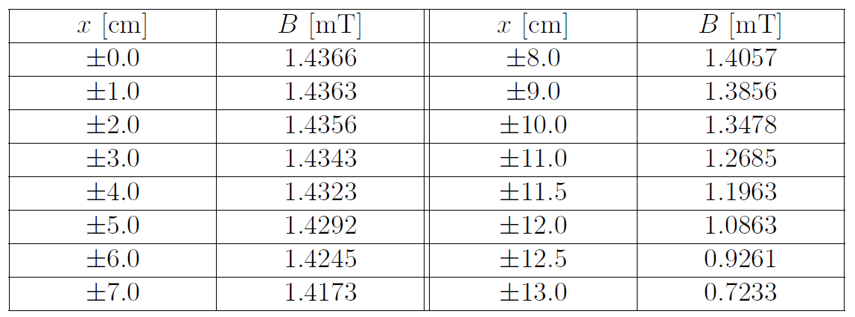

**Table 1 Theoretical value of the magnetic field inside the solenoid.**

**2.4 Study of the Geomagnetic Field with a Hall Probe**

The geomagnetic field of the Earth is similar to that of a bar magnet tilted about 11.5 from the spin axis of the Earth.

Figure 4 shows the magnetic filed lines of the Geomagnetic field.

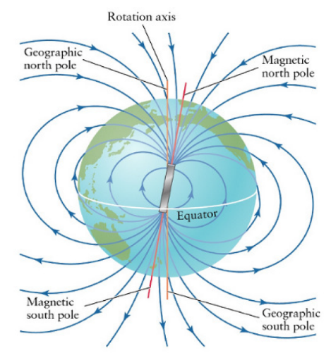

**Figure 4 Magnetic field of the Earth**

Figure 5 shows the geomagnetic field distribution of China in 1970. The magnetic inclination is about 44.5 and the magnitude of the magnetic field in Shanghai is about 48000nT.

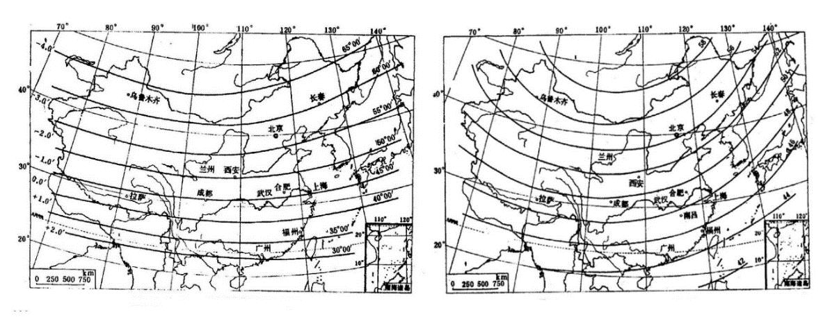

**Figure 5 Geomagnetic inclination in China,1970(left). The magnitude of the geomagnetic field in China,1970(right).**

**3. Experimental Setup**

**3.1 Apparatus**

Figure 6 shows the integrated Hall probe SS495A, a solenoid, a power supply, a voltmeter, a DC voltage divider, and a set of connecting wires.

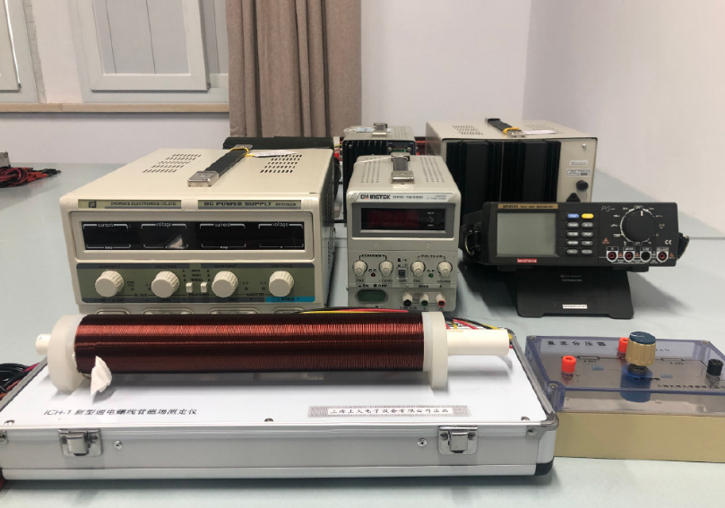

**Figure 6 Experimental setup**

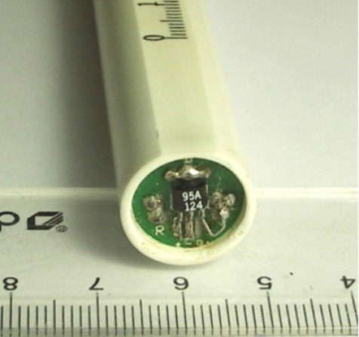

**Figure 7 Integrated Hall probe SS495A**

**3.2 Device Information**

The information of each measurement device is shown in Table 2.

|  |  |  |  |
| --- | --- | --- | --- |
| **apparatus** | **range** | **Minimum scale of value** | **Maximum uncertainty** |
| Voltage source | / | 0.01V |  |
| Voltimeter | / | 0.001Vor0.0001V | V |
| Current Source | / | 0.01A |  |
| Graduated Ruler | 0~30cm | 0.1cm | 0.05cm |

**Table 2 Information of Each Measurement Device**

**4. Measurement Procedure**

**4.1 Relation Between Sensitivity and Working Voltage**

1. Place the integrated Hall probe at the center of the solenoid. Set the working voltage at 5 V and measure the output voltage ( = 0) and U (= 250 mA). Take the theoretical value of B(x = 0) from Table 1 and calculate the sensitivity of the probe by using Eq. (2).

2. Measure for different values of (from 2.8 V to 10 V). Calculate and plot the curve vs. .

**4.2 Relation between Output Voltage U and Magnetic Field B**

1. With B=0, =5 V, connect the 2.4~2.6 V output terminal of the DC voltage divider and the negative port of the voltmeter. Adjust the voltage until = 0.

2. Place the integrated Hall probe at the center of the solenoid and measure the output voltage U for different values of ranging from 0 to 500 mA, with intervals of 50mA.

3. Explain the relation between B(x = 0) and the Hall voltage . Pay attention to the fact that the output voltage U is the amplified signal from . The theoretical value of B(x = 0) can be found from Table 1.

4. Plot the curve U vs. B and find the sensitivity by a linear fit (use a computer). Compare the value you obtained with the theoretical value in given in the Apparatus section and the value you have found in the first part.

**4.3 Magnetic Field Distribution Inside the Solenoid**

1. Measure the magnetic field distribution along the axis of the solenoid for = 250mA, record the output voltage U and the corresponding position x. Then find B = B(x). (Use the value of found in the previous part of the experiment).

2. Use a computer to plot the theoretical and the experimental curve showing the magnetic field distribution inside the solenoid. Use dots for the data measured and a solid line for the theoretical curve. The origin of the plot should be at the center of the solenoid.

**5. Results**

**5.1 Relation Between Sensitivity and Working Voltage**

**5.1.1 Calculation of**

|  |  |
| --- | --- |
| [V][V] | 5.00 |
| =0)[V][V] | 2.517 |
| =250mA)[V][V] | 2.636 |

**Table 3 Data for U0 and U with Us=5V**

From Table 1 we get when x=0cm, =0.1A, =1.4366mT.

Now I=250mA. Since B is proportional to I, we calculate B:

Using equation(2), we calculate

**5.1.2 Measurement of and U under different**

We change different value of .

is measured when =0

U is measured when =250mA.

The experimental data are recorded in Table 4.

|  |  |  |  |  |  |  |
| --- | --- | --- | --- | --- | --- | --- |
|  |  |  |  |  |  |  |
| 1 | 2.80 | 1.4336 | 1.5040 | 0.014 | 0.001 | 0.001 |
| 2 | 3.29 | 1.6768 | 1.7576 | 0.016 | 0.001 | 0.001 |
| 3 | 3.67 | 1.8665 | 1.9562 | 0.018 | 0.002 | 0.002 |
| 4 | 4.04 | 2.0523 | 2.146 | 0.020 | 0.002 | 0.002 |
| 5 | 4.65 | 2.347 | 2.460 | 0.023 | 0.007 | 0.007 |
| 6 | 4.98 | 2.508 | 2.619 | 0.025 | 0.007 | 0.007 |
| 7 | 5.25 | 2.640 | 2.763 | 0.026 | 0.007 | 0.007 |
| 8 | 5.83 | 2.919 | 3.054 | 0.029 | 0.007 | 0.008 |
| 9 | 6.32 | 3.157 | 3.293 | 0.032 | 0.008 | 0.008 |
| 10 | 6.75 | 3.364 | 3.512 | 0.034 | 0.008 | 0.008 |
| 11 | 7.01 | 3.489 | 3.639 | 0.035 | 0.008 | 0.008 |
| 12 | 7.53 | 3.746 | 3.901 | 0.038 | 0.008 | 0.008 |
| 13 | 7.92 | 3.935 | 4.091 | 0.040 | 0.008 | 0.008 |
| 14 | 8.30 | 4.117 | 4.275 | 0.042 | 0.008 | 0.008 |
| 15 | 8.86 | 4.395 | 4.566 | 0.044 | 0.008 | 0.008 |
| 16 | 9.27 | 4.590 | 4.761 | 0.046 | 0.008 | 0.008 |
| 17 | 9.74 | 4.816 | 4.992 | 0.049 | 0.008 | 0.008 |
| 18 | 10.00 | 4.951 | 5.121 | 0.050 | 0.008 | 0.009 |

**Table 4 Data for U0 and U with different Us**

**5.1.3 Relation between and**

Then we calculate

Using the first row of data as an example,

The values of with different and their uncertainties are shown in Table5.

|  |  |  |  |  |
| --- | --- | --- | --- | --- |
|  |  | ( | (V) |  |
| 1 | 2.80 | 7.00 | 0.014 | 0.14 |
| 2 | 3.29 | 6.84 | 0.016 | 0.12 |
| 3 | 3.67 | 6.81 | 0.018 | 0.`122 |
| 4 | 4.04 | 6.46 | 0.020 | 0.20 |
| 5 | 4.65 | 6.77 | 0.023 | 0.61 |
| 6 | 4.98 | 6.21 | 0.025 | 0.58 |
| 7 | 5.25 | 6.52 | 0.026 | 0.55 |
| 8 | 5.83 | 6.45 | 0.029 | 0.51 |
| 9 | 6.32 | 5.99 | 0.032 | 0.48 |
| 10 | 6.75 | 6.10 | 0.034 | 0.45 |
| 11 | 7.01 | 5.96 | 0.035 | 0.44 |
| 12 | 7.53 | 5.73 | 0.038 | 0.41 |
| 13 | 7.92 | 5.48 | 0.040 | 0.40 |
| 14 | 8.30 | 5.30 | 0.042 | 0.39 |
| 15 | 8.86 | 5.37 | 0.044 | 0.37 |
| 16 | 9.27 | 5.14 | 0.046 | 0.36 |
| 17 | 9.74 | 5.03 | 0.049 | 0.34 |
| 18 | 10.00 | 4.73 | 0.050 | 0.34 |

**Table 5 Us and KH/Us**

Then we plot the dots, shown in Figure8:

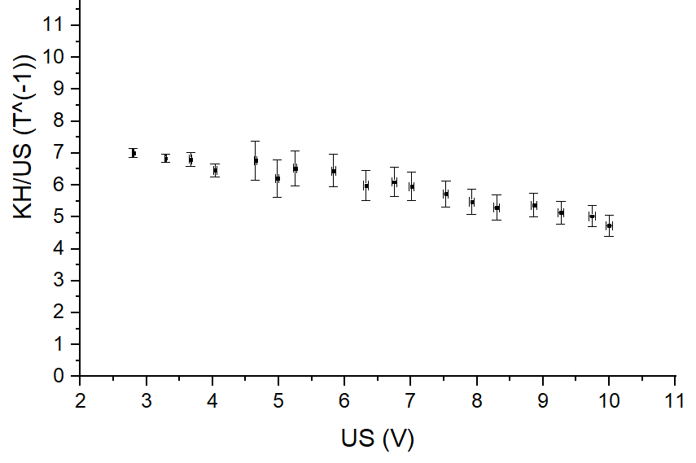

**Figure 8 Plot of KH/Us and Us**

**5.2 Relation between Output Voltage U and Magnetic Field B**

**5.2.1 Measurement of and U**

We measure output voltage U under different , and record the results in Table6:

|  |  |  |  |  |
| --- | --- | --- | --- | --- |
|  | [A] | [A] | U[V] | [V] |
| 1 | 0.00 | 0 | 0.0000 | 0.0006 |
| 2 | 0.05 | 0.001 | 0.0228 | 0.0006 |
| 3 | 0.10 | 0.002 | 0.0449 | 0.0006 |
| 4 | 0.15 | 0.003 | 0.0699 | 0.0006 |
| 5 | 0.20 | 0.004 | 0.0894 | 0.0006 |
| 6 | 0.25 | 0.005 | 0.1165 | 0.0007 |
| 7 | 0.30 | 0.006 | 0.1405 | 0.0007 |
| 8 | 0.35 | 0.007 | 0.1612 | 0.0007 |
| 9 | 0.40 | 0.008 | 0.1844 | 0.0007 |
| 10 | 0.45 | 0.009 | 0.2090 | 0.0007 |
| 11 | 0.50 | 0.01 | 0.2310 | 0.0007 |

**Table 6 Measurement data for the IM vs. U relation**

From Table 1 we get when x=0cm, =0.1A, =1.4366mT.

Now I=. Since B is proportional to I, we calculate B. Take =0.05A for example:

We arrange the data and the uncertainty in Table7:

|  |  |  |  |  |
| --- | --- | --- | --- | --- |
|  | U[V] | [V] | B[T] | [T] |
| 1 | 0.0000 | 0.0006 | 0 | 0 |
| 2 | 0.0228 | 0.0006 | 0.00072 | 0.00001 |
| 3 | 0.0449 | 0.0006 | 0.0014 | 0.00003 |
| 4 | 0.0699 | 0.0006 | 0.0022 | 0.00004 |
| 5 | 0.0894 | 0.0006 | 0.0029 | 0.00006 |
| 6 | 0.1165 | 0.0007 | 0.0036 | 0.00007 |
| 7 | 0.1405 | 0.0007 | 0.0043 | 0.00009 |
| 8 | 0.1612 | 0.0007 | 0.0050 | 0.00010 |
| 9 | 0.1844 | 0.0007 | 0.0058 | 0.00011 |
| 10 | 0.2090 | 0.0007 | 0.0065 | 0.00013 |
| 11 | 0.2310 | 0.0007 | 0.0072 | 0.00014 |

**Table 7 Relation of U and B**

Then we apply linear fit to U and B, shown in Figure 9:

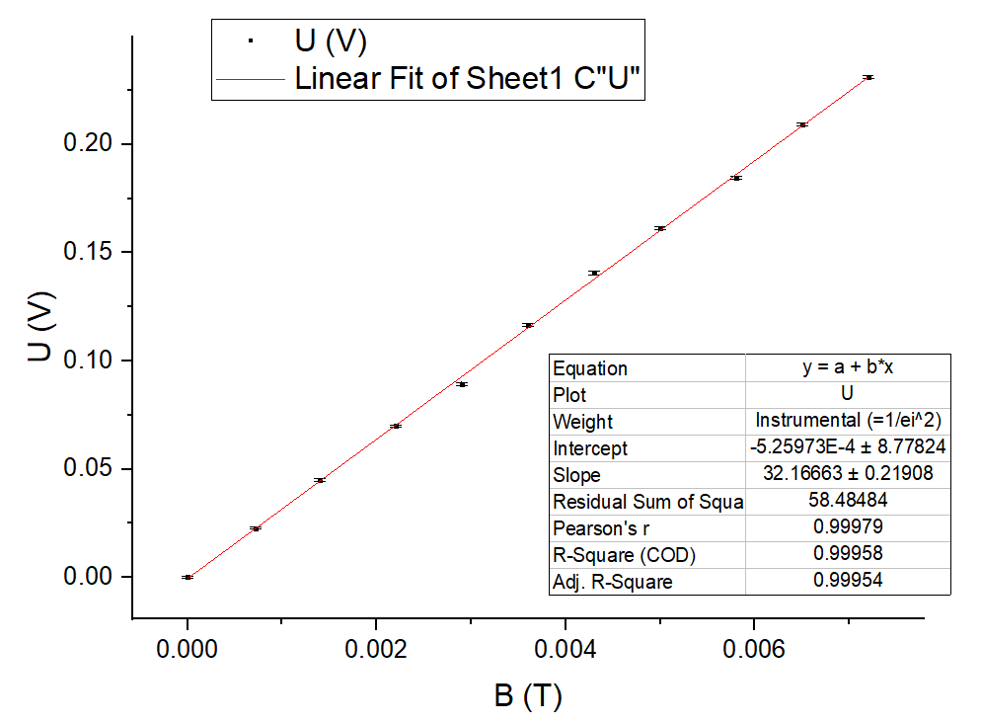

**Figure 9 Linear Fit of U and B**

The slope of the line is 32.17V/T, and the standard error is 0.21908V/T. The CI half-width is 0.21908rounded to be 0.5V/T. Therefore, the experimental .

In 5.1, we calculate is 33.13.

The relative error compared with is

We take marked on the apparatus as the theoretical value, the relative error compared with the theoretical value is

**5.3 Magnetic Field Distribution Inside the Solenoid**

We measured the magnetic field inside the Solenoid along the axis at different distance. The experimental data is shown in Table8:

|  |  |  |  |  |  |  |  |
| --- | --- | --- | --- | --- | --- | --- | --- |
|  | x[cm] | U[V] |  |  | x[cm] | U[V] |  |
| 1 | 0.00 | 0.0057 | 0.0006 | 27 | 12.50 | 0.1152 | 0.0007 |
| 2 | 0.30 | 0.0081 | 0.0006 | 28 | 14.00 | 0.1152 | 0.0007 |
| 3 | 0.60 | 0.0105 | 0.0006 | 29 | 15.00 | 0.1154 | 0.0007 |
| 4 | 0.80 | 0.0131 | 0.0006 | 30 | 16.50 | 0.1156 | 0.0007 |
| 5 | 1.00 | 0.0151 | 0.0006 | 31 | 18.00 | 0.1155 | 0.0007 |
| 6 | 1.20 | 0.0166 | 0.0006 | 32 | 20.00 | 0.1152 | 0.0007 |
| 7 | 1.40 | 0.0196 | 0.0006 | 33 | 21.00 | 0.1148 | 0.0007 |
| 8 | 1.80 | 0.0268 | 0.0006 | 34 | 22.00 | 0.1145 | 0.0007 |
| 9 | 2.00 | 0.0317 | 0.0006 | 35 | 23.00 | 0.1138 | 0.0007 |
| 10 | 2.30 | 0.0388 | 0.0006 | 36 | 24.50 | 0.1120 | 0.0007 |
| 11 | 2.60 | 0.0478 | 0.0006 | 37 | 25.50 | 0.1097 | 0.0007 |
| 12 | 2.80 | 0.0554 | 0.0006 | 38 | 26.50 | 0.1040 | 0.0007 |
| 13 | 3.20 | 0.0686 | 0.0006 | 39 | 27.00 | 0.0999 | 0.0007 |
| 14 | 3.50 | 0.0772 | 0.0006 | 40 | 27.50 | 0.0920 | 0.0006 |
| 15 | 3.80 | 0.0854 | 0.0006 | 41 | 27.90 | 0.0852 | 0.0006 |
| 16 | 4.50 | 0.0903 | 0.0006 | 42 | 28.20 | 0.0771 | 0.0006 |
| 17 | 5.00 | 0.0979 | 0.0006 | 43 | 28.50 | 0.0679 | 0.0006 |
| 18 | 5.50 | 0.1038 | 0.0007 | 44 | 28.80 | 0.0581 | 0.0006 |
| 19 | 6.00 | 0.1063 | 0.0007 | 45 | 29.00 | 0.0503 | 0.0006 |
| 20 | 6.50 | 0.1079 | 0.0007 | 46 | 29.30 | 0.0411 | 0.0006 |
| 21 | 7.20 | 0.1094 | 0.0007 | 47 | 29.50 | 0.0346 | 0.0006 |
| 22 | 7.80 | 0.1103 | 0.0007 | 48 | 29.60 | 0.0325 | 0.0006 |
| 23 | 8.50 | 0.1137 | 0.0007 | 49 | 29.70 | 0.0303 | 0.0006 |
| 24 | 9.50 | 0.1142 | 0.0007 | 50 | 29.80 | 0.0276 | 0.0006 |
| 25 | 10.50 | 0.1147 | 0.0007 | 51 | 29.90 | 0.0256 | 0.0006 |
| 26 | 11.50 | 0.1150 | 0.0007 | 52 | 30.00 | 0.0234 | 0.0006 |

**Table 8 U with different x**

Based on the value of U, we calculate the corresponding B by the equation:

Take U=0.0057V for example,

We arrange all the data and uncertainties in Table 9:

|  |  |  |  |  |  |  |  |
| --- | --- | --- | --- | --- | --- | --- | --- |
|  | x[cm] | B[T] |  |  | x[cm] | B[T] |  |
| 1 | 0.00 | 0.00018 | 0.00002 | 27 | 12.50 | 0.00358 | 0.00006 |
| 2 | 0.30 | 0.00025 | 0.00002 | 28 | 14.00 | 0.00358 | 0.00006 |
| 3 | 0.60 | 0.00033 | 0.00002 | 29 | 15.00 | 0.00359 | 0.00006 |
| 4 | 0.80 | 0.00041 | 0.00002 | 30 | 16.50 | 0.00359 | 0.00006 |
| 5 | 1.00 | 0.00047 | 0.00002 | 31 | 18.00 | 0.00359 | 0.00006 |
| 6 | 1.20 | 0.00052 | 0.00002 | 32 | 20.00 | 0.00358 | 0.00006 |
| 7 | 1.40 | 0.00061 | 0.00002 | 33 | 21.00 | 0.00357 | 0.00006 |
| 8 | 1.80 | 0.00083 | 0.00002 | 34 | 22.00 | 0.00356 | 0.00006 |
| 9 | 2.00 | 0.00099 | 0.00002 | 35 | 23.00 | 0.00354 | 0.00006 |
| 10 | 2.30 | 0.00121 | 0.00003 | 36 | 24.50 | 0.00348 | 0.00006 |
| 11 | 2.60 | 0.00149 | 0.00003 | 37 | 25.50 | 0.00341 | 0.00006 |
| 12 | 2.80 | 0.00172 | 0.00003 | 38 | 26.50 | 0.00323 | 0.00005 |
| 13 | 3.20 | 0.00213 | 0.00004 | 39 | 27.00 | 0.00311 | 0.00005 |
| 14 | 3.50 | 0.00240 | 0.00004 | 40 | 27.50 | 0.00286 | 0.00005 |
| 15 | 3.80 | 0.00265 | 0.00005 | 41 | 27.90 | 0.00265 | 0.00005 |
| 16 | 4.50 | 0.00281 | 0.00005 | 42 | 28.20 | 0.00240 | 0.00004 |
| 17 | 5.00 | 0.00304 | 0.00005 | 43 | 28.50 | 0.00211 | 0.00004 |
| 18 | 5.50 | 0.00323 | 0.00005 | 44 | 28.80 | 0.00181 | 0.00003 |
| 19 | 6.00 | 0.00330 | 0.00005 | 45 | 29.00 | 0.00156 | 0.00003 |
| 20 | 6.50 | 0.00335 | 0.00006 | 46 | 29.30 | 0.00128 | 0.00003 |
| 21 | 7.20 | 0.00340 | 0.00006 | 47 | 29.50 | 0.00108 | 0.00003 |
| 22 | 7.80 | 0.00343 | 0.00006 | 48 | 29.60 | 0.00101 | 0.00002 |
| 23 | 8.50 | 0.00353 | 0.00006 | 49 | 29.70 | 0.00094 | 0.00002 |
| 24 | 9.50 | 0.00355 | 0.00006 | 50 | 29.80 | 0.00086 | 0.00002 |
| 25 | 10.50 | 0.00357 | 0.00006 | 51 | 29.90 | 0.00080 | 0.00002 |
| 26 | 11.50 | 0.00357 | 0.00006 | 52 | 30.00 | 0.00073 | 0.00002 |

**Table 9 B with different x**

We then calculate the theoretical value of B using the data from Table1:

Take for example:

The x we take is the scale on the ruler, but the true x should be the distance from the center of the solenoid. Therefore, when we plot the figure, the horizontal coordinate should be x-13(cm).

For all the data, we calculate B(theo), shown in Table 10:

|  |  |  |  |  |  |
| --- | --- | --- | --- | --- | --- |
| x[cm] |  | B(theo)[T] | x[cm] |  | B(theo)[T] |
| -13.0 | 0.7233 | 0.0018 | 1.0 | 1.4363 | 0.0036 |
| -12.5 | 0.9261 | 0.0023 | 2.0 | 1.4356 | 0.0036 |
| -12.0 | 1.0863 | 0.0027 | 3.0 | 1.4343 | 0.0036 |
| -11.5 | 1.1963 | 0.0030 | 4.0 | 1.4323 | 0.0036 |
| -11.0 | 1.2685 | 0.0032 | 5.0 | 1.4292 | 0.0036 |
| -10.0 | 1.3478 | 0.0034 | 6.0 | 1.4245 | 0.0036 |
| -9.0 | 1.3856 | 0.0035 | 7.0 | 1.4173 | 0.0035 |
| -8.0 | 1.4057 | 0.0035 | 8.0 | 1.4057 | 0.0035 |
| -7.0 | 1.4173 | 0.0035 | 9.0 | 1.3856 | 0.0035 |
| -6.0 | 1.4245 | 0.0036 | 10.0 | 1.3478 | 0.0034 |
| -5.0 | 1.4292 | 0.0036 | 11.0 | 1.2685 | 0.0032 |
| -4.0 | 1.4323 | 0.0036 | 11.5 | 1.1963 | 0.0030 |
| -3.0 | 1.4343 | 0.0036 | 12.0 | 1.0863 | 0.0027 |
| -2.0 | 1.4356 | 0.0036 | 12.5 | 0.9261 | 0.0023 |
| -1.0 | 1.4363 | 0.0036 | 13.0 | 0.7233 | 0.0018 |
| 0.0 | 1.4366 | 0.0036 |  |  |  |

**Table 10 Theoretical value of B at different x**

We plot the experimental B and theoretical B in one figure:

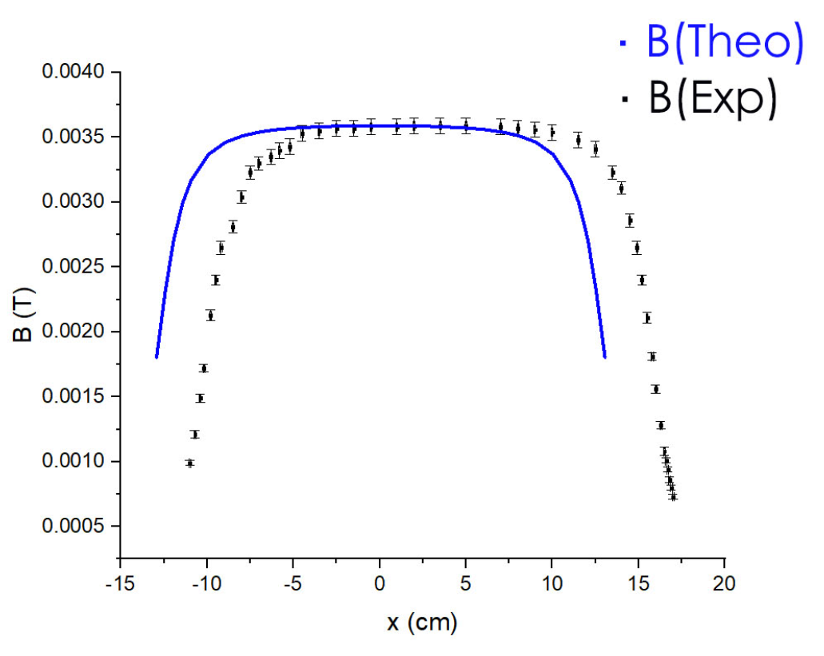

**Figure 10 B(exp) and B(Theo) vs. x**

**6. Conclusions and discussion**

**6.1 Conclusions**

In this lab, we

* Study the principle of the Hall effect and its applications by using a Hall probe.
* Calculate the sensitivity based on our experimental data and compare it with the theoretical value.
* Verify that the Hall voltage is proportional to the magnetic field B.
* Measure the magnetic field distribution along the axis of the solenoid and compare it with the corresponding theoretical curve.

In 5.1.1, when Us=5V, we measured =.

In 5.1.3, we plot vs. and found that almost remains the same although is changing. This shows that is proportional to . However, from the plot we can see has an incline to decrease when is increasing, and this error will be analyzed in 6.2.

In 5.2, we measured the output voltage U with different . Since is proportional to B, we thus get the relation between U and B. We find that U is proportional to B.

The slope indicates that .

We take marked on the apparatus as the theoretical value. Also, in 5.1.1 we measured =. Therefore, from linear fit has a relative error of -2.9% compared with and has a relative error of 2.9% compared with the theoretical value.

In 5.3, we measured the magnetic field B at different x along the axis of the solenoid.

From Table 1 we obtain the theoretical distribution of the magnetic field, and we plot them in Figure 10 and compare them. Their shapes coincide but there is a slight position deviation of the two shape, and the error will be discussed in 6.2.

**6.2 Error Analysis**

* In 5.1, the reason why has an incline to decrease when is increasing might be the wrong experimental procedure. I first set =0A, change the Us from 2.8 to 10V, finish this round of measurement and then set =250mA, set the Us equal to the round1 values and then did the second round of measurement. Therefore, with the same Us, U0 and U are measured under a large time interval, which results in deviations in these two factors.
* In 5.3, the reason why the two shapes has slight deviation might be: if the theoretical shape is moved 2cm to the right then the two shapes can cover each other. Hence, maybe the center of the solenoid is actually at 15cm on the scale.
* Other errors might exist because:

Instability of displaying of U0 and U;

In procedure 4.2.1, U0 is very hard to be adjusted to completely 0.

The Hall probe might move its position when measuring;

Rise of temperature causing R to change.

**6.3 Improvements**

* Since we have to change Us and Im by switching the channel, it’s hard to obtain the value we want. I suggest the source value can be set digitally.
* Add a procedure to let students determine the center of the solenoid.

**7. Reference**

[1] M. Krzyzosiak (2019). Exercise 2 - lab manual [rev. 3.8].pdf Shanghai: UMJI-SJTU.

**A. Measurement uncertainty analysis**

**A.1 Uncertainty in Analysis of the Relation Between Sensitivity and Working Voltage**

**A.1.1 Uncertainty in Calculation of**

**A.1.2 Uncertainty in Measurement of and U under different**

The uncertainty of Us is:

The uncertainty of is:

When has four decimal numbers.

When has three decimal numbers.

The uncertainty of is:

When has four decimal numbers.

When has three decimal numbers.

Take the 1st row of data for example:

We arrange all the data and uncertainties in Table 11:

|  |  |  |  |  |  |  |
| --- | --- | --- | --- | --- | --- | --- |
|  |  |  |  |  |  |  |
| 1 | 2.80 | 1.4336 | 1.5040 | 0.014 | 0.001 | 0.001 |
| 2 | 3.29 | 1.6768 | 1.7576 | 0.016 | 0.001 | 0.001 |
| 3 | 3.67 | 1.8665 | 1.9562 | 0.018 | 0.002 | 0.002 |
| 4 | 4.04 | 2.0523 | 2.146 | 0.020 | 0.002 | 0.002 |
| 5 | 4.65 | 2.347 | 2.460 | 0.023 | 0.007 | 0.007 |
| 6 | 4.98 | 2.508 | 2.619 | 0.025 | 0.007 | 0.007 |
| 7 | 5.25 | 2,640 | 2.763 | 0.026 | 0.007 | 0.007 |
| 8 | 5.83 | 2.919 | 3.054 | 0.029 | 0.007 | 0.008 |
| 9 | 6.32 | 3.157 | 3.293 | 0.032 | 0.008 | 0.008 |
| 10 | 6.75 | 3.364 | 3.512 | 0.034 | 0.008 | 0.008 |
| 11 | 7.01 | 3.489 | 3.639 | 0.035 | 0.008 | 0.008 |
| 12 | 7.53 | 3.746 | 3.901 | 0.038 | 0.008 | 0.008 |
| 13 | 7.92 | 3.935 | 4.091 | 0.040 | 0.008 | 0.008 |
| 14 | 8.30 | 4.117 | 4.275 | 0.042 | 0.008 | 0.008 |
| 15 | 8.86 | 4.395 | 4.566 | 0.044 | 0.008 | 0.008 |
| 16 | 9.27 | 4.590 | 4.761 | 0.046 | 0.008 | 0.008 |
| 17 | 9.74 | 4.816 | 4.992 | 0.049 | 0.008 | 0.008 |
| 18 | 10.00 | 4.951 | 5.121 | 0.050 | 0.008 | 0.009 |

**Table 11 uncertainties of Us U0 and U**

**A.1.3 Uncertainty in the analysis of the relation between and**

Take the 1st row of data for example:

We arrange all the data and uncertainties in Table 12

:

|  |  |  |  |  |
| --- | --- | --- | --- | --- |
|  |  | ( | (V) | ( |
| 1 | 2.80 | 7.00 | 0.014 | 0.14 |
| 2 | 3.29 | 6.84 | 0.016 | 0.12 |
| 3 | 3.67 | 6.81 | 0.018 | 0.22 |
| 4 | 4.04 | 6.46 | 0.020 | 0.20 |
| 5 | 4.65 | 6.77 | 0.023 | 0.61 |
| 6 | 4.98 | 6.21 | 0.025 | 0.58 |
| 7 | 5.25 | 6.52 | 0.026 | 0.55 |
| 8 | 5.83 | 6.45 | 0.029 | 0.51 |
| 9 | 6.32 | 5.99 | 0.032 | 0.48 |
| 10 | 6.75 | 6.10 | 0.034 | 0.45 |
| 11 | 7.01 | 5.96 | 0.035 | 0.44 |
| 12 | 7.53 | 5.73 | 0.038 | 0.41 |
| 13 | 7.92 | 5.48 | 0.040 | 0.40 |
| 14 | 8.30 | 5.30 | 0.042 | 0.39 |
| 15 | 8.86 | 5.37 | 0.044 | 0.37 |
| 16 | 9.27 | 5.14 | 0.046 | 0.36 |
| 17 | 9.74 | 5.03 | 0.049 | 0.34 |
| 18 | 10.00 | 4.73 | 0.050 | 0.34 |

**Table 12 Uncertainties of Us and KH/US**

**A.2 Uncertainty in the Analysis of the Relation between Output Voltage U and Magnetic Field B**

**A.2.1 Uncertainty in Measurement of and U**

Take the 2nd row of data for example:

We arrange the data and the uncertainty in Table 13

|  |  |  |  |  |
| --- | --- | --- | --- | --- |
|  | [A] | [A] | U[V] | [V] |
| 1 | 0.00 | 0 | 0.0000 | 0.0006 |
| 2 | 0.05 | 0.001 | 0.0228 | 0.0006 |
| 3 | 0.10 | 0.002 | 0.0449 | 0.0006 |
| 4 | 0.15 | 0.003 | 0.0699 | 0.0006 |
| 5 | 0.20 | 0.004 | 0.0894 | 0.0006 |
| 6 | 0.25 | 0.005 | 0.1165 | 0.0007 |
| 7 | 0.30 | 0.006 | 0.1405 | 0.0007 |
| 8 | 0.35 | 0.007 | 0.1612 | 0.0007 |
| 9 | 0.40 | 0.008 | 0.1844 | 0.0007 |
| 10 | 0.45 | 0.009 | 0.2090 | 0.0007 |
| 11 | 0.50 | 0.01 | 0.2310 | 0.0007 |

**Table 13 Uncertainties of Im and U**

**A.2.2 Uncertainty in Calculation of B**

Take the 2nd row of data for example:

For all the data, the uncertainties are listed in table 14:

|  |  |  |  |  |
| --- | --- | --- | --- | --- |
|  | [A] | [A] | B[T] | [T] |
| 1 | 0.00 | 0 | 0 | 0 |
| 2 | 0.05 | 0.001 | 0.00072 | 0.00001 |
| 3 | 0.10 | 0.002 | 0.0014 | 0.00003 |
| 4 | 0.15 | 0.003 | 0.0022 | 0.00004 |
| 5 | 0.20 | 0.004 | 0.0029 | 0.00006 |
| 6 | 0.25 | 0.005 | 0.0036 | 0.00007 |
| 7 | 0.30 | 0.006 | 0.0043 | 0.00009 |
| 8 | 0.35 | 0.007 | 0.0050 | 0.00010 |
| 9 | 0.40 | 0.008 | 0.0058 | 0.00011 |
| 10 | 0.45 | 0.009 | 0.0065 | 0.00013 |
| 11 | 0.50 | 0.01 | 0.0072 | 0.00014 |

**Table 14 Uncertainties of Im and B**

**A.3 Uncertainty in the Analysis of Magnetic Field Distribution Inside the Solenoid**

**A.3.1 Uncertainty of the U**

Take U=0.0081 for example,

For all the data, the uncertainties are listed in table 15:

|  |  |  |  |  |  |
| --- | --- | --- | --- | --- | --- |
|  | U[V] |  |  | U[V] |  |
| 1 | 0.0057 | 0.0006 | 27 | 0.1152 | 0.0007 |
| 2 | 0.0081 | 0.0006 | 28 | 0.1152 | 0.0007 |
| 3 | 0.0105 | 0.0006 | 29 | 0.1154 | 0.0007 |
| 4 | 0.0131 | 0.0006 | 30 | 0.1156 | 0.0007 |
| 5 | 0.0151 | 0.0006 | 31 | 0.1155 | 0.0007 |
| 6 | 0.0166 | 0.0006 | 32 | 0.1152 | 0.0007 |
| 7 | 0.0196 | 0.0006 | 33 | 0.1148 | 0.0007 |
| 8 | 0.0268 | 0.0006 | 34 | 0.1145 | 0.0007 |
| 9 | 0.0317 | 0.0006 | 35 | 0.1138 | 0.0007 |
| 10 | 0.0388 | 0.0006 | 36 | 0.1120 | 0.0007 |
| 11 | 0.0478 | 0.0006 | 37 | 0.1097 | 0.0007 |
| 12 | 0.0554 | 0.0006 | 38 | 0.1040 | 0.0007 |
| 13 | 0.0686 | 0.0006 | 39 | 0.0999 | 0.0007 |
| 14 | 0.0772 | 0.0006 | 40 | 0.0920 | 0.0006 |
| 15 | 0.0854 | 0.0006 | 41 | 0.0852 | 0.0006 |
| 16 | 0.0903 | 0.0006 | 42 | 0.0771 | 0.0006 |
| 17 | 0.0979 | 0.0006 | 43 | 0.0679 | 0.0006 |
| 18 | 0.1038 | 0.0007 | 44 | 0.0581 | 0.0006 |
| 19 | 0.1063 | 0.0007 | 45 | 0.0503 | 0.0006 |
| 20 | 0.1079 | 0.0007 | 46 | 0.0411 | 0.0006 |
| 21 | 0.1094 | 0.0007 | 47 | 0.0346 | 0.0006 |
| 22 | 0.1103 | 0.0007 | 48 | 0.0325 | 0.0006 |
| 23 | 0.1137 | 0.0007 | 49 | 0.0303 | 0.0006 |
| 24 | 0.1142 | 0.0007 | 50 | 0.0276 | 0.0006 |
| 25 | 0.1147 | 0.0007 | 51 | 0.0256 | 0.0006 |
| 26 | 0.1150 | 0.0007 | 52 | 0.0234 | 0.0006 |

**Table 15 Uncertainties of U**

**A.3.2 Uncertainty of B**

Take the 1st row of data for example:

For all the data, the uncertainties are listed in Table 16:

|  |  |  |  |  |  |
| --- | --- | --- | --- | --- | --- |
|  | B[T] |  |  | B[T] |  |
| 1 | 0.00018 | 0.00002 | 27 | 0.00358 | 0.00006 |
| 2 | 0.00025 | 0.00002 | 28 | 0.00358 | 0.00006 |
| 3 | 0.00033 | 0.00002 | 29 | 0.00359 | 0.00006 |
| 4 | 0.00041 | 0.00002 | 30 | 0.00359 | 0.00006 |
| 5 | 0.00047 | 0.00002 | 31 | 0.00359 | 0.00006 |
| 6 | 0.00052 | 0.00002 | 32 | 0.00358 | 0.00006 |
| 7 | 0.00061 | 0.00002 | 33 | 0.00357 | 0.00006 |
| 8 | 0.00083 | 0.00002 | 34 | 0.00356 | 0.00006 |
| 9 | 0.00099 | 0.00002 | 35 | 0.00354 | 0.00006 |
| 10 | 0.00121 | 0.00003 | 36 | 0.00348 | 0.00006 |
| 11 | 0.00149 | 0.00003 | 37 | 0.00341 | 0.00006 |
| 12 | 0.00172 | 0.00003 | 38 | 0.00323 | 0.00005 |
| 13 | 0.00213 | 0.00004 | 39 | 0.00311 | 0.00005 |
| 14 | 0.00240 | 0.00004 | 40 | 0.00286 | 0.00005 |
| 15 | 0.00265 | 0.00005 | 41 | 0.00265 | 0.00005 |
| 16 | 0.00281 | 0.00005 | 42 | 0.00240 | 0.00004 |
| 17 | 0.00304 | 0.00005 | 43 | 0.00211 | 0.00004 |
| 18 | 0.00323 | 0.00005 | 44 | 0.00181 | 0.00003 |
| 19 | 0.00330 | 0.00005 | 45 | 0.00156 | 0.00003 |
| 20 | 0.00335 | 0.00006 | 46 | 0.00128 | 0.00003 |
| 21 | 0.00340 | 0.00006 | 47 | 0.00108 | 0.00003 |
| 22 | 0.00343 | 0.00006 | 48 | 0.00101 | 0.00002 |
| 23 | 0.00353 | 0.00006 | 49 | 0.00094 | 0.00002 |
| 24 | 0.00355 | 0.00006 | 50 | 0.00086 | 0.00002 |
| 25 | 0.00357 | 0.00006 | 51 | 0.00080 | 0.00002 |
| 26 | 0.00357 | 0.00006 | 52 | 0.00073 | 0.00002 |

**Table 16 Uncertainties of B**