UM-SJTU Joint Institute

Physics Laboratory

(Vp241)

Laboratory Report

Exercise 3

Solar Cells:

I-V Characteristics

Name: Wenxin He ID: 518370910117 Group: 1

Name: Xiaoxuan Wang ID: 518021910460 Group:1

Date: 1 November 2019

**1. Objective**

The objective of this lab is to learn the working principle of solar cell and study its current-voltage characteristics.

**2. Theoretical Background**

Solar cells can transform solar radiations into electrical energy directly. Their advantages include no consumption of energy, silent operation, no moving parts and a long life time. They are also easy to maintain and do not cause air pollution. Hence, solar cells are regarded as a promising energy source in the 21st century. It is estimated that by the mid-21st century, 15-20% of the total electrical energy generated in the world will be produced by solar cells. Solar cells will become one of the leading energy sources in the near future.

**2.1 Solar Cell Structure**

Shown in Figure 1 is the structure of a crystalline silicon solar cell. It consists of n/p homo-junctions, a 10cmcm p-type silicon plate of thickness 500, covered with a heavily doped n-type layer with thickness 0.3. The metallic bars on the n-type layer serve as one electrode, with a metallic film at the bottom playing the role of another one. To reduce energy loss due to reflection, an anti-reflective film is often applied to cover the surface exposed to sunlight.



**Figure 1 Structure of a crystalline silicon solar cell**

**2.2 Photovoltaic Effect**

When the light enters the p-n junction near the solar cell surface, and the energy of incident photons is larger than the forbidden bandwidth(energy gap) Eg, the incident photons are absorbed and electron-hole pairs are excited. Minority charge carriers in the n- or p-type area diffuse due to their density gradient. Some of them can diffuse to the p-n junction where a built-in electric field which is directed from n to p exists. The diffused minority carriers are drown by this electric field, with holes to the p-type area and electrons to the n-type area. Therefore, an increase of positive charge will accumulate in the p-type area and negative charge in the n-type area. In this way, a photoelectric potential difference is generated. The phenomenon is known as the photovoltaic effect.

**2.3 Solar Cell Parameters**

Due to photovoltaic effect solar cell can generate an electric current from the n-type area to the p-type area when there is light incident on the solar cell.

In the device there is a forward diode currentfrom the p-type area to the n-type area, which is opposite to. Hence, the net current is

Where is the junction voltage, is the diode inverse saturation current, is the photocurrent determined by the structure and material characteristics of the solar cell. The coefficient n is a theoretical coefficient, with its value ranging from 1 to 2, that characterizes the p-n junction. Furthermore, q denoted the electron’s charge, kB is the Boltzmann’s constant, and T is the temperature in the absolute(Kelvin)scale. Ignoring the internal series resistance , the voltage equals the terminal voltage V and Eq.(1) can be rewritten as

When the output is short, i.e. V=0, the short-circuit current is

Whereas when the output is open, i.e. I=0, the open-circuit voltage is

=

When there is a load resistance R(the value of R ranging from zero to infinity), then corresponding I-V characteristics curve is shown in Figure 2. If for a certain load resistance R=the maximum output poweris ,

where is the optimal operating current, and is the optimal operating voltage. Then, FF=. The quantity FF is an important parameter of solar cells called the fill factor. The greater the fill factor is, the greater the output power. The fill factor is determined by a number of parameters, such as the incident light intensity, the forbidden bandwidth, the value of the theoretical coefficient n, and the series/parallel resistance.

The solar cell energy conversion efficiency is defined as .

Where denotes the total radiant power incident on the solar cell.



**Figure 2 The current-voltage characteristics of a solar cell**

**2.4 Solar Cell Equivalent Circuit**

Shown in Figure 3, a solar cell can be thought of as composed of a p-n junction diode D and a constant current source . Along with a series resistance Rs due to the electrodes in the solar cell and a parallel resistance Rsh, all elements form a circuit equivalent to a p-n junction leak-circuit. For the equivalent circuit one can find the following relationship between the current and the voltage

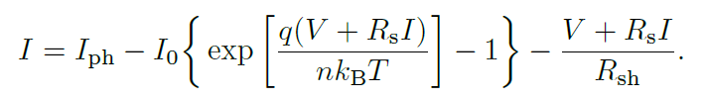

In order to provide a greater output power, the value of Rs should be decreased, while Rsh should increase.



**Figure 3 Solar cell equivalent circuit**

**3. Experimental Setup**

**3.1 Apparatus**

The setup consists of a photovoltaic device(5W), a 300W tungsten-halogen lamp serving as a radiation source, two digital multimeters, two adjustable resistors, a solar power meter, a wiring board and a measuring tape.

**3.2 Device Information**

The information of each measurement device is shown in Table 2.

|  |  |  |  |
| --- | --- | --- | --- |
| **apparatus** | **range** | **Minimum scale of value** | **Maximum uncertainty** |
| DC voltage multimeter | / | 0.01V |  |
| DC current multimeter | / | 0.1mA |  |
| Measuring tape | / | 0.1cm |  |
| Solar power meter | / | 0.1 |  |

**Table 1 Information of Each Measurement Device**

**4. Measurement Procedure**

1. Turn on both the light and the fan. Wait for at least five minutes, in order to let

the light reach its working intensity.

2. Design a measuring circuit with the photovoltaic device, multimeters set in an appropriate range, and the resistance. Connect the elements into a circuit using the

provided wiring board.

3. Work in pairs. Adjust the distance between the light source and the photovoltaic

device until the Voc and Isc of the two devices are about the same. Measure the

solar power by the provided solar power meter.

In order to collect the data to draw the I-V characteristics curve, change the resistance and measure the relevant current and voltage. Keep the distance between the light source and the photovoltaic device and do not move around the workstation during the measurement, to ensure the same light intensity is maintained during the whole process.

Measure the I-V characteristics curves and the values of Voc and Isc under each of

the following conditions:

(a) Two devices in series;

(b) Two devices in parallel;

(c) A single device

4. Change the distance between the light source and the photovoltaic device and measure the I-V characteristics curves and the values of Voc and Isc in a single-device

configuration. The new distance should be about 80% or 120% of the original one.

Measure the solar power at this distance.

5. Plot (use a computer)

(a) the I-V characteristics curves;

(b) the graph of the output power vs. the voltage.

Determine the values of Isc; Voc; Pm; Im; Vm;Rm, FF, and . Compile the data in the form of a table.

**5. Results**

**5.1 Multimeter precision**

|  |  |
| --- | --- |
| **QUANTITY** | **PRECISION** |
| DC voltage |  |
| DC current |  |
| Distance |  |
| Solar power |  |

**Table 2 Multimeter precision**

**5.2 Measurement of**

**5.2.1 Measurement of area**

We measure the length and width of the black area of the cell:

|  |  |
| --- | --- |
| Length[cm] | Width[cm] |
| 26.0 | 21.0 |

**Table 3 Measurement data for area**

Then we calculate the surface area of the solar cell:

**5.2.2 Measurement of solar power**

We measure the solar power of six different area of the solar cell with the distance 120cm and 140cm respectively:

|  |  |  |  |  |  |  |
| --- | --- | --- | --- | --- | --- | --- |
|  | 1 | 2 | 3 | 4 | 5 | 6 |
| [W/] | 199.3 | 165.7 | 183.3 | 185.1 | 162.0 | 176.0 |
| [W/] | 166.9 | 147.8 | 165.7 | 143.5 | 153.4 | 147.2 |

**Table 4 Measurement data for solar power**

Then we calculate the average solar power of the solar cell at 120cm and 140cm:

**5.2.3 Calculation of input power**

**5.3 Measurement of and**

|  |  |  |  |  |
| --- | --- | --- | --- | --- |
|  | Single device at 120cm | Single device at 140cm | series | parallel |
| [V] | 7.93 | 7.68 | 15.93 | 7.96 |
|  | 54.4 | 48.1 | 55.1 | 108.0 |

**Table 5 Measurement data for Uoc and Isc**

The uncertainty of these values will be shown in Table 14.

**5.4 Measurement of U and I relations of 4 types**

We measure U and I of the series connection, parallel connection, a single device at 120cm, and a single device of 140cm, and record them in Table 6,7,8,9.

|  |  |  |  |  |
| --- | --- | --- | --- | --- |
|  | U[V] |  | I[mA] |  |
| 1 | 0.06 | 0.01 | 55.5 | 0.9 |
| 2 | 1.43 | 0.02 | 53.9 | 0.9 |
| 3 | 2.22 | 0.02 | 52.9 | 0.9 |
| 4 | 4.20 | 0.03 | 50.3 | 0.9 |
| 5 | 6.16 | 0.04 | 47.1 | 0.8 |
| 6 | 7.90 | 0.05 | 43.7 | 0.8 |
| 7 | 9.43 | 0.06 | 39.5 | 0.7 |
| 8 | 10.42 | 0.06 | 36.2 | 0.6 |
| 9 | 10.99 | 0.06 | 33.9 | 0.6 |
| 10 | 11.45 | 0.07 | 31.0 | 0.6 |
| 11 | 11.79 | 0.07 | 30.2 | 0.6 |
| 12 | 12.22 | 0.07 | 28.0 | 0.5 |
| 13 | 12.55 | 0.07 | 26.2 | 0.5 |
| 14 | 12.86 | 0.07 | 24.5 | 0.5 |
| 15 | 13.12 | 0.08 | 22.9 | 0.4 |
| 16 | 13.27 | 0.08 | 22.0 | 0.4 |
| 17 | 13.40 | 0.08 | 21.1 | 0.4 |
| 18 | 13.65 | 0.08 | 19.4 | 0.4 |
| 19 | 13.90 | 0.08 | 17.6 | 0.4 |
| 20 | 14.06 | 0.08 | 16.4 | 0.3 |
| 21 | 14.22 | 0.08 | 15.1 | 0.3 |
| 22 | 14.30 | 0.08 | 14.6 | 0.3 |
| 23 | 14.18 | 0.08 | 15.5 | 0.3 |
| 24 | 14.09 | 0.08 | 16.1 | 0.3 |
| 25 | 13.98 | 0.08 | 17.0 | 0.4 |
| oc | 15.93 | 0.09 | 0 | 0 |
| sc | 0 | 0 | 55.1 | 0.9 |

**Table 6 Measurement data for U and I relation of series connection**

|  |  |  |  |  |
| --- | --- | --- | --- | --- |
|  | U[V] |  | I[mA] |  |
| 1 | 0.12 | 0.01 | 106.7 | 1.7 |
| 2 | 1.40 | 0.02 | 100.6 | 1.6 |
| 3 | 2.58 | 0.02 | 94.3 | 1.5 |
| 4 | 3.48 | 0.03 | 87.7 | 1.4 |
| 5 | 4.31 | 0.03 | 79.8 | 1.3 |
| 6 | 5.06 | 0.04 | 70.2 | 1.2 |
| 7 | 5.65 | 0.04 | 60.8 | 1.0 |
| 8 | 5.98 | 0.04 | 54.5 | 0.9 |
| 9 | 6.30 | 0.04 | 47.5 | 0.8 |
| 10 | 6.47 | 0.04 | 43.5 | 0.8 |
| 11 | 6.65 | 0.04 | 39.3 | 0.7 |
| 12 | 6.77 | 0.04 | 36.2 | 0.6 |
| 13 | 6.58 | 0.04 | 40.3 | 0.7 |
| 14 | 6.64 | 0.04 | 39.4 | 0.7 |
| 15 | 6.71 | 0.04 | 37.6 | 0.7 |
| 16 | 6.83 | 0.04 | 34.7 | 0.6 |
| 17 | 6.94 | 0.04 | 31.6 | 0.6 |
| 18 | 7.02 | 0.04 | 29.4 | 0.5 |
| 19 | 7.11 | 0.05 | 27.1 | 0.5 |
| 20 | 7.17 | 0.05 | 25.7 | 0.5 |
| 21 | 7.25 | 0.05 | 23.1 | 0.4 |
| 22 | 7.31 | 0.05 | 21.3 | 0.4 |
| 23 | 7.37 | 0.05 | 19.7 | 0.4 |
| 24 | 7.40 | 0.05 | 18.7 | 0.4 |
| 25 | 7.46 | 0.05 | 16.9 | 0.4 |
| oc | 7.96 | 0.05 | 0 | 0 |
| sc | 0 | 0 | 108.0 | 1.7 |

**Table 7 Measurement data for U and I relation for parallel connection**

|  |  |  |  |  |
| --- | --- | --- | --- | --- |
|  | U[V] |  | I[mA] |  |
| 1 | 0.01 | 0.01 | 57.2 | 1.0 |
| 2 | 0.40 | 0.01 | 56.5 | 0.9 |
| 3 | 1.12 | 0.02 | 55.0 | 0.9 |
| 4 | 2.06 | 0.02 | 53.0 | 0.9 |
| 5 | 2.51 | 0.02 | 51.7 | 0.9 |
| 6 | 3.04 | 0.03 | 49.4 | 0.8 |
| 7 | 3.77 | 0.03 | 46.4 | 0.8 |
| 8 | 3.81 | 0.03 | 46.7 | 0.8 |
| 9 | 4.70 | 0.03 | 42.0 | 0.7 |
| 10 | 5.08 | 0.04 | 39.2 | 0.7 |
| 11 | 5.56 | 0.04 | 35.2 | 0.6 |
| 12 | 5.96 | 0.04 | 31.7 | 0.6 |
| 13 | 6.26 | 0.04 | 28.5 | 0.5 |
| 14 | 6.56 | 0.04 | 24.9 | 0.5 |
| 15 | 6.72 | 0.04 | 22.7 | 0.4 |
| 16 | 6.93 | 0.04 | 20.0 | 0.4 |
| 17 | 7.08 | 0.05 | 17.7 | 0.4 |
| 18 | 7.20 | 0.05 | 15.9 | 0.3 |
| 19 | 7.41 | 0.05 | 12.6 | 0.3 |
| 20 | 7.51 | 0.05 | 10.9 | 0.3 |
| 21 | 7.57 | 0.05 | 9.8 | 0.2 |
| 22 | 7.65 | 0.05 | 8.4 | 0.2 |
| 23 | 7.68 | 0.05 | 7.8 | 0.2 |
| 24 | 7.70 | 0.05 | 7.4 | 0.2 |
| 25 | 7.76 | 0.05 | 0.0 | 0.1 |
| oc | 7.93 | 0.05 | 0 | 0 |
| sc | 0 | 0 | 54.4 | 0.9 |

**Table 8 Measurement data for U and I relation for single device at 120cm**

|  |  |  |  |  |
| --- | --- | --- | --- | --- |
|  | U[V] |  | I[mA] |  |
| 1 | 0.01 | 0.01 | 48.4 | 0.8 |
| 2 | 0.83 | 0.01 | 46.9 | 0.8 |
| 3 | 1.65 | 0.02 | 45.1 | 0.8 |
| 4 | 2.61 | 0.02 | 42.7 | 0.7 |
| 5 | 3.64 | 0.03 | 38.9 | 0.7 |
| 6 | 4.28 | 0.03 | 36.0 | 0.6 |
| 7 | 4.63 | 0.03 | 34.2 | 0.6 |
| 8 | 5.10 | 0.04 | 31.0 | 0.6 |
| 9 | 5.63 | 0.04 | 26.7 | 0.5 |
| 10 | 6.04 | 0.04 | 22.8 | 0.4 |
| 11 | 6.23 | 0.04 | 20.8 | 0.4 |
| 12 | 6.39 | 0.04 | 19.0 | 0.4 |
| 13 | 6.52 | 0.04 | 17.4 | 0.4 |
| 14 | 6.62 | 0.04 | 16.1 | 0.3 |
| 15 | 6.73 | 0.04 | 14.8 | 0.3 |
| 16 | 6.79 | 0.04 | 14.0 | 0.3 |
| 17 | 6.86 | 0.04 | 13.0 | 0.3 |
| 18 | 6.88 | 0.04 | 12.0 | 0.3 |
| 19 | 6.94 | 0.04 | 11.1 | 0.3 |
| 20 | 7.00 | 0.05 | 9.8 | 0.2 |
| 21 | 7.09 | 0.05 | 8.8 | 0.2 |
| 22 | 7.16 | 0.05 | 7.8 | 0.2 |
| 23 | 7.22 | 0.05 | 7.3 | 0.2 |
| 24 | 7.24 | 0.05 | 8.3 | 0.2 |
| 25 | 7.27 | 0.05 | 6.3 | 0.2 |
| oc | 7.68 | 0.05 | 0 | 0 |
| sc | 0 | 0 | 48.1 | 0.8 |

**Table 9 Measurement data for U and I relation for single device at 140cm**

Then we plot the I-V characteristics in Figure 4.

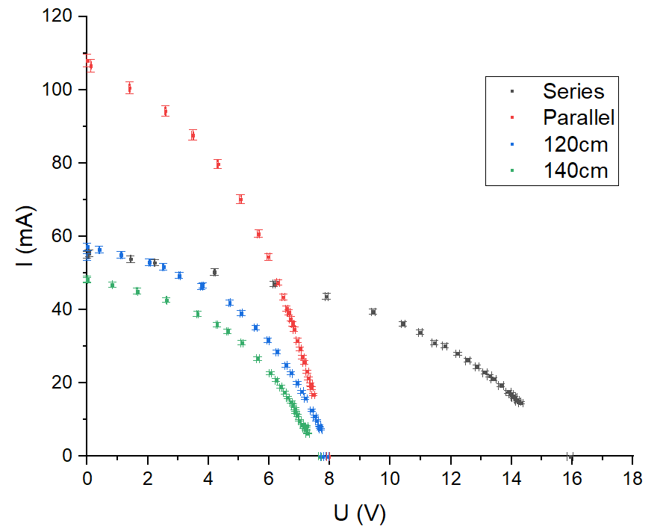

**Figure 4 I-V characteristics plot of the 4 types**

**5.4 Calculation of P and R**

Using data from Table 6,7,8,9, we calculate P and R of each type, and record them in Table 10,11,12,13.

Take the first row of data from Table 6 for example:

|  |  |  |  |  |  |  |  |  |
| --- | --- | --- | --- | --- | --- | --- | --- | --- |
|  | U[V] |  | I[mA] |  | P[W] |  | R[] |  |
| 1 | 0.06 | 0.01 | 55.5 | 0.9 | 0.0033 | 0.0006 | 1.081 | 0.2 |
| 2 | 1.43 | 0.02 | 53.9 | 0.9 | 0.0771 | 0.002 | 26.531 | 0.5 |
| 3 | 2.22 | 0.02 | 52.9 | 0.9 | 0.1174 | 0.002 | 41.966 | 0.8 |
| 4 | 4.20 | 0.03 | 50.3 | 0.9 | 0.2113 | 0.004 | 83.499 | 1.5 |
| 5 | 6.16 | 0.04 | 47.1 | 0.8 | 0.2901 | 0.005 | 130.786 | 2.4 |
| 6 | 7.90 | 0.05 | 43.7 | 0.8 | 0.3452 | 0.006 | 180.778 | 3.3 |
| 7 | 9.43 | 0.06 | 39.5 | 0.7 | 0.3725 | 0.007 | 238.734 | 4.4 |
| 8 | 10.42 | 0.06 | 36.2 | 0.6 | 0.3772 | 0.007 | 287.845 | 5.4 |
| 9 | 10.99 | 0.07 | 33.9 | 0.6 | 0.3726 | 0.007 | 324.189 | 6.1 |
| 10 | 11.45 | 0.07 | 31.0 | 0.6 | 0.3550 | 0.007 | 369.355 | 7.1 |
| 11 | 11.79 | 0.07 | 30.2 | 0.6 | 0.3561 | 0.007 | 390.397 | 7.5 |
| 12 | 12.22 | 0.07 | 28.0 | 0.5 | 0.3422 | 0.007 | 436.429 | 8.5 |
| 13 | 12.55 | 0.07 | 26.2 | 0.5 | 0.3288 | 0.007 | 479.008 | 9.4 |
| 14 | 12.86 | 0.07 | 24.5 | 0.5 | 0.3151 | 0.006 | 524.898 | 10.5 |
| 15 | 13.12 | 0.08 | 22.9 | 0.4 | 0.3004 | 0.006 | 572.926 | 11.6 |
| 16 | 13.27 | 0.08 | 22.0 | 0.4 | 0.2919 | 0.006 | 603.182 | 12.3 |
| 17 | 13.40 | 0.08 | 21.1 | 0.4 | 0.2827 | 0.006 | 635.071 | 13.1 |
| 18 | 13.65 | 0.08 | 19.4 | 0.4 | 0.2648 | 0.006 | 703.608 | 14.7 |
| 19 | 13.90 | 0.08 | 17.6 | 0.4 | 0.2446 | 0.005 | 789.773 | 16.9 |
| 20 | 14.06 | 0.08 | 16.4 | 0.3 | 0.2306 | 0.005 | 857.317 | 18.7 |
| 21 | 14.22 | 0.08 | 15.1 | 0.3 | 0.2147 | 0.005 | 941.722 | 21.1 |
| 22 | 14.30 | 0.08 | 14.6 | 0.3 | 0.2088 | 0.005 | 979.452 | 22.1 |
| 23 | 14.18 | 0.08 | 15.5 | 0.3 | 0.2198 | 0.005 | 914.839 | 20.3 |
| 24 | 14.09 | 0.08 | 16.1 | 0.3 | 0.2268 | 0.005 | 875.155 | 19.2 |
| 25 | 13.98 | 0.08 | 17.0 | 0.4 | 0.2377 | 0.005 | 822.353 | 17.8 |

**Table 10 Calculation of P and R of series connection**

|  |  |  |  |  |  |  |  |  |
| --- | --- | --- | --- | --- | --- | --- | --- | --- |
|  | U[V] |  | I[mA] |  | P[W] |  | R[] |  |
| 1 | 0.12 | 0.01 | 106.7 | 1.7 | 0.0128 | 0.001 | 1.125 | 0.1 |
| 2 | 1.40 | 0.02 | 100.6 | 1.6 | 0.1408 | 0.003 | 13.917 | 0.3 |
| 3 | 2.58 | 0.02 | 94.3 | 1.5 | 0.2433 | 0.005 | 27.359 | 0.5 |
| 4 | 3.48 | 0.03 | 87.7 | 1.4 | 0.3052 | 0.006 | 39.681 | 0.7 |
| 5 | 4.31 | 0.03 | 79.8 | 1.3 | 0.3439 | 0.006 | 54.010 | 1.0 |
| 6 | 5.06 | 0.04 | 70.2 | 1.2 | 0.3552 | 0.006 | 72.080 | 1.3 |
| 7 | 5.65 | 0.04 | 60.8 | 1.0 | 0.3435 | 0.006 | 92.928 | 1.7 |
| 8 | 5.98 | 0.04 | 54.5 | 0.9 | 0.3259 | 0.006 | 109.725 | 2.0 |
| 9 | 6.30 | 0.04 | 47.5 | 0.8 | 0.2993 | 0.006 | 132.632 | 2.4 |
| 10 | 6.47 | 0.04 | 43.5 | 0.8 | 0.2814 | 0.005 | 148.736 | 2.8 |
| 11 | 6.65 | 0.04 | 39.3 | 0.7 | 0.2613 | 0.005 | 169.211 | 3.2 |
| 12 | 6.77 | 0.04 | 36.2 | 0.6 | 0.2451 | 0.005 | 187.017 | 3.5 |
| 13 | 6.58 | 0.04 | 40.3 | 0.7 | 0.2652 | 0.005 | 163.275 | 3.0 |
| 14 | 6.64 | 0.04 | 39.4 | 0.7 | 0.2616 | 0.005 | 168.528 | 3.2 |
| 15 | 6.71 | 0.04 | 37.6 | 0.7 | 0.2523 | 0.005 | 178.457 | 3.4 |
| 16 | 6.83 | 0.04 | 34.7 | 0.6 | 0.2370 | 0.005 | 196.830 | 3.7 |
| 17 | 6.94 | 0.04 | 31.6 | 0.6 | 0.2193 | 0.004 | 219.620 | 4.2 |
| 18 | 7.02 | 0.05 | 29.4 | 0.5 | 0.2064 | 0.004 | 238.776 | 4.7 |
| 19 | 7.11 | 0.05 | 27.1 | 0.5 | 0.1927 | 0.004 | 262.362 | 5.2 |
| 20 | 7.17 | 0.05 | 25.7 | 0.5 | 0.1843 | 0.004 | 278.988 | 5.6 |
| 21 | 7.25 | 0.05 | 23.1 | 0.4 | 0.1675 | 0.003 | 313.853 | 6.4 |
| 22 | 7.31 | 0.05 | 21.3 | 0.4 | 0.1557 | 0.003 | 343.192 | 7.1 |
| 23 | 7.37 | 0.05 | 19.7 | 0.3 | 0.1452 | 0.003 | 374.112 | 7.9 |
| 24 | 7.40 | 0.05 | 18.7 | 0.4 | 0.1384 | 0.003 | 395.722 | 8.4 |
| 25 | 7.46 | 0.05 | 16.9 | 0.3 | 0.1261 | 0.003 | 441.420 | 9.6 |

**Table 11 Calculation of P and R for parallel connection**

|  |  |  |  |  |  |  |  |  |
| --- | --- | --- | --- | --- | --- | --- | --- | --- |
|  | U[V] |  | I[mA] |  | P[W] |  | R[] |  |
| 1 | 0.01 | 0.01 | 57.2 | 1.0 | 0.0006 | 0.0006 | 0.175 | 0.2 |
| 2 | 0.40 | 0.01 | 56.5 | 1.0 | 0.0226 | 0.0008 | 7.080 | 0.2 |
| 3 | 1.12 | 0.02 | 55.0 | 0.9 | 0.0616 | 0.001 | 20.364 | 0.4 |
| 4 | 2.06 | 0.02 | 53.0 | 0.9 | 0.1092 | 0.002 | 38.868 | 0.8 |
| 5 | 2.51 | 0.02 | 51.7 | 0.9 | 0.1298 | 0.003 | 48.549 | 0.9 |
| 6 | 3.04 | 0.03 | 49.4 | 0.8 | 0.1502 | 0.003 | 61.538 | 1.2 |
| 7 | 3.77 | 0.03 | 46.4 | 0.8 | 0.1749 | 0.003 | 81.250 | 1.5 |
| 8 | 3.81 | 0.03 | 46.7 | 0.8 | 0.1779 | 0.003 | 81.585 | 1.5 |
| 9 | 4.70 | 0.03 | 42.0 | 0.7 | 0.1974 | 0.004 | 111.905 | 2.1 |
| 10 | 5.08 | 0.04 | 39.2 | 0.7 | 0.1991 | 0.004 | 129.592 | 2.4 |
| 11 | 5.56 | 0.04 | 35.2 | 0.6 | 0.1957 | 0.004 | 157.955 | 3.0 |
| 12 | 5.96 | 0.04 | 31.7 | 0.6 | 0.1889 | 0.004 | 188.013 | 3.6 |
| 13 | 6.26 | 0.04 | 28.5 | 0.5 | 0.1784 | 0.004 | 219.649 | 4.3 |
| 14 | 6.56 | 0.04 | 24.9 | 0.5 | 0.1633 | 0.003 | 263.454 | 5.3 |
| 15 | 6.72 | 0.04 | 22.7 | 0.4 | 0.1525 | 0.003 | 296.035 | 6.1 |
| 16 | 6.93 | 0.04 | 20.0 | 0.4 | 0.1386 | 0.003 | 346.500 | 7.3 |
| 17 | 7.08 | 0.05 | 17.7 | 0.4 | 0.1253 | 0.003 | 400.000 | 8.6 |
| 18 | 7.20 | 0.05 | 15.9 | 0.4 | 0.1145 | 0.003 | 452.830 | 10.1 |
| 19 | 7.41 | 0.05 | 12.6 | 0.3 | 0.0934 | 0.002 | 588.095 | 14.0 |
| 20 | 7.51 | 0.05 | 10.9 | 0.3 | 0.0819 | 0.002 | 688.991 | 17.2 |
| 21 | 7.57 | 0.05 | 9.8 | 0.2 | 0.0742 | 0.002 | 772.449 | 20.1 |
| 22 | 7.65 | 0.05 | 8.4 | 0.2 | 0.0643 | 0.002 | 910.714 | 25.2 |
| 23 | 7.68 | 0.05 | 7.8 | 0.2 | 0.0599 | 0.002 | 984.615 | 28.1 |
| 24 | 7.70 | 0.05 | 7.4 | 0.2 | 0.0570 | 0.002 | 1040.541 | 30.4 |
| 25 | 7.76 | 0.05 | 0.0 | 0.1 | 0.0000 | 0.001 | / | / |

**Table 12 Calculation of P and R for single device at 120cm**

|  |  |  |  |  |  |  |  |  |
| --- | --- | --- | --- | --- | --- | --- | --- | --- |
|  | U[V] |  | I[mA] |  | P[W] |  | R[] |  |
| 1 | 0.01 | 0.01 | 48.4 | 0.8 | 0.0005 | 0.0005 | 0.207 | 0.2 |
| 2 | 0.83 | 0.01 | 46.9 | 0.8 | 0.0389 | 0.001 | 17.697 | 0.4 |
| 3 | 1.65 | 0.02 | 45.1 | 0.8 | 0.0744 | 0.002 | 36.585 | 0.7 |
| 4 | 2.61 | 0.02 | 42.7 | 0.7 | 0.1114 | 0.002 | 61.124 | 1.2 |
| 5 | 3.64 | 0.03 | 38.9 | 0.7 | 0.1416 | 0.003 | 93.573 | 1.8 |
| 6 | 4.28 | 0.03 | 36.0 | 0.6 | 0.1541 | 0.003 | 118.889 | 2.3 |
| 7 | 4.63 | 0.03 | 34.2 | 0.6 | 0.1583 | 0.003 | 135.380 | 2.6 |
| 8 | 5.10 | 0.04 | 31.0 | 0.6 | 0.1581 | 0.003 | 164.516 | 3.2 |
| 9 | 5.63 | 0.04 | 26.7 | 0.5 | 0.1503 | 0.003 | 210.861 | 4.2 |
| 10 | 6.04 | 0.04 | 22.8 | 0.4 | 0.1377 | 0.003 | 264.912 | 5.4 |
| 11 | 6.23 | 0.04 | 20.8 | 0.4 | 0.1296 | 0.003 | 299.519 | 6.3 |
| 12 | 6.39 | 0.04 | 19.0 | 0.4 | 0.1214 | 0.003 | 336.316 | 7.2 |
| 13 | 6.52 | 0.04 | 17.4 | 0.4 | 0.1134 | 0.003 | 374.713 | 8.2 |
| 14 | 6.62 | 0.04 | 16.1 | 0.3 | 0.1066 | 0.002 | 411.180 | 9.1 |
| 15 | 6.73 | 0.04 | 14.8 | 0.3 | 0.0996 | 0.002 | 454.730 | 10.3 |
| 16 | 6.79 | 0.04 | 14.0 | 0.3 | 0.0951 | 0.002 | 485.000 | 11.2 |
| 17 | 6.86 | 0.04 | 13.0 | 0.3 | 0.0892 | 0.002 | 527.692 | 12.4 |
| 18 | 6.88 | 0.04 | 12.0 | 0.3 | 0.0826 | 0.002 | 573.333 | 13.9 |
| 19 | 6.94 | 0.04 | 11.1 | 0.3 | 0.0770 | 0.002 | 625.225 | 15.5 |
| 20 | 7.00 | 0.05 | 9.8 | 0.2 | 0.0686 | 0.002 | 714.286 | 18.6 |
| 21 | 7.09 | 0.05 | 8.8 | 0.2 | 0.0624 | 0.002 | 805.682 | 21.9 |
| 22 | 7.16 | 0.05 | 7.8 | 0.2 | 0.0558 | 0.002 | 917.949 | 26.2 |
| 23 | 7.22 | 0.05 | 7.3 | 0.2 | 0.0527 | 0.002 | 989.041 | 29.1 |
| 24 | 7.24 | 0.05 | 8.3 | 0.2 | 0.0601 | 0.002 | 872.289 | 24.2 |
| 25 | 7.27 | 0.05 | 6.3 | 0.2 | 0.0458 | 0.001 | 1153.968 | 36.4 |

**Table 13 Calculation of P and R for single device at 140cm**

Then we plot the P-U and P-R relation in Figure 5 and Figure 6.

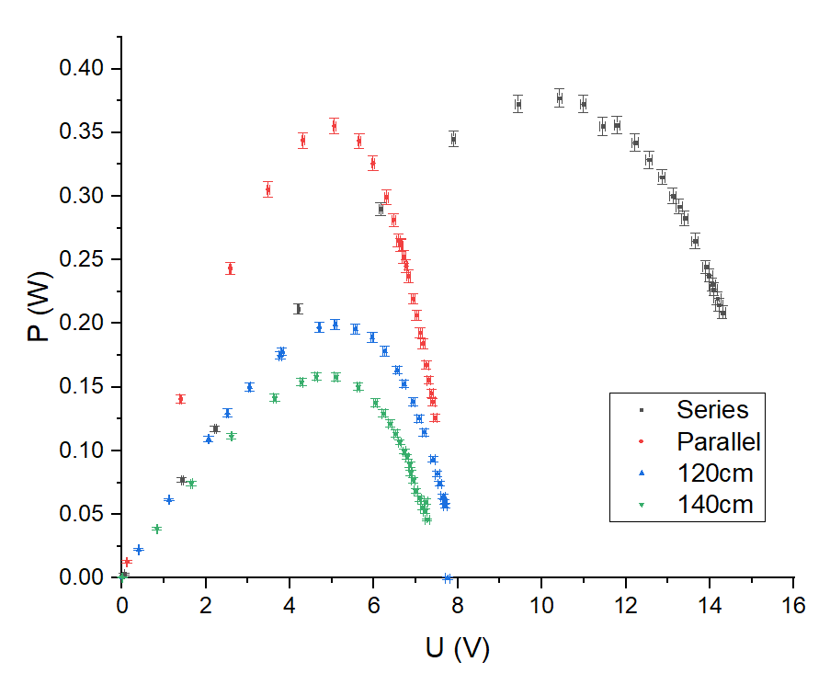

**Figure 5 P-U relation**

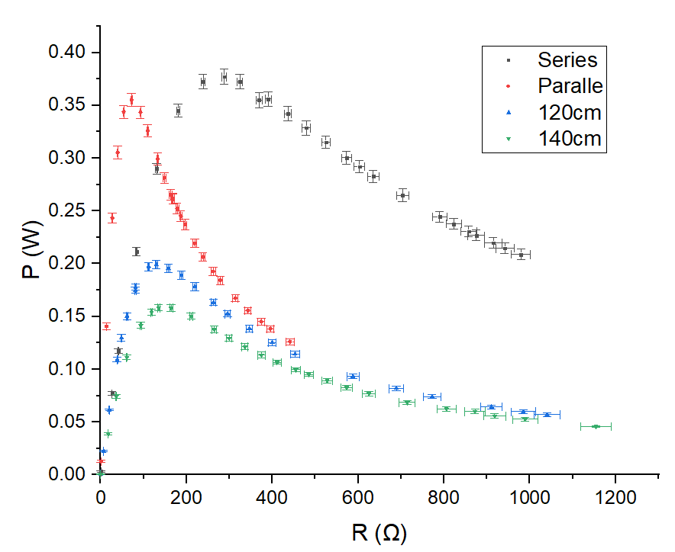

**Figure 6 P-R relation**

**5.5 Calculation of FF and**

FF=

For a single device at 120cm, =0.1991,

FF==0.4615

For a single device at 140cm, =0.1583,

FF==0.4285

|  |  |  |  |  |
| --- | --- | --- | --- | --- |
|  | Series | Parallel | 120cm | 140cm |
|  | 15.93 | 7.96 | 7.93 | 7.68 |
| [mA] | 55.1 | 108.0 | 54.4 | 48.1 |
|  | 0.3772 | 0.3552 | 0.1991 | 0.1583 |
| [V] | 10.42 | 5.06 | 5.08 | 4.63 |
|  | 36.2 | 70.2 | 39.2 | 34.2 |
|  | 287.845 | 72.080 | 129.592 | 135.3 |
| FF | / | / | 0.4615 | 0.4285 |
|  | / | / |  |  |

**Table 14 Factors**

**6. Conclusions and discussion**

**6.1 Conclusions**

In this lab, we learn the working principle of solar cell and study its current voltage characteristics. We repeat U and I measurement for 4 types of solar cell circuits:

1. Two solar cells in series
2. Two solar cells in parallel
3. One solar cell at the distance 120cm from light source
4. One solar cell at the distance 140cm from light source

Based on the different behavior of the four types, we then analyze the effect of the changing factors.

**6.1.1 Effects of Configuration**

The two combining solar cells have the same distance as one single device.

By comparing the I-U plot of the types, we observe the following characteristics.

* Under the same voltage, the current through the solar cells in parallel is twice as much as that of one single cell.
* Under the same current, the voltage of the solar cells in series is twice as much as that of one single cell.
* The solar cells in parallel have the same open-circuit voltage as one single device.
* The solar cells in series have the same short-circuit current as one single device.

By comparing the data in Table14, we observe the following characteristics.

* The maximum power of the two configurations are almost the same, and they are twice as much as that of one single device.
* When the power reaches the maximum, compared with one single device, solar cells in series show a double voltage while solar cells in parallel show a double current. of cells in series doubles of one single cell and is four times of of cells in parallel.

**6.1.2 Effects of Distance**

One single device is studied with the distance of 120cm and 140cm from the light source respectively.

By comparing the I-U plot of the types, we observe the following characteristics.

* Under the same voltage, the current of the cell is negatively related with the distance.
* Under the same current, the voltage of the cell is positively related with the distance.
* When the distance increases, both the open-circuit voltage and short-circuit current decrease.

By comparing the data in Table14, we observe the following characteristics.

* With the distance increasing, the maximum power decreases and the corresponding and decrease. increases.
* With the distance increasing, decreases which means the utilization of energy decreases, since more energy is consumed due to greater inner resistance.
* With the distance increasing, FF decreases, which means the output power of the solar cell is smaller. This is reasonable because the incident light density is smaller.

**6.2 Error Analysis**

* In Table 6 and Table 8, we can see that the first rows of data show larger currents than the short-circuit currents measured previously. This might be caused by the fact that neighboring groups have moved their devices, resulting in the light intensity change on our solar cells. This error might exist throughout the whole experiment.
* Sheltering the light source accidentally may also cause errors.
* The light intensity distributes nonuniformly on the solar cell, which causes inaccuracy of calculation of Pin.
* The circuits have inner resistance, which causes inaccuracies in U and I measurements.
* The multimeter readings are unstable, which causes inaccuracies of the data.

**6.3 Improvements**

* This experiment should be carried out in light-stable environment. The light condition should remain the same throughout the experiment.
* The approximate value of and should be calculated or provided before the measurement in case of missing of the interval where the maximum P exists.
* We should do more contrast experiments.

**7. Reference**

[1] M. Krzyzosiak (2019). Exercise 3 - lab manual [rev. 5].pdf Shanghai: UMJI-SJTU.

**A. Measurement uncertainty analysis**

**A.1 Uncertainty in Calculation of**

**A.1.1 Uncertainty in Calculation of Area**

**A.1.2 Uncertainty in Measurement of solar power**

**A.1.2.1 Uncertainty of**

**A.1.2.2 Uncertainty of**

**A.1.3 Uncertainty in Calculation of**

**A.2 Uncertainty in I-V Characteristics**

Take U=0.06V, I=55.5mA for example,

For the uncertainty of open-circuit voltage and short-circuit current in Table 5, we record them in Table:

|  |  |  |  |  |
| --- | --- | --- | --- | --- |
|  | Single device at 120cm | Single device at 140cm | series | parallel |
| [V] | 7.93 | 7.68 | 15.93 | 7.96 |
| [V] | 0.05 | 0.05 | 0.09 | 0.05 |
|  | 54.4 | 48.1 | 55.1 | 108.0 |
| [mA] | 0.9 | 0.8 | 0.9 | 1.7 |

**Table 15 Voc and Isc with uncertainties**

**A.3 Uncertainty in Calculation of P and R**

Take U=0.06V and I=55.5mA for example:

Take U=0.06V and I=55.5mA for example:

**A.4 Uncertainty in Calculation of FF and**

FF=

For a single device at 120cm:

For a single device at 140cm:

**B. Data Sheet**

