UM-SJTU Joint Institute

Physics Laboratory

(Vp241)

Laboratory Report

Exercise 5

RC, RL, AND RLC CIRCUITS

Name: Wenxin He ID: 518370910117 Group: 1

Date: 23 November 2019

**1. Objective**

The objective of this exercise is to understand the physics of alternating-current circuits, in particular the processes of charging/discharging of capacitors, the phenomenon of electromagnetic induction in inductive elements, and other dynamic processes in RC, RL, and RLC series circuits. Moreover, methods for measuring the amplitude-frequency and the phase-frequency characteristics of RC, RL, and RLC series circuits will be studied. The resonance frequency of an RLC circuit as well as the quality factor of the circuit will be found from the amplitude-frequency curve.

**2. Theoretical Background**

Electric circuits consist of basic elements like resistors, capacitors, and inductors. Depending on a particular arrangement of these elements, RC, RL, RLC alternating-current (AC) circuits may display various features, including transient, steady state, and resonant behavior.

**2.1 Transient Processes in RC, RL, RLC Series Circuits**

**2.1.1 RC Series Circuits**

In an RC circuit, the process of charging or discharging of the capacitor is an example

of a transient process. Figure 1 shows a RC series circuit with the source signal of a square-wave.

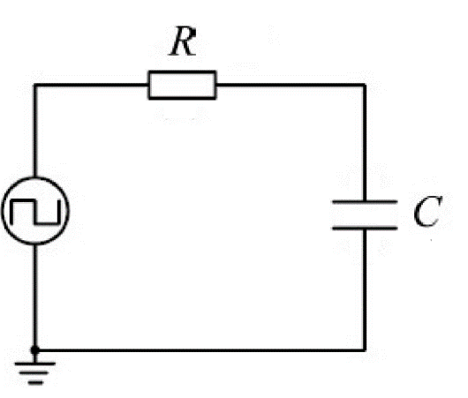

**Figure 1 RC series circuit**

In the first half of the cycle, the square-wave voltage is U(t) = and it charges the capacitor. In the second half-cycle, the square-wave voltage is zero, and the capacitor discharges through the resistor. The loop equation (Kirchhoff's loop rule) for the charging process is

With the initial condition (t = 0) = 0, the solution of Eq. (1) can be found as

Hence the voltage across the capacitor increases exponentially with time t, whereas the voltage on the resistor UR decreases exponentially with time. The curves U(t), UC(t), and UR(t) are shown in Figure 2.

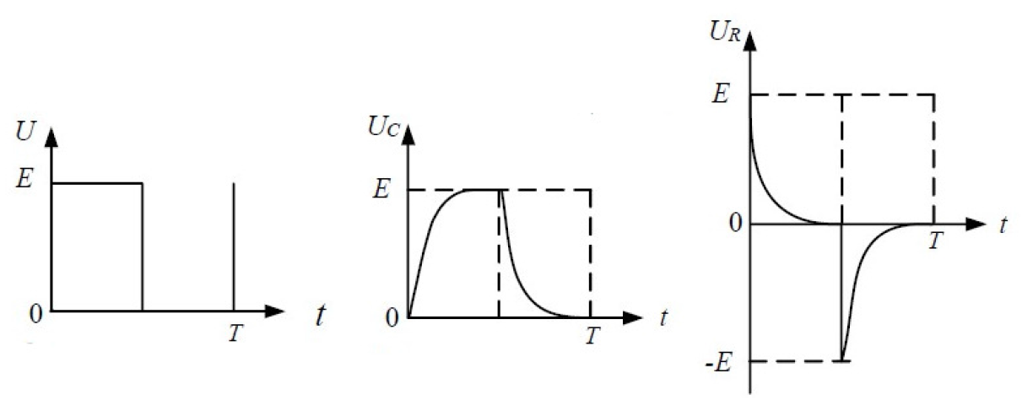

**Figure 2 Charging/discharging curves for a RC series circuit**

For the discharging process, the loop rule gives

The solution of Eq. (2), with the initial condition (t = 0) = , is

and, consequently,

where the magnitudes of both UC and UR decrease exponentially with time. Since RC= has the units of time, it is called the time constant of the circuit, and characterizes the dynamics of the transient process. There is another characteristic related to the time constant, easier to measure in experiments, which is called the half-life period T1/2. The half-life period is the time needed for UC to decrease to a half of the initial value (or increase to a half of the terminal value), and may be also used to characterize the dynamics of the transient process. Both quantities, in the process with exponential dynamics discussed above, are related by the equation

T1/2 = ln 2 =0.693.

**2.1.2 RL Series Circuit**

A similar analysis can be carried out for a RL series circuit. In this case,

and

**2.1.3 RLC Series Circuit**

First, let us discuss the situation when a power source is suddenly plugged into an RLC circuit. Then the voltage across the capacitor satisfies the differential equation （3）

following again from the loop rule. Dividing both sides of the equation by LC and

introducing the symbols

and , (4)

Eq. (3) can be rewritten as

（5）

Note that Eq. (5) is an inhomogeneous differential equation and it is mathematically

equivalent to the equation of motion of a damped harmonic oscillator with a constant driving force. Therefore, the complementary homogeneous equation is fully analogous to the equation of motion of a damped harmonic oscillator, with being the damping coefficient, and —the natural angular frequency. Moreover, after a specific solution to the inhomogeneous equation is found, a unique solution to the initial value problem consisting of Eq. (5) and the initial conditions

（6）

can be found.

Exactly as for mechanical oscillations, depending on the relation between and,

there are three regimes, as implied by the solution of the complementary homogeneous equation:

* If (weak damping), the system is in the underdamped regime and the solution to the initial value problem is of the form

Where

* If (strong damping), the system is in the overdamped regime with

the solution of the form

* Finally, if the system is said to be critically damped, and

When the circuit reaches steady state, the power source is suddenly removed (= 0).

The differential equation for the discharging process is similar to that of the charging process, and there are also three regimes of the process.

The above discussion is valid for an ideal circuit and a step-signal source with zero

internal resistance. In the experiment, the ideal system is replaced by a square-wave

source with a small internal resistance. The period of the square-signal must be much greater than the time constant of the circuit. Note that, according to the above equations, the voltage across the capacitor UC will finally reach regardless of the regime (Figure 3)

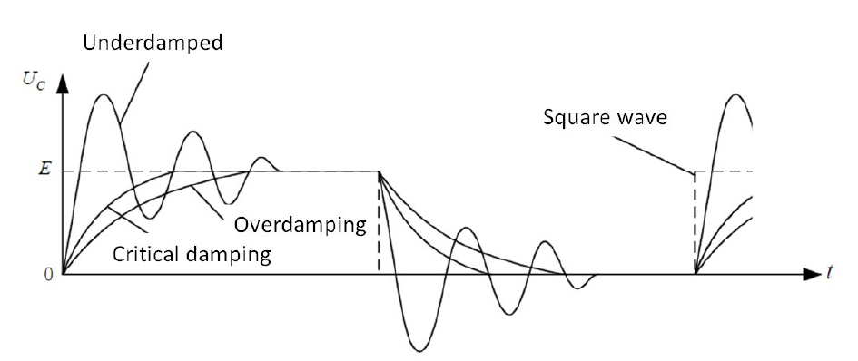

**Figure 3 Three different regimes of transient processes in an RLC series circuit**

**2.2 RC, RL Steady-State Circuits**

When a sinusoidal alternating input voltage is provided to a RC (or RL) series circuit,

the amplitude and the phase of the voltage across the capacitor and the resistor will change with the frequency of the input voltage. Then the amplitude vs. frequency relation and the phase vs. frequency relation can be obtained by measuring the voltage across the elements in the circuit for different input signal frequencies

**2.3 RLC Resonant Circuit**

**2.3.1 RLC Series Circuit**

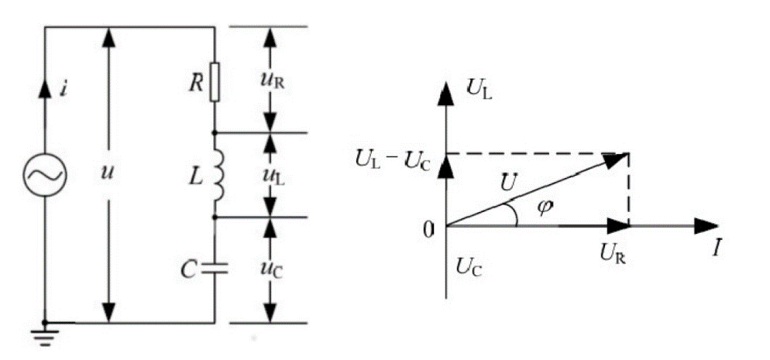

**Figure 4 RLC series circuit**

A generic RLC series circuit is shown in Figure 4. The impedance and the phase difference in the RLC circuit can be calculated, e.g., by using the phasors technique.

Representing the current I by a vector along the horizontal axis, the phase differences between the current and the voltages across the resistor, coil, and capacitor are

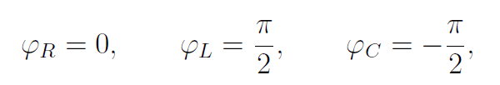

respectively. The corresponding voltage amplitudes across the elements are

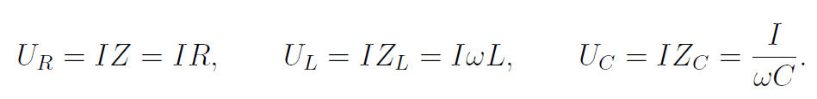

Hence, the voltage amplitude

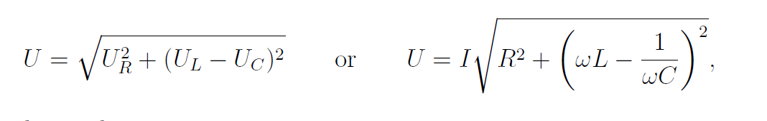

and the total impedance

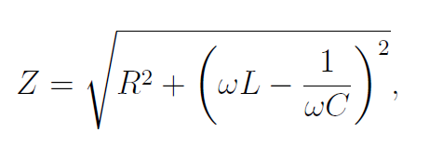

with the phase difference between the current and the voltage in the circuit

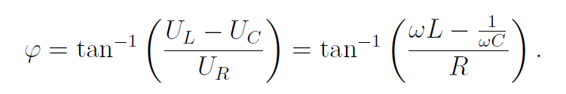

**2.3.2 Resonance**

If the frequency of the input signal provided by the source satisfies the condition 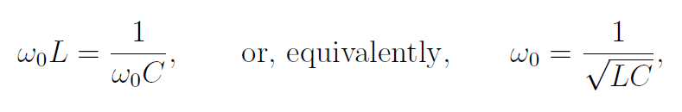

the total impedance will reach a minimum, Z0 = R. Note that the resistance R in a real

circuit includes the internal resistance and all kinds of alternating-current power losses, so its actual value will be greater than the theoretical one.

When the current reaches its maximum, Im = U=R, the circuit is said to be at resonance. The frequency

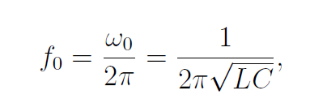

at which the resonance phenomenon occurs, is called the resonance frequency.

The total impedance Z, the current I, and the phase difference all depend on the frequency, with generic shapes of the three curves shown in Figure 5. According to Eqs. (8) and (9), when the frequency is low (f < f0, i.e. 1/C > L), then < 0.In this situation the total voltage lags behind the current and the circuit is said to be capacitive.

When the circuit is resonant (f = f0, i.e. 1/C =L), then = 0 and the voltages across the capacitor and the inductor should be equal. The circuit is said to be resistive.

Finally, when the frequency is high (f > f0, i.e. 1/C <L), then > 0. In this situation the total voltage leads the current, and the circuit is said to be inductive.

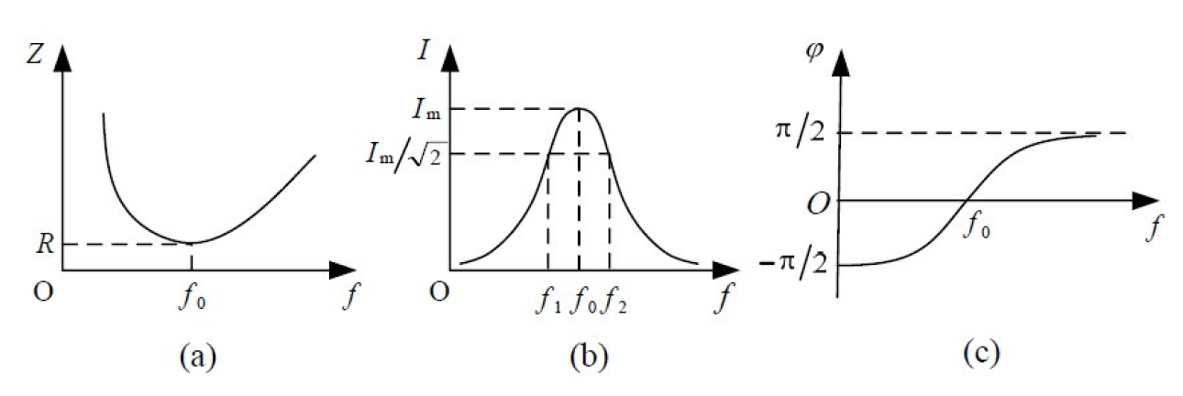

**Figure 5 The impedance, the current and the phase difference as functions of the frequency for an RLC series circuit (generic sketches)**

**2.3.3 Quality Factor in Resonant Circuits**

Since Im = U/R, the voltages across the resistor, the inductor, and the capacitor are

UR = ImR = U;

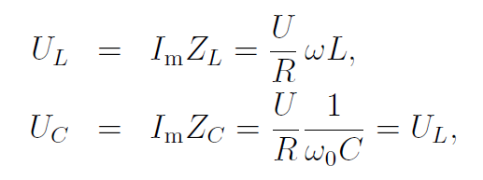

respectively. For a circuit driven at the resonance frequency, the ratio of UL (or UC) to

U is called the quality factor Q of a resonant circuit 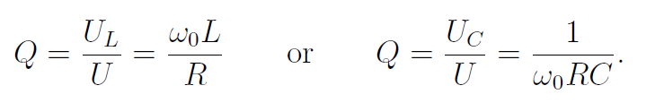

When the total voltage is fixed, the greater Q is, the greater UL and UC are. The value

of Q can be used to quantify the efficiency of resonant circuits.

The quality factor can also be found as

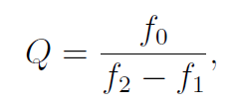

where f1 and f2 are two frequencies such that I(f1) = I(f2) = Im/(see Figure 5b).

**3. Experimental Setup**

**3.1 Apparatus**

The measurement setup consists of the following main elements: a signal generator, an oscilloscope, a digital multimeter, a wiring board, a fixed resistor 100 (2W), a variable resistor 2k (2W), two capacitors 0.47 F and 0.1 F, as well as two inductors (10 mH and 33 mH).

**3.2 Device Information**

The information of each measurement device is shown in Table 1.

|  |  |
| --- | --- |
| **apparatus** | **uncertainty** |
| Signal generator |  |
| Cursor(time) |  |
| Cursor(amplitude) |  |
| Multimeter(resistance) |  |
| Multimeter(capacitance) |  |

**Table 1 Information of Each Measurement Device**

**4. Measurement Procedure**

**4.1 RC, RL Series Circuit**

1. Choose a capacitor and an inductor to assemble a circuit with the fixed-resistance

resistor. Adjust the output frequency of the square-wave signal provided by

the signal generator. Observe the change of the waveform when the time constant

is smaller or greater than the period of the square-wave. Choose the frequency

that allows the capacitor to fully charge/discharge. Use the PRINT function of the

oscilloscope to store the waveforms.

2. Adjust display parameters of the oscilloscope and measure T1/2 for the studied circuits. Then, calculate the time constant and compare it with the theoretical value.

In order to find the time constant accurately, only one period should be displayed

on the oscilloscope screen.

**4.2 RLC Series Circuit**

1. Choose a capacitor and an inductor to assemble an RLC series circuit with the variable resistor. Observe the waveform of the capacitor voltage in the underdamped, critically damped, and overdamped regimes. Use the PRINT function of the oscilloscope to store the waveforms.

2. Adjust the variable resistor to the critically damped regime. According to the definition of the half-life period T1/2, we have T1/2 = 1.68. By finding the value of

T1/2, the time constant can be found as = 1/ = T1/2/1.68. Compare your result

with the theoretical value.

**4.3 RLC Resonant Circuit**

Apply a sinusoidal input voltage Ui to the RLC series circuit, change the frequency,

then observe the change of the voltage UR for a fixed resistor R, as well as the phase

difference between UR and Ui. Measure how UR changes with Ui and calculate the phase difference according to Figure 4. Plot the graphs I=Im vs. f=f0 and vs. f=f0. Estimate the resonance frequency and calculate the quality factor Q.

**4.4 Cautions**

* Read manuals carefully before operating the instruments.
* The circuit should be grounded to the same point as the instruments used in the measurements.
* Power supply should be turned on after the circuit is completed.

**5. Results**

**5.1 RC series circuit**

We then calculate the time constant:

Theoretically, the time constant should be:

The relative error is:

The error is relatively large, which will be discussed in the error analysis part.

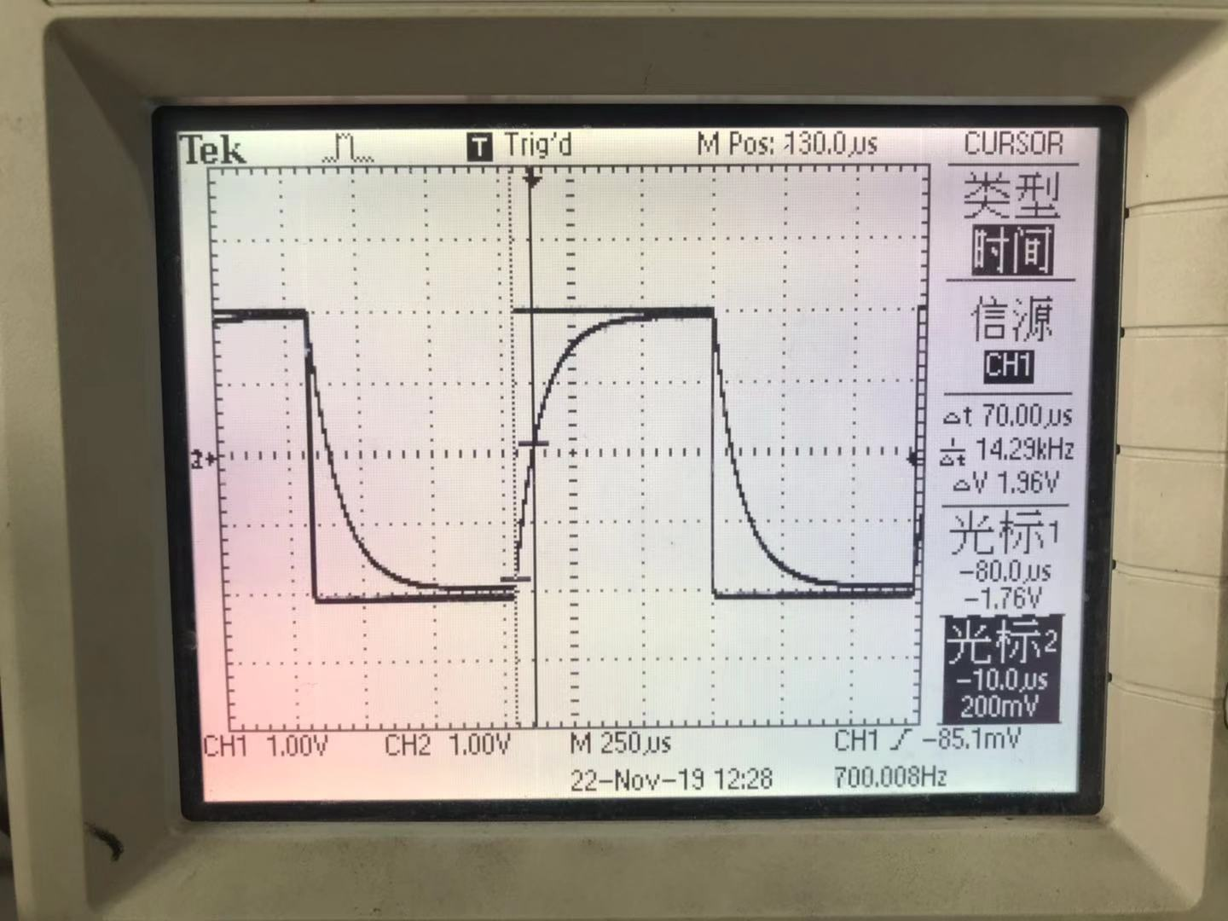

**Figure 6 Waveform of RC circuit**

**5.2 RL series circuit**

We then calculate the time constant:

Theoretically, the time constant should be:

The relative error is:

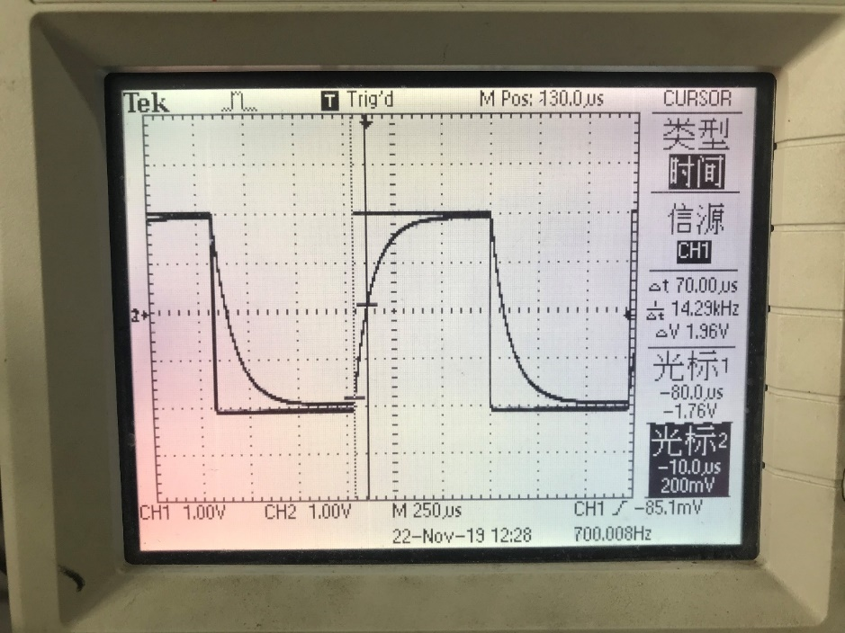

**Figure 7 Waveform of RL circuit**

**5.3 RLC series circuit**

When critically damped,

We then calculate the time constant:

Theoretically, the time constant should be:

The relative error is:

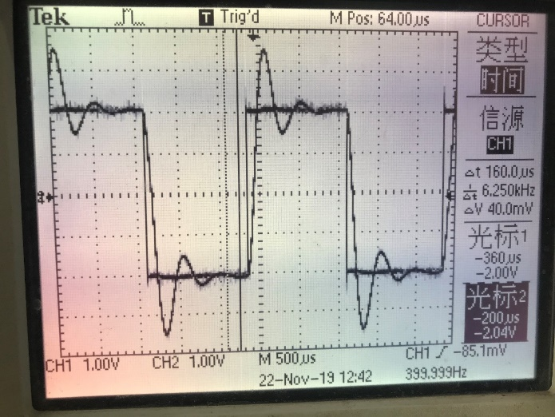

**Figure8 Waveform of Under-damped regime of RLC circuit**

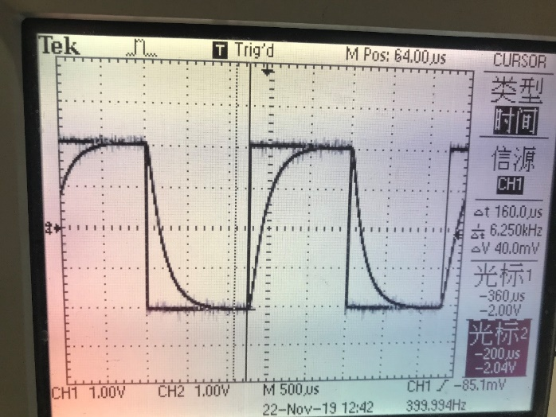

**Figure9 Waveform of critically-damped regime of RLC circuit**

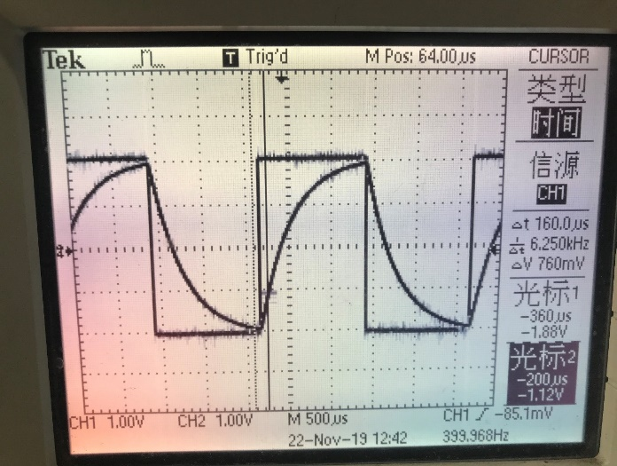

**Figure10 Waveform of over-damped regime of RLC circuit**

**5.4 RLC resonant circuit**

|  |  |  |  |
| --- | --- | --- | --- |
|  |  |  | f[Hz] |
| 1 | 0.520 | 0.002 | 400.000 |
| 2 | 0.920 | 0.002 | 700.000 |
| 3 | 1.40 | 0.02 | 1000.000 |
| 4 | 1.96 | 0.02 | 1300.000 |
| 5 | 2.20 | 0.02 | 1400.000 |
| 6 | 2.88 | 0.02 | 1700.000 |
| 7 | 3.12 | 0.02 | 1800.000 |
| 8 | 3.36 | 0.02 | 1900.000 |
| 9 | 3.56 | 0.02 | 2000.000 |
| 10 | 3.72 | 0.02 | 2100.000 |
| 11 | 3.84 | 0.02 | 2200.000 |
| 12 | 3.92 | 0.02 | 2300.000 |
| 13 | 3.88 | 0.02 | 2400.000 |
| 14 | 3.80 | 0.02 | 2500.000 |
| 15 | 3.72 | 0.02 | 2600.000 |
| 16 | 3.48 | 0.02 | 2800.000 |
| 17 | 3.20 | 0.02 | 3000.000 |
| 18 | 2.76 | 0.02 | 3300.000 |
| 19 | 2.20 | 0.02 | 3900.000 |
| 20 | 1.88 | 0.02 | 4300.000 |
| 21 | 1.32 | 0.02 | 5600.000 |

**Table 2 Measurement of RLC Resonant Circuit**

**5.4.1 Relationship between and**

We want to find the relation between and f/f0. Thus, we calculate the value of and f/f0.

Take the first row of data for example:

We show the result of all data and their uncertainties in Table 3:

|  |  |  |  |  |
| --- | --- | --- | --- | --- |
|  |  |  |  |  |
| 1 | 0.133 | 0.0008 | 0.174 | 4 |
| 2 | 0.235 | 0.001 | 0.304 | 5 |
| 3 | 0.357 | 0.005 | 0.435 | 5 |
| 4 | 0.500 | 0.006 | 0.565 | 5 |
| 5 | 0.561 | 0.006 | 0.609 | 5 |
| 6 | 0.735 | 0.006 | 0.739 | 5 |
| 7 | 0.796 | 0.007 | 0.783 | 6 |
| 8 | 0.857 | 0.007 | 0.826 | 6 |
| 9 | 0.908 | 0.007 | 0.870 | 6 |
| 10 | 0.949 | 0.007 | 0.913 | 6 |
| 11 | 0.980 | 0.007 | 0.957 | 6 |
| 12 | 1.000 | 0.007 | 1.000 | 6 |
| 13 | 0.990 | 0.007 | 1.043 | 6 |
| 14 | 0.969 | 0.007 | 1.087 | 6 |
| 15 | 0.949 | 0.007 | 1.130 | 7 |
| 16 | 0.888 | 0.007 | 1.217 | 7 |
| 17 | 0.816 | 0.007 | 1.304 | 7 |
| 18 | 0.704 | 0.006 | 1.435 | 8 |
| 19 | 0.561 | 0.006 | 1.696 | 9 |
| 20 | 0.480 | 0.006 | 1.870 | 9 |
| 21 | 0.337 | 0.005 | 2.435 | 1 |

**Table 3 relation between and f/f0**

Using Originlab, we plot the figure of I/Im vs f/f0, shown in Figure11:

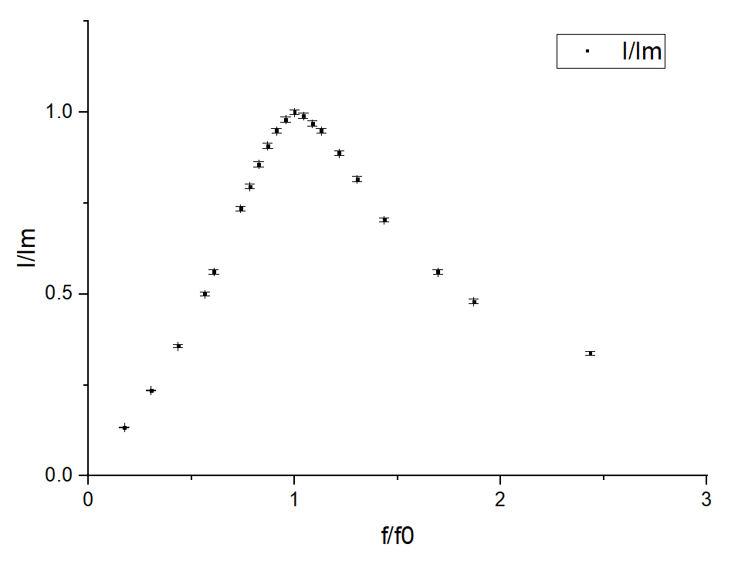

**Figure 11 relation between and f/f0**

**5.4.2 Phase Shift**

Take the first row of data for example:

Then we calculate the result of all the data, arranged in table 4:

Caution: for data 1-11, we add a negative sign in front of .

|  |  |  |  |  |  |  |
| --- | --- | --- | --- | --- | --- | --- |
|  |  |  |  |  |  |  |
| 1 | 0.174 | 4 | -1.45 | 3 | -1.44 | 0.0009 |
| 2 | 0.304 | 5 | -1.35 | 5 | -1.33 | 0.001 |
| 3 | 0.435 | 5 | -1.23 | 9 | -1.21 | 0.006 |
| 4 | 0.565 | 5 | -1.07 | 1 | -1.05 | 0.007 |
| 5 | 0.609 | 5 | -1.01 | 2 | -0.97 | 0.007 |
| 6 | 0.739 | 5 | -0.77 | 2 | -0.75 | 0.009 |
| 7 | 0.783 | 6 | -0.67 | 3 | -0.65 | 0.01 |
| 8 | 0.826 | 6 | -0.56 | 3 | -0.54 | 0.01 |
| 9 | 0.870 | 6 | -0.44 | 3 | -0.43 | 0.02 |
| 10 | 0.913 | 6 | -0.32 | 3 | -0.32 | 0.02 |
| 11 | 0.957 | 6 | -0.19 | 3 | -0.20 | 0.04 |
| 12 | 1.000 | 6 | -0.06 | 3 | 0.00 | / |
| 13 | 1.043 | 6 | 0.07 | 3 | 0.14 | 0.05 |
| 14 | 1.087 | 6 | 0.19 | 3 | 0.25 | 0.03 |
| 15 | 1.130 | 7 | 0.30 | 3 | 0.32 | 0.02 |
| 16 | 1.217 | 7 | 0.48 | 2 | 0.48 | 0.01 |
| 17 | 1.304 | 7 | 0.63 | 2 | 0.62 | 0.01 |
| 18 | 1.435 | 8 | 0.80 | 1 | 0.79 | 0.009 |
| 19 | 1.696 | 9 | 1.00 | 7 | 0.97 | 0.007 |
| 20 | 1.870 | 9 | 1.09 | 6 | 1.07 | 0.006 |
| 21 | 2.435 | 1 | 1.24 | 3 | 1.23 | 0.006 |

**Table4 Calculation result of phase shift**

Then we use origin lab to plot the figures of

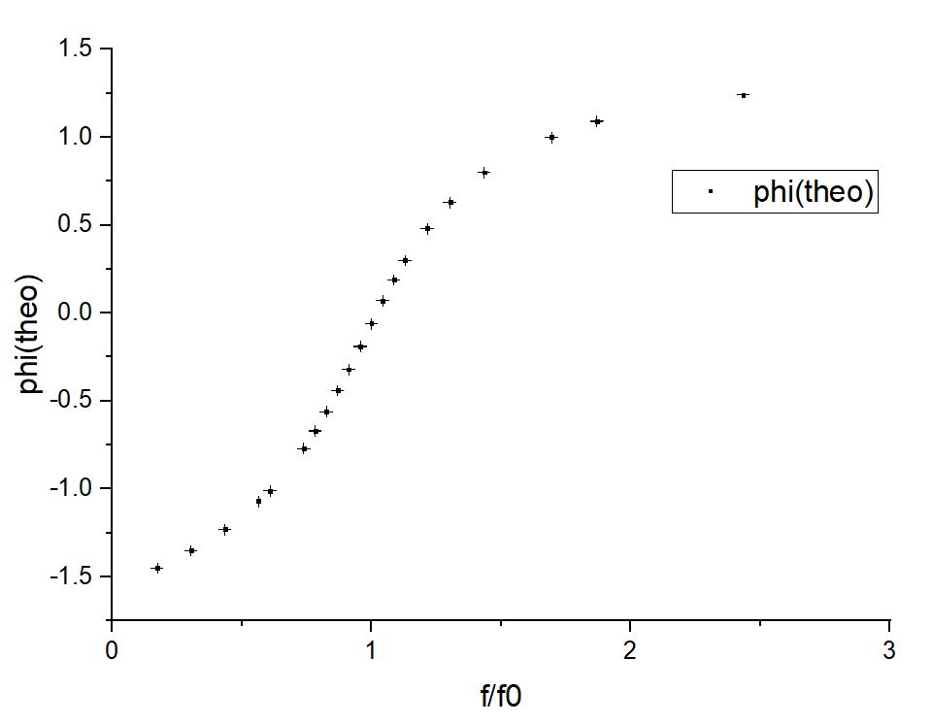

Figure 12

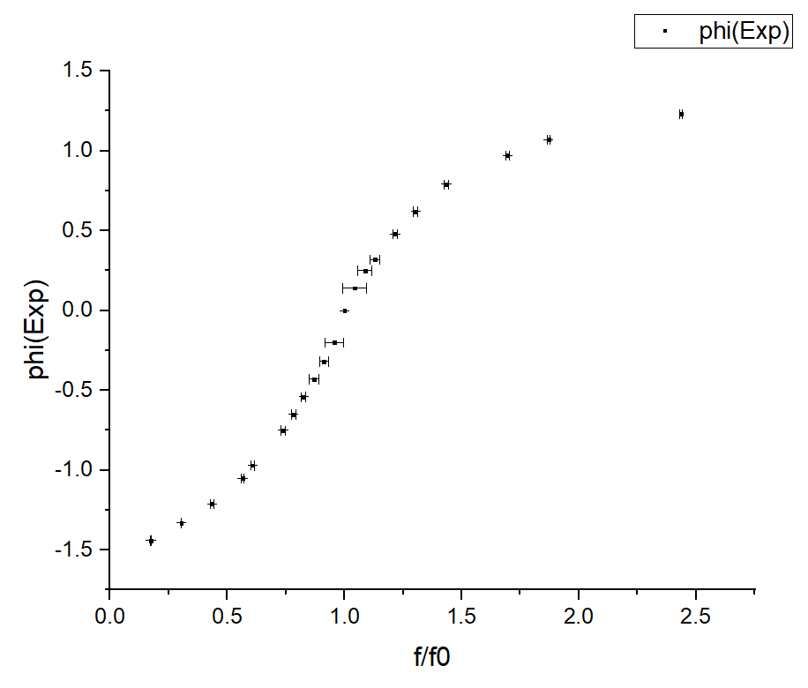

Figure 13

The theoretical resonate frequency

2345.3[Hz]±0.3[Hz]

The experimental resonate frequency is 2300±0.001[Hz]

The relative error of f0 is:

**5.5 Quality Factor**

when I(f1) = I(f2) = Im/

The closet frequency is =1700 3300Hz.

Hence,

The relative error of Q is:

**6. Conclusions and discussion**

**6.1 Conclusions**

In this lab, we have understood the physics of alternating-current circuits, in particular the processes of charging/discharging of capacitors, the phenomenon of electromagnetic induction in inductive elements, and other dynamic processes in RC, RL, and RLC series circuits. Moreover, we have studied methods for measuring the amplitude-frequency and the phase-frequency characteristics of RC, RL, and RLC series circuits. Finally, we found the resonance frequency of an RLC circuit as well as the quality factor of the circuit.

**6.1.1 RC series circuit**

The time constant

The relative error is

**6.1.2 RL series circuit**

The time constant

The relative error is

**6.1.3 RLC series circuit (critically damped)**

The time constant is found:

The relative error is

**6.1.4 RLC series resonant circuit**

**6.1.4.1 Relationship between I and f**

From Figure11 we can see that when f=f0, the circuit reaches resonance and I reaches its maximum. Moving further from f0, I becomes smaller, which matches our expectation.

**6.1.4.2 Phase shift**

Comparing Figure12 and Figure 13, we can see that the phase shift is increasing. When f=f0, the phase shift is 0. When f<f0, the phase shift is negative. When f>f0, the phase shift is positive. When f is very small or very large, the phase shift is close to

**6.1.4.3 Resonant frequency**

The resonant frequency is found at f0=2300.000.Compared with the theoretical value:2345.3±0.3Hz, the relative error of f0 is -1.93%.

**6.1.4.4 Quality factor**

The quality factor is found:

The relative error is -2.31%.

**6.2 Error Analysis**

* In RC and RLC series circuit, the relative error of time constant is quite large. This may due to the inaccuracy in the reading of because the magnitude of U cannot reach precisely at half of Um. This error might be magnified during following calculation.
* In the RLC series circuit section, it is hard to determine whether the critically-damped regime is reached by eye.
* The oscilloscope may have resistance.
* The resistance of the circuit may change because of rise of temperature.
* When calculating the experimental quality factor, we just take the closest values from Im/ as f1 and f2 from our experimental data. This step causes huge error.

**6.3 Improvements**

* Make the resistance of the changeable resistor visible so that the critically-damped regime can be reached more precisely.
* Improve the accuracy of the equipment.
* Repeat the experiment of RLC resonant series to find f1 and f2 precisely.

**7. Reference**

[1] M. Krzyzosiak (2019). Exercise 5 - lab manual.pdf Shanghai: UMJI-SJTU.

**A. Measurement uncertainty analysis**

**A.1 Uncertainty in RC Series Circuit**

**A.2 Uncertainty in RL Series Circuit**

**A.3 Uncertainty in RLC Series Circuit**

**A.4 Uncertainty in RLC Resonant Circuit**

**A.4.1 Uncertainty in Analysis of the Relationship between and**

Take the first row of data for example:

We calculate the result of all data, arranged in Table 5:

|  |  |  |  |  |  |  |  |
| --- | --- | --- | --- | --- | --- | --- | --- |
|  |  |  | f[Hz] |  |  |  |  |
| 1 | 0.520 | 0.002 | 400.000 | 0.133 | 0.0008 | 0.174 | 4 |
| 2 | 0.920 | 0.002 | 700.000 | 0.235 | 0.001 | 0.304 | 5 |
| 3 | 1.40 | 0.02 | 1000.000 | 0.357 | 0.005 | 0.435 | 5 |
| 4 | 1.96 | 0.02 | 1300.000 | 0.500 | 0.006 | 0.565 | 5 |
| 5 | 2.20 | 0.02 | 1400.000 | 0.561 | 0.006 | 0.609 | 5 |
| 6 | 2.88 | 0.02 | 1700.000 | 0.735 | 0.006 | 0.739 | 5 |
| 7 | 3.12 | 0.02 | 1800.000 | 0.796 | 0.007 | 0.783 | 6 |
| 8 | 3.36 | 0.02 | 1900.000 | 0.857 | 0.007 | 0.826 | 6 |
| 9 | 3.56 | 0.02 | 2000.000 | 0.908 | 0.007 | 0.870 | 6 |
| 10 | 3.72 | 0.02 | 2100.000 | 0.949 | 0.007 | 0.913 | 6 |
| 11 | 3.84 | 0.02 | 2200.000 | 0.980 | 0.007 | 0.957 | 6 |
| 12 | 3.92 | 0.02 | 2300.000 | 1.000 | 0.007 | 1.000 | 6 |
| 13 | 3.88 | 0.02 | 2400.000 | 0.990 | 0.007 | 1.043 | 6 |
| 14 | 3.80 | 0.02 | 2500.000 | 0.969 | 0.007 | 1.087 | 6 |
| 15 | 3.72 | 0.02 | 2600.000 | 0.949 | 0.007 | 1.130 | 7 |
| 16 | 3.48 | 0.02 | 2800.000 | 0.888 | 0.007 | 1.217 | 7 |
| 17 | 3.20 | 0.02 | 3000.000 | 0.816 | 0.007 | 1.304 | 7 |
| 18 | 2.76 | 0.02 | 3300.000 | 0.704 | 0.006 | 1.435 | 8 |
| 19 | 2.20 | 0.02 | 3900.000 | 0.561 | 0.006 | 1.696 | 9 |
| 20 | 1.88 | 0.02 | 4300.000 | 0.480 | 0.006 | 1.870 | 9 |
| 21 | 1.32 | 0.02 | 5600.000 | 0.337 | 0.005 | 2.435 | 1 |

**Table 5 uncertainties of I/Im and f/f0**

**A.4.2 Uncertainty in Phase Shift**

**A.4.2.1 Uncertainty of**

Take the first row of data for example:

=262774.543

Hence,

**A.4.2.2 Uncertainty of**

Take the first row of data for example:

Hence,

Then we calculate the result of all data, arranged in Table6:

|  |  |  |  |  |  |  |
| --- | --- | --- | --- | --- | --- | --- |
|  |  |  |  |  |  |  |
| 1 | 0.174 | 4 | -1.45 | 3 | 1.44 | 0.0009 |
| 2 | 0.304 | 5 | -1.35 | 5 | 1.33 | 0.001 |
| 3 | 0.435 | 5 | -1.23 | 9 | 1.21 | 0.006 |
| 4 | 0.565 | 5 | -1.07 | 1 | 1.05 | 0.007 |
| 5 | 0.609 | 5 | -1.01 | 2 | 0.97 | 0.007 |
| 6 | 0.739 | 5 | -0.77 | 2 | 0.75 | 0.009 |
| 7 | 0.783 | 6 | -0.67 | 3 | 0.65 | 0.01 |
| 8 | 0.826 | 6 | -0.56 | 3 | 0.54 | 0.01 |
| 9 | 0.870 | 6 | -0.44 | 3 | 0.43 | 0.02 |
| 10 | 0.913 | 6 | -0.32 | 3 | 0.32 | 0.02 |
| 11 | 0.957 | 6 | -0.19 | 3 | 0.20 | 0.04 |
| 12 | 1.000 | 6 | -0.06 | 3 | 0.00 | / |
| 13 | 1.043 | 6 | 0.07 | 3 | 0.14 | 0.05 |
| 14 | 1.087 | 6 | 0.19 | 3 | 0.25 | 0.03 |
| 15 | 1.130 | 7 | 0.30 | 3 | 0.32 | 0.02 |
| 16 | 1.217 | 7 | 0.48 | 2 | 0.48 | 0.01 |
| 17 | 1.304 | 7 | 0.63 | 2 | 0.62 | 0.01 |
| 18 | 1.435 | 8 | 0.80 | 1 | 0.79 | 0.009 |
| 19 | 1.696 | 9 | 1.00 | 7 | 0.97 | 0.007 |
| 20 | 1.870 | 9 | 1.09 | 6 | 1.07 | 0.006 |
| 21 | 2.435 | 1 | 1.24 | 3 | 1.23 | 0.006 |

**Table 6 Uncertainties of**

**A.4.2.3 Uncertainty of the theoretical**

**A.4 Uncertainty of Quality Factor**

