layout_constraintTop_toBottomOf
app:layout_constraintLeft_toLeftOf="@id/rootLayout"
app:layout_constraintLeft_toRightOf="@id/rootLayout"
app:layout_constraintRight_toLeftOf="@id/rootLayout"
app:layout_constraintRight_toRightOf="@id/rootLayout"
app:layout_constraintTop_toBottomOf="@id/rootLayout"
app:layout_constraintTop_toTopOf="@id/rootLayout"
app:layout_constraintBottom_toBottomOf="@id/rootLayout"
app:layout_constraintBottom_toTopOf="@id/rootLayout"
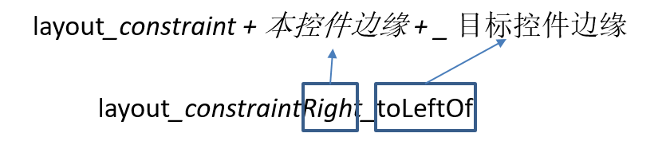

layout_constraintHorizontal_bias
android:layout_width="wrap_content" 可以 是 wrap_content 或者 200dp，对match_parent 无效
<ImageView
android:layout_width="200dp"
android:layout_height="0dp"
android:src="@drawable/timg"
app:layout_constraintHorizontal_bias="0.3"
app:layout_constraintLeft_toLeftOf="@+id/rootLayout"
app:layout_constraintRight_toRightOf="@+id/rootLayout"
/>
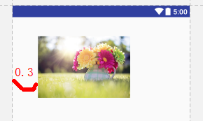

layout_constraintVertical_bias
android:layout_height="wrap_content" 可以 是 wrap_content 或者 200dp，对match_parent 无效
<ImageView
android:layout_width="match_parent"
android:layout_height="wrap_content"
android:src="@drawable/timg"
app:layout_constraintBottom_toBottomOf="@id/rootLayout"
app:layout_constraintTop_toTopOf="@id/rootLayout"
app:layout_constraintVertical_bias="0.3"
/>
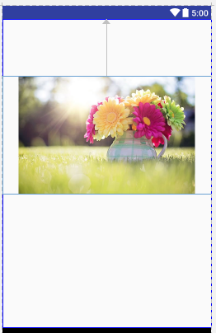

layout_constraintDimensionRatio

<ImageView
android:layout_width="0dp"
android:layout_height="wrap_content"
android:adjustViewBounds="true"
android:src="@drawable/timg"
app:layout_constraintDimensionRatio="16:10"
app:layout_constraintLeft_toLeftOf="@id/rootLayout"
app:layout_constraintRight_toRightOf="@id/rootLayout"/>
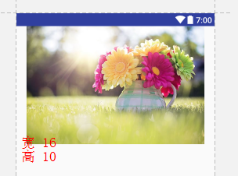

layout_constraintHorizontal_weight
app:layout_constraintHorizontal_weight="2" 要结合 app:layout_constraintHorizontal_chainStyle="spread_inside" （非 packed ）
app:layout_constraintHorizontal_chainStyle 这个属性只加给 ConstraintLayout 的第一个直接子控件 有效
<TextView
android:id="@+id/textView1"
android:layout_width="0dp"
android:layout_height="wrap_content"
android:background="@color/colorPrimary"
android:gravity="center"
android:text="首页"
android:textColor="#FFFFFF"
app:layout_constraintHorizontal_chainStyle="spread_inside"
app:layout_constraintHorizontal_weight="2"
app:layout_constraintLeft_toLeftOf="@+id/rootLayout"
app:layout_constraintRight_toLeftOf="@+id/textView2"
app:layout_constraintTop_toTopOf="@+id/rootLayout"/>
<TextView
android:id="@+id/textView2"
android:layout_width="0dp"
android:layout_height="wrap_content"
android:background="@color/colorPrimaryDark"
android:gravity="center"
android:text="新闻"
android:textColor="#FFFFFF"
app:layout_constraintHorizontal_weight="5"
app:layout_constraintLeft_toRightOf="@id/textView1"
app:layout_constraintRight_toRightOf="@+id/rootLayout"
app:layout_constraintTop_toTopOf="@+id/rootLayout"/>
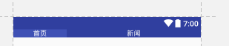 2:5 展示

layout_constraintHorizontal_chainStyle
app:layout_constraintHorizontal_chainStyle="packed" 写在 ConstraintLayout 的第一个直接子控件有效 有 "packed"、"spread"、"spread_inside"3种属性
<?xml version="1.0" encoding="utf-8"?>
<android.support.constraint.ConstraintLayout
xmlns:android="http://schemas.android.com/apk/res/android"
xmlns:app="http://schemas.android.com/apk/res-auto"
xmlns:tools="http://schemas.android.com/tools"
android:id="@+id/rootLayout"
android:layout_width="match_parent"
android:layout_height="match_parent"
tools:context="com.alex.constraintlayout.MainActivity"
tools:ignore="all">
<TextView
android:id="@+id/textView1"
android:layout_width="80dp"
android:gravity="center"
android:layout_height="wrap_content"
android:background="@color/colorPrimary"
android:text="首页"
android:textColor="#FFFFFF"
app:layout_constraintHorizontal_chainStyle="packed"
app:layout_constraintLeft_toLeftOf="parent"
app:layout_constraintRight_toLeftOf="@+id/textView2"
app:layout_constraintTop_toTopOf="parent"/>
<TextView
android:id="@+id/textView2"
android:layout_width="80dp"
android:gravity="center"
android:layout_height="wrap_content"
android:background="@color/colorPrimary"
android:text="新闻"
android:textColor="#FFFFFF"
app:layout_constraintLeft_toRightOf="@id/textView1"
app:layout_constraintRight_toLeftOf="@id/textView3"
app:layout_constraintTop_toTopOf="parent"/>
<TextView
android:id="@+id/textView3"
android:layout_width="80dp"
android:gravity="center"
android:layout_height="wrap_content"
android:background="@color/colorPrimary"
android:text="娱乐"
android:textColor="#FFFFFF"
app:layout_constraintLeft_toRightOf="@id/textView2"
app:layout_constraintRight_toRightOf="parent"
app:layout_constraintTop_toTopOf="parent"/>
</android.support.constraint.ConstraintLayout>

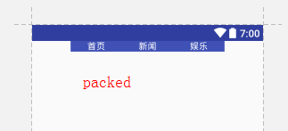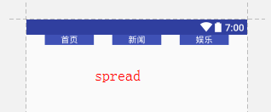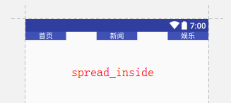
packed 居中紧凑； spread均分所有间距展开；spread_inside均分内部间距展开；

layout_goneMarginLeft
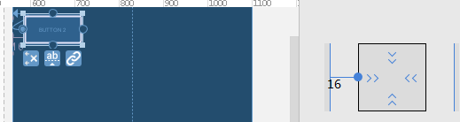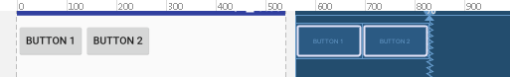
Button1 和 Button2，2依赖1，当1 visible 的时候，1 、2之间并没有间距，当 1 gone 的时候， 1、2之间有16dp 间距；
visibility 加给1， layout_goneMarginLeft 加给2
<Button
android:id="@+id/button1"
android:layout_width="wrap_content"
android:layout_height="wrap_content"
android:text="Button 1"
android:visibility="visible"
tools:layout_editor_absoluteY="10dp"
app:layout_constraintRight_toLeftOf="@+id/button2"
app:layout_constraintLeft_toLeftOf="@+id/rootLayout" />
<Button
android:id="@+id/button2"
android:layout_width="wrap_content"
android:layout_height="wrap_content"
app:layout_goneMarginLeft="16dp"
android:text="Button 2"
tools:layout_editor_absoluteY="10dp"
app:layout_constraintLeft_toRightOf="@+id/button1" />

Guideline
android:orientation="vertical"
app:layout_constraintGuide_percent="0.5"
app:layout_constraintGuide_begin="0dp"
app:layout_constraintGuide_end="0dp"

先画两条引导线，构成十字
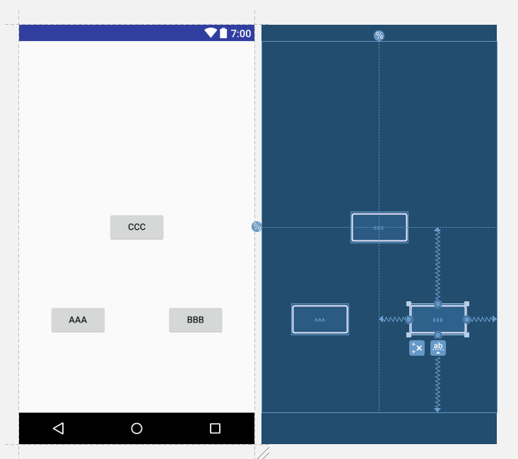

<?xml version="1.0" encoding="utf-8"?>
<android.support.constraint.ConstraintLayout
xmlns:android="http://schemas.android.com/apk/res/android"
xmlns:app="http://schemas.android.com/apk/res-auto"
xmlns:tools="http://schemas.android.com/tools"
android:id="@+id/rootLayout"
android:layout_width="match_parent"
android:layout_height="match_parent"
tools:context="com.alex.constraintlayout.MainActivity"
tools:ignore="all">
<android.support.constraint.Guideline
android:id="@+id/guidelineVertical"
android:layout_width="wrap_content"
android:layout_height="wrap_content"
android:orientation="vertical"
app:layout_constraintGuide_begin="0dp"
app:layout_constraintGuide_end="0dp"
app:layout_constraintGuide_percent="0.5"
/>
<android.support.constraint.Guideline
android:id="@+id/guidelineHorizontal"
android:layout_width="wrap_content"
android:layout_height="wrap_content"
android:orientation="horizontal"
app:layout_constraintGuide_percent="0.5"
/>
<Button
android:id="@+id/button2"
android:layout_width="wrap_content"
android:layout_height="wrap_content"
android:text="AAA"
app:layout_constraintBottom_toBottomOf="@+id/rootLayout"
app:layout_constraintLeft_toLeftOf="@+id/rootLayout"
app:layout_constraintRight_toLeftOf="@+id/guidelineVertical"
app:layout_constraintTop_toTopOf="@+id/guidelineHorizontal"
tools:layout_editor_absoluteY="482dp"/>
<Button
android:id="@+id/button"
android:layout_width="wrap_content"
android:layout_height="wrap_content"
android:text="BBB"
app:layout_constraintBottom_toBottomOf="@+id/rootLayout"
app:layout_constraintLeft_toLeftOf="@+id/guidelineVertical"
app:layout_constraintRight_toRightOf="@+id/rootLayout"
app:layout_constraintTop_toTopOf="@+id/guidelineHorizontal"
tools:layout_editor_absoluteY="482dp"/>
<Button
android:id="@+id/button3"
android:layout_width="wrap_content"
android:layout_height="wrap_content"
android:text="CCC"
app:layout_constraintBottom_toBottomOf="@+id/rootLayout"
app:layout_constraintHorizontal_bias="0.5"
app:layout_constraintLeft_toLeftOf="@+id/rootLayout"
app:layout_constraintRight_toRightOf="@+id/rootLayout"
app:layout_constraintTop_toTopOf="@+id/rootLayout"
app:layout_constraintVertical_bias="0.5"
/>
<Button
android:id="@+id/button3"
android:layout_width="wrap_content"
android:layout_height="wrap_content"
android:text="DDD"
app:layout_constraintBottom_toBottomOf="@+id/rootLayout"
app:layout_constraintHorizontal_bias="0.5"
app:layout_constraintLeft_toLeftOf="@+id/rootLayout"
app:layout_constraintRight_toRightOf="@+id/rootLayout"
app:layout_constraintTop_toTopOf="@+id/rootLayout"
app:layout_constraintVertical_bias="0.25"
/>
</android.support.constraint.ConstraintLayout>

complie
com.android.support.constraint:constraint-layout:1.0.1

参考
https://blog.stylingandroid.com/tag/constraintlayout/

