先找到 studio 所在的路径
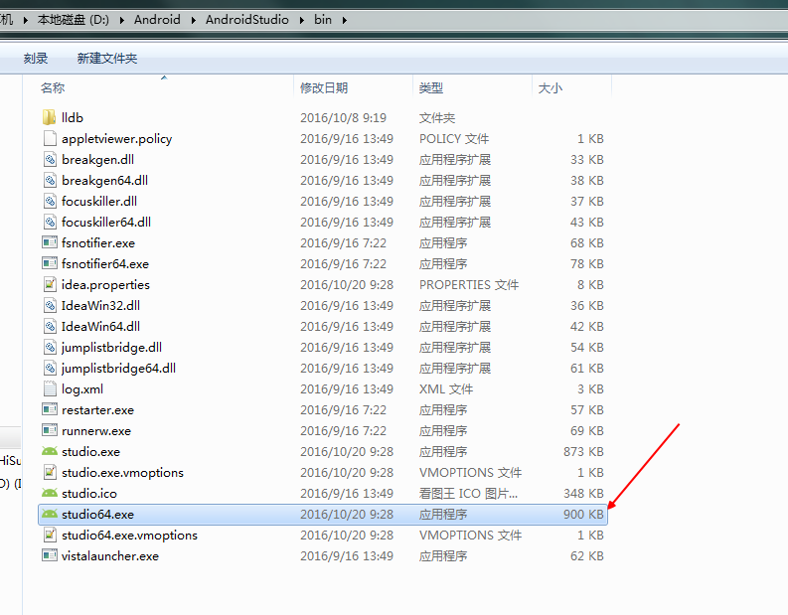

先找到 gradle 所在的路径
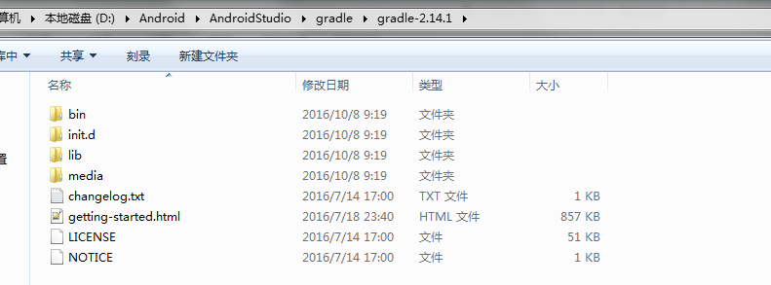

GRADLE_HOME
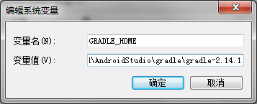
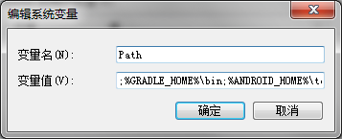
gradle -v
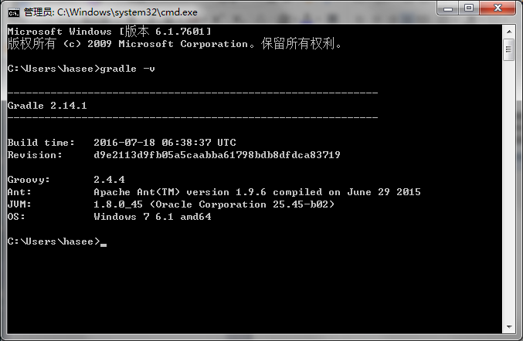

配置gradle
apply plugin: 'com.android.library'
android {
buildTypes {
}
lintOptions {
abortOnError false
}
}
dependencies {
compile fileTree(dir: 'libs', include: ['*.jar'])
compile 'com.android.support:appcompat-v7:24.2.1'
compile 'com.android.support:recyclerview-v7:24.2.1'
}
task makeJar(type: Jar) {
delete 'build/libs/alex-tools-3.2.6.jar'
baseName 'alex-tools-3.2.6'
from('build/intermediates/classes/release')
exclude('android/', 'BuildConfig.class', 'R.class')
exclude "**/BuildConfig.class"
exclude "**/R.class"
exclude "META-INF"
exclude {
it.name.startsWith('R$');
}
}
makeJar.dependsOn(build)

运行gradle
gradlew makejar
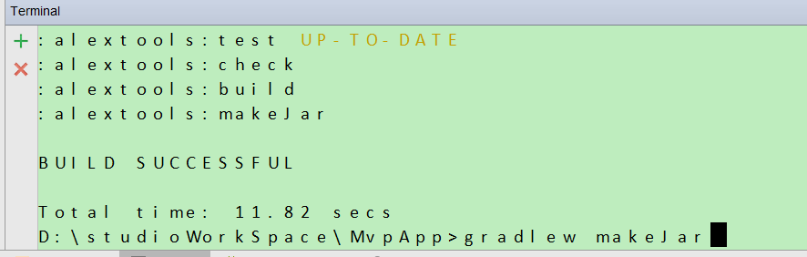
成功了
