gradle.properties
org.gradle.jvmargs=-Xmx1536m
#Maven Repo
URL_UPLOAD_SNAPSHOT=http://10.129.0.147:8081/nexus/content/repositories/snapshots/
USER_NAME=admin
USER_PASSWORD=Maven.456
GMJR_GROUPID=com.gmjr.android

配置 全局的build.gradle
buildscript {
repositories {
jcenter()
maven {
url "http://10.129.0.147:8081/nexus/content/repositories/snapshots/"
}
}
}
allprojects {
repositories {
jcenter()
maven {
url "http://10.129.0.147:8081/nexus/content/repositories/snapshots/"
}
}
}
task clean(type: Delete) {
delete rootProject.buildDir
}

配置 模块的build.gradle
apply plugin: 'com.android.library'
apply plugin: 'maven'
dependencies {
compile 'com.android.support:appcompat-v7:23.3.0'
}
uploadArchives{
repositories{
mavenDeployer{
repository (url:URL_UPLOAD_SNAPSHOT){
authentication(userName:USER_NAME, password:USER_PASSWORD)
}
pom{
groupId=GMJR_GROUPID
artifactId="keyboard"
version="1.0.0-SNAPSHOT"
name="keyboard"
packaging="aar"
}
}
}
}
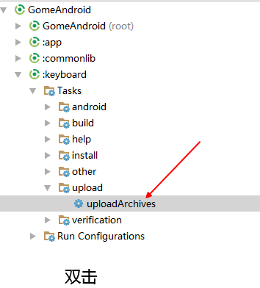

引用 全局的build.gradle
buildscript {
repositories {
jcenter()
maven {
url "http://10.129.0.147:8081/nexus/content/repositories/snapshots/"
}
}
}
allprojects {
repositories {
jcenter()
maven {
url "http://10.129.0.147:8081/nexus/content/repositories/snapshots/"
}
}
}

引用 模块的build.gradle
dependencies {
compile 'com.gmjr.android:keyboard:1.0.0-SNAPSHOT'
}

