Picasso

width
方法调用了 Picasso.Builder.build();
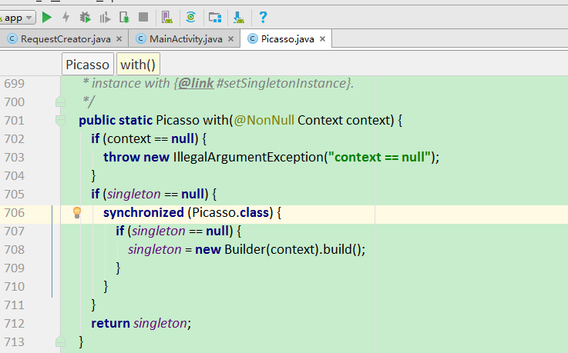

load
public RequestCreator picasso.load(@Nullable String path);
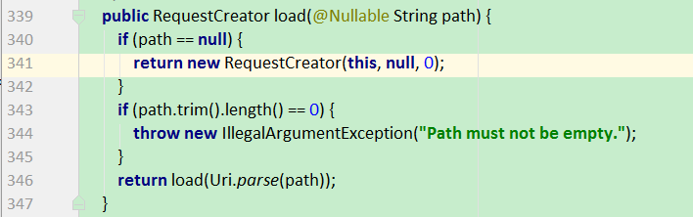

enqueueAndSubmit
void enqueueAndSubmit(Action action);
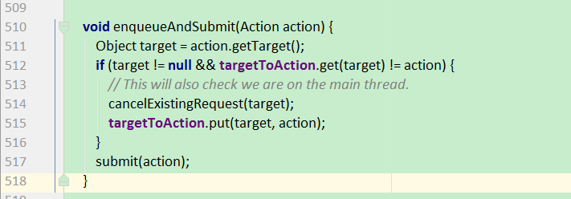

submit
void submit(Action action);
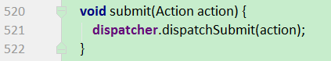
dispatcher在哪里初始化的？？详见 Picasso.Builder.build();
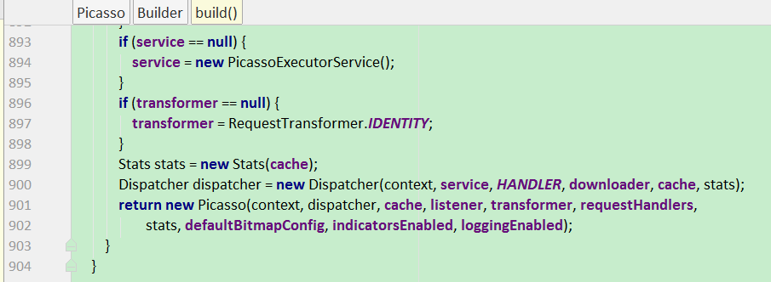

HANDLER mainThreadHandler
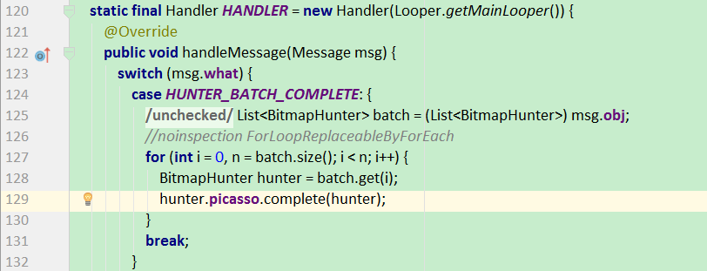

complete
void complete(BitmapHunter hunter);
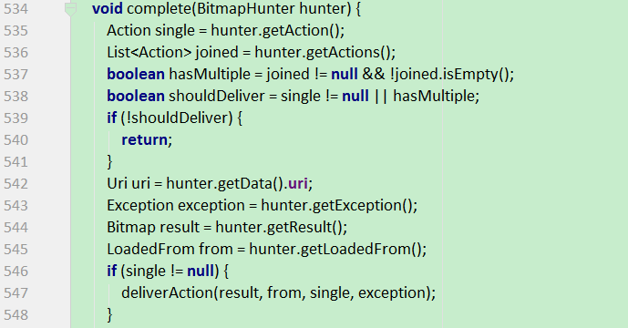

deliverAction
private void deliverAction(Bitmap result, LoadedFrom from, Action action, Exception e);
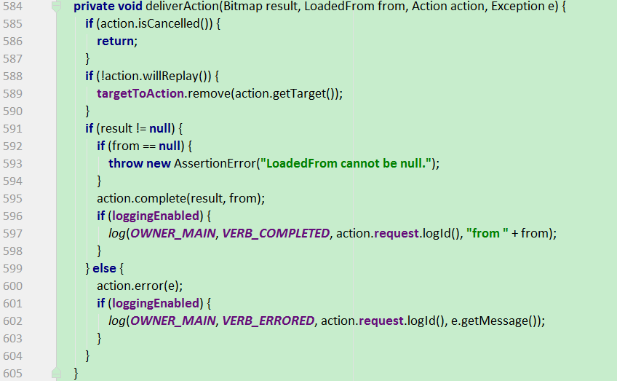

getRequestHandlers
List<RequestHandler> getRequestHandlers();


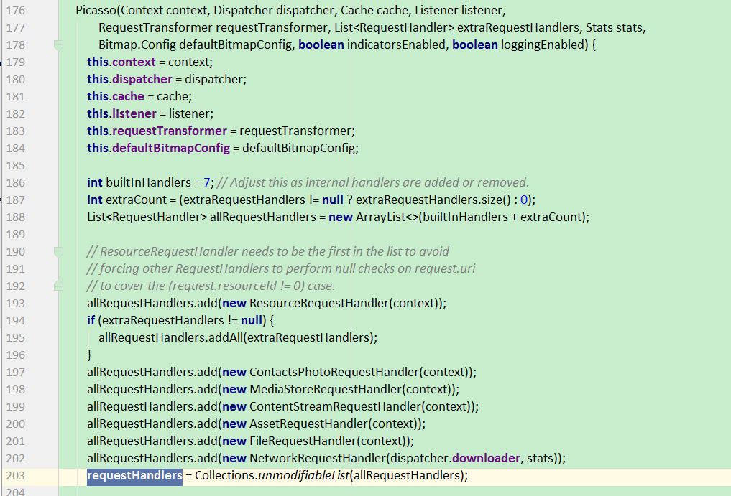
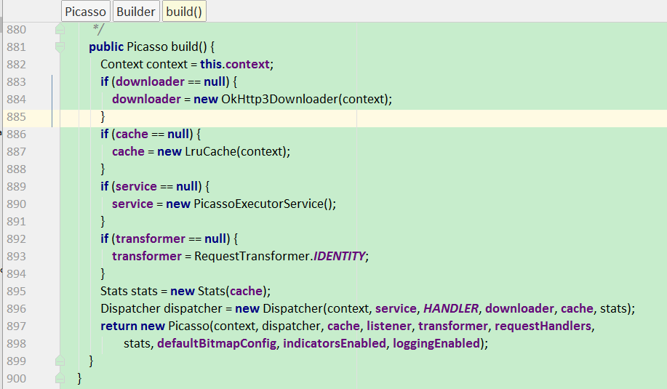

addRequestHandler
public Builder addRequestHandler(@NonNull RequestHandler requestHandler);
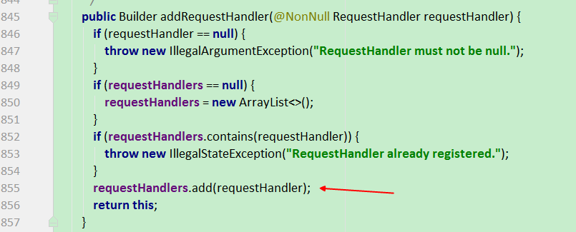

NetworkRequestHandler

load
public Result load(Request request, int networkPolicy) throws IOException;

OkHttp3Downloader

load
@Override
public Response load(@NonNull Request request) throws IOException {
return client.newCall(request).execute();
}

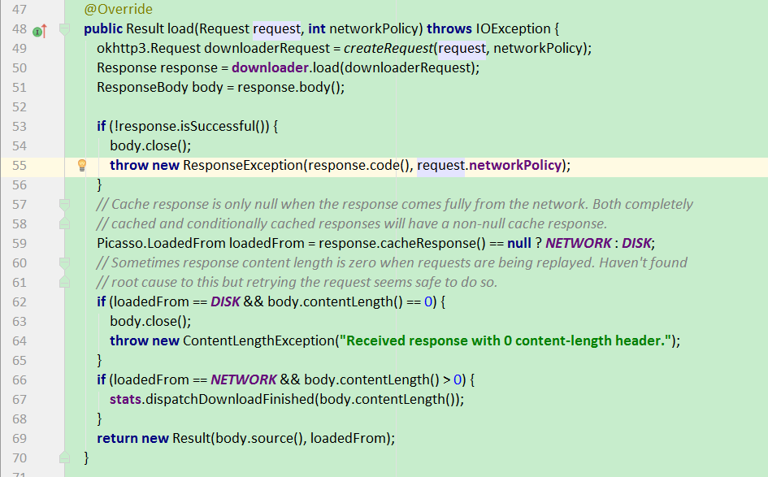

RequestCreator
为下载图片的请求构建流畅的api

RequestCreator
RequestCreator(Picasso picasso, Uri uri, int resourceId);
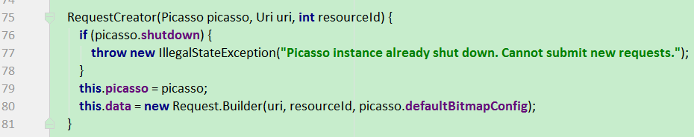

into
public void into(ImageView target)


into
public void into(ImageView target, Callback callback);
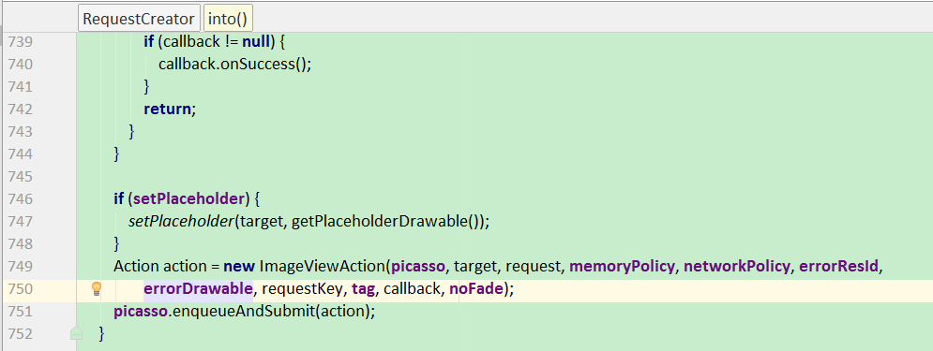

ImageViewAction

complete
public void complete(Bitmap result, Picasso.LoadedFrom from);
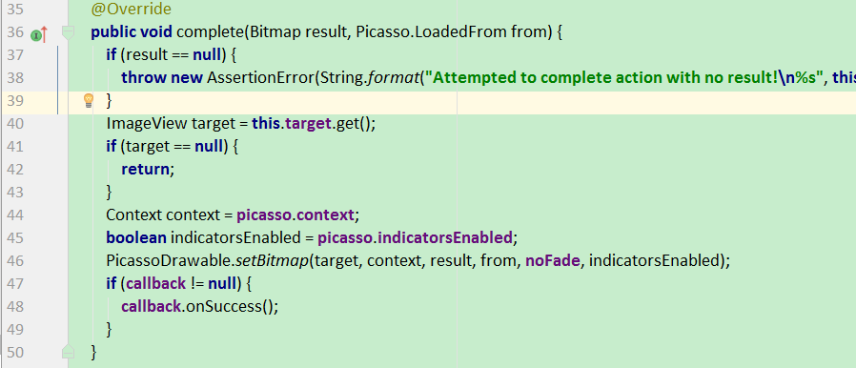

PicassoDrawable

setBitmap
static void setBitmap(ImageView target, Context context, Bitmap bitmap,Picasso.LoadedFrom loadedFrom, boolean noFade, boolean debugging) {
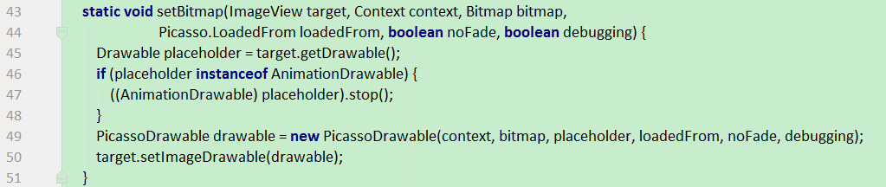

PicassoDrawable
PicassoDrawable(Context context, Bitmap bitmap, Drawable placeholder,Picasso.LoadedFrom loadedFrom, boolean noFade, boolean debugging);
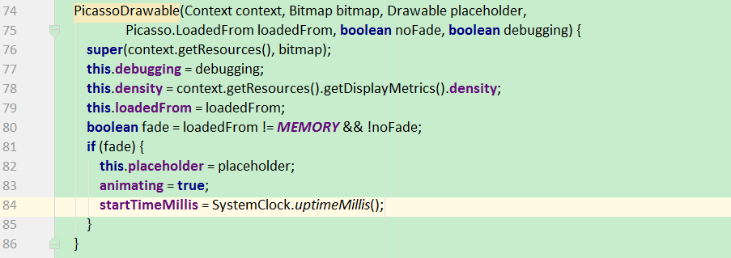

Picasso.Builder

build

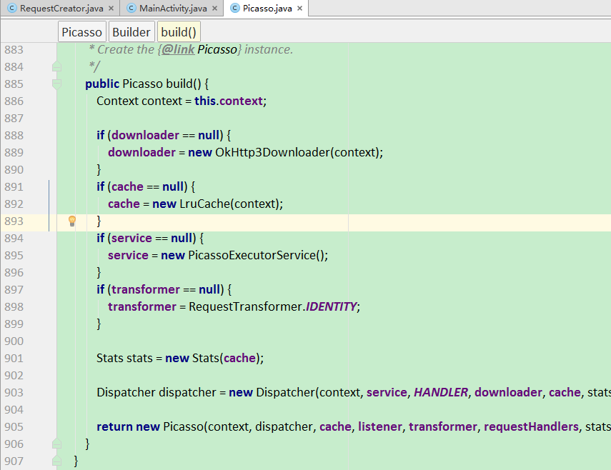

Dispatcher

dispatchSubmit
void dispatchSubmit(Action action);
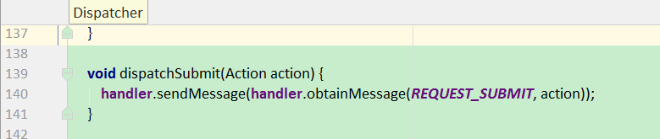

handler
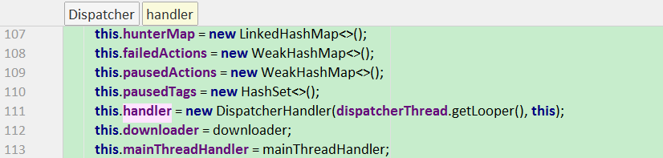

DispatcherHandler
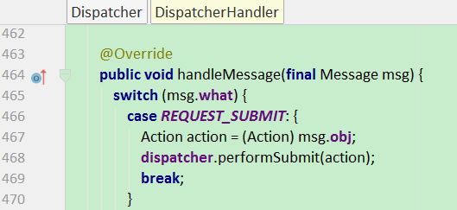

performSubmit
void performSubmit(Action action);
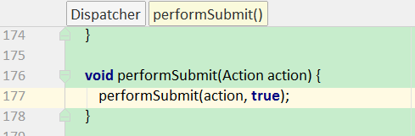

performSubmit
void performSubmit(Action action, boolean dismissFailed);
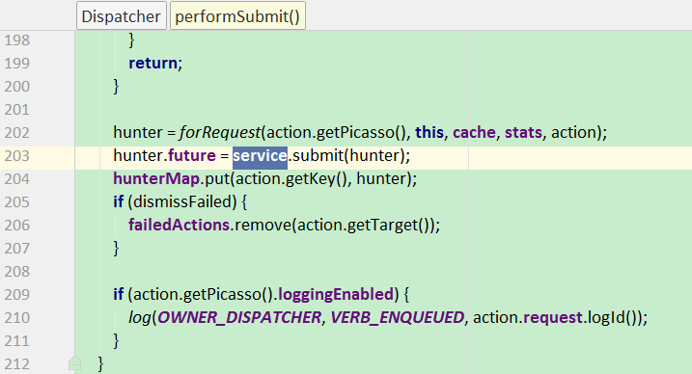
service哪里来的？
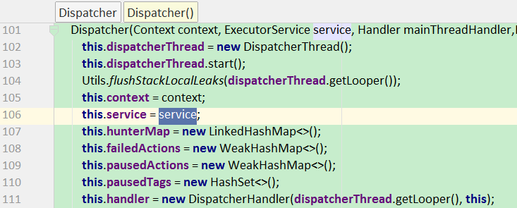
详见Picasso.Builder的构造方法
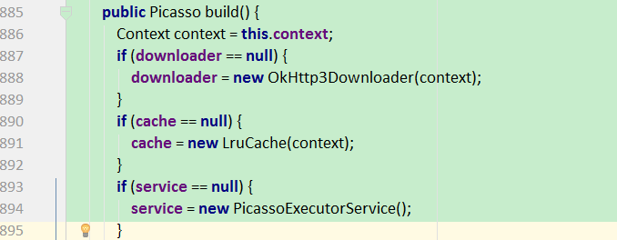

performComplete
void performComplete(BitmapHunter hunter);
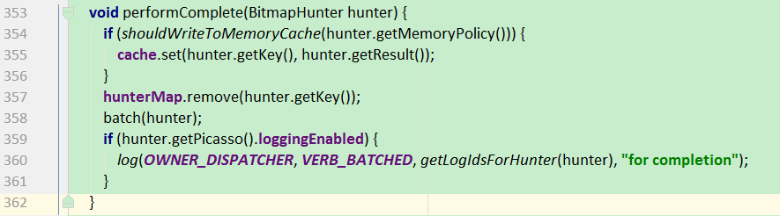

batch
private void batch(BitmapHunter hunter) ;
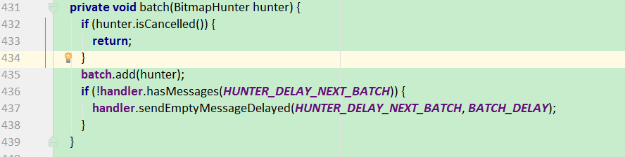

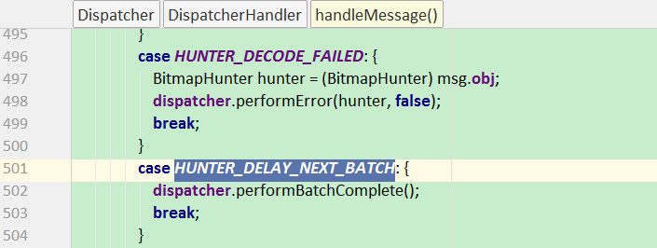

performBatchComplete
void performBatchComplete();
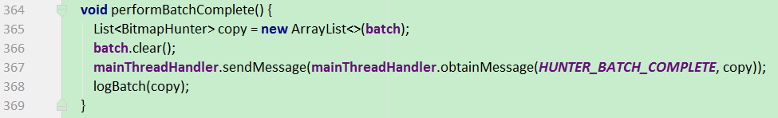
mainThreadHandler在哪里初始化的？？
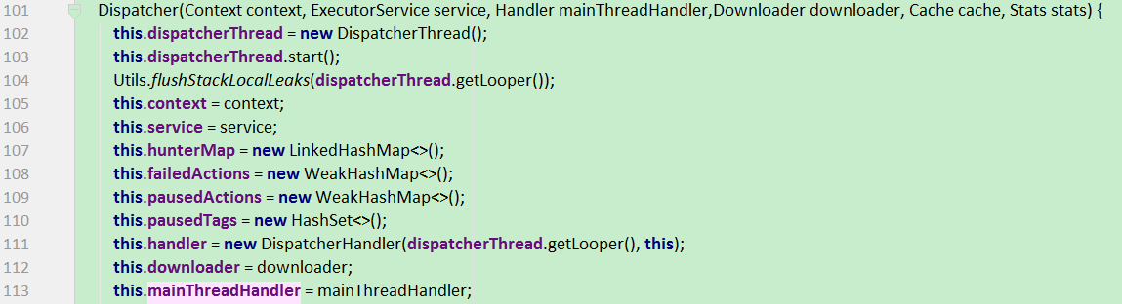
详见Picasso.Builder.build
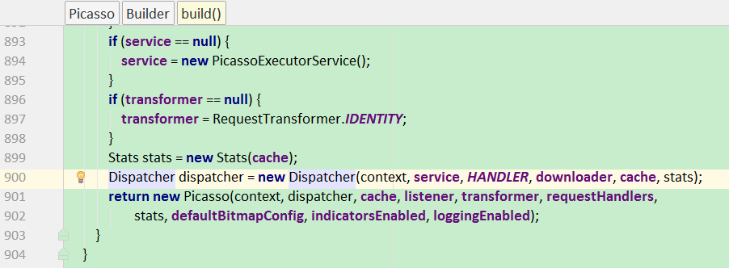

PicassoExecutorService

submit
public Future<?> submit(Runnable task);
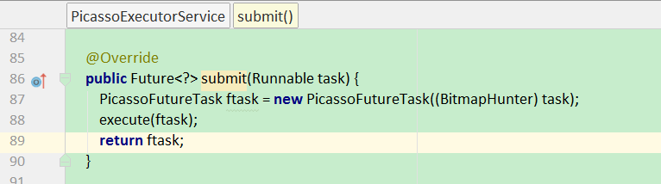

BitmapHunter

forRequest
static BitmapHunter forRequest(Picasso picasso, Dispatcher dispatcher, Cache cache, Stats stats, Action action);
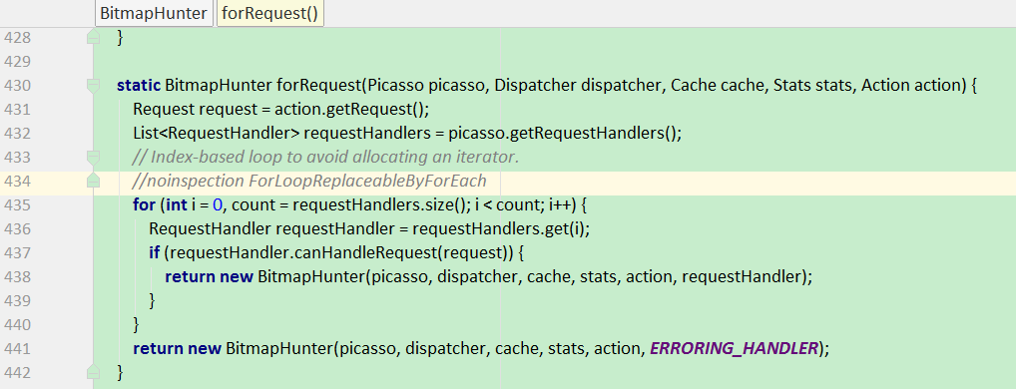

BitmapHunter
BitmapHunter(Picasso picasso, Dispatcher dispatcher, Cache cache, Stats stats, Action action, RequestHandler requestHandler) ;
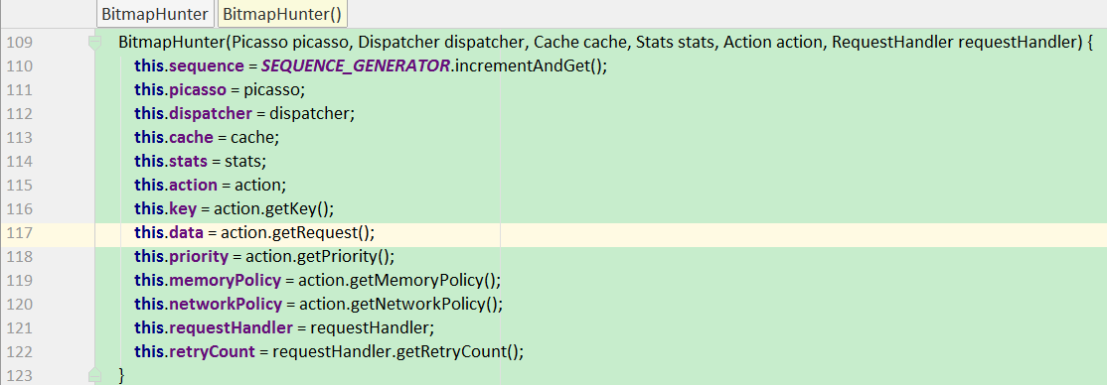

run
public void run();
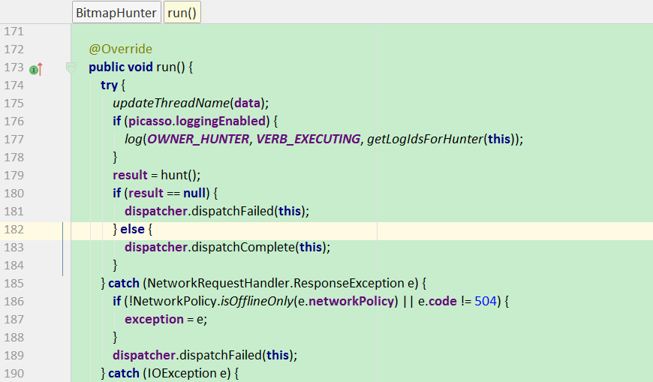

hunt
Bitmap hunt() throws IOException;

内存中有数据
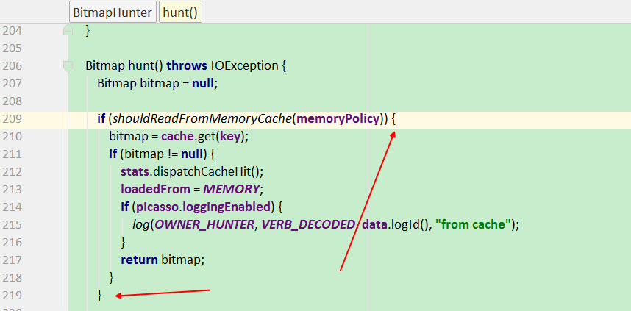

内存中没有数据
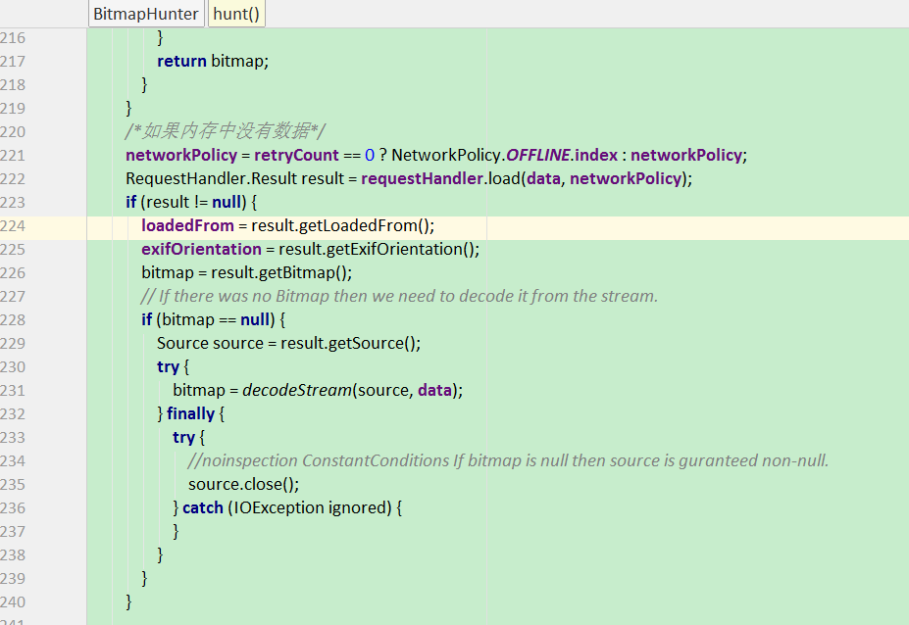
requestHandler哪里来的？？
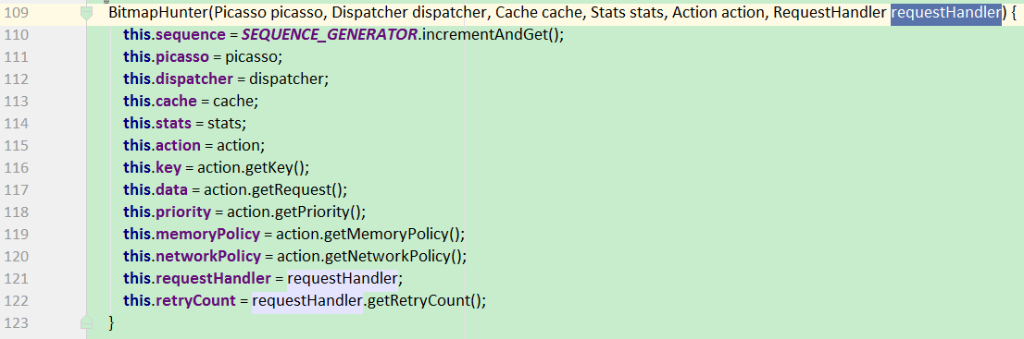

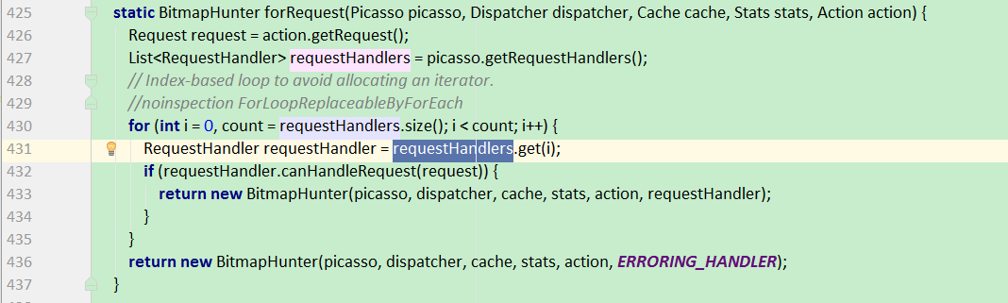

decodeStream
static Bitmap decodeStream(Source source, Request request) throws IOException;
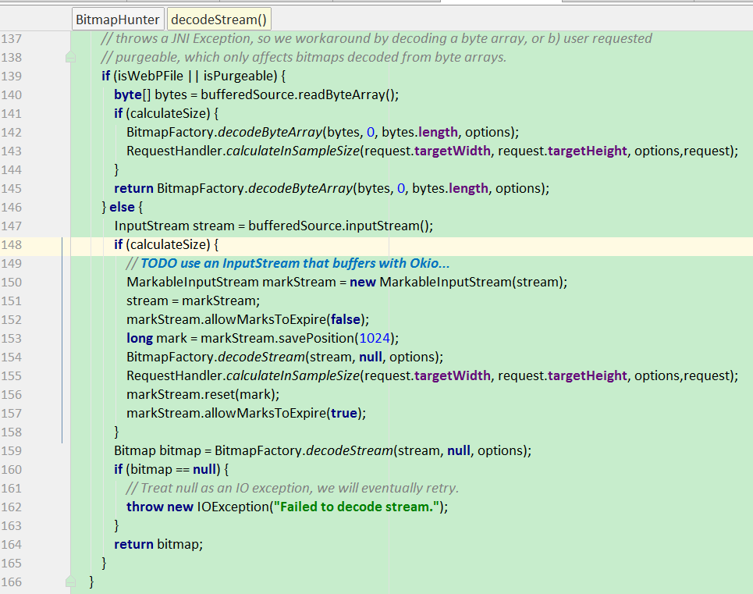

RequestHandler

设计模式

