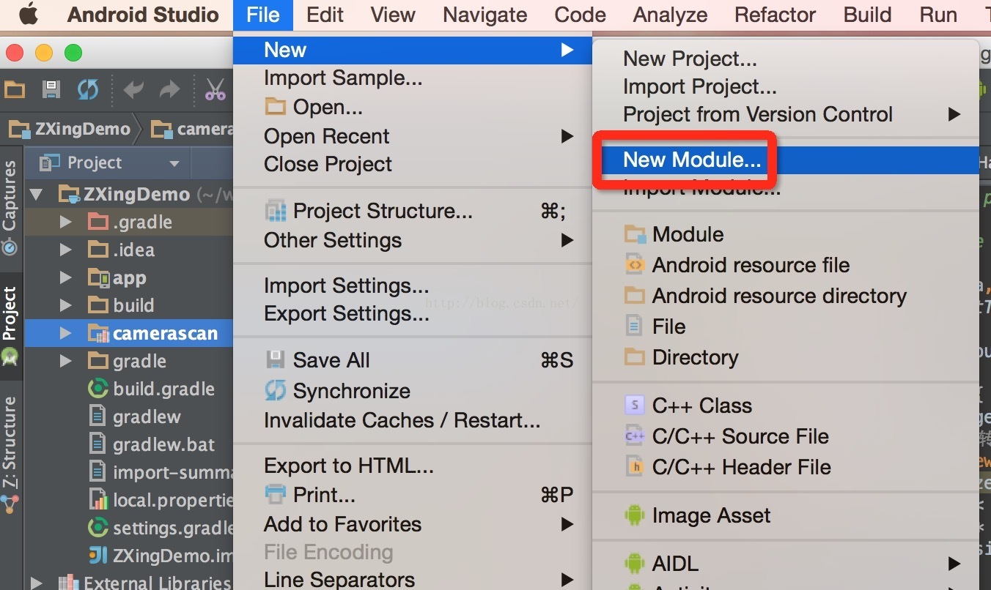

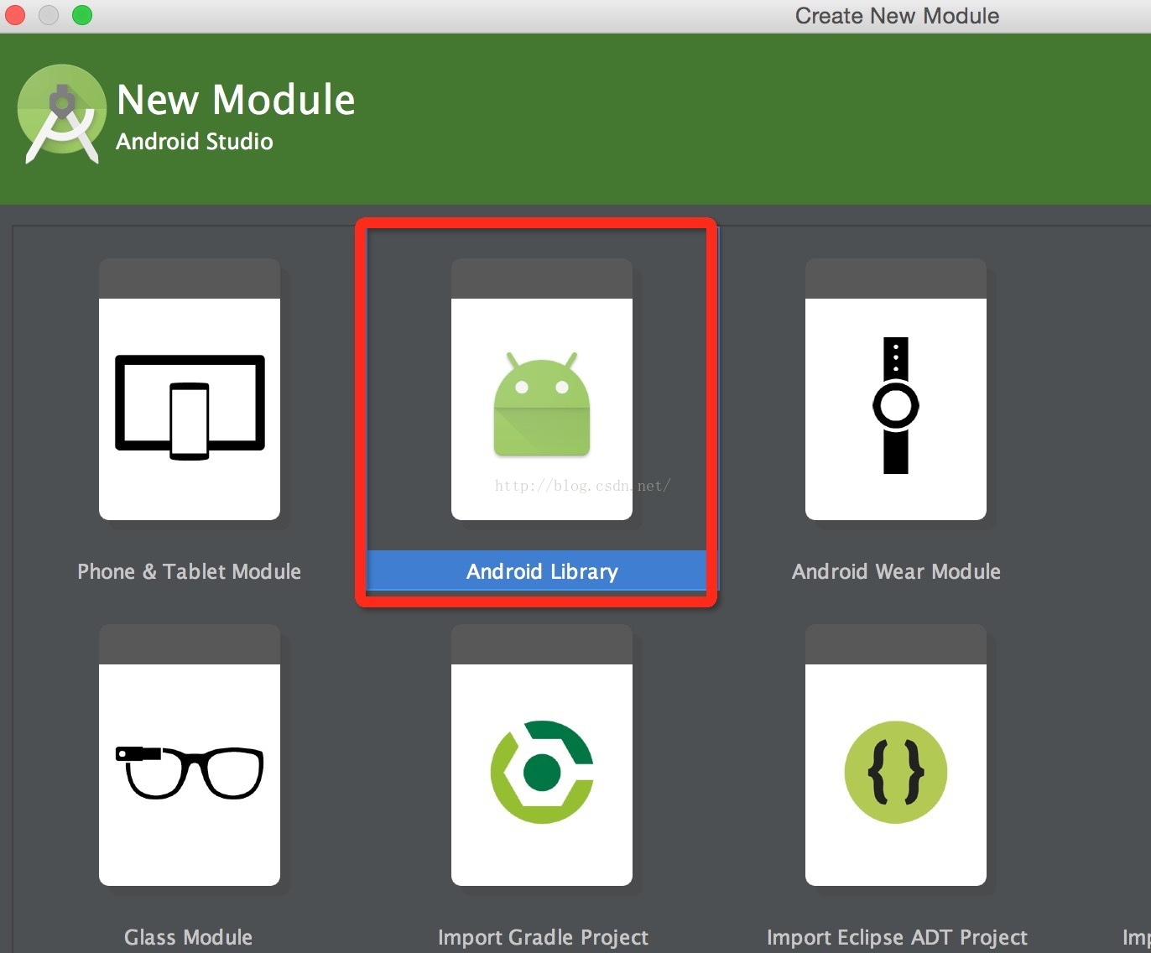

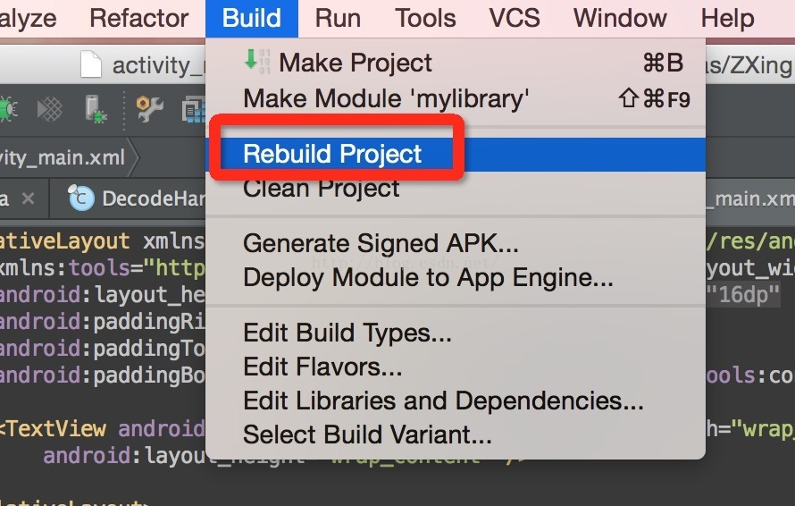

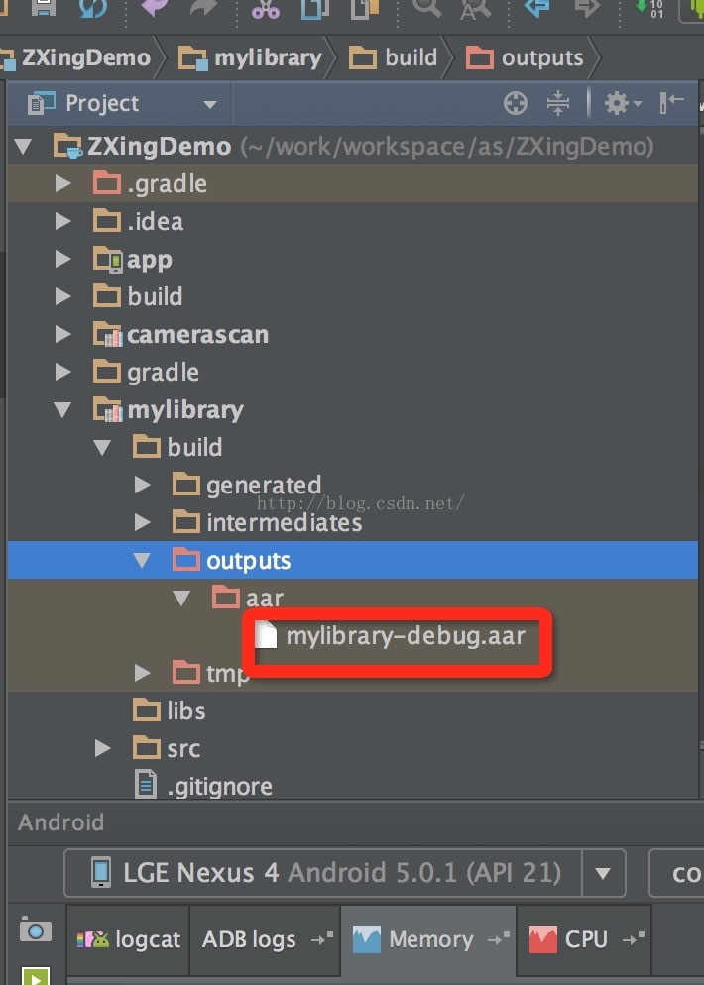

android {

buildTypes {

release {

minifyEnabled false

proguardFiles getDefaultProguardFile('proguard-android.txt'), 'proguard-rules.pro'

}

}

repositories {

flatDir {

dirs 'libs'

}

}

}

dependencies {

compile fileTree(dir: 'libs', include: ['\*.jar'])

compile(name:'camerascan-1.0', ext:'aar')

compile 'com.android.support:appcompat-v7:22.2.0'

}