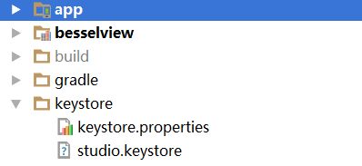

keystore.properties

**STORE_FILE** = **../keystore/studio.keystore  
STORE_PASSWORD** = **123123  
KEY_ALIAS** = **123123  
KEY_PASSWORD** = **123123**

模块的 build.gradle

apply **plugin**: **'com.android.application'**Properties properties = **new** Properties()  
properties.load(**new** FileInputStream(file(**"../keystore/keystore.properties"**)))  
android {  
 compileSdkVersion 25  
 buildToolsVersion **"25.0.0"** defaultConfig {  
}  
 buildTypes {  
 }  
 signingConfigs {  
 release {  
 storeFile file(properties[**'STORE_FILE'**])  
 storePassword properties[**'STORE_PASSWORD'**]  
 keyAlias properties[**'KEY_ALIAS'**]  
 keyPassword properties[**'KEY_PASSWORD'**]  
 }  
 }  
}