Lajpat Rai Sharma
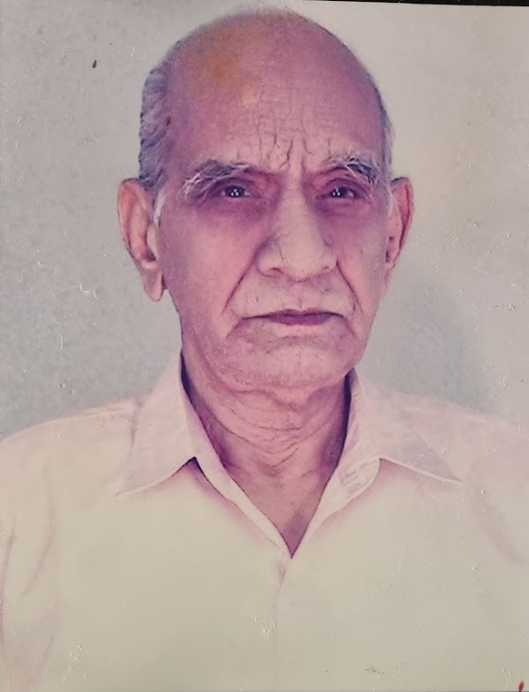
Lajpat Rai Sharma was born on 15, Oct 1923 in Nasirabad, Rajasthan. He completed his early education in Ajmer. He earned a master's degree in English from Agra University. 1948, Married to Kasturi Devi Sharma. He passed on his legacy of higher education to all his six kids.
For the initial 12 years, 1947-58, he was professor at Chandausi, U.P., Ajmer, Rajasthan and Jaipur, Rajasthan. The Colombo Plan is a regional organization of 27 countries designed to strengthen economic and social development of member countries in the Asia-Pacific region. It was established by Great Britain in Colombo, Ceylon, in 1950. In 1958, under the Colombo Plan, he was appointed as English professor at Kathmandu, Nepal for four years.

From 1963 to 69 he was Professor, Senior Professor and Head at Kota government college. From 1970 to 75 he was Head of college at Ajmer Government College. 1975 to 79 he was principal at government college in Chittorgarh, Sri Ganganagar, and Kota.

He had very active participation, both as student and teacher, in literary, cultural, games, and sports activities. He was president of all Nepal colleges sports board, Kathmandu.

Likewise, he was a general secretary of Indian Association of English studies and Rajasthan University and College Teachers Association (thrice), Publicity Committee, XXXI All India educational conference. Furthermore, he was chief editor, souvenirs at Pre-Asian basketball at Kota and XXX All India Aquatic Championship at Jaipur. He was also the journal reviewer at HCM Rajasthan State Institute of Public Administration.

At the age of 86 years, in Udaipur, Rajasthan, on 29, Apr 2009 he left us alone. He will be in our thoughts always.

