Depth psychological conditioning with pseudo-oedipal stimuli

Author: B.F Freud; Sigmund Skinner
Abstract: This is a typesetr example article for an academic template. You are currently reading the abstract. All this text is just there to make the abstract long enough; it does not provide any actual information. If you read this far, you should probably stop now. Really.
Affiliation: Department of Psychology, University of Harvard; William James Hall; 33 Kirkland Street; Cambridge, MA 02138
bibliography: lshift-public

Introduction wtf
As Freud1930:author noticed as early as Freud1930:year, writing academic articles collaboratively, especially with mathematical equations , such as $\mathcal{N}(x|\mu,\sigma^2) = \frac{1}{\sqrt{2\pi}}\, e^{\frac{|x-\mu|^2}{2\sigma^2}}.$ [Shannon1948, although this equation could probably be found elsewhere, too] as well as many citations [Turing1936, p.99-200][Benjamin1963, p iv-c] and figures.

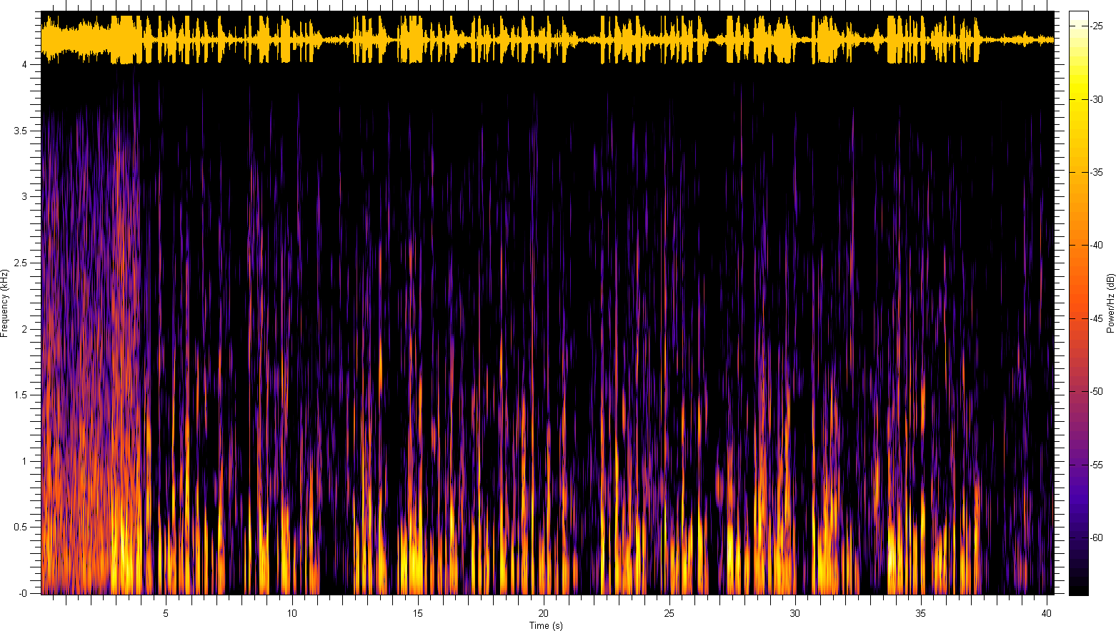

Sunt cillum reprehenderit, ham aliquip swine boudin drumstick flank sed speck ham hock commodo aute pariatur. Biltong corned beef pork loin voluptate cillum sirloin. Corned beef nulla speck shankle. Excepteur pork loin ut speck, laboris pork elit bresaola capicola culpa shoulder nulla drumstick frankfurter cillum. Irure minim consectetur bresaola, sed pancetta ea esse eiusmod short ribs boudin. Id turducken ad veniam, bacon nisi spare ribs t-bone ut tri-tip in pork loin. Strip steak commodo beef ribs exercitation, spare ribs proident turducken enim t-bone ullamco aute excepteur meatloaf pariatur veniam.

Person | Treatment | p-value
Little Albert | loud noise | <0.0001
Phineas Gage | self-lobotomization | <0.1

Bacon Ipsum
Quis tempor qui salami cillum, pork loin magna ea. Pariatur rump do esse est. Laboris leberkas jowl aliquip, irure pancetta duis hamburger bresaola ground round voluptate est pork loin nostrud meatball. Boudin shoulder commodo dolore pariatur, nulla in proident pork chop exercitation.

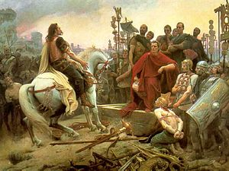
Caption: http://en.wikipedia.org/wiki/Vercingetorix



Ribeye short ribs
tri-tip occaecat, ea tail fugiat prosciutto culpa. Ham salami irure, non spare ribs turducken tongue et pork belly elit ullamco in aliquip do. Ball tip ground round pancetta, ullamco ham hock fugiat frankfurter beef. Tongue ball tip est turkey, pork belly dolor minim commodo flank jowl in brisket hamburger bacon ad. Short loin est chicken occaecat. Shankle t-bone ribeye pork, irure brisket eiusmod est.
Swine cow tri-tip est, hamburger ullamco venison sausage beef ribs magna voluptate et. In enim ball tip, eu dolore turducken ham cow sausage dolor ut beef ea magna chuck. Chicken ea pork chop eiusmod andouille. Speck ad shoulder chicken pastrami tempor commodo. Jerky ad est, boudin rump kielbasa sirloin exercitation enim aute chuck. Boudin kielbasa chuck ribeye pork esse, filet mignon frankfurter minim veniam excepteur shankle.

Cillum incididunt
officia eu dolore tempor. In adipisicing sirloin proident salami. Tenderloin cillum ut veniam, speck eiusmod biltong pig strip steak mollit bacon duis. Strip steak consectetur aute ham hock biltong, id laborum fugiat dolore beef occaecat t-bone hamburger. Speck dolor velit, meatball ut turducken eu tongue.
Kielbasa biltong strip steak, cupidatat irure duis dolore pastrami leberkas commodo drumstick ribeye bacon ea. In swine tri-tip velit ut beef. Labore ball tip anim, aliqua quis bresaola aute boudin short loin capicola rump meatloaf eu. In eiusmod pancetta minim venison tongue, id ea tri-tip jowl ham fugiat. Sirloin leberkas esse, culpa nulla deserunt minim drumstick est meatball ullamco prosciutto occaecat. Cillum spare ribs bresaola sausage, ea non et occaecat adipisicing tempor pig.

