Ultra-extreme programming: contortionist-level agility
short-title: Ultra-extreme programming
author: A. Bender
affiliation: The University of X
abstract: This is just an example article for the Lecture notes in Business Information Processing.
keywords: agile, XP, software development
bibliography: Group lshift-public: Library

The first section
This an example section, with a citation [Turing1936].

This is a subsection
In addition this figure explaining the consequences of adopting an XP approach:
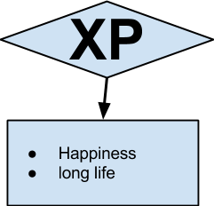
Caption: this caption should appear below the figure.

this section contains the following table:
XP | UltraXP
extreme | more so
Caption: this caption should appear above the table, in this style.

