Provocative Typesetr tutorial
being a mashup of said doc and “Provocative Alloys”
author: Alexander Schmolck; Anon
date: 2012-10-18
abstract: This is a mashup test doc for epub output.
keywords: tutorial; typesetr; epub
isbn: 978-1-906496-95-1
cover-image: 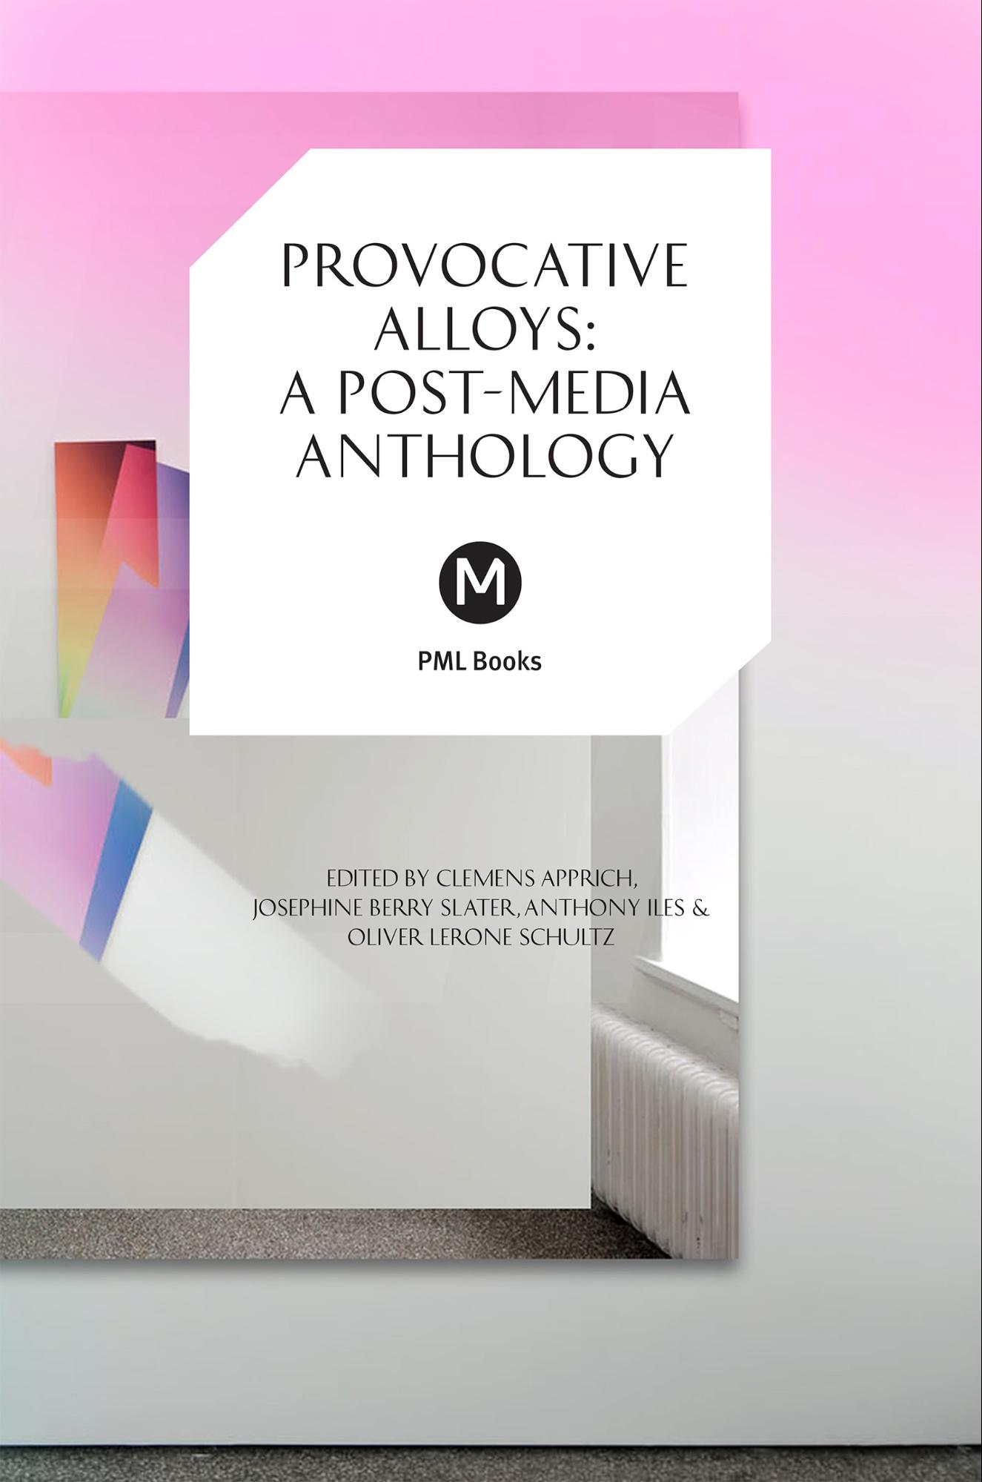

Note: Everything before this paragraph is metadata which can be supplied directly in the typesetr UI, but if you want you can also edit the metadata manually, as long as you follow the right format.

The typesetr approach
The Google Doc determines the structure of your output, the template you select determines the styling.

Basic formatting
Consequently normal structural formatting like headings, bold or italic text work as expected (but not underlines) as do
- numbered lists
- bulletted lists
  - such as this one
  - you can also use links
However, changing the font to “Comic Sans” or 24 point Times New Roman will not affect the output (the exception is that Courier New and other fixed width fonts will render as fixed width, for example for code examples or computer output). Similarly, non-structural formatting like margin sizes in the document will be ignored by typesetr. So will be consecutive whitespace (so make sure you use real lists and headings rather than just indenting text manually with spaces or changing fonts).

Advanced features
Although typesetr separates the tasks of content creation and style creation, there are areas where this boundary becomes fuzzy. For example, it is impossible to create a compelling table without any notion of how the columns will fit on the physical page, and similarly it is (rarely) necessary to manually specify a pagebreak to achieve the desired output. Therefore typesetr preserves manual pagebreaks and (relative) sizes of figures and table columns (with some twists, see below). Also some purely semantic features such as captions are not directly supported in Google docs, here typesetr relies on a few simple conventions. g

Figures
Typesetr supports three basic types of figures:

1. Freestanding figures (with or without a caption). These are on a paragraph on their own and are typeset to have the same relative width in the output document.

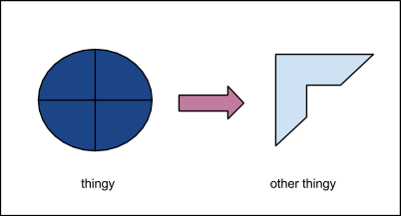

2. Margin figures, created by inserting and image  into the text flow. The image will be sized to fit the margin in the typeset document.

3. Fullwidth figures (with or without caption), are created by sizing figures so they extend into the Google document margin

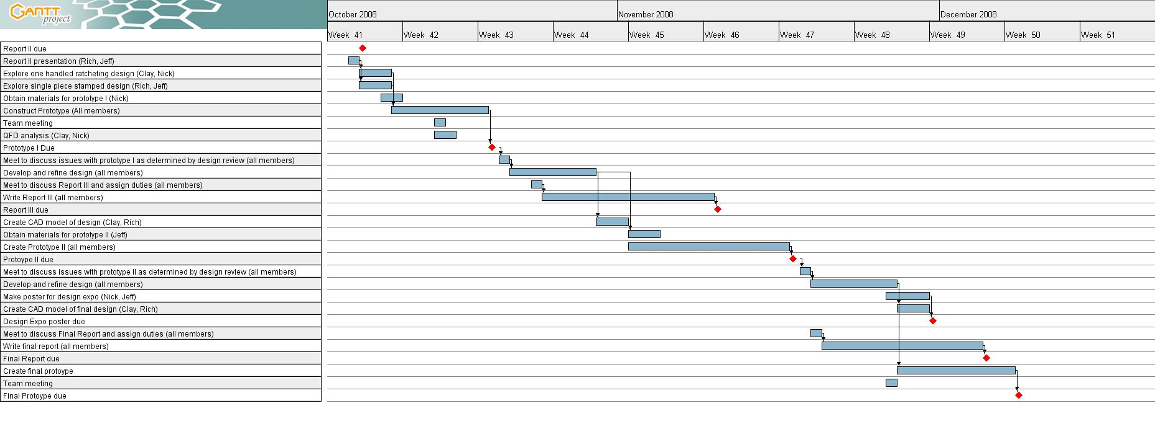Caption: Fullwidth figures are useful for e.g. Gantt charts.

Pagebreaks
You can’t see it, but below this paragraph there is a pagebreak (inserted with Control+Return), which typesetr will preserve in the final output.

Tables

Table headings are bold | and can also be... | ...centered... | ...or right justified
The relative width |  | table cell alignment for a column | 1
of a column |  | comes  fro  the cell heading | 100
is preserved in the typeset document |  | the alignment of  individual  cells  is | 1000
 |  | ignored | 10000
Caption: To add a caption to a a figure or a table, write the underlined word “Caption:” (note the colon) followed by the caption text as in this example.

A table doesn’t have to span the whole text-width, have table headings or a caption, you can also just have a small simple table to appear inline in your text:

2009 | $1000
2008 | $1423
2007 | $4

such as the above.

Underlines are used for special commands to typesetr to supply features that are not directly available in Google docs, such as Figure captions (BTW, as you can see: footnotes work, too!).

