The document title

with subtitle

Author: Alexander Schmolck

Project: typesetr

Client: LShift

Version: 1.3.0

Date: today

# This is a level 1 heading with comment[1]

A paragraph (with {braces}, and lots of punctuation: !"#$%&\'()*+,-./:;<=>?@[\]^_`{|}~).

Another paragraph.

A centered paragraph

A right justified paragraph

A block paragraph.

*An indented paragraph in italic, with*

* 1. *a*
  2. *list*

Some identation by 3 spaces, two spaces after the preceding comma

Indentation by tab, followed by 2 trailing tabs

blah

Indentation on its own means blockquote:

The son of a father to whom history will accord certain attenuating circumstances, but also as worthy of esteem as that father had been of blame; possessing all private virtues and many public virtues; careful of his health, of his fortune, of his person, of his affairs, knowing the value of a minute and not always the value of a year; sober, serene, peaceable, patient; a good man and a good prince; sleeping with his wife, and having in his palace lackeys charged with the duty of showing the conjugal bed to the bourgeois, an ostentation of the regular sleeping-apartment which had become useful after the former illegitimate displays of the elder branch; knowing all the languages of Europe, and, what is more rare, all the languages of all interests, and speaking them; an admirable representative of the “middle class,” but outstripping it, and in every way greater than it; possessing excellent sense, while appreciating the blood from which he had sprung, counting most of all on his intrinsic worth, and, on the question of his race, very particular, declaring himself Orleans and not Bourbon; thoroughly the first Prince of the Blood Royal while he was still only a Serene Highness,[...]

Victor Hugo, *Les Miserables* (cut short, mid-sentence)

Indented monospaced text means code (styling is ignored, note how half the code below is styled and half isn’t):

**def** **_pred_repr**(pred, pargs, pkwargs)

**if** **not** pred:

**return** ''

**else**:

myrepr = lambda x: x.__name__ if hasattr(x, '__name__') else repr(x)

f = myrepr(pred)

args = map(myrepr, pargs)

kwargs = ["%s=%r" % (k, myrepr(v)) for (k, v) in pkwargs.values()]

return "(%s)" % ", ".join([f] + args + kwargs)

There should probably also be a way to have code captions...

## A level 2 heading (bookmarked), with url <https://google.com>

Some nasty long urls like <https://github.com/lshift/cloverage/commit/9318ea9fa081044b00de0f214a6fc63d5105eab2> in the body, here is a shorter one, but a bit weird: <http://en.wikipedia.org/wiki/PC_Tools_(Central_Point_Software)>, because wikipedia thinks urls with parens [http://Example.com/frag;query?param=}&anotherParam=[blah]&oneMore=(æäae)&chars=(x[${'\foo|^2_3-'}]@)#!fräg](http://example.com/frag;query?param=%257D&anotherParam=%5Bblah%5D&oneMore=(æäae)&chars=(x%5B$%257B'/foo%257C%255E2_3-'%257D%5D@)#!fräg) are a fine idea. Some balanced parens: [http://example.com/{balanced}](http://example.com/%7Bbalanced%7D)

### A level 3 heading (also bookmarked),with drawing inside

##### A level 5 heading with monospace and *italics*

###### A level 6 heading

**bold tex.** *Italic text.* ***Bold italic text.*** ~~Strikethru.~~

Italic correction test: *half*hearted **half**hearted *half***hearted**

multi-para italics: *italics before the break*

*italics after the break*

Red background green text.subscriptedandsuperscripted. Finally, a Footnote[2].

1. A numbered list, first item
2. A numbered list, second item
3. A numbered list, third item, with a subnumbered list:
   1. A numbered sublist, first item
   2. A numbered sublist, second item (with 2 random spaces: ‘ ‘)
   3. A bulleted subitem
      * a sub-bullet
        + a sub-sub-bullet
          - a sub-sub-sub bullet
4. A toplevel numbered list
   1. A numbered list following below it
5. This is a new numbered list -- why I do not know
6. This is new numbered list because I told it to renumber, starting at 10
7. Item number 11, out of 2 (or 3)?
8. A new list alternating between bullets and numbers without renumbering
   * bullet switch1
     1. number switch1
        + bullet switch2
          1. number switch2

[A partly **bold** link to google](http://www.google.com?q=frob&ie=UTF8). the preceding picture is inline.



Caption: The preceding picture has fixed position.

It’s also possible to have drawings (which can contain links):

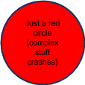

Also, an empty caption means the figure will still receive a label (but no label/text separator like :):



Caption:

A link to heading 2 A link to a bookmarked sub-bullet Hey it seems possible to reference formulas! but not tables?

Some courier text. Times new 𝝰 Roman text. Arial Text. Tahoma 14pt, now *italic.* Corsiva for quotations?, although I wonder what it looks in *italic* -- hmm weird, but ***bold italic*** is even worse.

Sycopante is dusgusting but *even* worse in **bold *italic.***

consolas looks pretty **OK** for monotype. Some 14 Pt Georgia.

A formula:

This is an inline math formula:\(\sum_{i=0}^N\sqrt{2\pi\sigma^2}\exp(\frac{(x_i-\mu)^2}{\sigma^2})\) (should look as the picture above).

2 lines with larger linespacing:

1.15

1.5

2

A paragraph with space after it.

A paragraph with space before it.

|  |  |
| --- | --- |
| A | plain |
| 2x2 | table |

Caption: A very simple and plain table that takes only a small part of the page.

## MŨĻŤĮŁÄŃĜŮĂĢȄ

Ŵëśțêřñ | Çèņŧŕåľ Êûřȍpĕ | Қӥрӣллӥцӓ + Àşîãń | Ţúřķïšħ | Båĺťįč | ελληνική

### Punctuation

"Nerds like 'straight' quotation marks!"

“Doing ‘inner quotations’ American style”.

„Deutsche Anführungszeichen, auch ‚Gänsefüßchen‘ gennant.“

”Lainausmerkit”

«Swiss French ‹Guillemets›».

— the em dash […] is much less fussy than quotation marks, writes Bringhurst.

#### Dashes, hyphens and minuses

Ranges should use en-dashes like so: 25–30mm.

Negative numbers hould use a minus sign: −3 not a hyphen: -3.

Wikipedia either suggests:

[Em dash:] A flock of sparrows—some of them juveniles—alighted and sang.

[En dash:] A flock of sparrows – some of them juveniles – alighted and sang.

### Latin-1 (apart from the Ō)

Not everything can be expressed in $s and ¢s, never mind English £s and

Japanese ¥, or indeed other ¤. Some ¦s have holes, some |s don't. All these §s

and ¶s are © by me. Acme®. «1ªdonna nº1». 2b or ¬2b. A few µs after a good sneeze

ÇÜŌÁ becomes CUOA¸¨¯´. ¼ ± ½x² + ¾x³ = y is a polynomial. 3*4 is ugly, but either 3·4 or 3×4 are fine. However, 3/4 is preferable to 3÷4. He made a 180° turn. ¿Por qué dices eso?

¡Qué va!

ÀÁÂÃÄÅÆ Ç E:ÈÉÊË ÌÍÎÏ Ð Ñ ÒÓÔÕÖØ ÙÚÛÜ Ý Þß

àáâãäåæ ç èéêë ìíîï ð ñ òóôõöø ùúûü ýÿ þ

**Other languages**

Hàn Thế Thành would know the Ý under the name Ý Đại Lợi.

Not in Latin1: [Ǿ](http://en.wikipedia.org/wiki/%C3%98), ǿ, [Ÿ](http://en.wikipedia.org/wiki/%C5%B8),[Œ](http://en.wikipedia.org/wiki/%C5%92),[Š](http://en.wikipedia.org/wiki/%C5%A0), š, [Ž](http://en.wikipedia.org/wiki/%C5%BD), ž,[Ő](http://en.wikipedia.org/wiki/%C5%90), ő, [Ű](http://en.wikipedia.org/wiki/%C5%B0), ű,Ḃ, ḃ, Ċ, ċ, Ḋ, ḋ, Ḟ, ḟ, Ġ, ġ, Ṁ, ṁ, Ṡ, ṡ, Ṫ, ṫ,[Ā](http://en.wikipedia.org/wiki/%C4%80), ā, [Ē](http://en.wikipedia.org/wiki/%C4%92), ē, [Ī](http://en.wikipedia.org/wiki/%C4%AA), ī, [Ō](http://en.wikipedia.org/wiki/%C5%8C), ō,[Ū](http://en.wikipedia.org/wiki/%C5%AA), ū,[Ā](http://en.wikipedia.org/wiki/%C4%80), ā, [Ē](http://en.wikipedia.org/wiki/%C4%92), ē, [Ī](http://en.wikipedia.org/wiki/%C4%AA), ī, [Ō](http://en.wikipedia.org/wiki/%C5%8C), ō,[Ū](http://en.wikipedia.org/wiki/%C5%AA), ū,[Ŵ](http://en.wikipedia.org/wiki/%C5%B4), ŵ, [Ŷ](http://en.wikipedia.org/wiki/%C5%B6), ŷ

Greek: Ζαφείρι δέξου πάγκαλο, βαθῶν ψυχῆς τὸ σῆμα.

Russian: Эх, чужак, общий съём цен шляп (юфть) – вдрызг!

Ukrainian: Жебракують філософи при ґанку церкви в Гадячі, ще й шатро їхнє п'яне знаємо.

صِف خَلقَ خَودِ كَمِثلِ الشَمسِ إِذ بَزَغَت — يَحظى الضَجيعُ بِها نَجلاءَ مِعطارِ

„Grüß الله（akaﷲ)!” – 【本当のバイエルン語じゃない)

「简体字」≠『簡體字』

〈Ａ〉、《Ｂ》。〔Ｃ〕‥ ｛Ｄ｝…（Ｅ）！［Ｆ〜Ｇ］？｟5時〜6時｠〒“〃＄″‘한’ ※ヽ〽

≠

〈A〉,⟪B⟫.⟬C⟭..{D}̣̣̣…(E)![F~G]?⸨5~6⸩

a☔😃

a hline

Some code samples

# fork bomb

:(){ :|:& };:

Some crap that should get culled

above there are lotsa empty paragraphs

# This heading has no anchor

# 

above there is an empty heading

URLs with hashes in them

[Innocent looking failure text.](http://www.google.com#test%20problematic%7Bchars%7D)[3]

Images without DPI Information

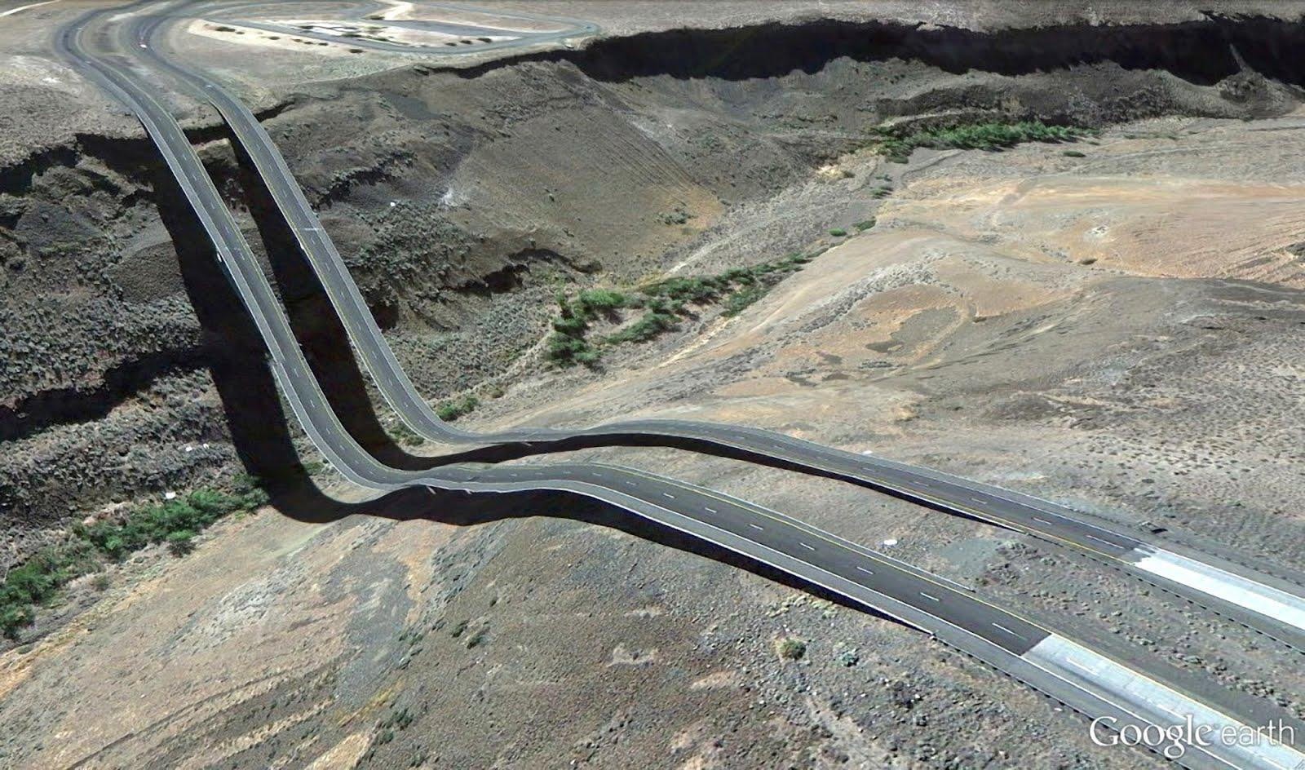

# 

# List Test

1. 1
   1. a
      1. i
         1. 11
            1. aa

ii

111

aaa

iii

bbb

222

ii.ii

* + - * 1. bb
      1. 22
    1. ii
  1. b

1. 2

* *
  + o
    - []
      * **
        + oo

[][]

***

ooo

[][][]

ooo

***

[][]

* + - * + oo
      * **
    - []
  + 2o
* *
* []
  + *
    - o
    - o
  + *
* []

1. A
   1. I
   2. II
2. B
3. TopLevelNumbered
   1. **bold** subnumbered
   2. *italic subnumbered*
      * bulletSublist
   3. c subnumbered
4. 2ndTopLevelNumbered
   1. aSublist
   2. bSublistBeforeEmpty
   3. aRenumberedSublist
      * subsubBullet
        1. subsubsubNumber
           + subsubsubsubBullet1

sixthlevel

7thlevel

8thlevel

9thlevel

* + - * + subsubsubsubBullet2FollowedByEmtpy
    - subsubBullet2
      1. Next1subsubNumber
    - subsubBullet3
* TopLevelBullet
  1. aSubList
  2. 1renumberedSubList
  3. 10renumberedSublist
  4. 11SublistFollowedBySubsubsubBullet
     + - * This does not render properly right now

# Table test

## In-depth tests of various table features

A totally minimal table:

|  |
| --- |
| This is a table consisting of a single cell. |

Caption: table numero uno

|  |  |  |  |  |
| --- | --- | --- | --- | --- |
|  | **Left Column** | **Centered Column** | **Right Column** | **Justified Column** |
| **Heading Column** | left | center | right | just |
| **2nd Heading Column** | leftsmall | *centersmallitalic* | **rightbold** | just small |

Caption: A table *caption with some* ***bold italic*** *but mostly italic* text. And a Footnote[4]. It should be #2.

|  |  |  |
| --- | --- | --- |
| A | 3 x2 | red text color cell |
| table (col1 1inch wide, row 2; row 2 2 inch min height) | with a nested list:   1. point 1 (w/ subpoints)    1. this is a subpoint 2. point 2 3. a footnote[5] | |  |  | | --- | --- | | A | 2x2 | | subtable[6] | this cell blue center |   Caption: Even the inner table[7] has a caption. |

Caption: this is a nested table.

|  |  |
| --- | --- |
| A table with some figures | This is very round |
| Caption: freestanding square[8]. | Another freestanding square[9]: |

Table with tricky headers (no spans, caused bug!):

## Pre-project (firm)

|  |  |  |  |  |
| --- | --- | --- | --- | --- |
| **Who** | **Resource** | **Rate** | **Time** | **Total** |
| One | 1 FTE | £0 | 6 days | £0 |
| Two | 2.25 FTE | £1 | 13 days | £13 |

A table with multiple paragraphs of text:

|  |  |
| --- | --- |
| Here’s some text. | And here’s a lot of text:  Lorem ipsum dolor sit amet, consectetur adipiscing elit. Donec lacinia, elit eu facilisis lacinia, libero quam porta tortor, quis iaculis nunc lacus quis erat. Aliquam erat volutpat. Aliquam erat volutpat. Donec felis sapien, ullamcorper ut porttitor sed, vestibulum ac nulla. Aenean sodales arcu eget magna malesuada consequat. Maecenas cursus feugiat interdum. Curabitur in nunc nunc. Morbi tincidunt magna sit amet turpis lobortis in faucibus metus ornare. Maecenas porttitor dolor neque, in lacinia nisl. Etiam hendrerit accumsan odio eu tristique. Mauris pharetra molestie lectus, at dictum mauris gravida in. In hac habitasse platea dictumst.  Praesent ut erat vitae justo viverra posuere ac sed turpis. Praesent consequat ipsum sed purus ultrices laoreet venenatis enim rutrum. Sed commodo, nisl eu cursus sodales, ligula massa pharetra risus, ac consectetur orci nisl quis odio. Curabitur dapibus sollicitudin justo, ut sollicitudin leo ultricies sed. Etiam sit amet dui mi. Maecenas nec nulla vitae velit fringilla consequat. In lacus dolor, fermentum viverra commodo sit amet, venenatis eleifend purus. Suspendisse potenti. Vivamus pellentesque dui sed mauris adipiscing lacinia.  diam, malesuada in scelerisque eu, lacinia vitae nibh. Sed porta auctor hendrerit. |
| A middling | row |
| Another multi paragraph Cell, ended by a list:  Second Paragraph  Lorem ipsum:  Vestibulum ante ipsum primis in faucibus orci luctus et ultrices posuere cubilia Curae; Vivamus sed pretium tellus. Nam commodo justo in massa dignissim tincidunt. Proin enim metus, sagittis in adipiscing eu, lobortis id est. Sed cursus tempus arcu vel egestas. Morbi rhoncus sem ut quam suscipit fringilla. Fusce orci mauris, scelerisque in vehicula vel, consectetur non magna. Fusce neque dolor, tincidunt eget blandit eget, consequat vel nulla. Phasellus luctus pretium dui et faucibus. Maecenas posuere, ligula id viverra scelerisque, urna metus volutpat elit, non euismod magna neque a velit.  Mauris lobortis volutpat dui vel tincidunt. Nam congue odio fermentum dui pellentesque ac adipiscing libero tempor. Nulla facilisi. Nunc ac sem non justo venenatis hendrerit nec vitae quam. Etiam adipiscing pulvinar felis et vestibulum. Phasellus turpis augue, venenatis eget venenatis nec, rhoncus non orci. Aenean iaculis massa in elit congue ut sagittis nisl rutrum. Suspendisse potenti. Nullam feugiat eros vel libero rutrum ultricies. In hac habitasse platea dictumst. Duis dapibus, libero sit amet mollis tincidunt, quam neque feugiat massa, eget porttitor elit magna nec massa. Donec posuere ullamcorper lectus, non gravida elit bibendum quis. Morbi vitae lacinia nulla. Etiam nisi metus, viverra a auctor nec, tempor vitae purus. Mauris mi   1. Last paragraph, in a list | Short cell |

Caption:

The preceding table has an empty caption, which means it should still be numbered but not have a label / text separator.

# Standalone Figure Test

This inline figure in this document should float.

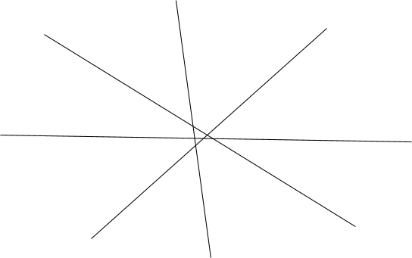Caption: This figure floats (hopefully).

Having the caption[10] in the next paragraph should give the same result



Caption: This figure floats (hopefully).

Same without caption:



But inline, anchored inside the text stream should result in anchored margin figure: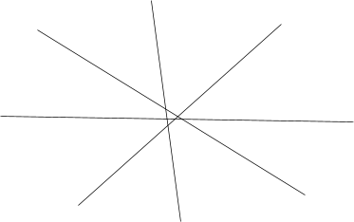

That is, as long as it isn’t too big, because large figures will be assumed to be intended as freestanding 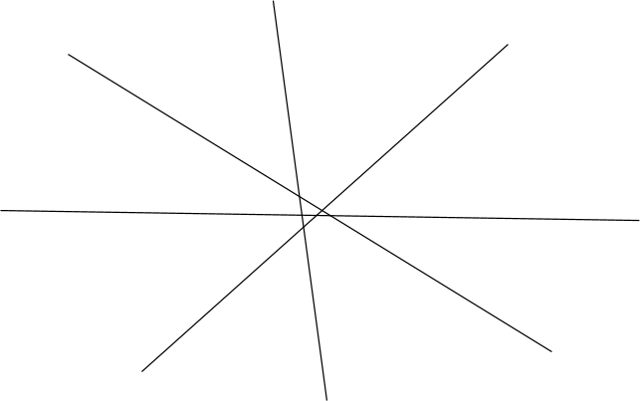 figure.

Fixed position figures should always float:

This fixed position figure in this document should float.



Caption: This figure floats (hopefully).

Having the caption in the next paragraph should give the same result



Caption: This figure floats (hopefully).

Fixed position Same without caption:



These oversized figures should snap to extra margins:

This inline figure in this document should float.

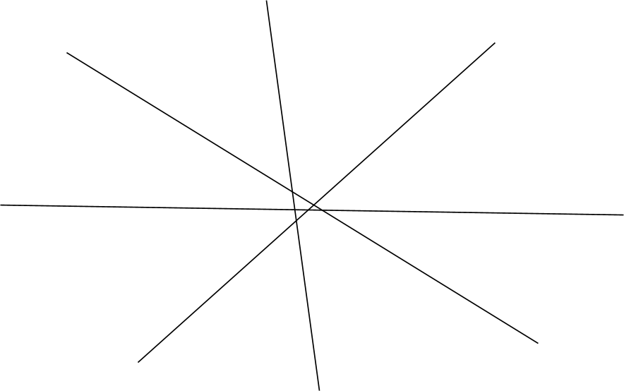Caption: This figure[11] floats (hopefully).

Having the caption in the next paragraph should give the same result

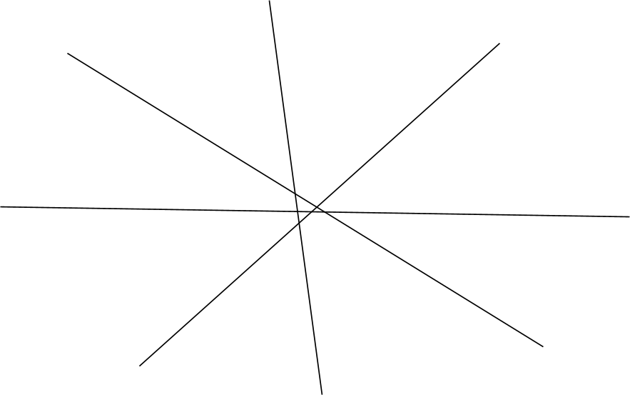

Caption: This figure floats (hopefully).

Same without caption:



# Page Break Tests

This is the first page.

And this is the second page.

## HEADINGS CAN ALSO HAVE PAGEBREAKS

third page

# Finally, some slightly malformed stuff

The next heading is just two figures and a space:

## 

##### A list of

###### headings

|  |
| --- |
| This table just has a single column with a level5 heading |

# 

1. And a footnote.
2. Some Footnote text! With **bold, *italic,*** a raw url <http://www.lshift.net> and weird symbols: Ω≈.

   Also, this Footnote has two paragraphs!
3. [One more for the road!](http://www.lshift.net#test%202)
4. This is a caption footnote.

   It has a **second** paragraph.
5. This is a table footnote!

   With two paragraphs even!
6. With its own footnotes of course.
7. With its own footnotes and caption footnotes
8. (not round at all)
9. Well, to be precise its more a rectangle.
10. which has a footnote
11. (oversized)