

Πανεπιστήμιο Πειραιώς – Τμήμα Πληροφορικής
Πρόγραμμα Μεταπτυχιακών Σπουδών
«Πληροφορική»

Μεταπτυχιακή Διατριβή

Τίτλος Διατριβής | (Ελληνικά)  Στοχευμένες καμπάνιες χρησιμοποιόντας τις δυνατότητες των κινητών συσκευών  (Αγγλικά)  Targeted Campaigns Using the Power of Mobile Devices
Ονοματεπώνυμο Φοιτητή | Ιωάννης Κοζομπόλης
Πατρώνυμο | Χρήστος
Αριθμός Μητρώου | ΜΠΣΠ 15036
Επιβλέπων | Ευθύμιος Αλέπης, Επίκουρος Καθηγητής

Ημερομηνία Παράδοσης | Μήνας Έτος

Τριμελής Εξεταστική Επιτροπή

(υπογραφή) | (υπογραφή) | (υπογραφή)
Όνομα Επώνυμο  Βαθμίδα | Όνομα Επώνυμο  Βαθμίδα | Όνομα Επώνυμο  Βαθμίδα

Table of Contents
1. Abstract 5
2. Introduction 5
2.1 What is a campaign and how we could apply using information technology? 5
2.2 Gathering information using Mobile Devices 5
2.3 Design Campaigns using WEB Application 6
3. Field Review 6
3.1 Hiscox’s B2B Location-Based WiFi Campaign 6
3.2 Paramount’s Shrek Display Ad Campaign 7
3.3 Campaign tool – TargetEveryOne 7
3.4 Campaign tool – Autopilot 7
4. Presentation and Application Use 8
4.1 General Description 8
4.2 Android Application 9
4.3 Web Application – Admin Tool 21
5. System Architecture 30
5.1 Implementation structure 30
5.2 Implementation and Design Tools 32
5.2.1 Netbeans IDE 8.2 32
5.2.2 Android Studio 33
5.2.3 Microsoft Visio 34
5.2.4 Git 35
5.2.5 Genymotion 36
5.2.6 pgAdmin 4 37
5.2.7 Postman 38
5.2.8 Google Chrome – Developer Tools 39
5.3 Programming languages and Frameworks 41
5.3.1 Java 41
5.3.2 Javascript 41
5.3.3 Bootstrap 41
5.3.4 Maven 41
5.3.5 Spring Boot 41
5.3.6 Android SDK 41
5.4 Database Architecture 41
5.5 UML Diagrams 41
5.6 Special Code Sections 41
6. Conclusions and Future Extensions 41
7. Bibliography 41
8. Annex 41

Abstract
We all know about the advertisement campaigns or simple campaigns. In our days, it is the most profitable way for promotional activities, sharing content and attracting interest. The central idea is a series of messages that aim to convince and urge the users. The dissertation focuses on the power of mobile devices and how that can be exploited in order to design targeted campaigns. A mobile device is possible to provide useful information about user activities, interests and location. Imagine a mobile application that has the ability to recognize the exact location every time a user accesses the location service. Furthermore, think how easily a mobile application could access personal data, activities, education and interests from social media such as Facebook. There is a way to incorporate all of these features into one large company mobile application. The application will save this information in a database. An admin tool will manage this data in order to design targeted campaigns for these users. By having a lot of information, we could increase the effectiveness of the campaigns. Also, the campaigns will not be disturbing and they will be appealing to the right users.

Introduction

What is a campaign and how we could apply using information technology?
Campaign defined a series of coordinated activities, such as public speaking and demonstrating, designed to achieve a social, political or commercial goal. By using the information technology is possible to gather useful information. The information could be analyzed and studied in order a system recognize future activities. Furthermore, it is able to target specific segment, depending on the collected information. Imagine a target group extracted, by a specific location or specific studies and working experience. Also, the technology could help on scheduling and automating campaigns with dynamic content.

In the current dissertation, is described a method to collect specific information from the users using mobile devices. Specifically, it has been developed a Mobile Application, that contains features and services, which are collecting the specific data. Additional, it has been developed a WEB Application, which is capable to create specific segments. The segments can be targeted from campaigns. The campaigns can be scheduled at specific date/time and send specific text to the mobile users, who are using the Mobile Application. The users are able to receive the specific content via push notification. So, the current dissertation implements the central idea of the campaigns. That is, a series of message that share a single idea and theme which make up an integrated communication. Furthermore, it is targeted campaigns using the power of mobile devices. Such campaigns, are more efficient and not annoying.

Gathering information using Mobile Devices
Every person has at least a mobile device. The mobile devices are used for communication. However, the evolution of the smartphones has change our life. Such devices integrate many sensors and useful applications. The sensors give us information such us, user location, environment temperature, speed and lightness. Also, there is possibility to be developed a mobile application, which will access information from user’s social media account. The social media accounts can provide useful information such us, interests, origin, working experience and personal data.
According to these possibilities, it has been developed a Mobile Application, which exploits these features. Specifically, the application runs a service that recognize the location coordinates every time the GPS is enabled. Also, scheduled jobs save the last location in a database. The application has been implemented with Facebook login. The Graph API is used in order to access the useful information that is mentioned above. In conclusion, it is provided communication via push notifications. This communication channel is used in order campaigns interact with the end user.

Design Campaigns using WEB Application
A WEB Application is an application that is running on a WEB Server. The WEB Server can be accessed from the Internet. So, the clients could interact with the WEB Application from the Internet. Such applications, are consisted from WEB Services. A WEB Service help the application to communicate with other applications. By developing WEB APIs is possible the interacting between a Mobile Application and WEB Application. Also, the WEB Applications are able to provide high performance, complex services, data protection, storage data, dynamic operation and remote access using a simple web browser.
According the above flexibility, it has been implemented a WEB Application. The application provides WEB Services, which have the ability to save data in a database, authenticate the users and send push notifications. An admin tool is available as WEB page. The administrator can use filters to create specific segments from registered users. The segments are created by the useful information that is collected from the Mobile Application. The administrator could use the segment in order to design a campaign to be executed for specific users. Another feature, is the campaign creation. The administrator could schedule a campaign to run at specific date/time using a specific segment of users in order to send a specific message via push notification.

Field Review

Hiscox’s B2B Location-Based WiFi Campaign
Hiscox, is an international specialty insurance company. The company has launched a location-based WiFi campaign in the United Kingdom that integrated mobile display ads with an existing outdoor board campaign.
When businesspeople logged on to public WiFi in the vicinity of one Hiscox’s outdoor boards, they were greeted by a digital ad on their browser start-up screens that correlated with the existing outdoor boards in the immediate vicinity. In other words, if they logged on to the internet while sitting at a restaurant in Covent Garden, the ads on the start-up screen matched the ads on the nearby outdoor boards. Both the internet ads and outdoor boards were specifically designed for people who were located near Covent Garden. The result was a double impact: first on the outdoor boards that were strategically located near the WiFi hot spots, and the second on the start-up screen that greeted people accessing the Internet using their smartphones, laptops, or tablet computers.
How did the campaign perform? Like gangbusters. The click-through rates on the location-based WiFi campaign were five times higher than the company’s average rate for traditional online display ads.

Paramount’s Shrek Display Ad Campaign
Over 50 mission people visit Yahoo!’s mobile home page each month, which is about 1.5 million visits per day. Regarding the high volume of traffic decided the creation of a “rich-media” campaign around the release of the latest Shrek movie.
Visitors to Yahoo!’s mobile home screen were able to see Shrek’s head along the bottom of their smartphone screens. When the people touched the top of Shrek’s head, the character would pop up and fill the whole screen. If they tapped Shrek’s head again, they would be redirected to the mobile microsite where they could buy tickets or see more information about showtimes.

Campaign tool – TargetEveryOne
TargetEveryOne is a cloud based admin tool that easily could be used from large scale companies. The companies could design scheduled campaigns and communicate via major channels such us, Social Networks, SMS, Email, Mobile Apps and QR Codes. The idea is to recruit the valuable customers into a database, add segment which is filtered valuable contacts based on their preferences and interaction behaviors over time, create digital marketing campaigns using drug-and-drop action based interactive module, choose the preferred communication channel and analyze statistics to help you facilitate successful marketing strategies.

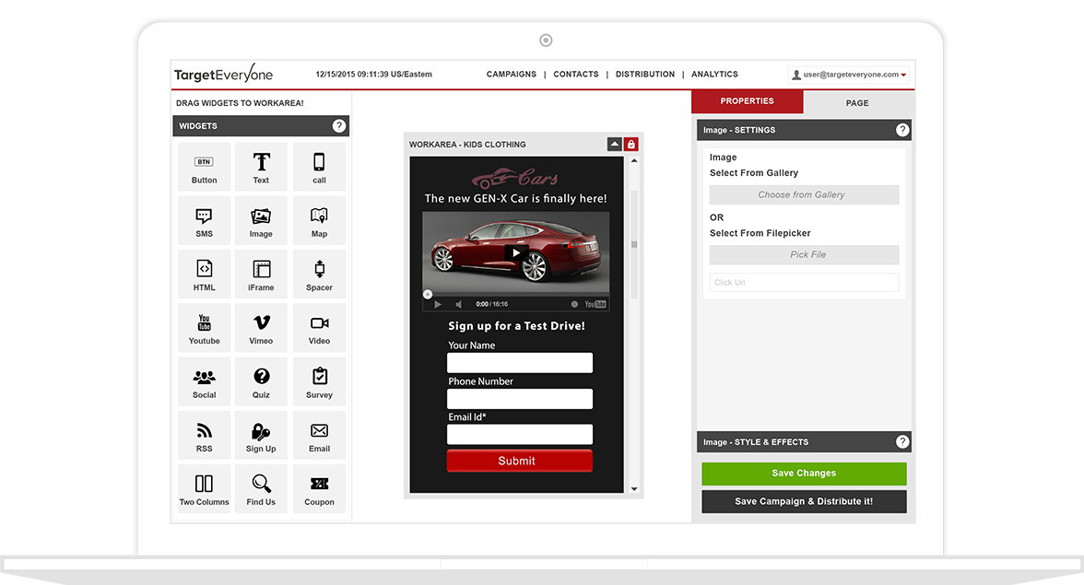

Campaign tool – Autopilot
Autopilot is a cloud based tool for design targeted campaigns. The tool is able to create campaigns that could support marketing journeys. The campaigns could be designed with multiple flows, which could interact with user inputs, in order to decide dynamically the next marketing actions. The campaigns could use communication channels such us emails, Headsup messages, SMS and Postcards. All contacts imported and organized into lists, smart segments, and folders. So, the target segment is created dynamically and matched any combinations of field values and behaviors.
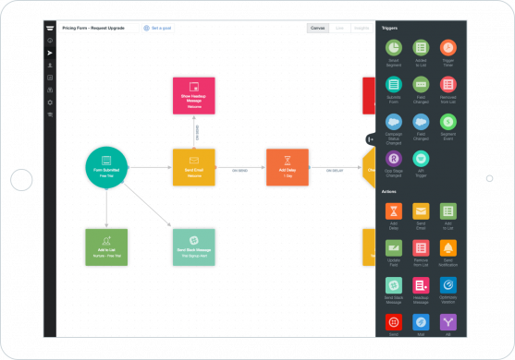

Presentation and Application Use

General Description
The implementation includes two different applications. It has been implemented an Android Application and a Web Application.
The Android Application is a simple mobile native application that includes custom login, registration flow, facebook login, retrieve facebook data feature and custom location-service, which recognize user’s last known location. The Android Application does not include any other operation. Imagine that it is a commercial mobile application from a large-scale company and integrates all the above login flows and the services that have been implemented. Using the custom location-service the application could update the user’s last known location. The service it has designed to recognize whenever the GPS is enabled in order to retrieve the location. A scheduled job updates the last known location in a remote database using a Web service. Using the facebook login, the application is able to retrieve a lot of information from facebook Graph API about the user. The different data from facebook login are recorded into a database using different Web services.
The Web Application includes Web services and Admin Tool web page. A lot of Web services are used from Android Application in order to save useful data on the database. The Admin Tool is a web page that the user could design segments to target specific users. The segments are designed via filters that access the information from every user in the database. The Admin Tool provides also the possibility of creation simple notification campaigns. This operation aims to schedule simple notifications to be sent to android mobile devices that they are using the Android Application. The simple notification campaigns are configured for specific users target groups (segments) and specific execution time.

Android Application
The Android Application could be installed on Android Smartphones. The login screen appears, when the user opens the application from the menu. The user could use two login methods, the custom login or facebook login. For custom login user should fill with valid username, password and then presses the login button. For facebook login user should press simple the facebook login button. If the user does not exists in the database, he could register a custom account by pressing the “Don’t have an account? Register Here”, or he could simple continue pressing the facebook login button. By using the facebook login the registration comes true automatic.

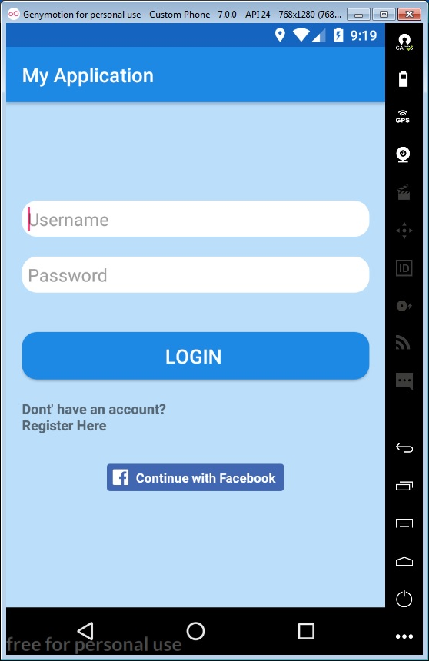
Figure 1: Android Application - Login screen

The custom login returns invalid message, while the user is trying to login with invalid credentials. A message appears on the bottom of the screen with the text “Invalid username or password”.
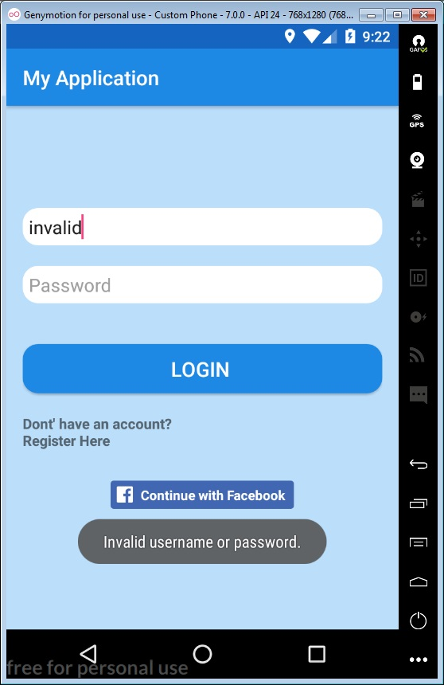
Figure 2: Android Application - Login screen invalid username
The user could create new custom account by pressing “Don’t have an account? Register Here”. If the user presses the text, the application will leave the current screen. The user will be redirected to the first register screen. In the register screen, the inputs with the username and password should be filled. By pressing the “NEXT” button the system uses a Web service in order to validate that the username is not used from another user. If the username is unique then the user is redirected to second registration screen, else an invalid message informs the user that the current username exists in the database.

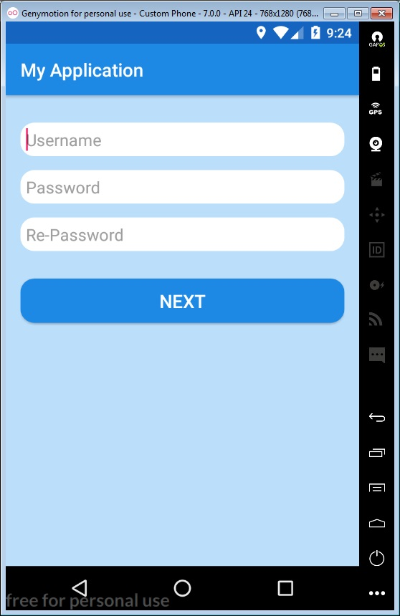
Figure 3: Android Application - Registration screen 1

The invalid message “The username exists” is appear, while the user is trying to register username that exists in the database.
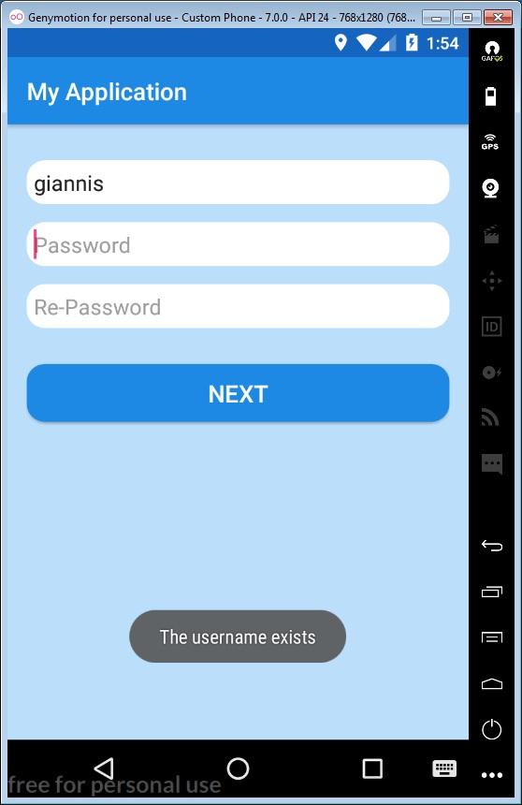
Figure 4: Android Application - Registration screen 1, username exists

The second registration screen includes inputs that the user could fill a few personal data. The inputs include name, surname, email and mobile. The user should press the register button in order to register his account. The user will be redirected to the central screen of the application and the credentials with the given information will be saved on the database using a specific web service.

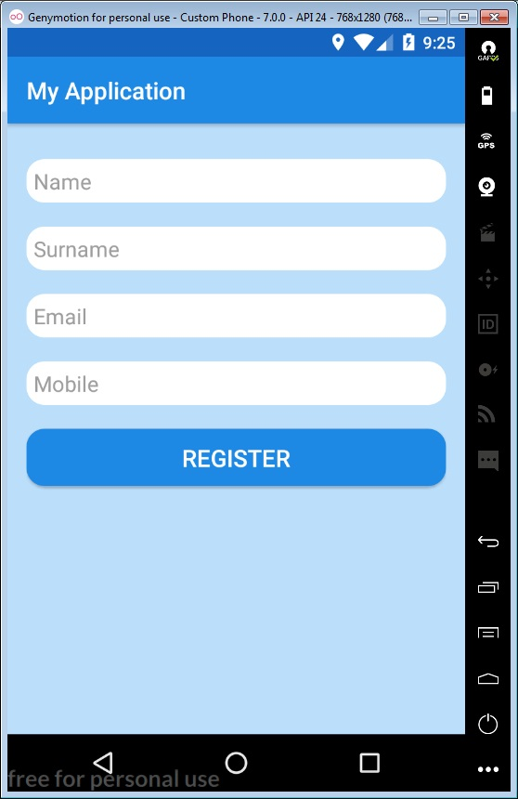
Figure 5: Android Application - Registration screen 2

The user also could register or login automatic from the login screen pressing the facebook button. By pressing the button a facebook interface opens on the screen. The user should fill the facebook credentials and presses login. Then a second page of facebook interface will ask the user to accept, that the application will use him account and will retrieve some data.

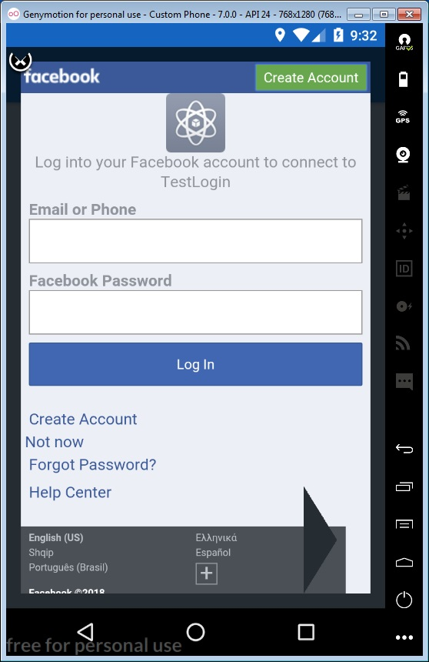
Figure 6: Android Application - Facebook login

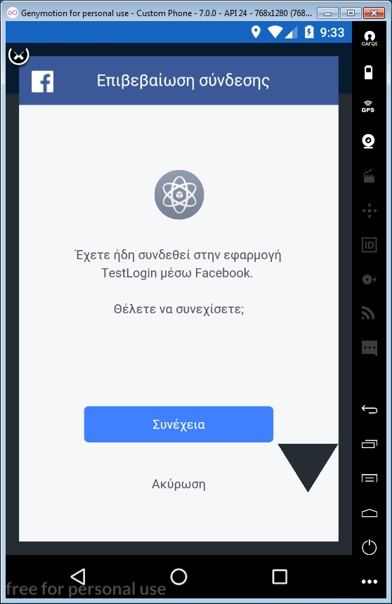
Figure 7: Android Application - Accept Facebook Application

The user either login via custom login, either facebook login he will be redirected to the central screen that will start the application. The central screen does not contain something. As discussed above, the application contain only the features that will be integrated in an commercial application in order to provide the implemented services.

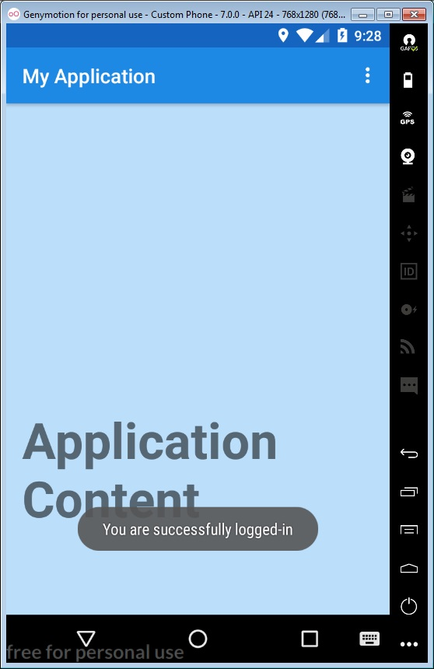
Figure 8: Android Application - Central screen

An option menu has been implemented in the central screen. The menu contain a few operations. The Show Personal Data returns the registration info from the user. The Get Last Location returns the last known location that has been detected from the custom location service. The Enable Location Detection enables the custom location service. The Disable Location Detection disable the custom location service. The Logout logout the user from the application.

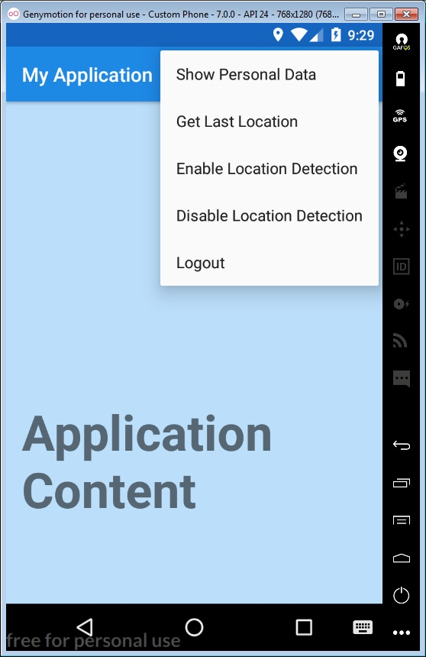
Figure 9: Android Application - Options menu

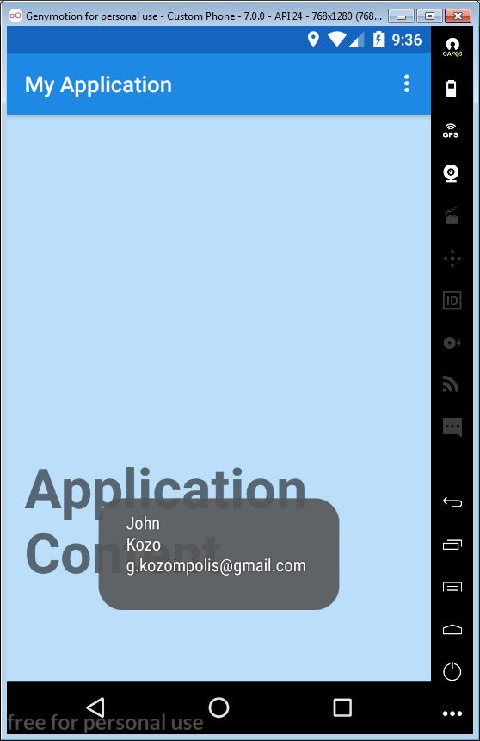
Figure 10: Android Application - Show registration data
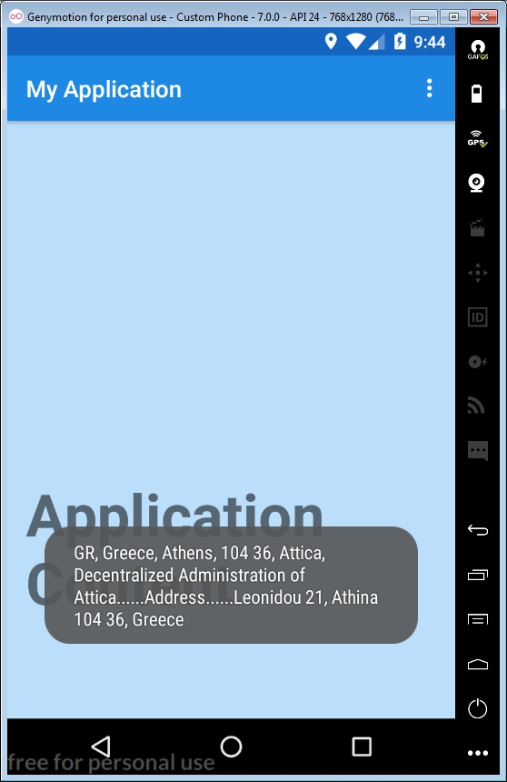
Figure 11: Android Application - Get Last Location
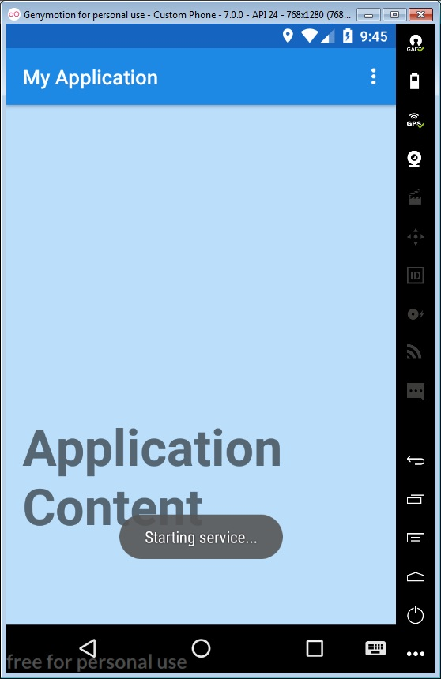
Figure 12: Android Application - Start Service

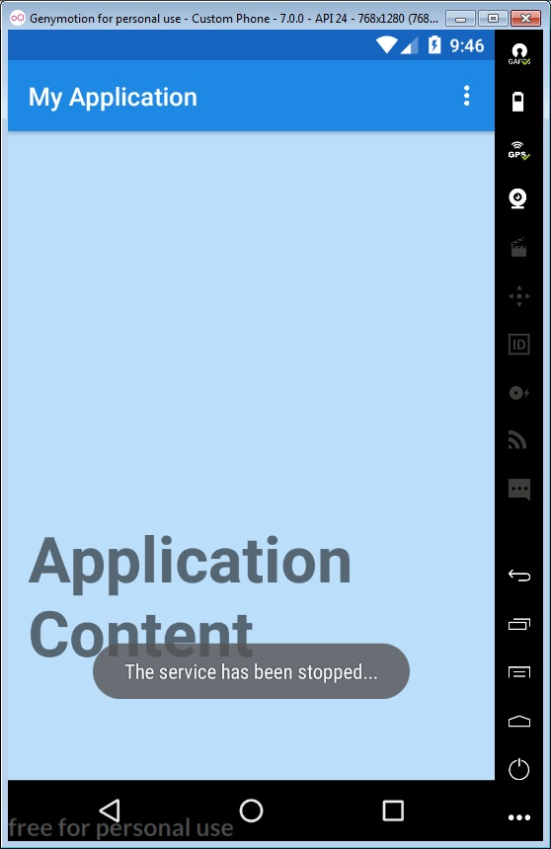
Figure 13: Android Application - Stop service

Web Application – Admin Tool
The WEB Application consists of the Admin Tool and Web services. The admin tool opens in browser as web page. The Admin Tool provides segment creation using dynamic filters and campaign configuration.

Right of the page is appear a menu when the user navigates to the web page. The user can navigate to segmentation page by pressing “Segments” on the right menu. Bellow you can see the segmentation page. The page contains a list with the available segments. By pressing “New Segment” button, the user has the possibility to create new segment. The segment is a group of users, which is created using data that are collected from Android Application. The segments are necessary for campaign configuration.
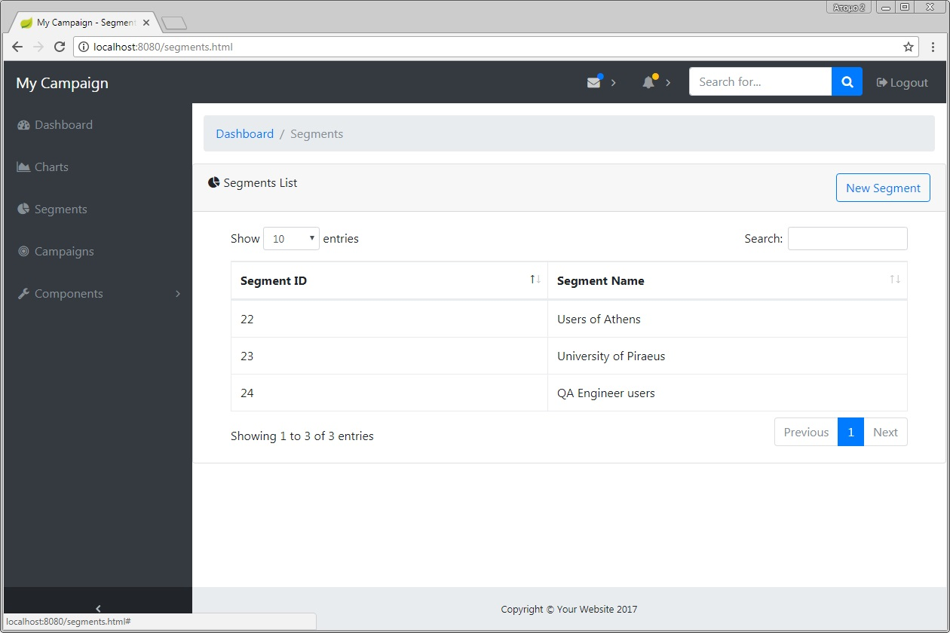
Figure 14: Admin Tool - Segmentation page

The user can configure a segment at the new segment section. The first configuration is to fill the name and the description of the segment. The “Target Location” section contains filter, where the user could select specific location. The filter consists of five steps:
- Country
- Department
- Prefecture
- City
- Postal Code

The user can select or not-select item in every step. The selected options return dynamic choices in every step.
e.g. “If the user selects Greece as country option, the next step filter will contain departments only from Greece”.
The “Target Work Info” section contains filters that the user could select target group from specific employers and work positions. The filter consists of two steps:
- Employer
- Position
The “Target Education” section contains filters that the user could select specific education experience. The filter consists of three steps:
- School
- Degree
- Year

The “Extra Information” section contains 5 simple filters:
- Books: Is used to recognize users, who prefer particular books
- Teams: Is used to filter users, who support a particular sports team
- Events: Is used to filter users, who are interest for particular events
- Music: Is used to filter users, who listen particular music
- Pages: Is used to filter users, who like particular pages on facebook

All the filters can be used in order to create a segment. In multiple selection, the segment is created with logic AND. Bellow is a configured segment that contain users from Department of Applied Information and Multimedia of Crete.

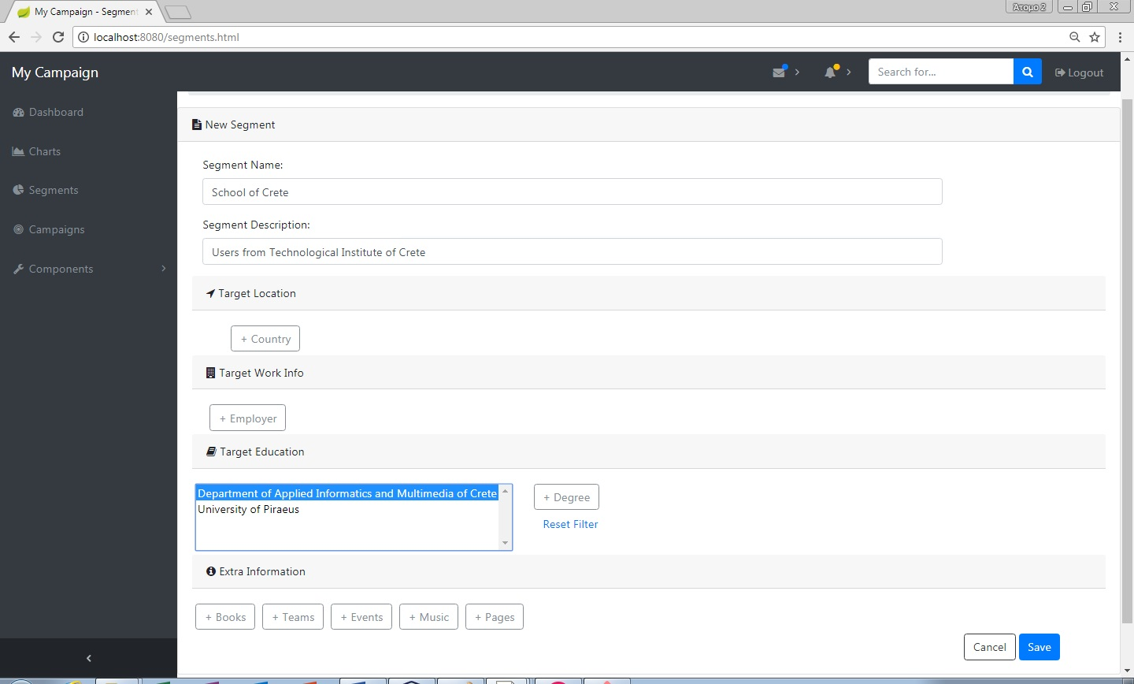
Figure 15: Admin Tool - New Segment

Bellow is a configured segment that includes users who live in Peloponnese:
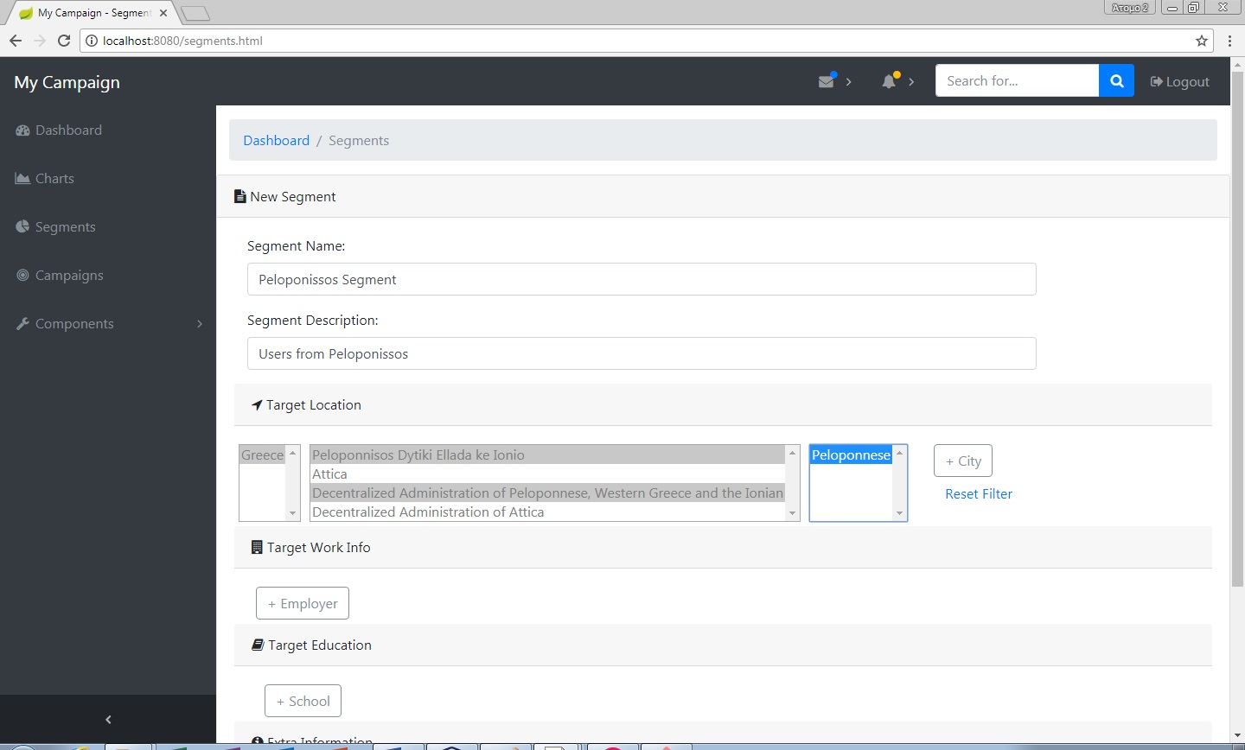
Figure 16: Admin Tool - Peloponnese segment
If the user fills the name and description inputs, he could save the segment after the filter selection. If the segment saved successfully the bellow success message will be displayed “Success! The segment has been tested successfully”.

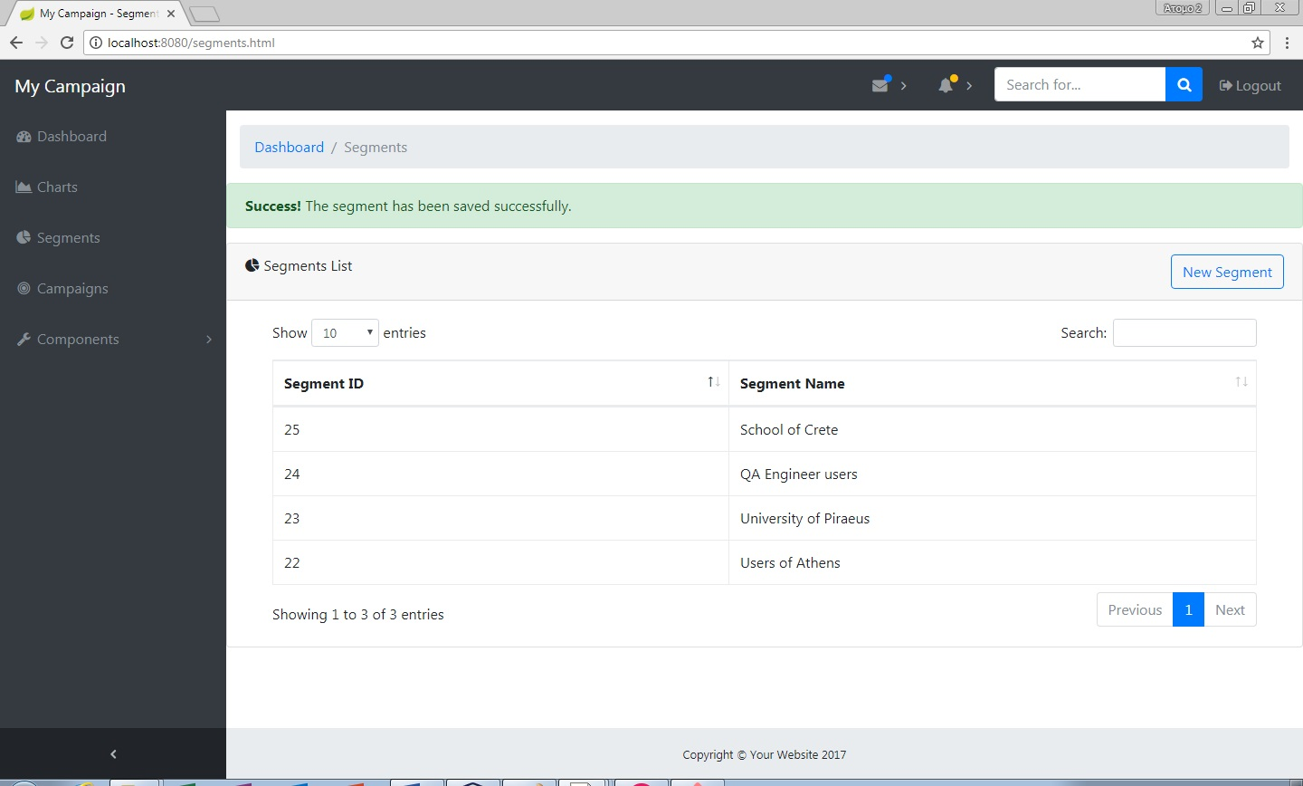
Figure 17: Admin Tool - Segment success message
The campaigns can be created from the Campaign section. The Campaigns page includes a list with the configured campaigns. The user can edit a campaign where is not active. The Activate button enables the campaign in order to be executed on the configured time. The details button shows the configuration of the campaign. The New Campaign button contains different types of campaigns. Only Simple Notification campaign has been implemented, about this dissertation.

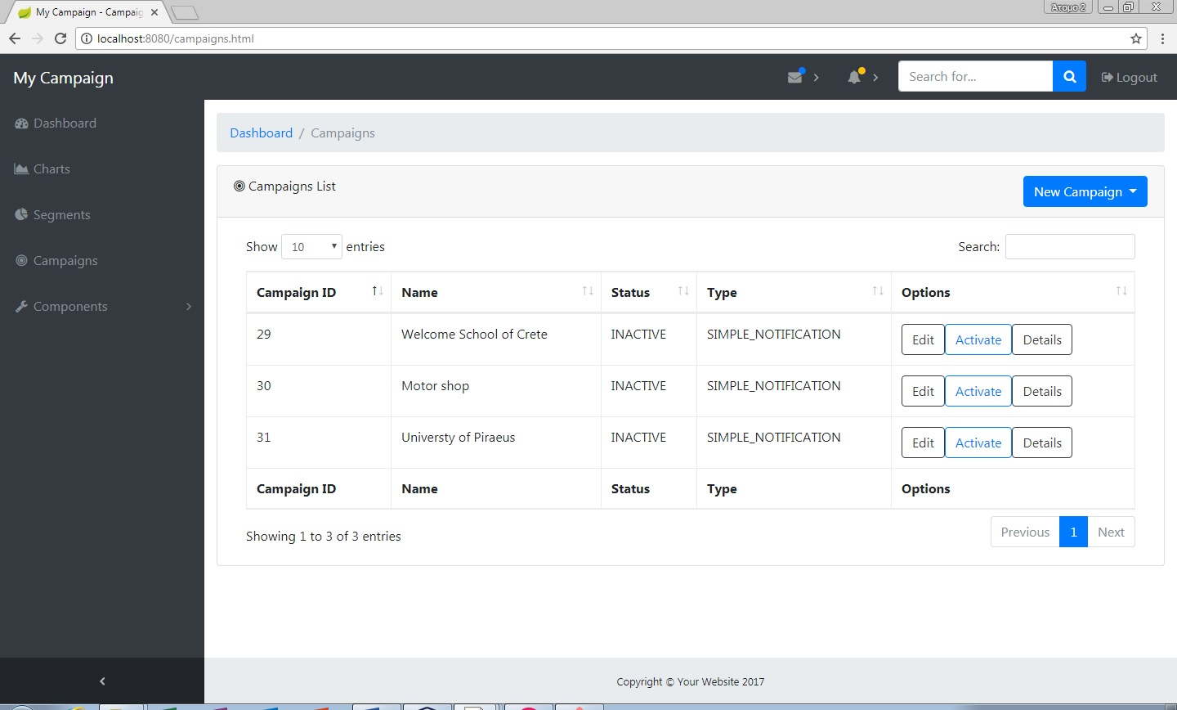
Figure 18: Admin Tool - Campaigns Page

By click on New Campaign button and then Simple Notification the user could create a new campaign of type Simple Notification.
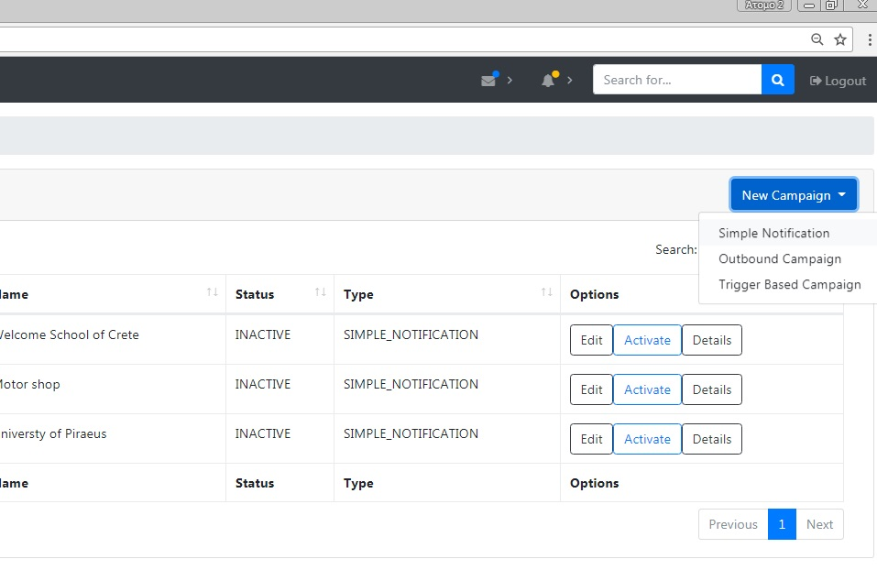
Figure 19: Admin Tool - New Campaign button

When is selected to create new Simple Notification campaign, a new section appears for configuration. The user should fill the name and description of the campaign.

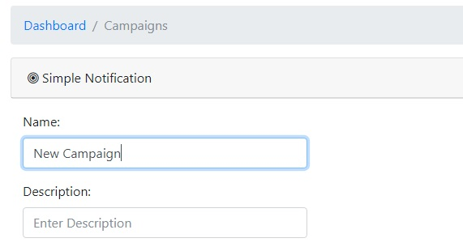
Figure 20: Admin Tool - Campaign name and description
The next configuration is to be selected the specific segment that the campaign will target. The segment can be selected from the Select Segment section.

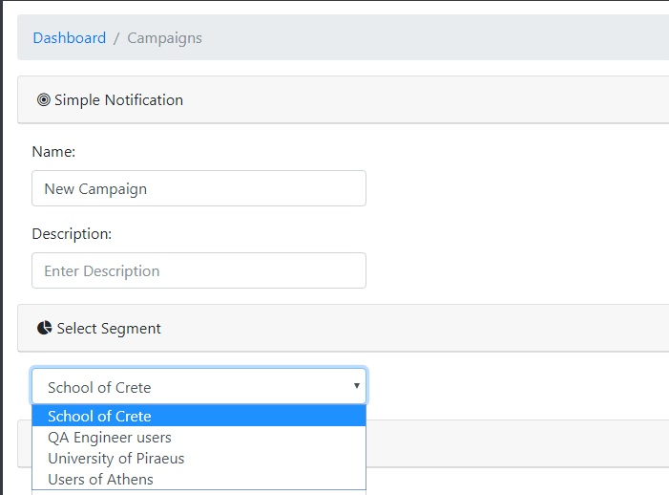
Figure 21: Admin Tool - Select campaign's segment

The next configuration is to select the execution time that the campaign will executed:

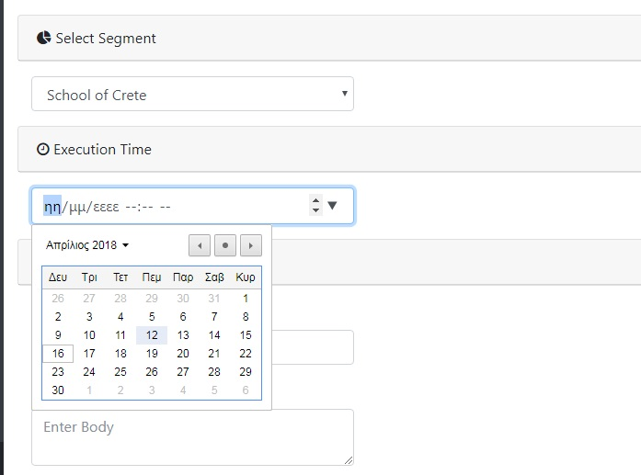
Figure 22: Admin Tool - Campaign's execution time

The last step is to fill the title and the body of the notification and save the campaign. The notification is sent to the Android Mobile users who use the Android Application and included in the chosen segment. The segment is created in Segments page as described above:

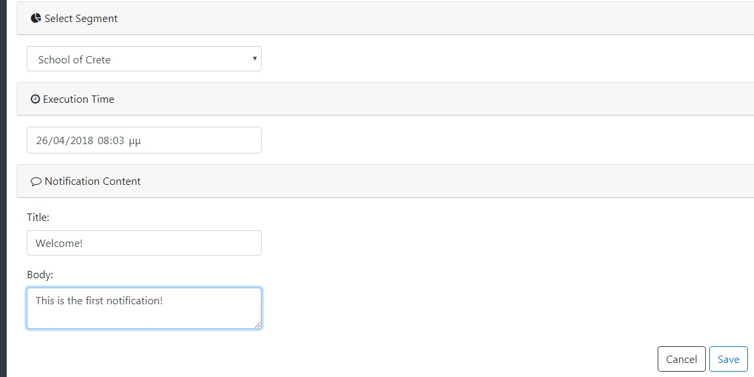
Figure 23: Admin Tool - Campaign's Notification Content

Bellow you can see the details of a configured campaign:

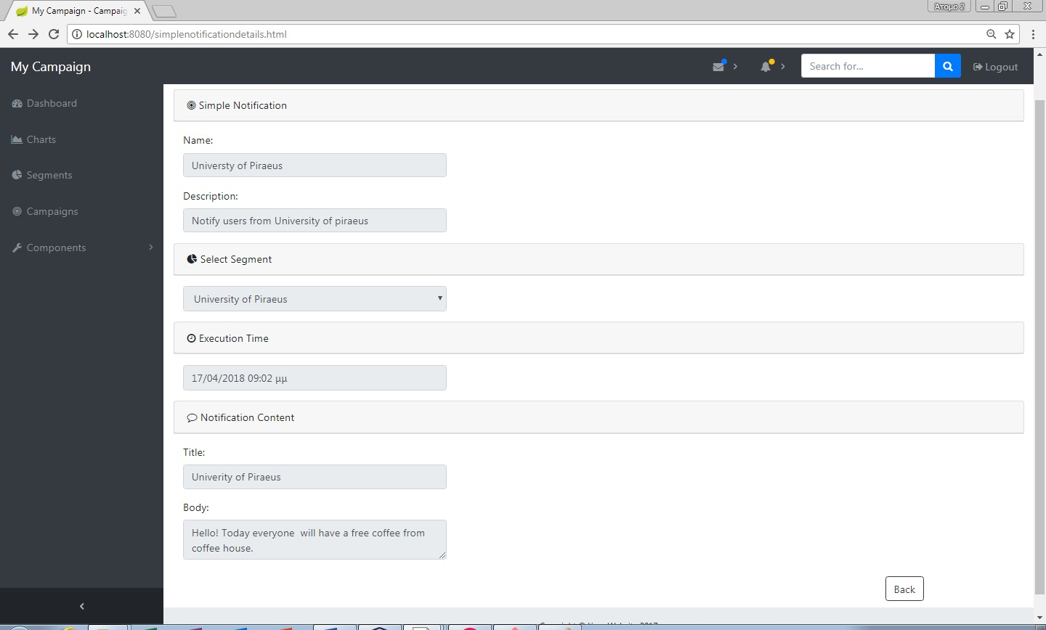
Figure 24: Admin Tool - Campaign Detail Section

When the configuration is completed the user can activate the campaign by pressing the Activate button in the Campaigns page. Then all the users who contained in the chosen segment will receive the notification on their mobile devices.
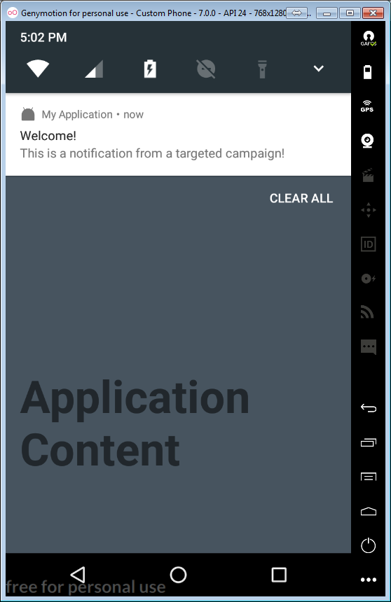
Figure 25: Android Application - Received Notification

System Architecture

Implementation structure

The implementation consists of two applications. An Android application has been developed to run on mobile devices. Also, a Web Application has been developed in order to provide specific Web Services.
The Android Application is installed on mobile devices. The application is using the internet connection provided by Wi-Fi Network or Mobile Network, in order to communicate with the Web Application. By the internet connection the Android Application is able to access all the needed Web Services. The application needs internet connection to work. A service has been developed that is running in background mode on Android OS, which is recognize whenever the GPS sensor is enabled. In separate time sections the service saves the last known location locally. A scheduled job uses a Web Service, which uploads the last location on the database, when the internet connection is on. The application also has been developed to support facebook login. The application exploits the facebook Graph API. By graph API is able to access information about user facebook profile and facebook activity. The application uses Web Services in order to upload this information in the database. Every android application is connected with the firebase cloud messaging service.

The Web Application has been installed on a Web Server, which is accessible from the internet connection. Direct the network the Web Application communicates with the database. All Web Services are implemented on this application. Also, the web page of Admin Tool is hosted on the Web Server. The web page could be accessed from a simple web browser over the internet network. The cloud messaging service is used from the Web Application in order to send simple notifications to the mobile devices.

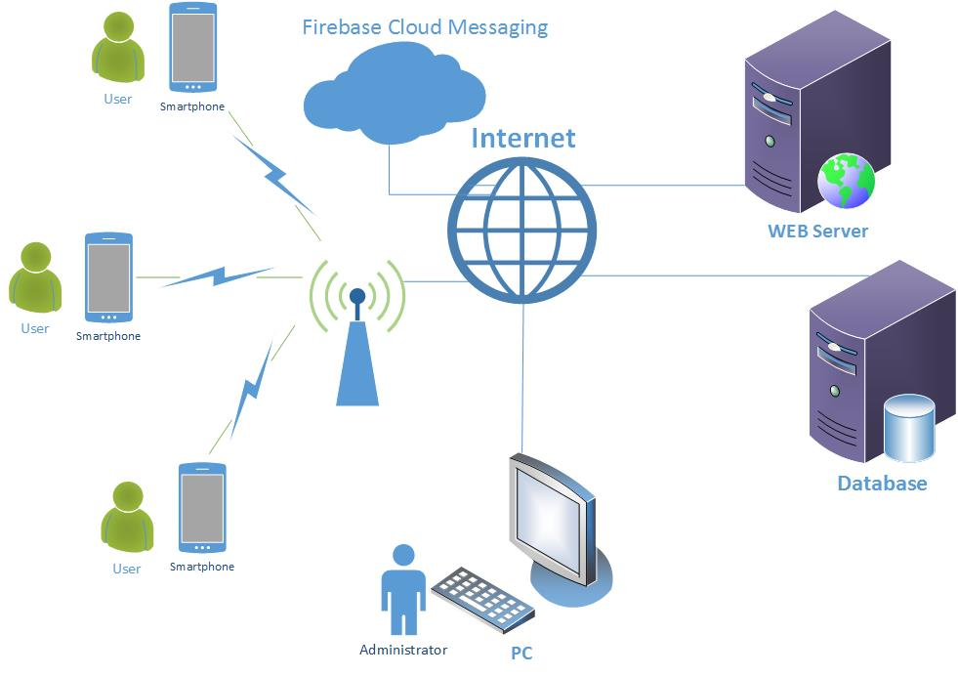
Figure 26: Implementation Structure - Implementation Diagram

Implementation and Design Tools
The tools that were used in the whole implementation are the bellow:
- Netbeans IDE 8.2
- Android Studio
- Microsoft Visio
- Git
- Genymotion
- pgAdmin 4
- Postman
- Google Chrome – Developer Tools

Netbeans IDE 8.2
Netbeans is an integrated development environment (IDE) for Java. Netbeans allows applications to be developed from a set of modular software components called modules. Netbeans runs on Microsoft Windows, macOS, Linux and Solaris. In addition to Java development it has extensions for othe languages like PHP, C, C++ and HTML5, Javadoc and Javascript.

The Netbeans IDE has been used in order to write and compile java code about the Web Application. The Netbeans provides a lot of useful frameworks (like maven), web servers (like Tomcat) and Database Services (like JDBC drivers) which are useful for the implementation. The IDE helps the developer to write clear and structured java code. The NetBeans Editor indents lines, matches words and brackets, and highlights source code syntactically and semantically. It lets y easily refactor code, with a range of handy and powerful tools, while it also provides code templates, coding tips, and code generators.

Keeping a clear overview of large applications, with thousands of folders and files, and millions of lines of code, is a daunting task. NetBeans IDE provides different views of your data, from multiple project windows to helpful tools for setting up your applications and managing them efficiently, letting you drill down into your data quickly and easily, while giving you versioning tools via Subversion, Mercurial, and Git integration out of the box.

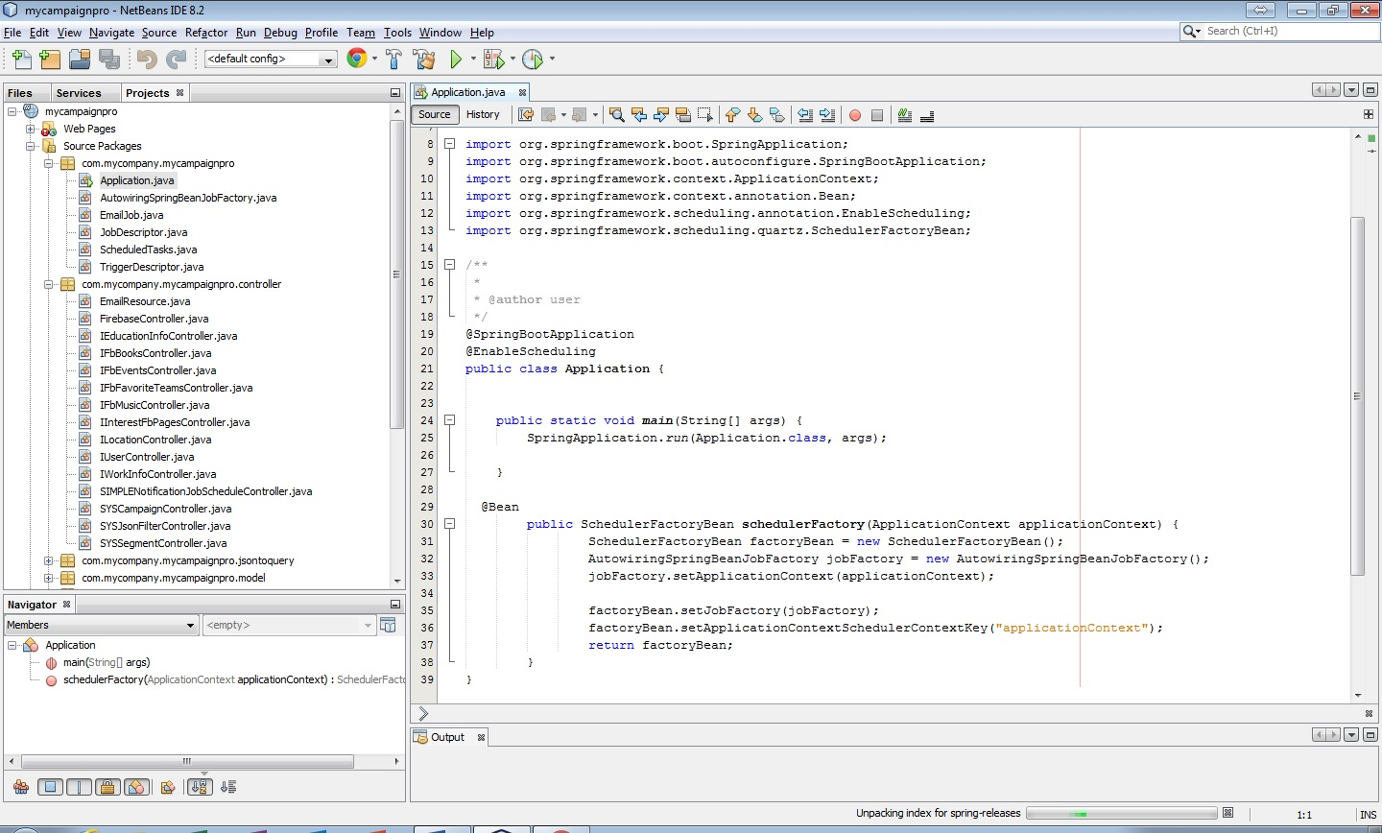
Figure 27: Implement Tools - Netbeans

Android Studio
Android Studio is the official integrated development environment (IDE) for Google’s Android operating system, built on JetBrains’ IntelliJ IDEA software and designed specifically for Android development. It is available for Windows, macOS and Linux based operating systems. It is replacement for the Eclipse Android Development Tools (ADT) as primary IDE for native Android application development.
The Android Studio provides code editors that developer could write correct and structure Java code about Android Application. Android Studio uses Gradle, an advanced build toolkit, to automate and manage the build process, while allowing you to define flexible custom build configurations. The developer could define many dependencies in order to include a lot of libraries which will be used.
Also, the IDE provides layout editor where the designer can quickly build layouts by dragging UI elements into a visual design editor or write the layout in XML by hand. In the design editor, is possible the view of different devices and versions, and designers can resize the layout to be sure it works well on different screen sizes.

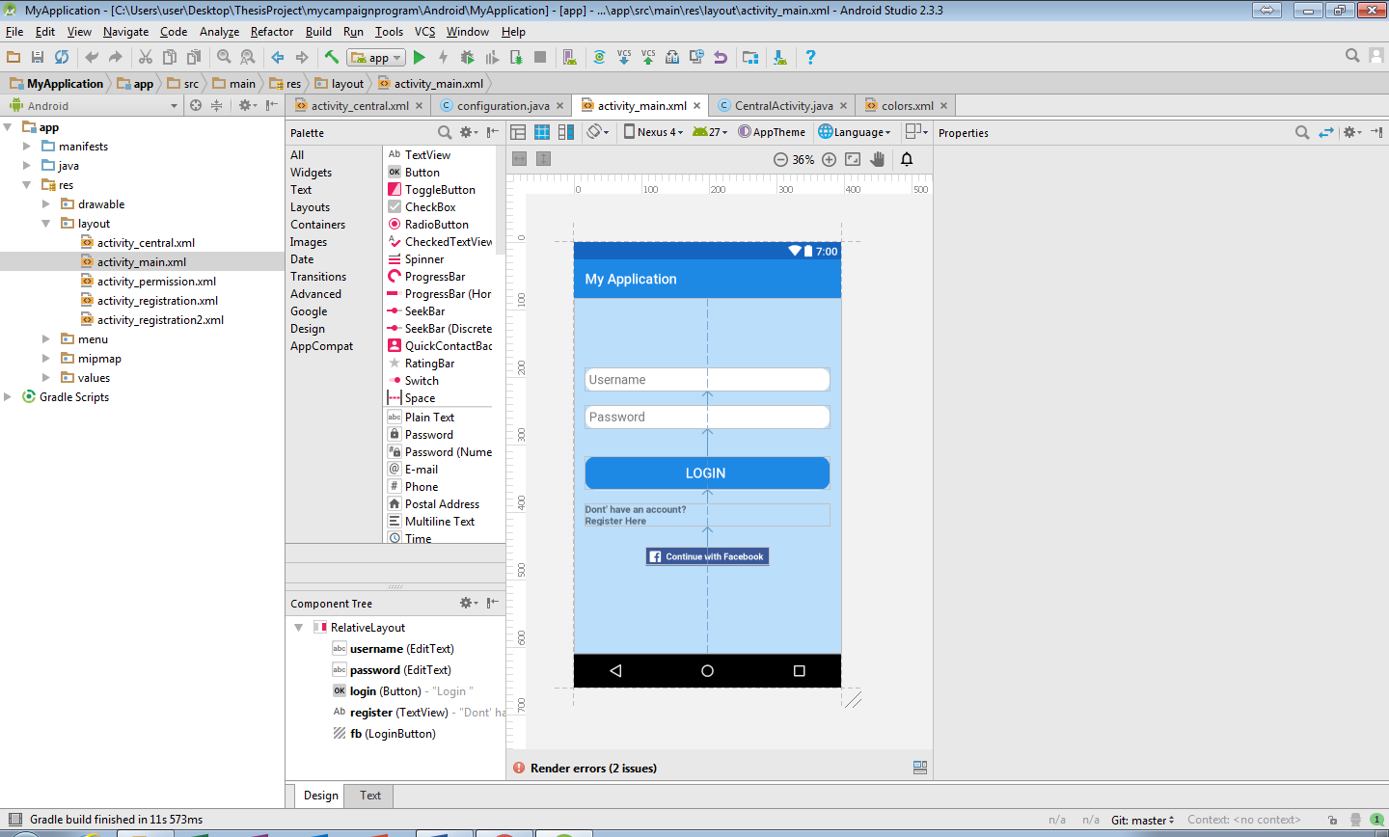
Figure 28: Implementation and design tools - Android Studio, layout editor

Microsoft Visio
Microsoft Visio is a diagramming and vector graphics application and is part of Microsoft Office family. This program supports many different types of diagrams. The diagrams apply to many different specialties. One of them is the software technology. The visio supports all the types of UML diagrams. A software engineer can design all the UML diagrams using the visio. The UML diagrams helps in order to analyze the use cases and design better the application. In the visio a software engineer can design the bellow UML diagrams:
- Class diagrams
- Object diagrams
- Component diagrams
- Deployment diagrams
- Use case diagrams
- Sequence diagrams
- Collaboration diagrams
- Statechart diagrams
- Activity diagrams

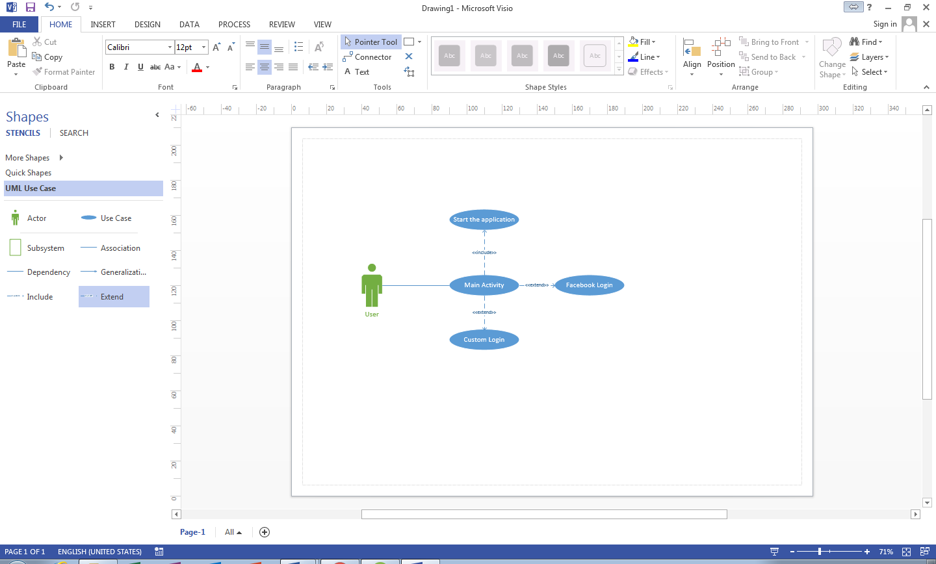
Figure 29: Implement and Design Tools - Microsoft Visio, use case diagram

Git
Git is a version control system for tracking changes in computer files and coordinating work on those files among multiple people. It is primarily used for source code management in software development, but it can be used to keep track of changes in any set of files. As a distributed revision control system it is aimed at speed, data integrity and support for distributed, non-linear workflows.
The git helps developers to save their work in separate versions. This is helpful because many times a specific change or a new feature in the code could affect the other project functionality. The git provides the possibility to return the code versions before in the case that we need it. Also, two or more developers could work together in a project. The only needed is to pull the last changes of the code before the start of their work and push the new changes at the end of their work. The git provides mechanism which avoids conflicts on the committed code in the case that two developers have change the same part of code.
For this dissertation a repository created on https://github.com. The code was committed using the git from two different work PCs.
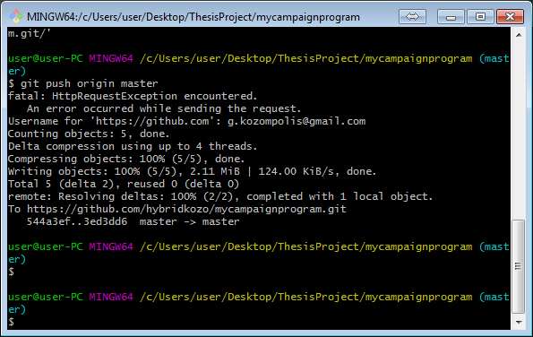
Figure 30: Implement and Design Tools - Git

Genymotion
Genymotion is an Android emulator, which supports a lot of mobile devices and Android OS versions. The emulator is used in order to run the developed applications and test their functionalities in multiple devices and OS versions. The emulation includes all the exist sensors from real devices like location sensor.
The developer or tester can select the preferred device and OS version or create him custom device with a specific OS version. Just choose the configured device and starts the virtual machine. Then he can install the APK and start the application from virtual machine.
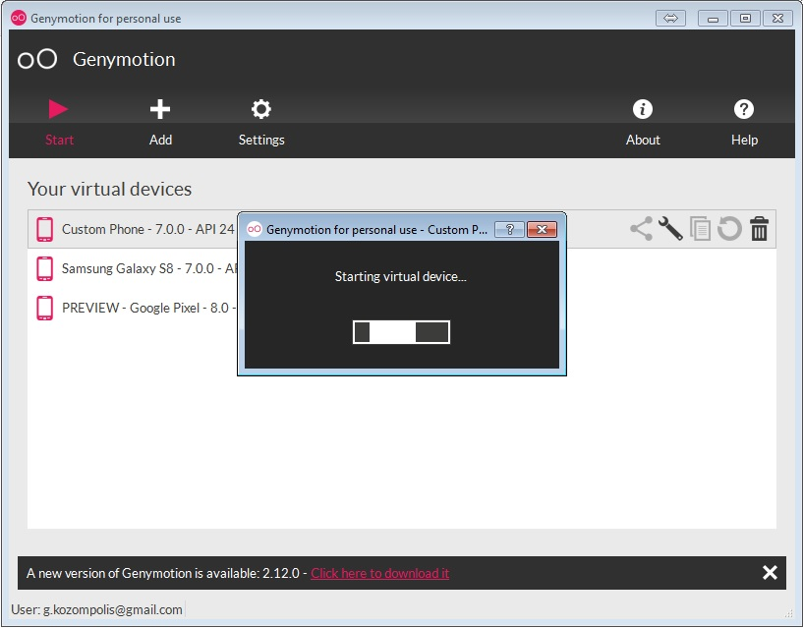
Figure 31: Implement and Design Tools - Genymotion

pgAdmin 4
pgAdmin is a management tool for PostgreSQL and derivative relational databases. It may be run either as web or desktop application. The desktop application has been used on windows for this dissertation.
The pgAdmin application helps a database administrator to connects and manages postgreSQL databases. It is possible to design new tables, columns and relations from user interface without write any SQL script. The administrator can access or update all the tables, the data, the relations, the sequences and everything else having high user experience.
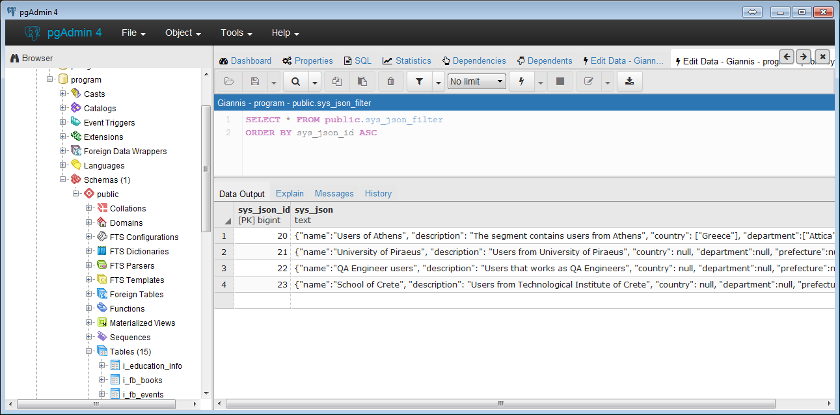
Figure 32: Implement and Design Tools - pgAdmin

Postman
It is a Google Chrome plug-in for API development & testing. You can build, test, and document your APIs faster, and share your work with other team members.
Main Features of Postman:
- Managing API collections, environments, tests and sharing
- Import & export API collections
- Extensive team collaboration tools
- Maintain history of API requests
- Extended API documentation & monitoring features

The postman was useful in order to test the APIs that implemented for the communication between Android Application – Web Application.

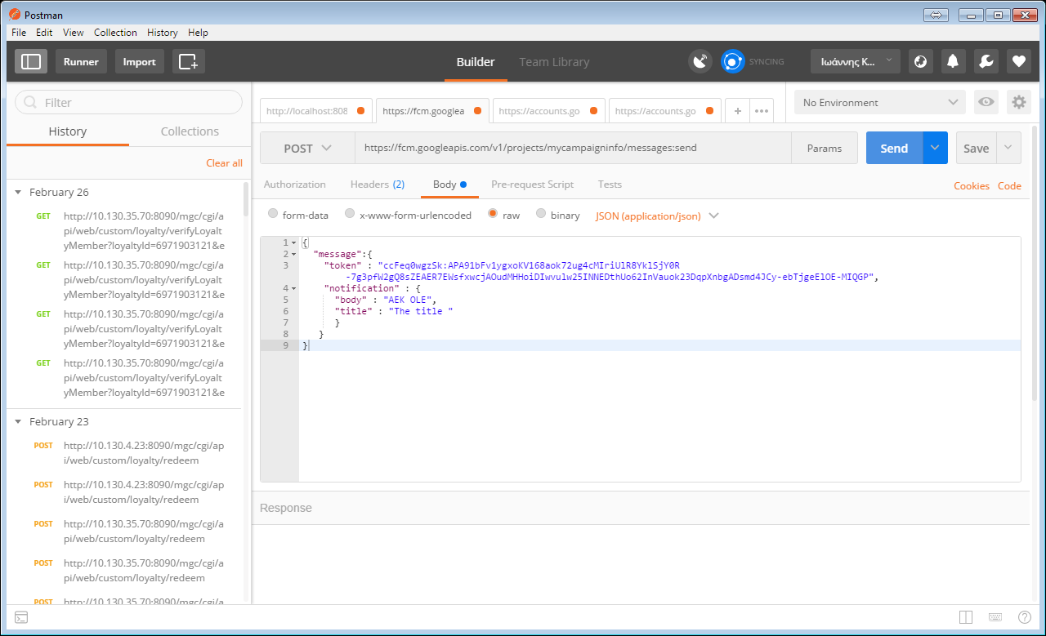
Figure 33: Implement and Design Tools - Postman

Google Chrome – Developer Tools
The Chrome Developer Tools (DevTools for short), are a set of web authoring and debugging tools built into Google Chrome. The DevTools provide web developers deep access into the internals of the browser and their web application. Use the DevTools to efficiently track down layout issues, set JavaScript breakpoints, and get insights for code optimization.
The Dev Tools were used for inspecting HTML DOM elements and the styles, checking errors in console and Javascript debugging.
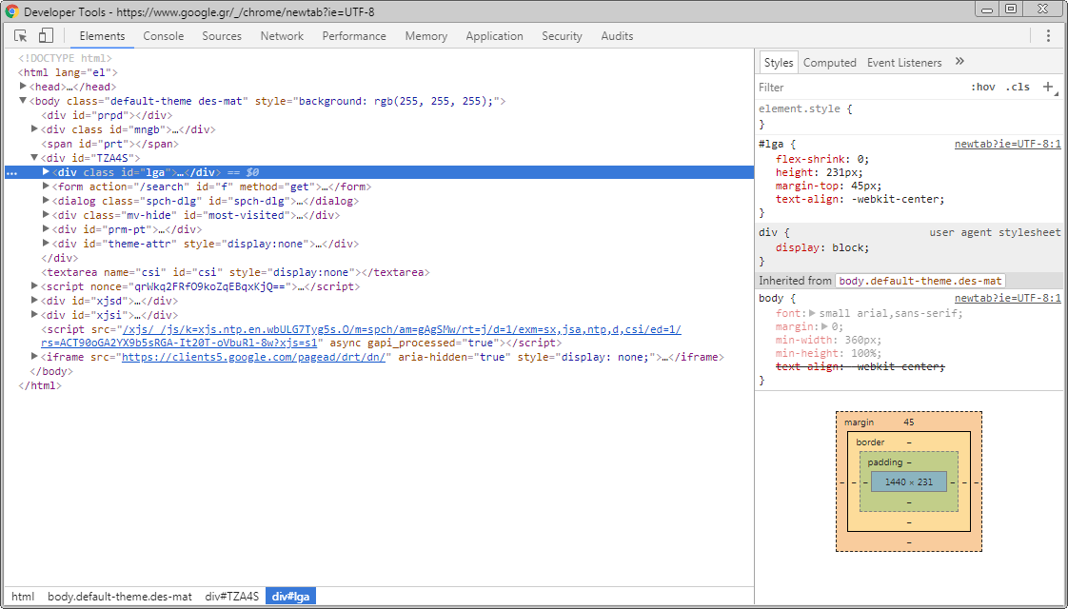
Figure 34: Implement and Design Tools - Chrome Developer Tools

Programming languages and Frameworks

Java
Java is a general-purpose computer-programming language that is class-based, object-oriented and specifically designed to have as few implementation dependencies as possible. The compiled Java code can run on all platforms that support Java without the need for recompilation. Java applications are typically compiled to bytecode that can run on any Java Virtual machine (JVM) regardless of computer architecture. Reported that 9 million developers use the Java programming language and is one of the most popular programming languages particularly for client-server web applications. The language derives much of its syntax from C and C++, but it has fewer low-level facilities than either of them.
Java has designed to be portable. This means that all the programs written for the Java platform, must run similarly on any combination of hardware and operating system with adequate runtime support. This is achieved by compiling the Java language code to an intermediate representation called Java bytecode, instead of directly to architecture-specific machine code. Java bytecode instructions are analogous to machine code, but they are intended to be executed by a virtual machine (VM) written specifically for the host hardware.
The Java language has been used in order to programming both Android Application and Web Application. The Java has been used in Android Application in order to program the whole functionality. It has been programmed the graphic interface to listen on user’s interactions, the REST APIs, which are necessary for the communication with the Web Application, services, jobs and user authentication functionalities. At the Web Application side, the Java has been used in order to programming Web Services which called from REST APIs, controllers, repositories, services and database connection.

JavaScript
JavaScript is a high-level, interpreted programming language. It is a language which is also characterized as dynamic, weakly typed, prototype-based and multi-paradigm. The JavaScript is one of the three core technologies of World Wide Web with HTML and CSS. This language enables interactive web pages and thus is an essential of web applications. The vast majority of websites use it and all major web browser have a dedicated JavaScript engine to execute it. Initially the JavaScript designed to run on client-side (web browsers) but now is embedded to run for server-side purposes.
This language is used for the Admin Tool web page in client side. By using JavaScript the elements change dynamically according user interactions. The JavaScript is possible to change the HTML DOM file of the web page after user interactions, handled events and programmatically actions. Also, the JavaScript used to request data from the back end and then process the results in the client-side changing dynamically the web page content.

Bootstrap
Bootstrap is a free and open source front end development framework for the creation of websites and web apps. The Bootstrap framework is built on HTML, CSS, and JavaScript (JS) to facilitate the development of responsive, mobile-first sites and apps.
Responsive design makes it possible for a web page or app to detect the visitor’s screen size and orientation and automatically adapt the display accordingly. The mobile first approach assumes that smartphones, tablets and task-specific mobile apps are employees' primary tools for getting work done and addresses the requirements of those technologies in design.
The web pages of Admin Tool designed using a free Bootstrap Template. The framework helps to appear a responsiveness template with high user experience. Using the Bootstrap template the buttons, the inputs, the forms, the tables and the navigation menu are more effective without need of specific CSS configurations and JavaScript scripts for more animation effectiveness.

Maven
Maven is a build automation tool which is used primarily for java projects. The maven describes how software is built and which dependencies are used. An XML file is used to define how the project being built, the dependencies on other external modules and components, the build order, directories and the required plug-ins.
At the build process maven can download dynamically Java libraries and Maven plug-ins from one or more repositories such as Maven 2 Central Repository and store them in a local cache. The dependencies are defined in XML file named POM (Project Object Model). The POM file also configured with project name and plugin configuration. One can define a compiler-plugin that will use Java 1.5 for compilation.
The maven has been used in Web Application in order to define the project build process. The POM file inserted in the home directory of the project. All the needed plugins, dependencies, repositories and project information contained in the POM file. The maven facilitates the implementation by organizing the whole built process in a file. The developer can define a dependency for a specific library in three lines. The maven dynamically downloads the current library in the local cache on built process. If the developer needs to update the library with new version, the only thing is needed is to change the dependency version definition and re-built the project.

Spring Boot
Spring is an open source framework which simplifying the Java development. Spring was created to address the complexity of enterprise application development and makes it possible to use plain-vanilla Javabeans to achieve things that were previously only possible with EJB. But Spring’s usefulness isn’t limited to server-side development. Any Java application can benefit from Spring in terms of simplicity, testability, and loose coupling.
To back up its attack on Java complexity, Spring employs four key strategies:
- Lightweight and minimally invasive development with POJOs
- Loose coupling through DI and interface orientation
- Declarative programming through aspects and common conventions
- Eliminating boilerplate code with aspects and templates
The Spring framework supports dependency injection. In object oriented development many times two or more classes are collaborate together.The dependency injection is, when an object is able to use the dependencies of other object

Android SDK

Database Architecture

PostgreSQL

Database Schema
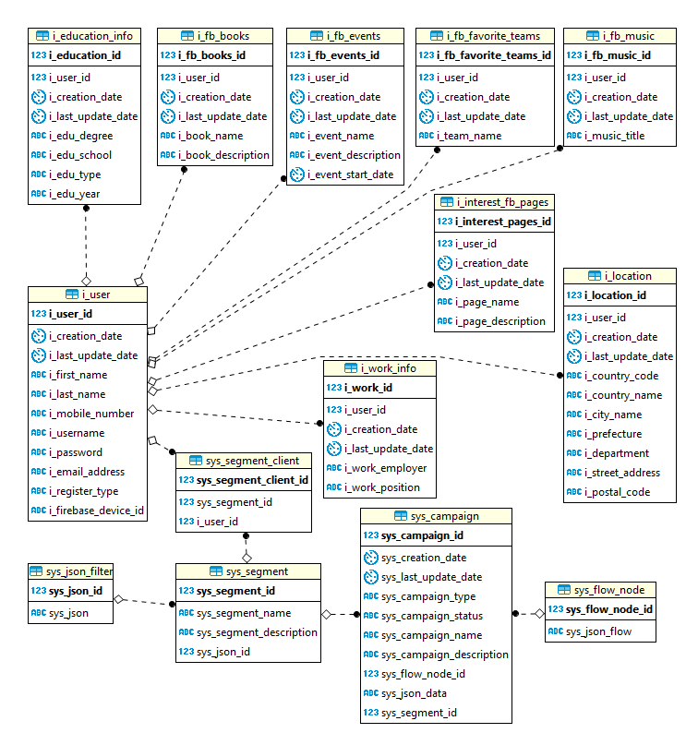

UML Diagrams

Special Code Sections

Conclusions and Future Extensions

Bibliography
[1] Craig, Walls., 2015. Spring in action. 4th edition. USA: Kindle Edition

[2] Jeanne, Hopkins., Jamie, Turner., 2012. Go Mobile: Location-Based Marketing, Apps, Mobile Optimized Ad Campaigns, 2D Codes and Other Mobile Strategies to Grow Your Business. Canada: Wiley

Annex

